11. Managing Seed Stock

Introduction:

Objectives: At the end of this chapter, the user will be able to:

- Create lot locations for the F₅ list.
- Deposit F₅ seeds for stocking.
- Committing transactions.
- Viewing seed stock through the Reporting Tool.

Tutorial Steps:

A. Creating lot location for the F5 list

- Open SETGEN, select U06DSF₅ from the List Selector (double click).
- Tag all entries on the Edit Window of SETGEN
- Right-click on the white space and select <View Inventory> on the pop-up menu. A message will display prompting the user to deposit now.

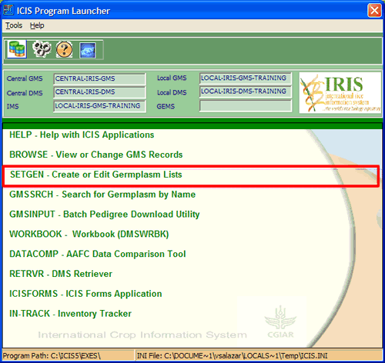
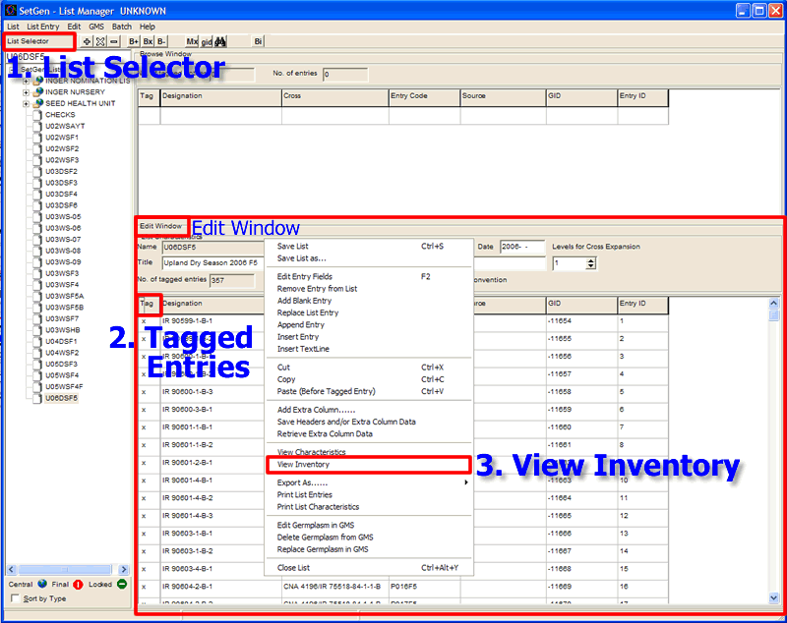
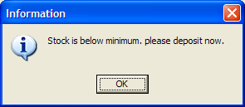

- The Inventory Tracker window will display.
- Right-click on the inventory details section of the Inventory Tracker window and select <Add Lot> from the pop-up menu. A message will display prompting the user to select GID, location and scale.
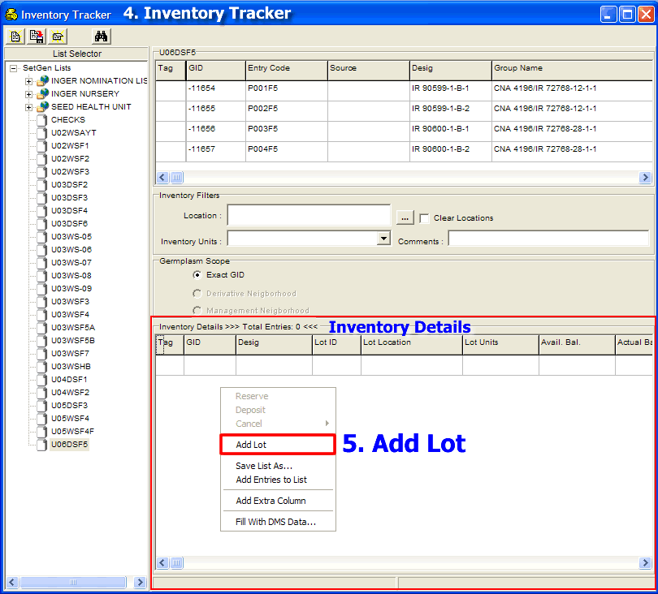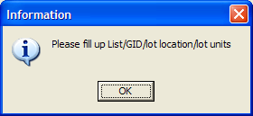

- On the germplasm section, click on the <tag> column header to tag all records.
- On the inventory filters section, click on the elipses button to view the location window.
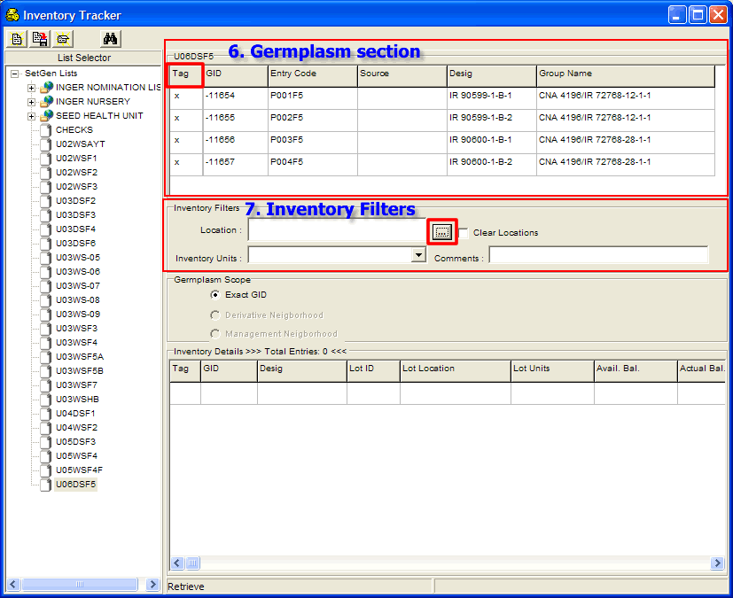

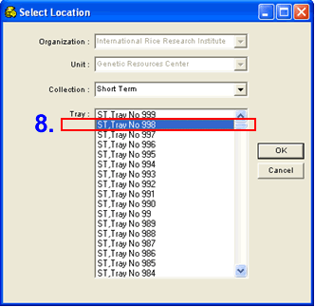

- Select <Short Term> on the Collection drop-down list then select <ST, Tray No. 998> on the Tray drop-down list. Click on the <OK> button to close the window and update the location field on the inventory details section.
- Select <Packet> on the Inventory Units drop-down list.
- On the Comments field, type “lot created” and type the current date.
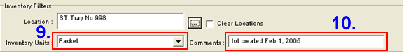
- Click on the <Save> button on the toolbar to update the database. The new lot locations are displayed on the Inventory Details section.

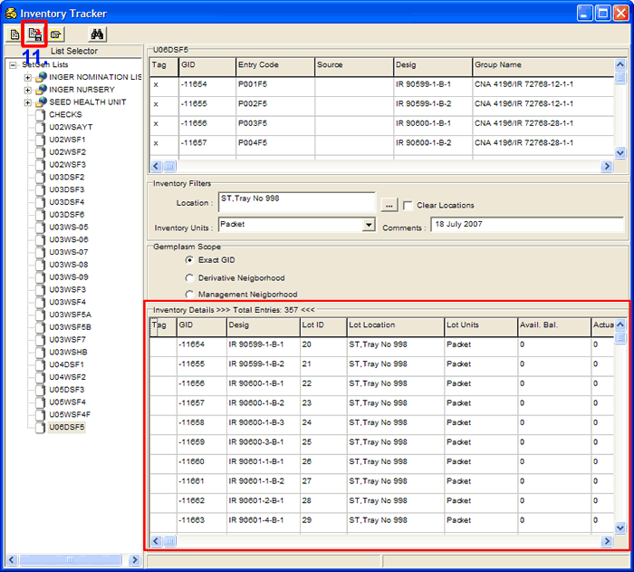

B. Depositing seed stock for the F₅ list

- Tag all the items in the Inventory Details section.

- Right-click on the white space and select <Deposit> on the pop-up menu. The Transaction window will display on the screen.

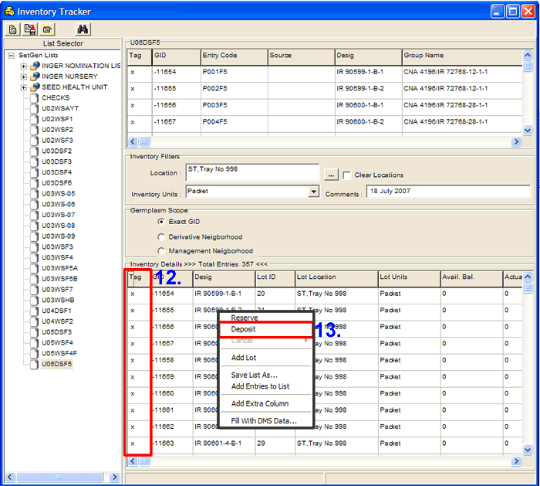
- Encode the number of units to deposit, commitment date of the deposit and any comment on the deposit being made, on the space provide for each item.

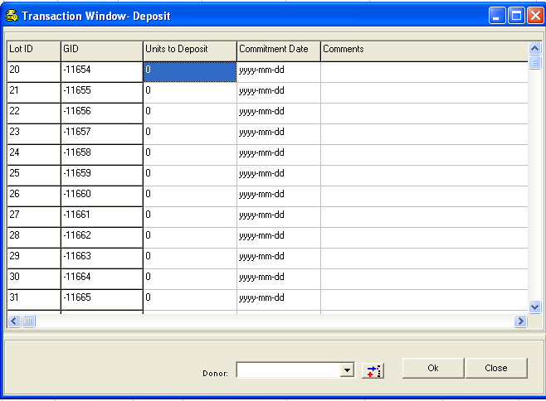

- If the values for all items are the same, click on the column headers of <Units to Deposit>, <Commitment Date> and <Comments>, then a pop-up menu will be displayed.

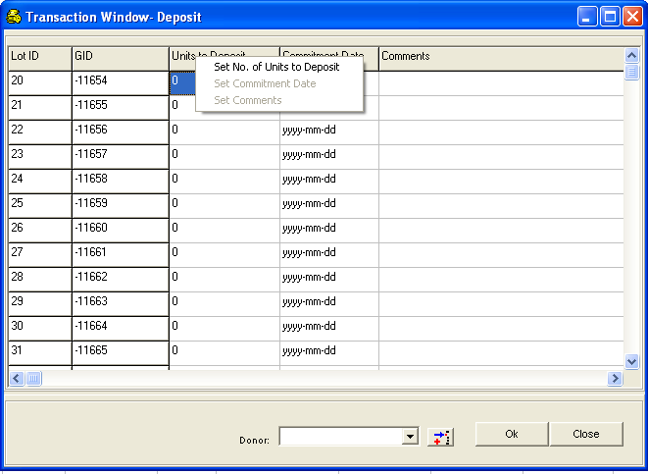89

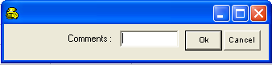
- Click on the enabled sub-menu item to display a small window where data can be entered.
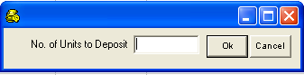
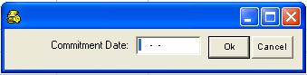

- When you want to assign a donor for this transaction, select an item from the Donor drop-down list.

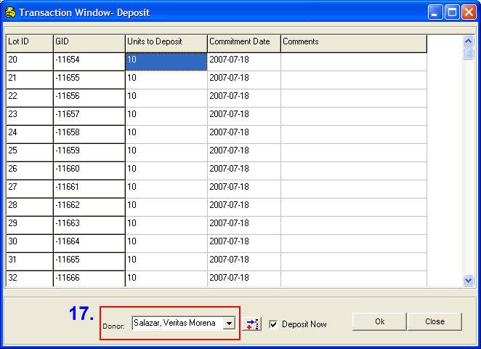

- The system will show a confirmation message on sending an email request to the administrator.

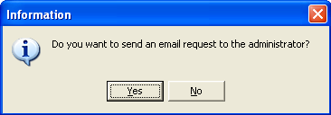

- Click on <No> to continue without sending an email message to the administrator.
- Click <Yes> a Send Email confirmation window displays, select recipient from the drop down arrow <To> and click <Add> then <Send Mail> button.
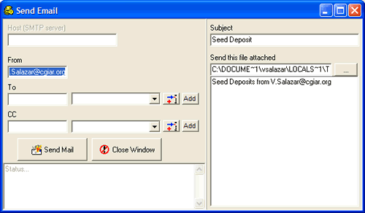

- Click on <Ok> to save changes to the database. The Transaction Window closes and the system goes back to the Inventory Tracker window. Check for Seed Deposit attachment in your mailbox.

C. Committing Transactions
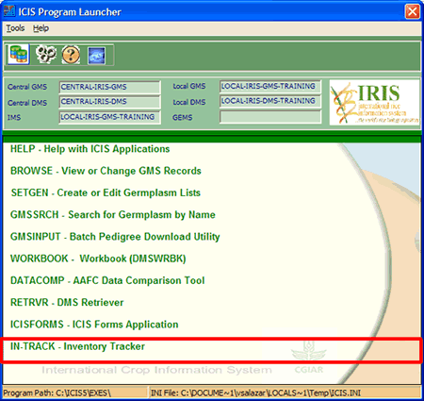
- Close the SetGen Application. Open InTrack from the Launcher.
- Select <Security><LogOn as Administrator> from the menu.

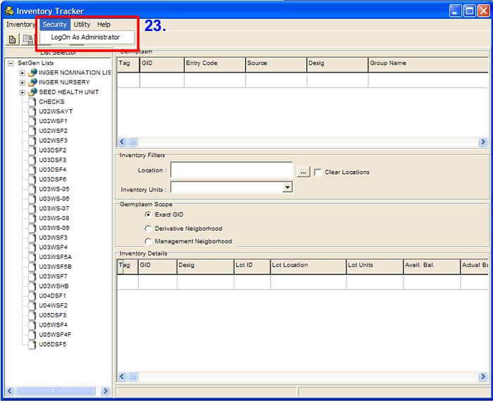

- The Administrator LogOn window appears. For the purpose of this training, the administrator’s username and password are provided. Click on the <Ok> button to access the Administrator form.

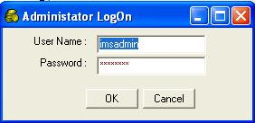

- Select the U06DSF₅ from the List Selector (click). Select <Inventory> <Retrieve> <Deposits> from the menu. The deposit transactions are retrieved on the Inventory window.

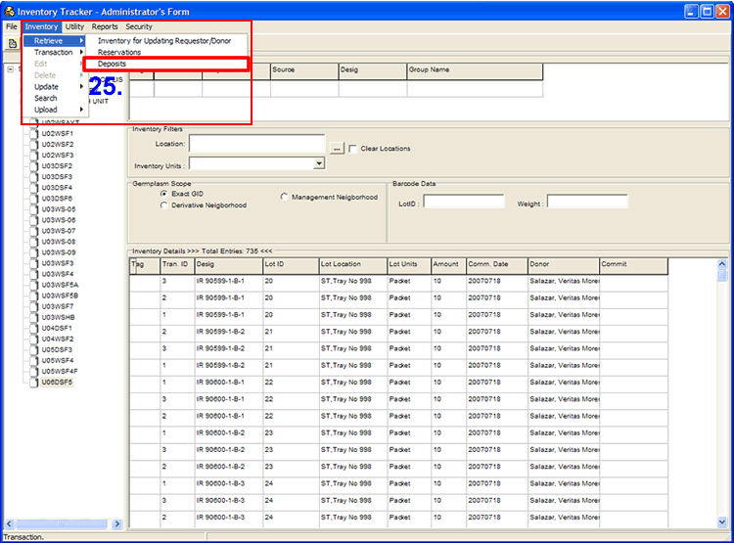

- Right-click on the <Commit> header then select <Commit All> from the pop-up menu to commit all transactions. You will notice that the column is filled with ‘Yes’, meaning these records are ready for commitment.

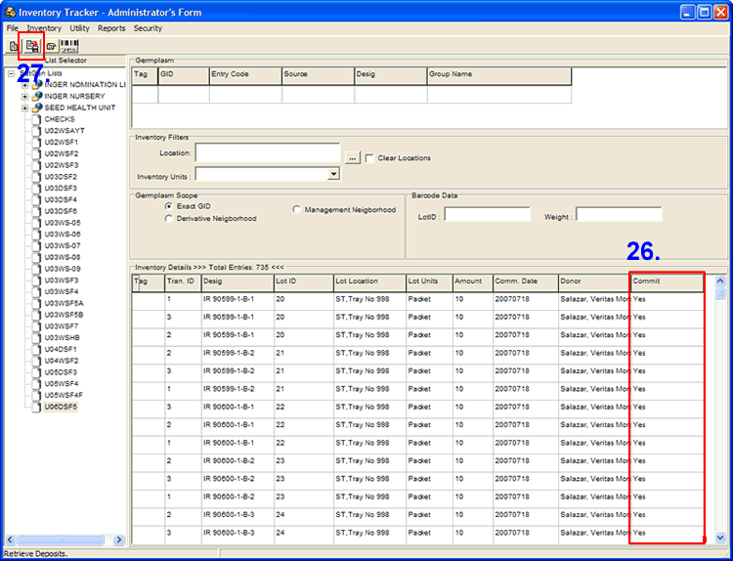

- Click on the <Save> button to commit these transactions. An information window is displayed specifying the total number of transactions processed, the number of successful transactions and the number of transactions that failed.

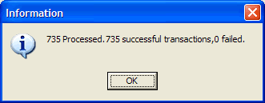

- Select U03WSHB from the List Selector and repeat steps 25 – 27 for the committing reservations.

- Select <Inventory> <Retrieve> <Reservations> from the menu. The reserve transactions are retrieved on the Inventory window.
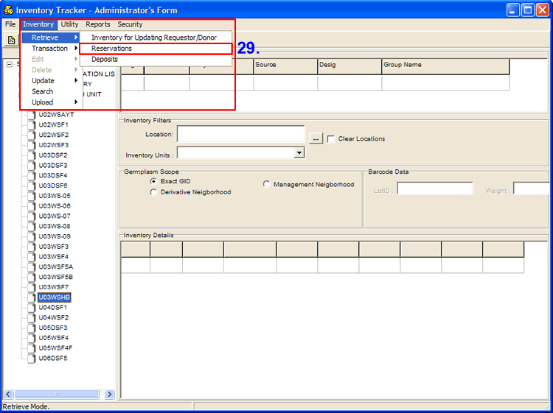

- Right-click on the <Commit> header then select <Commit All> from the pop-up menu to commit all transactions. You will notice that the column is filled with ‘Yes’, meaning these records are ready for commitment.

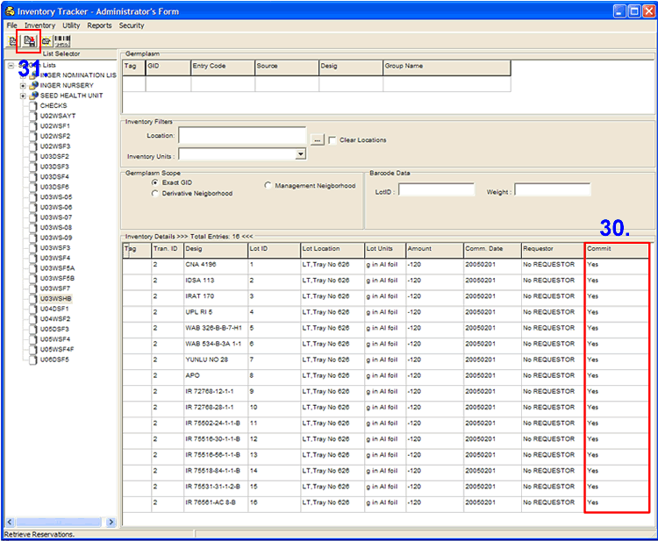

- Click on the <Save> button to commit these transactions. An information window is displayed specifying the total number of transactions processed, the number of successful transactions and the number of transactions that failed.

D. Viewing seed stock through the Reporting Tool.

- Without closing the Inventory Tracker window, select <Reports> <Empty Lots> from the menu.
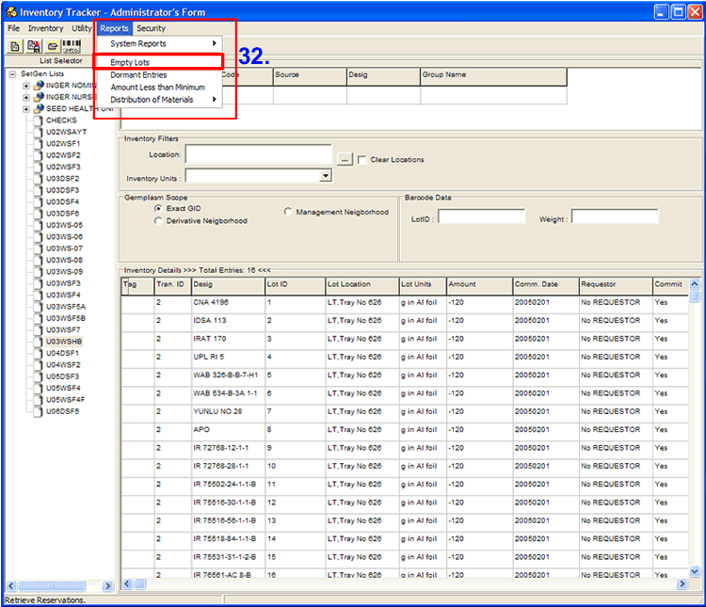

- The system will display a Report Form. You can choose from the toolbars if you want to Show Report, Preview or Print. MS Word format is also created from here, you can edit the layout of the report like the header, footer, page number et al. You can print the report the usual way as printing word documents.
