- Workbook Templates

Introduction:

A nursery trial is usually done in regular season. Creating a Workbook for each trial with the same set of variables applied and observed is a repeated task. Hence, a template Workbook for trials with the same factors and variates is a convenient way to handle this repeated task. The creation of the template is discussed in the section Setting Up Nursery Templates.

Objectives: At the end of this chapter, the user should be able to:

- Use a Workbook template to retrieve a germplasm list
- Record data about the entries in the list, and
- Load and retrieve the recorded data.

Tutorial Steps:

Preparing the Fieldbook

  - Start the ICIS Workbook from the Launcher.
  - Click on the Study ► Open File ► From File menu or the icon then select → F4_template.xls (from the directory → X:\ICIS5\Documents\TDM\II Users Manual and Training Material\C. Breeder's Training Course\5 08_09 Using Workbook to manage evaluation data)

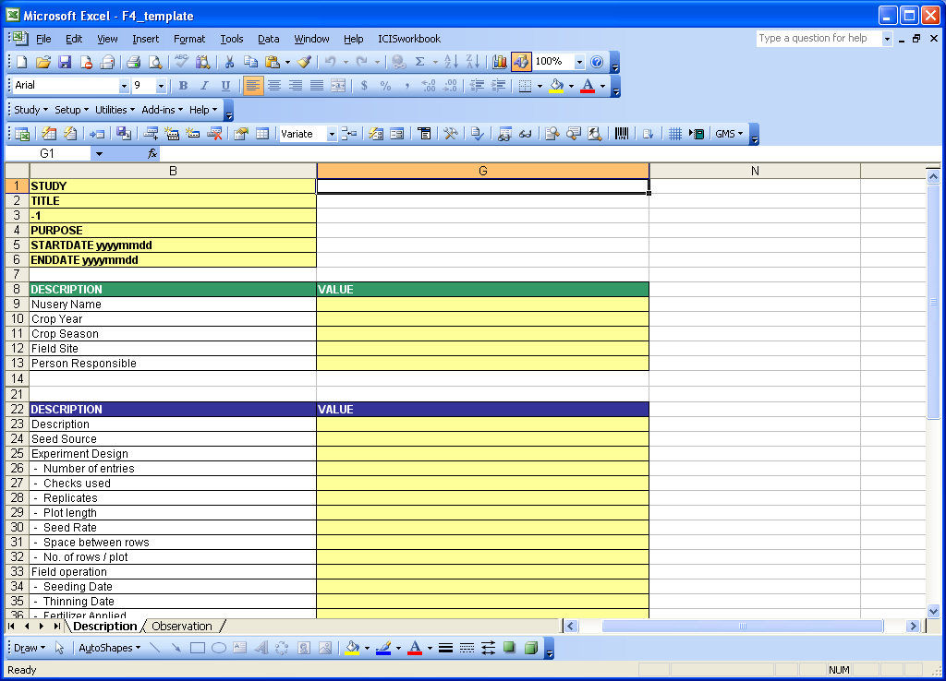

  - On the Excel menu click on the Tools ► Protection ► Unprotect Sheet then enter the password → DMS to unprotect the Description sheet. 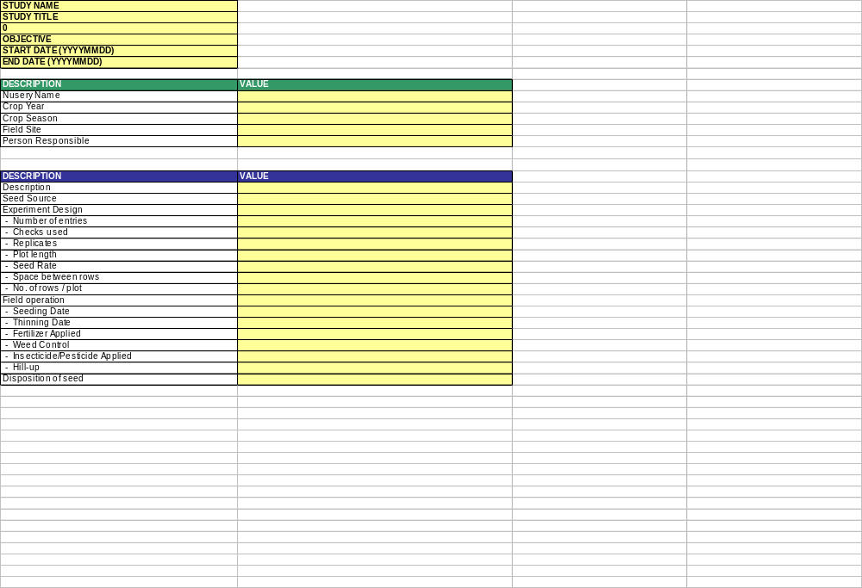
  - Click on the Observation tab to go to the Observation sheet.

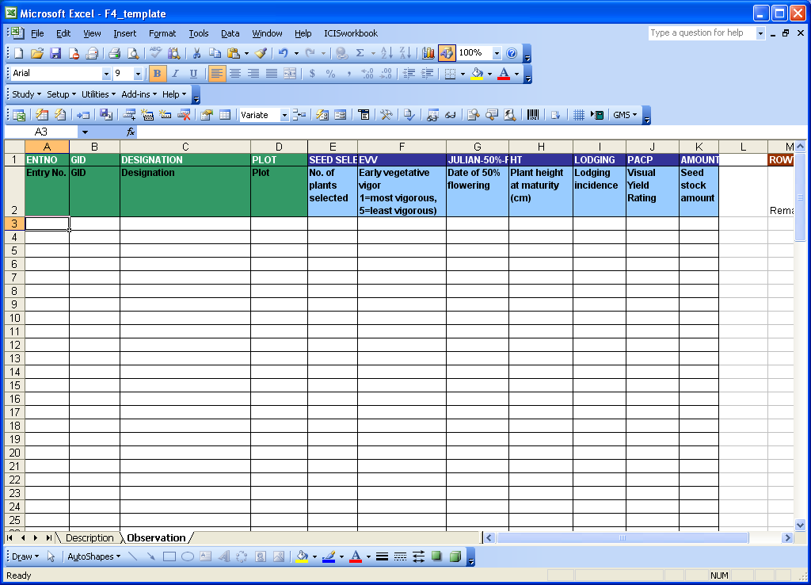

  - Again, click on the Tools ► Protection ► Unprotect Sheet then enter the password → DMS to unprotect the Observation sheet.
  - On the ICISworkbook menu, click on the Add-ins ► Import Data From ► SetGen or the icon. The “Import Data from SetGen” dialog interface will appear.
  - In the search box under the section “SetGen List”, type → U05WSF4F
  - Notice that at the right side of the dialog interface under the section “Workbook Columns”, the SetGen variables are being mapped with the corresponding Workbook variables. Make the necessary changes if there should be.

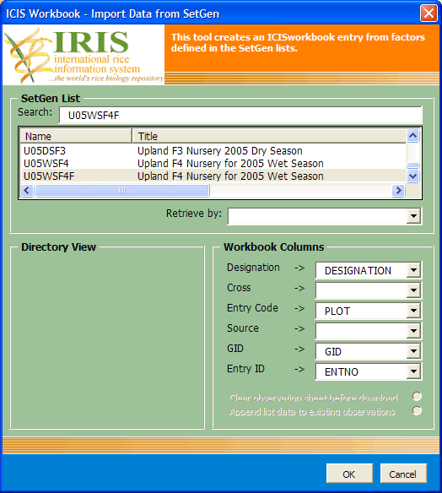

  - Once the desired germplasm list has been selected and the mappings already set, click on the “OK” button.

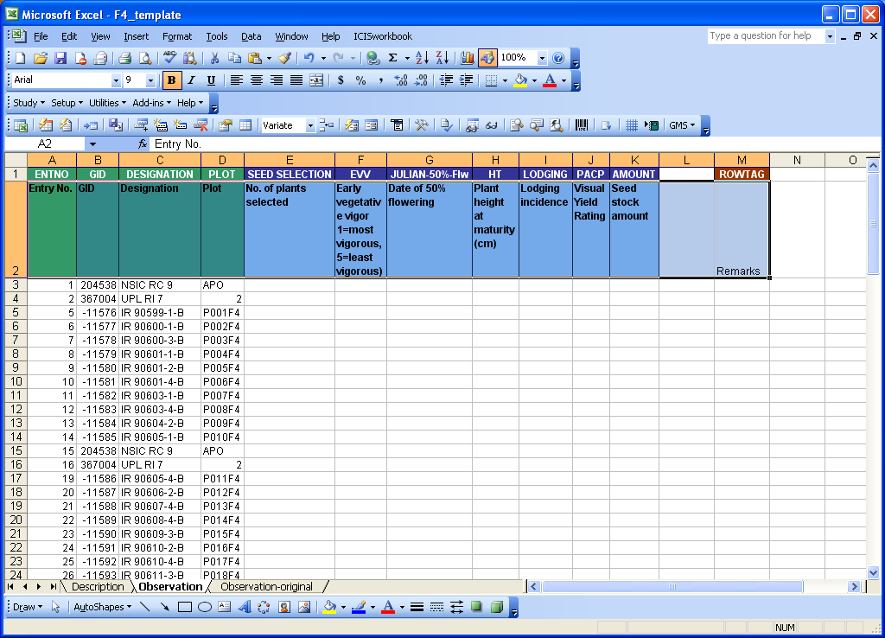

  - Now go to the Excel menu and click on the File ► Open then select → Appendix F.xls (from the directory → X:\ICIS5\Documents\TDM\II Users Manual and Training Material\C. Breeder's Training Course\5 08_09 Using Workbook to manage evaluation data)

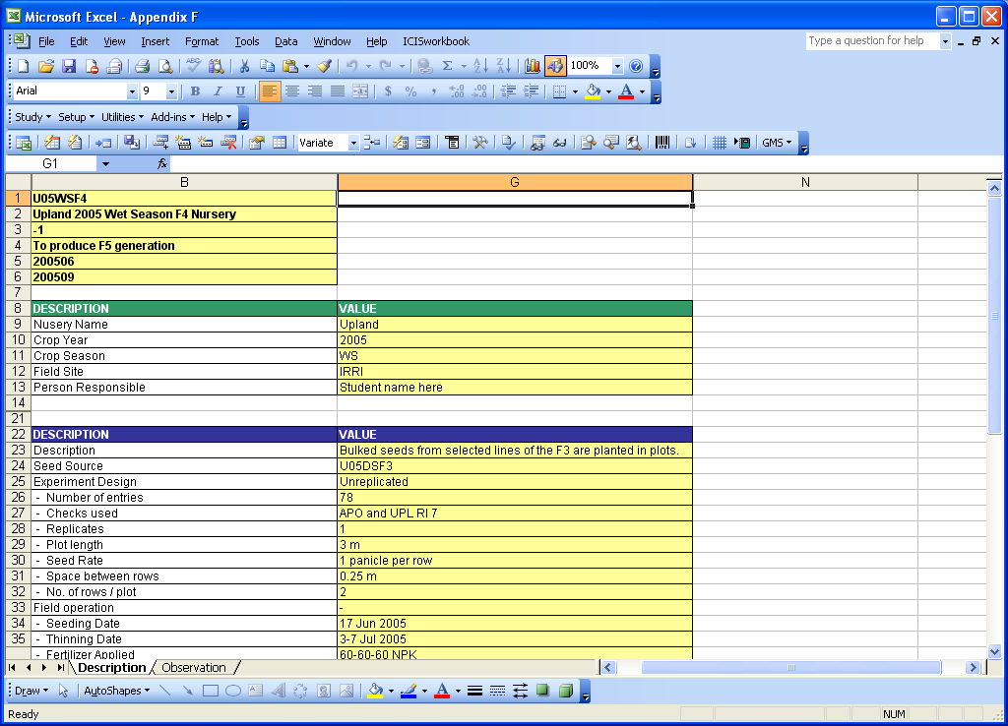

  - For the topmost block of yellow cells in “Appendix F.xls”, select only the last four rows and paste them on the same row numbers in the Description sheet of “F4_template.xls”. Then, select each of the remaining two blocks of yellow cells from “Appendix F.xls” and paste them on the appropriate group of yellow cells in “F4_template.xls”.
  - On the Excel menu click on the File ► Save As then type the name → U05WSF4.xls.

  - On the Description Sheet of the file “U05WSF4.xls” fill in Values for Condition.
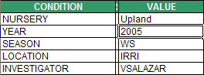

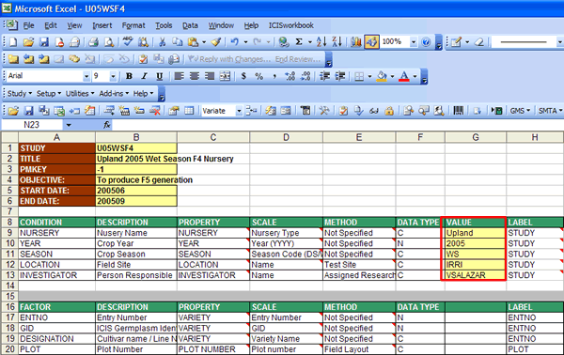

Entering the Data

- Select the block of data under the variate columns in the Observation sheet of “Appendix F.xls” and paste them on the corresponding cells in the Observation sheet of “U05WSF4.xls”.

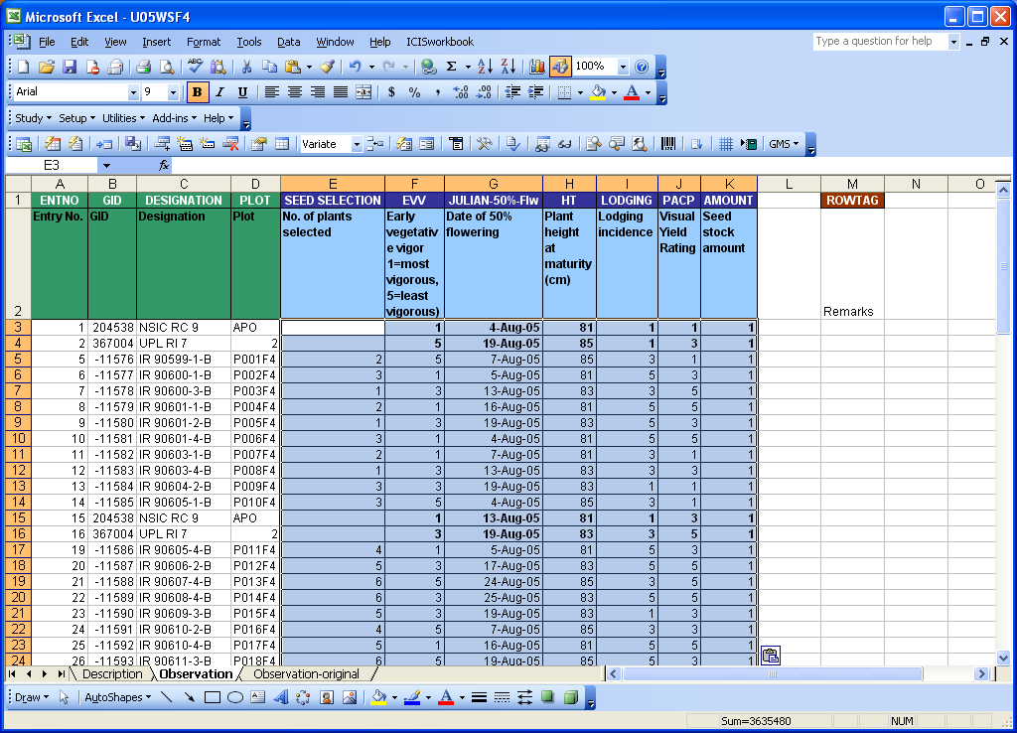

- Check the data entry by reading back with a colleague.
- On the Excel menu, click on the File ► Save.
- On the ICIS Workbook menu, click on the Study ► Load or click the icon to upload the data to the DMS local database.

- When the study is loaded, exit the ICIS Workbook.

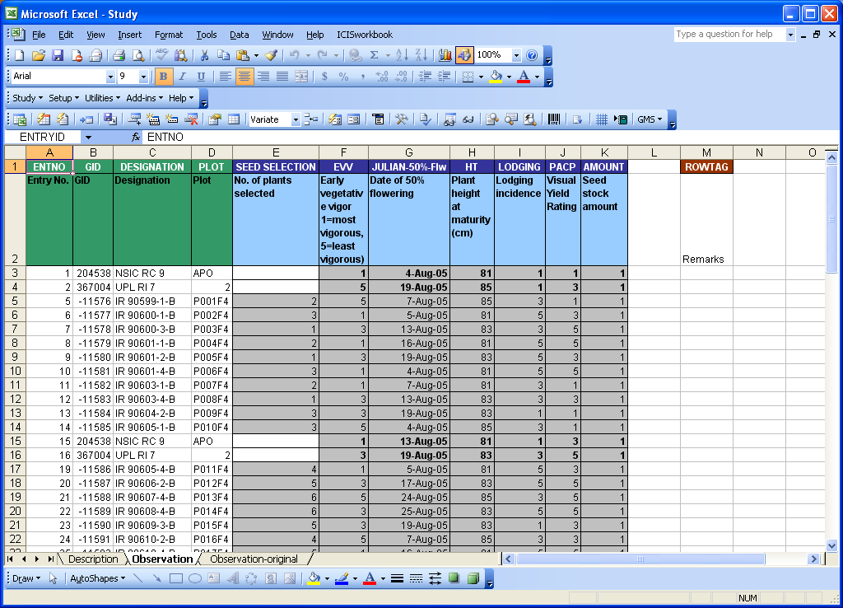

Retrieving the Data

- Start the ICISworkbook from the Launcher.
- Click on the Study ► Retrieve ► Dataset menu or the icon.
- Select the study you want to view then the dataset and click the “OK” button.

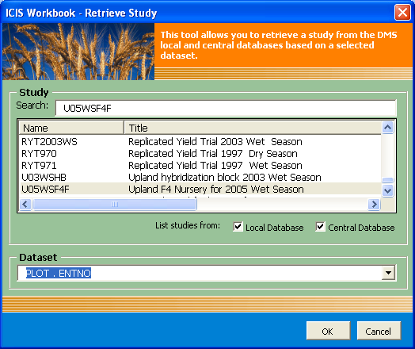

- The study will then be downloaded to a workbook file.

