10. Advancing of Pedigree Nursery by Batch Processing

Introduction:

Objective: At the end of this chapter, the user will be able to advance a pedigree nursery through batch processing by using a DMS study as input list.

Tutorial Steps:

- Start SETGEN from the Launcher.

- Click on the ‘B-‘ button from the speed toolbar. The Generate Derivatives in Batch Mode window will appear (see http://cropwiki.irri.org/icis/index.php /TDM_SET_GENERATION_5.4#Batch_Mode_Processing).

- In the Source Study section, select ‘U05WSF4F’ from the Name drop down list ‘GID’ from the GID drop down list.

- In the Destination List section, type ‘U06DSF5’ in the Name edit box; select ‘PN’ in the Type drop down list; type ‘2006-01-10’ for the Date edit box; and enter ‘Upland Dry Season 2006 F5’ in the Title edit box.

- In the CONSTANT SELECTION PARAMETERS section, select ‘DER 205DSP SINGLE PLANT SELECTION’ in the Method drop down list; select ‘DERIVATIVE NAME’ in the Name Type drop down list; type ‘2006-01-10’ for the Germplasm Date; and select ‘IRRI-INTERNATIONAL RICE RESEARCH INSTITUTE, LOS BANOS’ for the Germplasm Location.

- In the Naming Convention of Designation, select ‘DESIGNATION’ from the Designation drop down list and choose ‘SEED SELECTION’ in the No. of Selections drop down list. Set the Start No. value to ‘1’.

- In the Naming Convention of Entry Code section, put ‘P’ in the Prefix field; put ‘1’ in the Start No. field, and ‘F5’ in the Suffix field.

- Click on the Include leading zeros check box and specify ‘3’ in the Numeric Field Width.

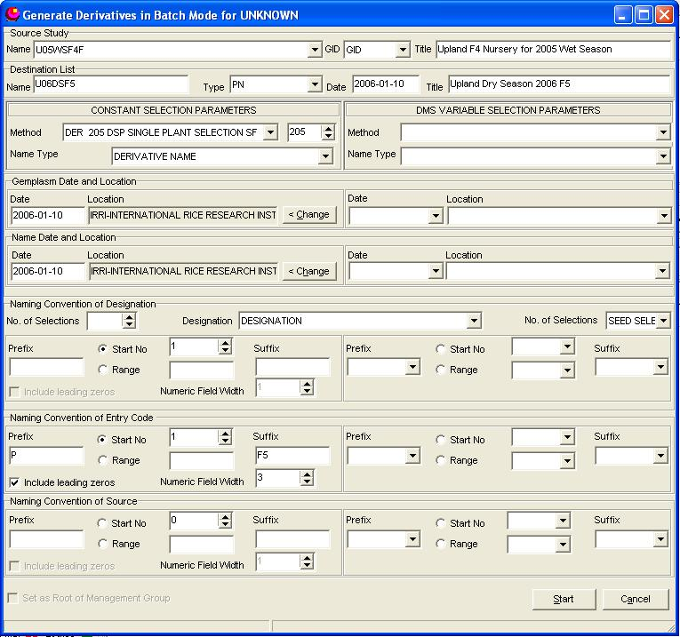

- Click on the <Start> button.

- This window will close and the U06DSF5 list will be opened in the Edit window for your preview.

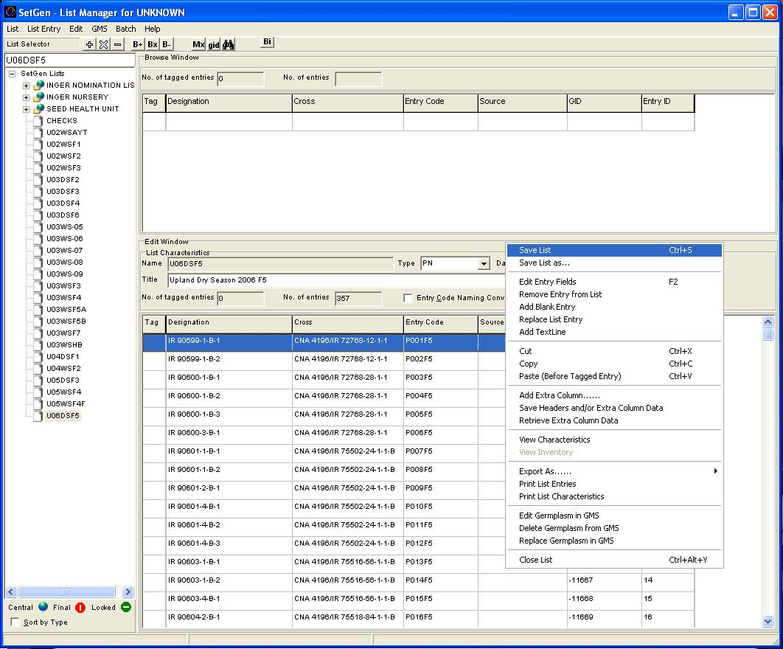

11. Right Click and select <Save List> on the pop-up menu.

