8. Managing Pedigree Nursery Information with IRIS

Introduction:

Objectives: At the end of this chapter, the user will be able to:

- Generate the F₃ and F₄ nursery lists.
- Generate germplasm derivatives interactively;

Tutorial Steps:

In this exercises, we will form the F₃ nursery list by selecting four plants from each plot in the F₂ nursery. On the other hand, we will generate the F₄ nursery by bulking the seeds from selected rows in the F₃ nursery.

A. Generating the F₃ Nursery List:

- Start SETGEN from the Launcher (see http://cropwiki.irri.org/icis/index.php /TDM_SET_GENERATION_5.4#Starting_SETGEN).
- Select the U04WSF₂ list from the List Selector and click <List><Browse> (see http://cropwiki.irri.org/icis/index.php/TDM_SET_GENERATION_5.4#The_List_Manager).
- Click on the <List><New> menu.
- Make a new list called U05DSF₃ with ‘Upland F₃ Nursery 2005 Dry Season’ as the title of the list.

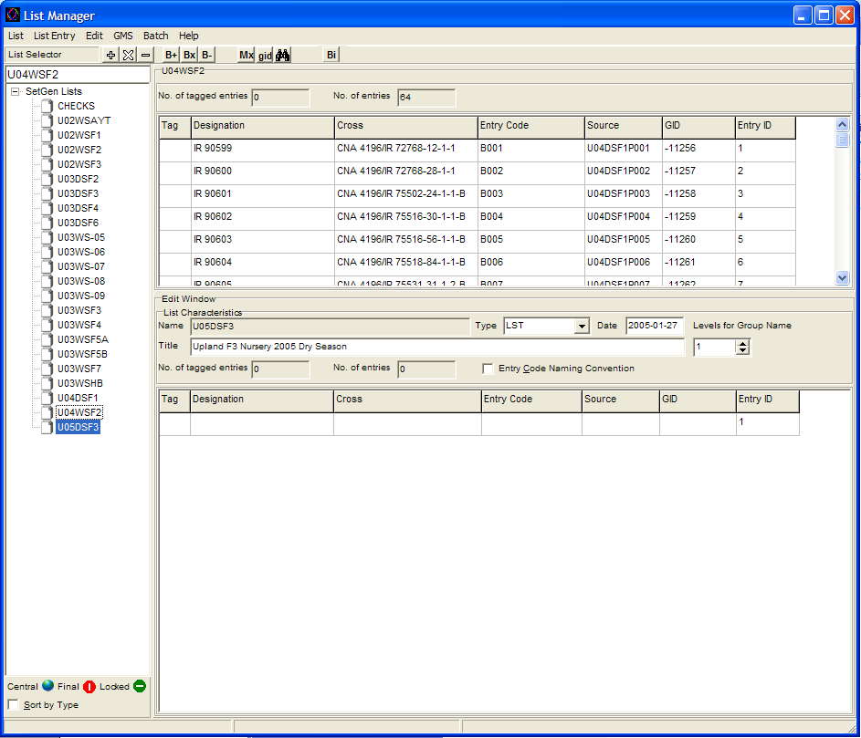
Figure 7.1 After opening a list in the Browse window and creating a new list in the Edit window.

- Select all the entries from the browse window. This is done by right-clicking the mouse Tag column header then right click the mouse and choose Tag All. After selecting the entries, notice the letter ‘X’ appeared in the ‘Tag’ column. This indicates that those entries tagged with ‘X’ have been selected.

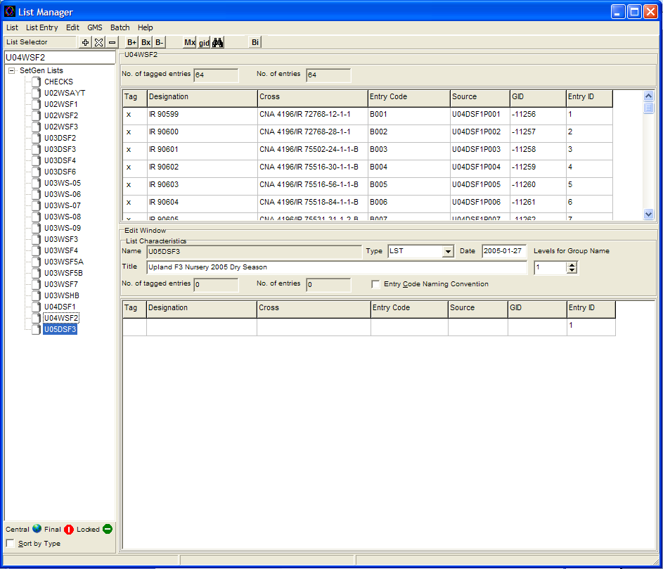
Figure 7.2 Selecting entries in the Browse window for advancing a line.

- Click the ‘-‘ button. The <Advance a Line One Generation> window will appear.

- Specify the necessary information needed for advancing the F2 lines. For this exercise, we will pick the DER 205 DSP SINGLE PLANT SELECTION for the <Derivative Breeding Method>, and enter ‘4’ and in the <Plant Selected> under the <Naming Convention of Designation> section.

- Supply also the dates and location under the <Germplasm Date and Location> section. For this exercise, type 2005-01-01 for the date, and select IRRI-INTERNATIONAL RICE RESEARCH INSTITUTE, LOS BANOS for the location.

To change the location click on the <Change> button to make the <Select Location> window appears, and choose PHILIPPINES as Country, and select IRRI-INTERNATIONAL RICE RESEARCH INSTITUTE, LOS BANOS found in the list box under the location section.

- In the <Naming Convention of Source> section, select the <ListName> and the <EntryCode> check boxes.

- After specifying the information in the <Advance a Line One Generation> window, click the <Ok to All> button.

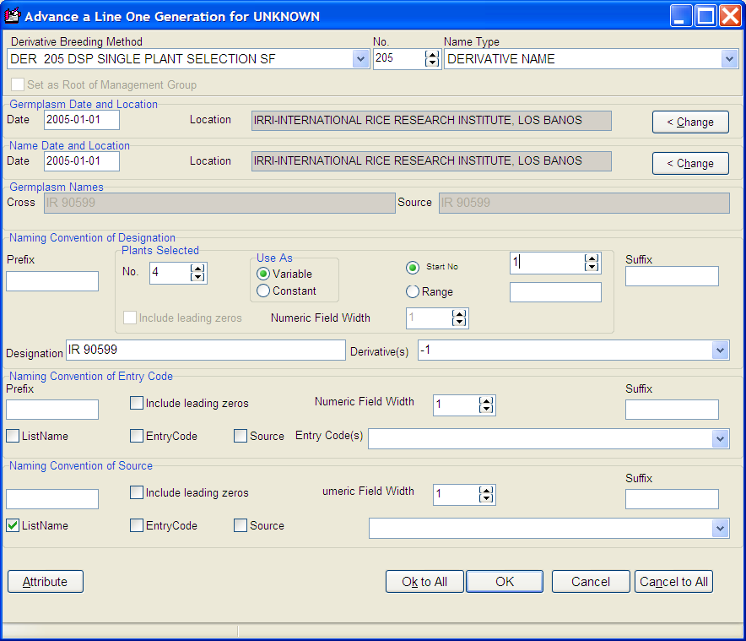
Figure 7.3 The Advance a Line One Generation window

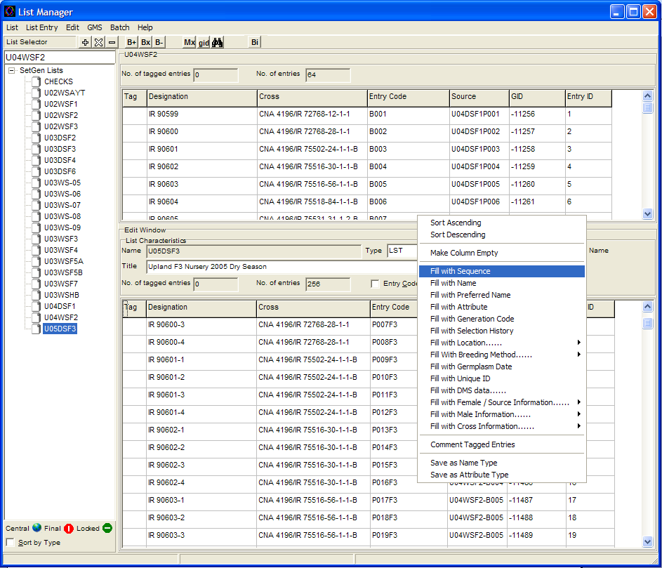
Figure 7.4 Result after advancing the selected entries.

- To change the values on the <Entry Code> column, point the mouse cursor at the ‘Entry Code’ header column and right click the mouse. A small menu box will appear with some options you can select from to fill in the ‘Entry Code’ column. For this exercise choose <Fill with Sequence…>.

- The <Naming Convention> window will appear. Type ‘P’ in the <Prefix> section, type ‘1’ in the <Start No.> section and ‘F3’ in the <Suffix> section then click on the <Include leading zeros> check box and type ‘3’ on the <Numeric Field Width> section then click on the ‘Ok’ button. Notice that the <Entry Code> column has been filled up with sequential numbers.

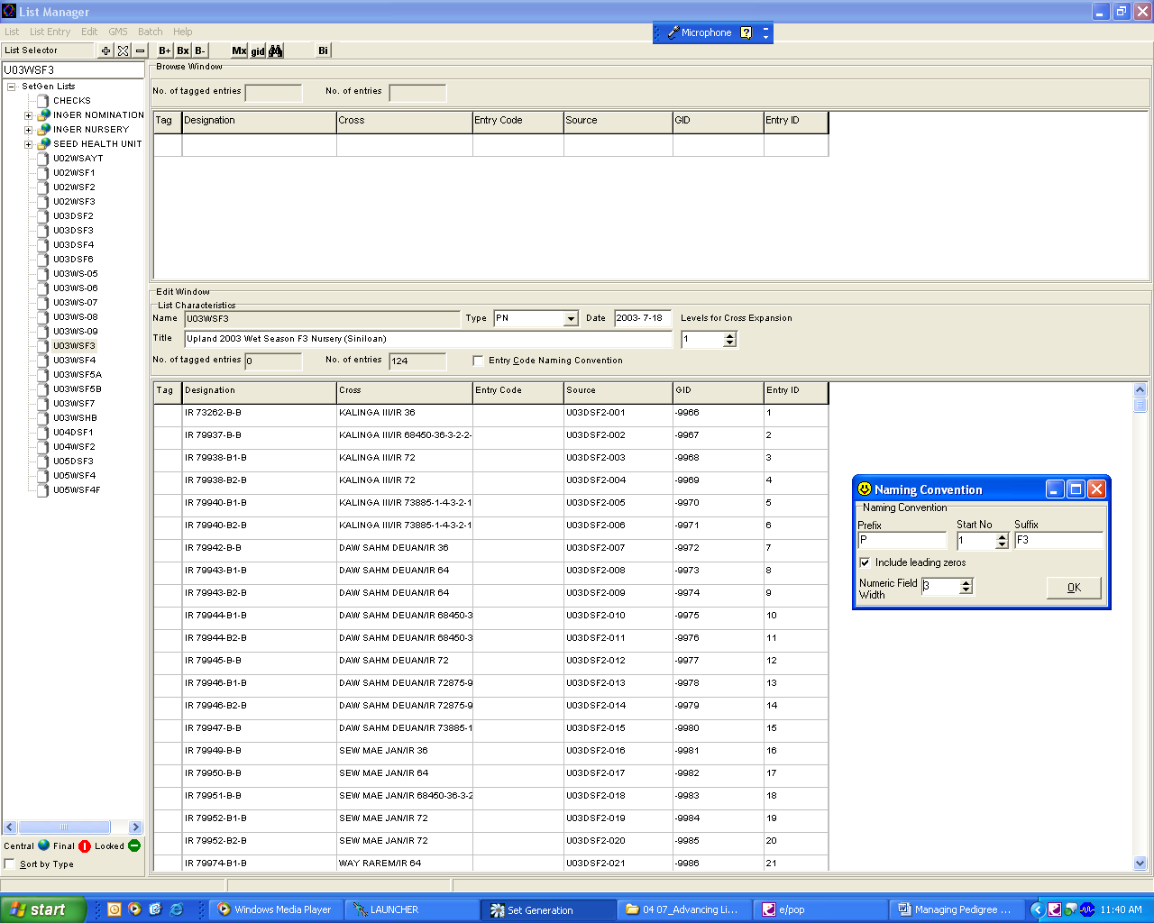
Figure 7.5 Naming Convention window.

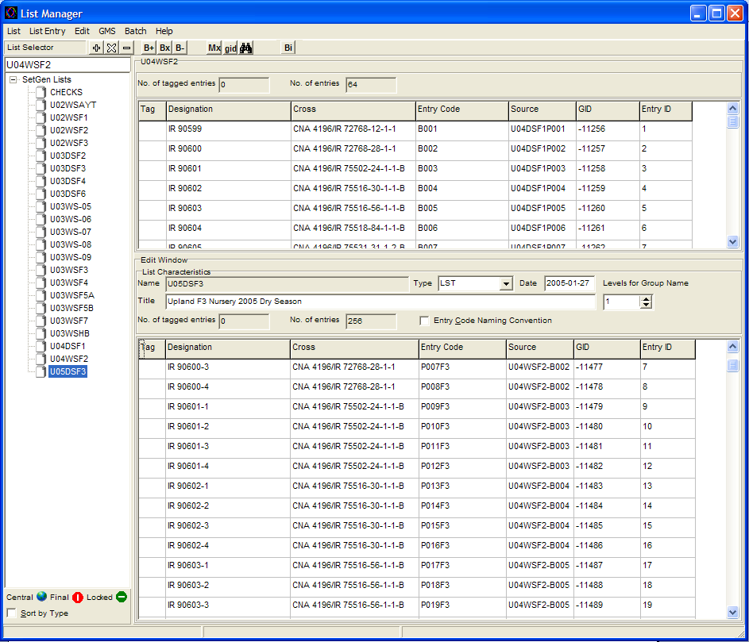
Figure 7.6 Result after filling up the Entry Code with sequential numbers.

- Click on the <List><Save> to save the new list.

- You could export the list into an XLS fieldbook by clicking <List><Export As><XLS Fieldbook>.

- Click on the <List><Close List><All> to clear the <Edit> and <Browse> windows. Close Setgen.

B. Generating the F₄ Nursery List

- Start Setgen. Select the F₃ Nursery List <U05DSF₃> from the List Selector and open it on the <Browse> window.

- Create a new list called <U05WSF₄> with ‘Upland F₄ Nursery 2005 Wet Season’ as the title of this list.

- Randomly select about 50 to 70 entries in the <Browse> window. These represent the entries you choose to advance by field inspection and data collection on the F3 nursery.

- Click on the ‘-‘ button to advance the selected entries in the <Browse> window by one generation.

- Pick the ‘DER 207 DRB RANDOMBULK SF’ under the <Derivative Breeding Method> section. Check if the Dates and Locations under the <Germplasm Date and Location> still have the suitable information.

- Type “B” in the <Suffix> under the <Naming Convention of Designation> Section.

- Under the <Naming Convention of Source> section, select <Listname> and the <EntryCode> check boxes.

- Click the <Ok to All> button.

- Repeat steps 11-13 of this exercise to generate and save the F₄ nursery list.

C. Adding Checks to a Pedigree Nursery

- Open the CHECKS list in the Edit Window (double click). Tag the last two entries. Select menu item <Edit><Remove Entry from List> to remove the last two lines from the check list. Save the CHECK list with the remaining two entries.

- Open the F4 nursery list U05WSF4. On the Edit Window, right-click on the white space then select <Save List As…> menu item to make a copy of the list called U05WSF4F. Click on the <Ok> button. With this list open, use menu item <List><Add Checks to List>.

- In the <Add Check Entry to Edit List> dialogue window set the <Specify List of Check Entries> to ‘CHECKS’ set the <First Check Position> to ‘1’ and <Check Frequency> to ‘10’. Then check the <Add All Checks at Each Position> button. Click OK to add the checks. Click on Yes on the Confirmation Window.

- Right click on the <Entry Code> column and use the <Fill with Sequence…> item to add plot numbers <P001F4> to the list. Save and close the <U05WSF4F> list.

- Exit SETGEN.

