13. Depositing of Seed Stock for RYT List – Batch

Introduction:

Objectives: At the end of this chapter, the user will be able to:

- Deposit a seed stock from a study through the batch facility.
- View the seed stock of the uploaded study.

Tutorial Steps:

A. Depositing a Seed Stock Using the Batch Facility

- Inside SETGEN, click on ‘Bi’ button on the toolbar. The Inventory Tracker – Batch processing window will display.

- On the Source Study section, select U06WSRYT on the <Name> drop-down list then select GID on the <GID> drop down list.

- On the Constant Selection Parameters section, click on the ellipses button to view the location window.

- Select <Long Term> on the Collection drop-down list then select <LT, Tray No. 625> on the Tray drop-down list. Click on the <OK> button to close the window and update the location field on the Batch Inventory Information section.
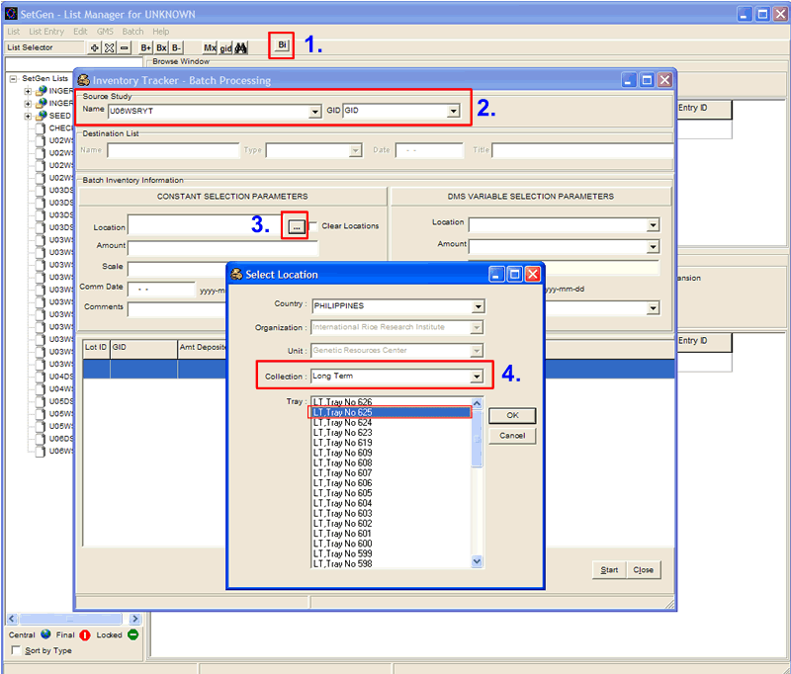
- Type the current date on the Commitment Date field and “loaded from a study” on the Comments field, respectively.

- On the DMS Variable Selection Parameters section, select AMOUNT on the Amount drop-down list. Notice that the Scale field is generated by the system then click <Start> button.

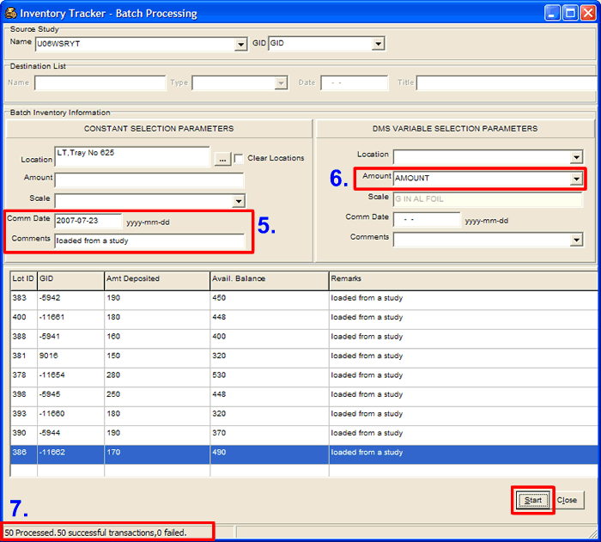

- On the lower part of the window, the processed data is displayed. On the status bar, the system displays the total number of records processed, the number of successful transactions made, as well as the number of failed transactions.

B. Viewing the Seed Stock of the Uploaded Study

- Close the Batch Processing window. Double-click U06WSRYT on the List Selector.

- Tag all entries on the Edit window. Right-click on the white space and select <View Inventory> on the pop-up menu. The Inventory Tracker window will display. Click on the <Remarks> column header on the Inventory Details section. The data uploaded from the study is displayed.

