The ICIS Setup Program
The ICIS SetUp program automates the process of establishing a new ICIS implementation or installing a new or updated local database for an existing ICIS implementation (crop).
Requirements:
- Windows 98 or Windows NT operating system
- At least 16 MB of memory
- Internet Explorer version 5.1 or higher
- Minimum Install: at least 10 MB of hard disk
- Full Install: add the size of the central database file
- At least 2x speed CD-ROM drive
- Administrator privilege if installing under Windows NT
Install GMS for the First Time
The ICIS setup program should automatically run when the CD is inserted into the CD-ROM drive. If it does not, run the Setup.exe program from the CD drive with Explorer or from the command line.
- The main window appears. Click <Existing ICIS Implementations>.
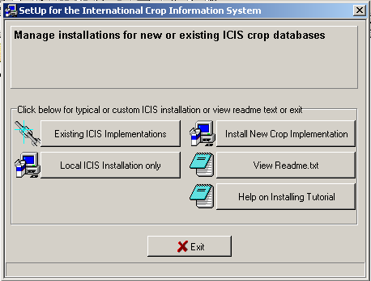
- A welcome dialog box appears. Click <Next>.
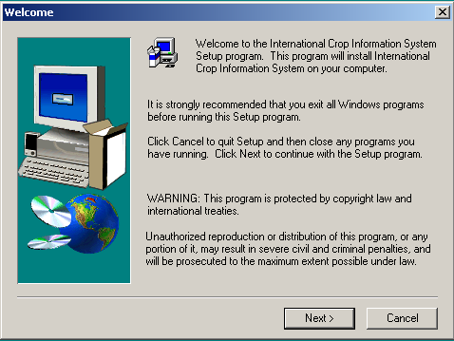
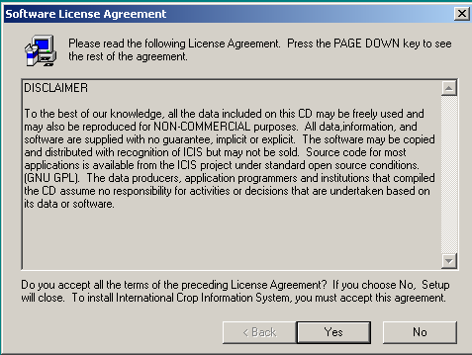
- The software license agreement appears. Click <Yes> to accept the agreement; otherwise, click <No>. You will not be able to proceed with the installation if <No> is clicked.
If ODBC is not installed, or, if the installed ODBC is older than the setup version, setup will install its version.
In Windows 95, setup tries to detect if DCOM95 is installed. This is required to register some components needed by MDAC. If not, setup will install DCOM95, then reboot. To continue, repeat step 1.
The Microsoft Data Access Components (MDAC) is installed next.
- Specify where to install ICIS. The default destination folder is C:\ICIS. To specify an alternative location, click <Browse>. A dialog box appears. Choose the desired drive and directory to install ICIS.
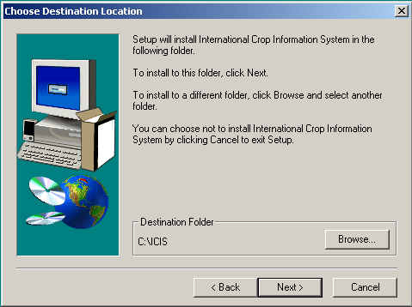
If the specified folder does not exist, a dialog box appears. Click <Yes> to create the new folder; click <No> to repeat the step. After a destination is specified, click <Next>.
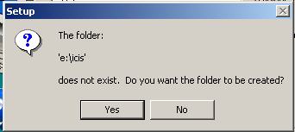
- A list of crop implementations that can be installed appear. Select from the list which crop implementation to install, then click <Next>.
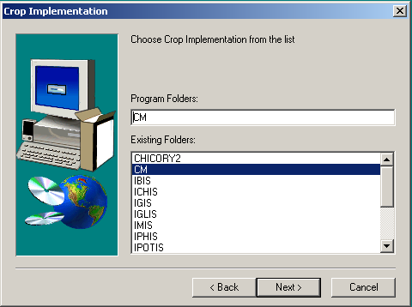
- The query to copy the central database to the hard drive appears. Click <Yes> to copy the central database onto the hard drive; or click <No> to use the central database in the CD.
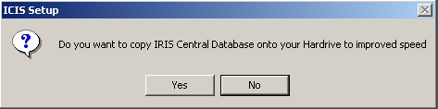
Notes:
  - If <Yes> is clicked and there is not enough space on the hard drive for the central database, the setup program will abort. The setup must be repeated.
  - If <No> is clicked, each time ICIS is run, the CD must be inserted in the CD-ROM drive for ICIS to run. Otherwise, no ICIS application can be run.
- Either a new local installation or an existing local installation can be installed. Select the first option to install a new local database. Select the second option to specify an existing local database from a previous installation. Click <Next>.
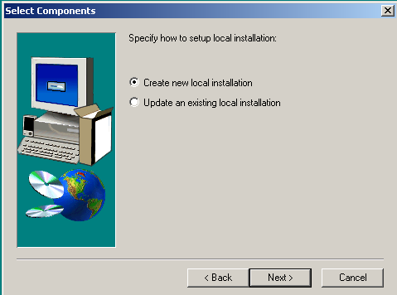
If the first option is selected, proceed to step 8; otherwise, proceed to step 11.
- Enter a short description for the new installation. Maximum length of the description is 255. A description must be entered to proceed. Click <Next>.
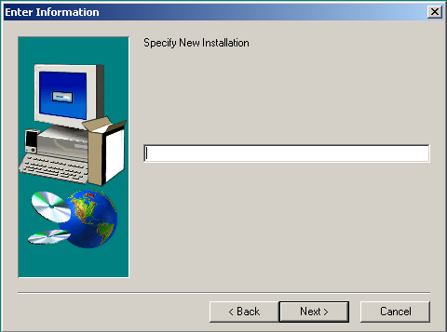
- Prescribe the administrator username and password for the new local database. The maximum length for username is 30; the maximum length for a password is 10. Click <Next>.
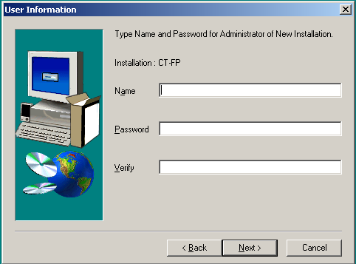
- Prescribe a local database name. This corresponds to the database filename. Do not add an extension for the name. The setup automatically adds the file extension. Click <Next> and proceed to step 14.
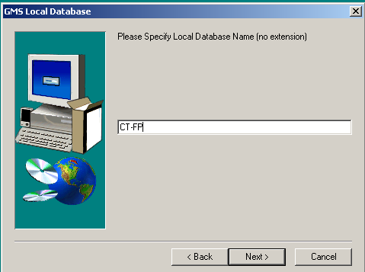
- A list of existing local installations of the crop implementation appears.
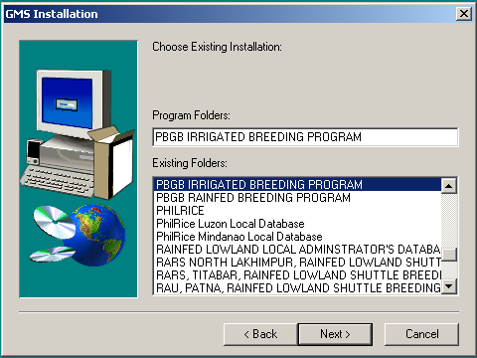
Select from the list the desired local installation to use. Click <Next>.
- The local database administrator and password must be specified. The information that must be specified is the same information that was prescribed in step 9 when the local database was installed. Click <Next>.
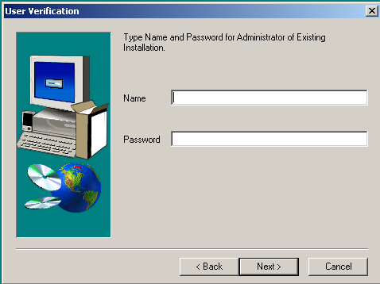
If either local administrator name or password is incorrect, an error message appears. Repeat this step.
- Repeat step 10.
To use the same local database (which may have be an updated version), the same filename that was previously prescribed in step 10 must be specified. The updated local database is copied from the setup to the hard drive. Otherwise, if a name other than the existing name in the setup is specified, a new file of the local database is created.
- A summary is displayed. To start copying the files onto the hard drive, click <Next>. Files are copied to the destination directory.
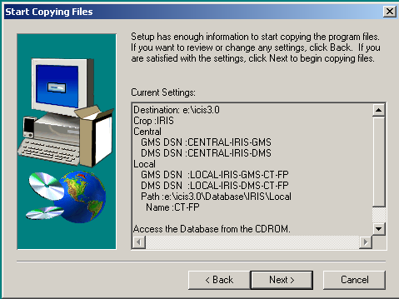
- To create a shortcut to the launcher on the desktop, check the ‘Create a shortcut on the desktop’ checkbox. Otherwise, uncheck the box. Click <Finish>.
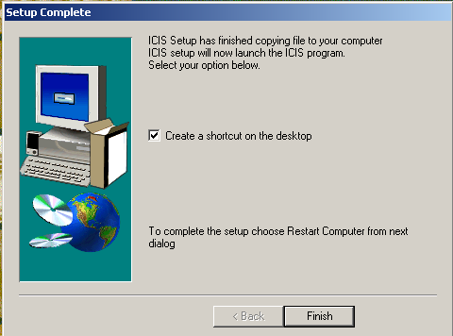

- After the setup is complete, the option to restart the computer or not appears. It is recommended that the computer be restarted. Otherwise, components that were installed in the setup process might not work properly. Click <Finish>.
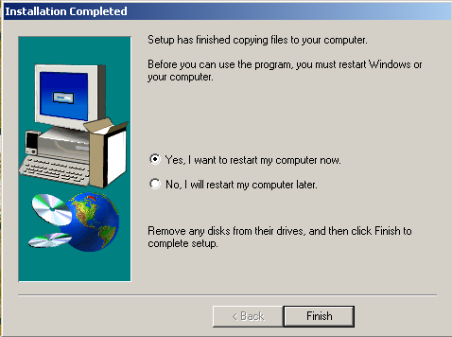

Install New Crop Implementation
- From the window in 4.3.1, step 1, click <Install New Crop Implementation>. Repeat 4.3.1, steps 2-4.
- Specify an alias name for the new crop, i.e., IRIS for Rice, IWIS for wheat, etc. Click <Next>.
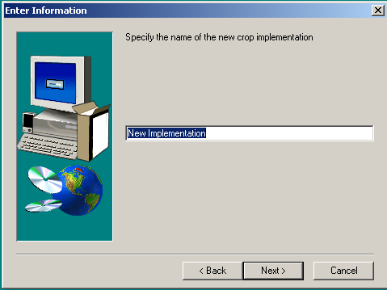

- Enter a description of the new local database by repeating section 4.3.1, step 8.
- Prescribe the central database administrator name and password. Click <Next>.
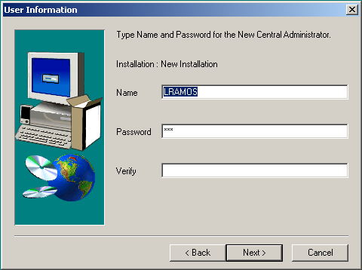
- Repeat section 4.3.1, steps 9-10; 14-16.
Install New Local Installation
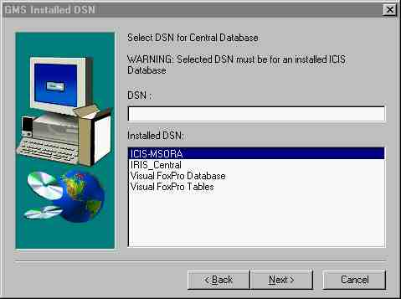
- Run setup exactly as in step 1) of section 4.3.1. Click on the Install Local Installation Only button.
- Select a DSN. The initial dialog box lists all DSN installed by the ICIS setup program. The user may choose one of these and proceed to step e. If the desired DSN is not in the list click Next and proceed to the next step.
- If DSN have been setup outside the ICIS setup program by using the ODBC administrator then that DSN will not appear in the above dialog. After clicking Next button from the above dialog the dialog below will appear listing DNSs not listed from the previous dialog. Select the desired DSN and proceed to the next step.

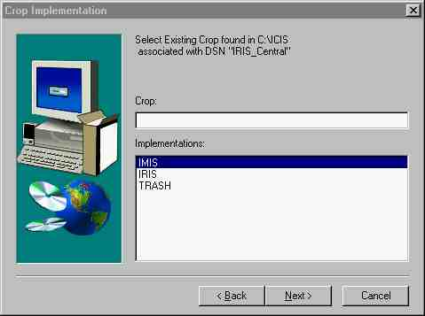
- Setup will register the selected user-created DSN from the previous dialog. At this point setup needs to know to what crop implementation does the selected DSN is associated. In the next dialog all crop implementations are listed and ask to specify the associated implementation. i.e. for IRIS_Central DSN is associated with IRIS implementation.

- Follow exactly steps 4) to 6) of section 4.3.1.

