16. Importing Existing Nursery Lists into ICIS

Introduction:

Pedigree nursery lists are often stored in excel files in a variety of formats. To be able to use such files, the user must first clean and format the Excel spreadsheet in a way that SETGEN can read and translate correctly. An example is given below.

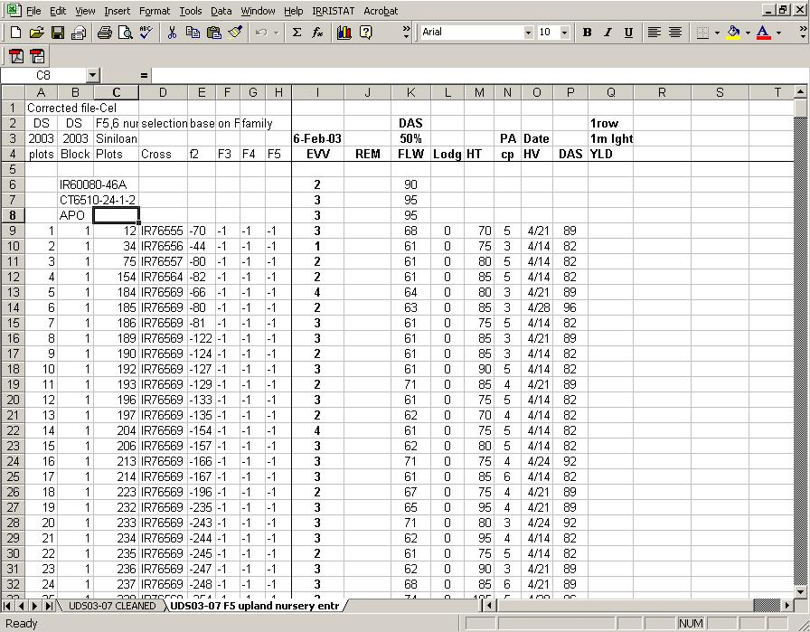

Looking at the example above, notice that each generation had been broken down into a series of cells. The first thing that the user should do is to link together the pedigree lines into a single column. Then, he should replace the column header with the appropriate column names that he can easily identify.

A suitable format is shown in the Figure below, which is a view of the file C:\ICIS5\Document\\TDM\II Users Manual and Training Material\C. Breeder's Training Course\13 16_Importing Nursery Lists\UDS03-07 F5.xls which we will use for the import exercise.

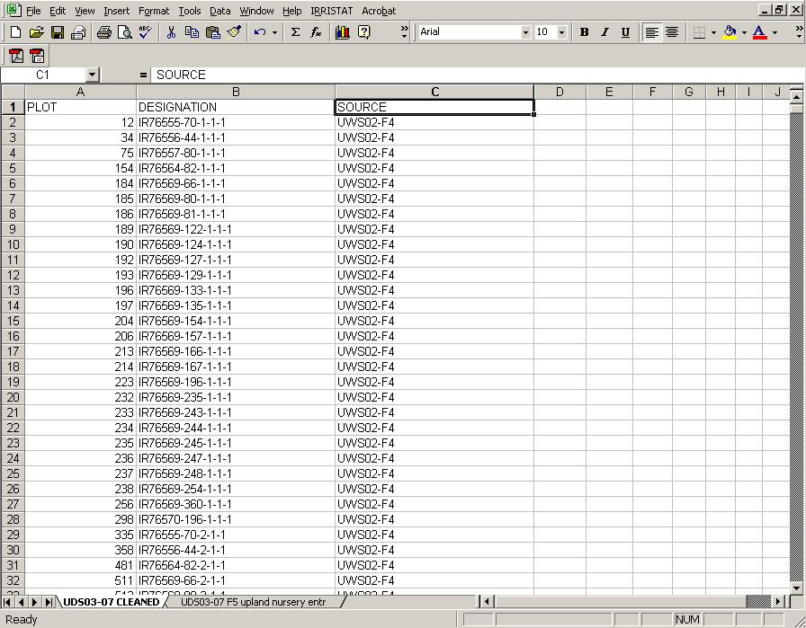

Objective: At the end of this chapter, the user should be able to import a pedigree nursery from an Excel spreadsheet into a SETGEN List.

Tutorial Steps:

Importing Nursery List from an Excel Spreadsheet

- Start SETGEN from the Launcher.

- Click on the <List><Import List>.The Import Germplasm List window will appear.

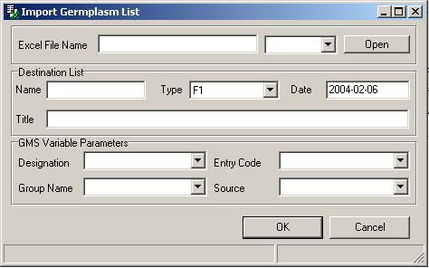

- Within SETGEN, attach the excel spreadsheet that you wish to import by clicking on the <Open> button. For this tutorial C:\ICIS5\Document \\TDM\II Users Manual and Training Material\C. Breeder's Training Course\13 16_Importing Nursery Lists\UDS03-07 F5.xls

- In the Destination List section, enter ‘TEMP’ as temporary list name. In the Title field, type ‘Temp list for import’.

- In the GMS Variable Parameters section, you can specify the Designation, Group Name, Entry Code and Source by selecting the variable found in the pull down list of each field. These variables are the column headings of UDS03-07 F5 in the excel spreadsheet. For this tutorial, select ‘DESIGNATION’ for the Designation box, ‘PLOT’ for the Entry Code and ‘SOURCE’ for Source. Leave the Group Name blank.

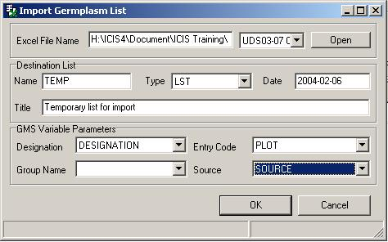

- Click <OK>. After the import facility finishes reading the excel spreadsheet, a confirmation window will appear asking if you want to save the records. Click <Yes>.

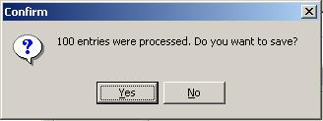
- After importing the excel spreadsheet, the Generate GIDs in Batch Mode window will appear
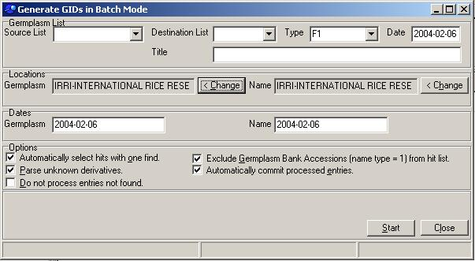

- In the Germplasm List section, select ‘TEMP’ in the Source List pull down menu, type ‘UDS03F5’ in the Destination List box, select ‘PN’ for the Type, and enter ‘Upland Dry Season 2003 F5’ in the Title box.

- Supply also the dates and location. For this exercise type in 2003-00-00 for the date and select IRRI-INTERNATIONAL RICE RESEARCH INSTITUTE, LOS BANOS for the location

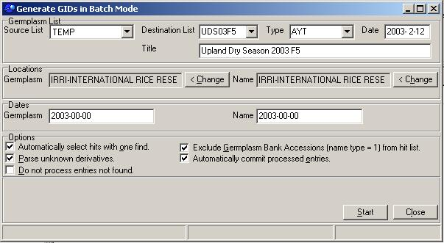

- Click <Start>

- A confirmation window will appear. Select <Yes>.

