

ICIS Developers’ Workshop 2009
16-20 Feb 2009
Bayer (South East Asia) Pte Ltd
63 Chulia Street OCBC Centre East
14th floor, Singapore 1-3 Conference rooms
Singapore 049514

Registration Form

Please have the following filled-out and emailed to May Ann Sallan not later than 10 January 2009
Surname:
First Name:
Email Address:
Tel No:
Institution/Company:
Expected date of arrival in Singapore:
Expected date of departure:

- Do you need an invitation letter to enter Singapore? If so, please provide the following details:
Full Name (as written in passport)
Date of Birth
Passport Number
Place of Issue
Date of Issue
Date of Expiry

- Do you have suggestions for additional items to be added to the agenda?

- Do you wish to do a presentation? If yes, please provide a description of your presentation, and the duration.

Expenses for this workshop
There is no registration fee for this workshop. However, all expenses such as accommodation, transport, and meals will be borne by the participants.

How to get to the Workshop venue:
The workshop will be held at the Bayer SEA office, OCBC building (East wing). It is located at the heart of Singapore’s central business district. Going to the venue should not be difficult. If you are riding a taxi, simply tell the driver to take you to “OCBC building, Raffles Place”. If you are taking the MRT, alight at Raffles Station, and follow the exit indicating ‘OCBC Centre’.
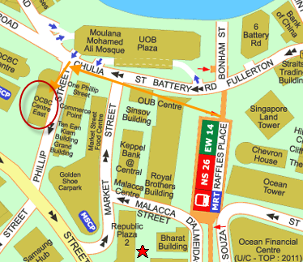
(See whole Map)

Transportation in Singapore:
Singapore is known to have a very good public transport system. For complete information see Transport in Singapore.

Accommodations:
Workshop participants will be expected to arrange for their own accommodations. See List of hotels.

Food:
Lunches will be at participant’s own expense. There are many restaurants surrounding the Bayer SEA office. Refer to this site.

For special dietary needs inquiry, please email May Ann Sallan.

There will be a workshop Dinner to be sponsored by Bayer. Details will be provided soon.

Every effort will be made to accommodate those with special dietary needs/requests.

Snacks and refreshments will be provided by Bayer during workshop breaks.

City Information:
Please visit this site for useful information about Singapore.

Questions?
Please direct any question to May Ann Sallan

