Prepare a germplasm list and field book for a replicated yield trial

Introduction:

Objectives: At the end of this chapter, the user should be able to:

- Prepare the RYT list
- Check the availability of seed stock and reserve
- Prepare the randomized field layout of the RYT (using CropStat); and
- Merge the Germplasm list and the Layout file.

Tutorial Steps:

  - Preparing the RYT list with 25 entries

- Open SETGEN and create a new list using menu option List>New. Enter the name U06WSRYT, select type RYT, set date 20060801 and enter title: ‘Upland replicated yield trial – Siniloan 2006 WS’
- Open list U06DSF₅ in the browse window and tag ten entries. (Randomly select the entries for this exercise, but generally they will be the ones chosen on merit to be advanced to the RYT). Add these entries to the new list using the + button on the tool bar. Add a New List Entry displays select <Ok to All>.
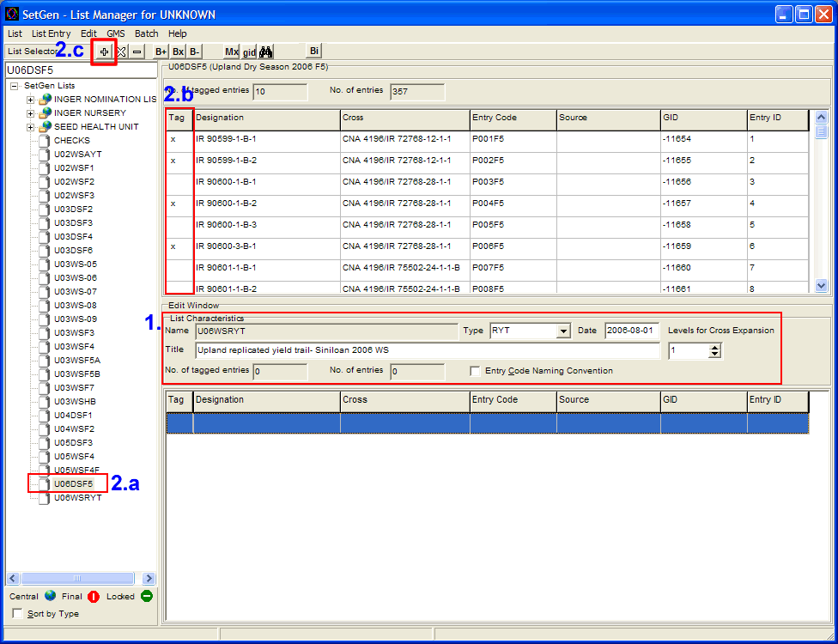

- Open U03WSF₅ in the Browse window and tag another ten entries and add those to the new list with the + button also.
- Close the browse window.
- Use the + button to add five checks: IRRI 132, MOROBEREKAN, VANDANA, YUNLU NO 28 and CNA 4196. (Enter the names one at a time in the designation box, click OK and select the ones with the IRTP number).
- Save the list.

  - Checking the availability of seed stocks and reserve

- Launch SetGen. Select U06WSRYT open on the edit window (please refer to previous exercise), tag all entries and right-click on the white space. Select <View Inventory> from the pop-up menu.
- Tag the first ten entries on the inventory details section of the IMS. Right-click on the white space and select <Reserve> from the pop-up menu.
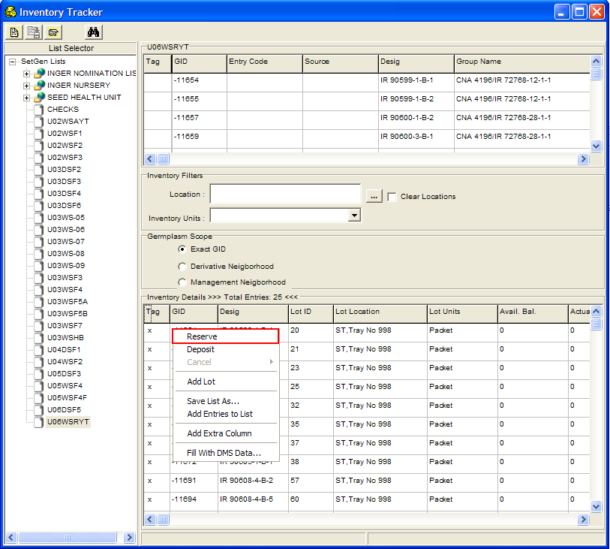
- Click on the <Units to Reserve> column header and select <Set no of Units to Reserve> on the pop-up menu.
- Type ‘1’ on the edit box then press <Enter> to update the Transaction window.
- Repeat step 3 and 4 by clicking on the <Commitment Date> and <Comment> column headers and typing the current date on the edit box, respectively.
- Click on the <Ok> button on the Transaction window.

  - Preparing the randomized layout file with Alpha Lattice design in two replications with 5 blocks each and with 5 plots per block.

- Run CropStat from the desktop Icon.
- Select the menu item: Utilities>Randomization and Layout>Plant Breeding Designs (Single factor).
- In the Open Command File Dialogue window navigate to the C:\ICIS directory. Type the name RYTS in the File name edit box and click Open. Click ‘Yes’ to create a new command file.
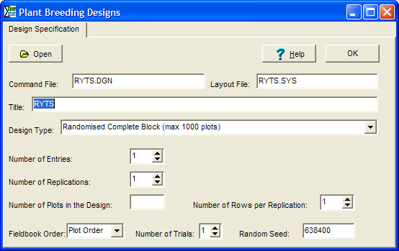
- Enter ‘Upland replicated yield trial – Siniloan 2006 WS’ in the Title Edit Box.
- Select Alpha Lattice in the Design Type box.
- Specify 25 Entries, 2 reps and 5 plots per block. Click OK to generate the design. The randomized design will be in the IRRISTAT SYS file C:\ICIS\RYTSin.SYS.

  - Merge the Germplasm List and the Lay-out file.

- Start the ICISworkbook from the Launcher.
- Click on the Add-ins ► Generate Fieldbook menu or the icon.
- In the Open Template dialog interface, select the file → URYT-Template.xls from the directory → X:\ICIS5\Documents\TDM\II Users Manual and Training Material\C. Breeder's Training Course\08 12_Replicated Yield Trials.

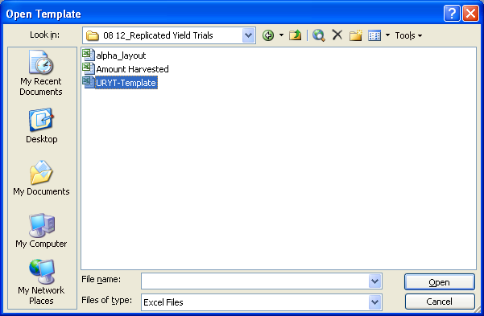

- In the next dialog interface, specify the path of the layout file “alpha_layout.xls” in the textbox provided or use the “Browse” button to go to the directory → X:\ICIS5\Documents\TDM\II Users Manual and Training Material\C. Breeder's Training Course\08 12_Replicated Yield Trials and select the said layout file.
- In the search box under the “SetGen List”, type → U06WSRYT.
- Click on the dropdown list beside the word TRIAL and select → TRIAL.
- Click on the dropdown list beside the word PLOT and select → PLOT.
- Click on the dropdown list beside the word NREP and select → REP.
- Click on the dropdown list beside the word ENTRY and select → ENTNO.
- Click on the dropdown list beside the word BLK and select → BLOCK.
- Leave the dropdown list beside the word PLT blank.

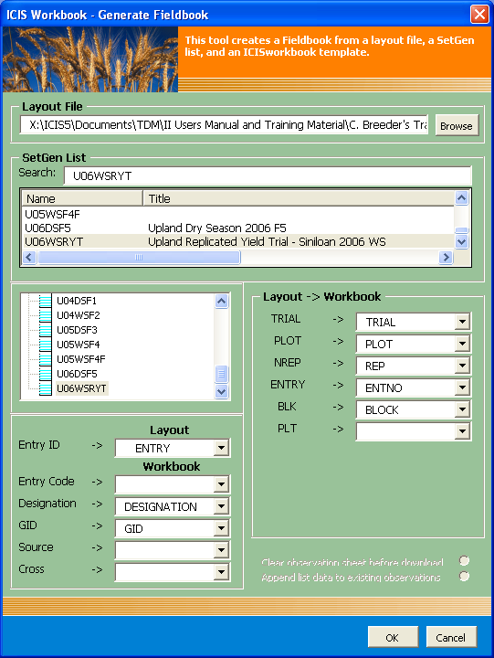

- Click on the “OK” button.
- If “Decision Required” window display, just click ‘Yes’

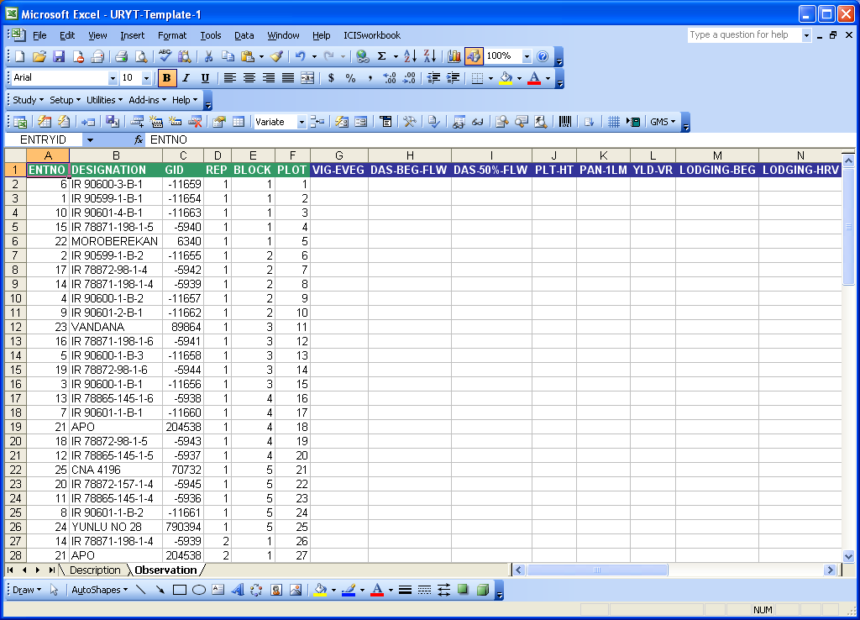

- Click on the Description tab at the bottom of the Workbook to go to the Description sheet.
- In the cell beside the “OBJECTIVE”, type → Yield test of 20 advanced lines.
- In the cell beside the “START DATE”, type → 20060801.
- In the cell beside the “END DATE”, type → 20061111.
- Under the VALUE column and on the LOCATION row of the CONDITION section, type → Siniloan.
- Under the VALUE column and on the LOCID row of the CONDITION section, type → 10123. (10123 is the IRIS LocID for Siniloan)

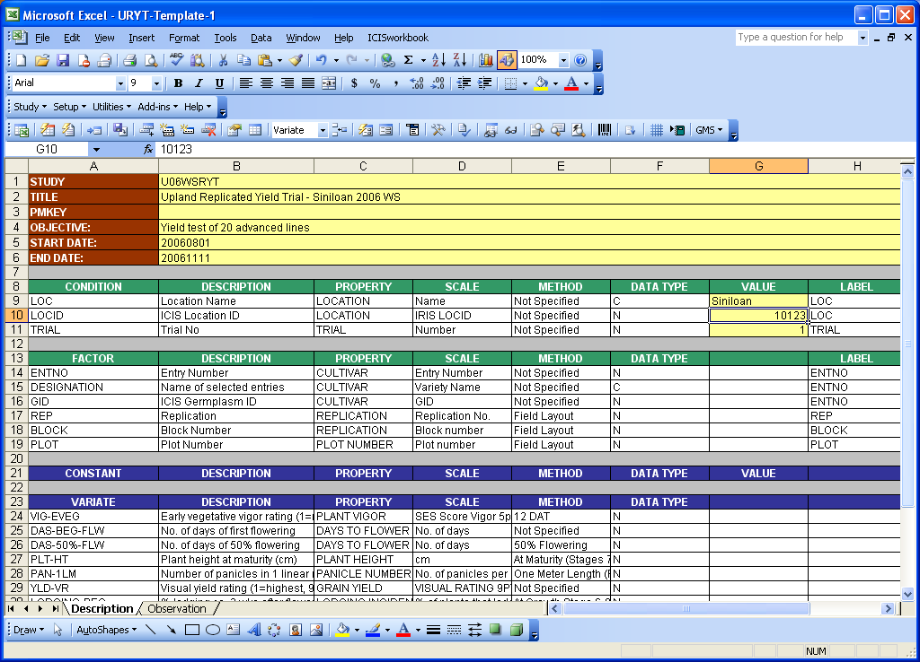

- Click the File ► Save As from the MS Excel menu then type the name → U06WSRYTFB.xls.
- Click the File ► Open on the Excel menu then select the file → Amount Harvested.xls from the directory → X:\ICIS5\Documents\TDM\II Users Manual and Training Material\C. Breeder's Training Course\08 12_Replicated Yield Trials.
- Select the block of data under the variate column “AMOUNT HARVESTED” in the Observation sheet of the file “Amount Harvested.xls” and paste them under the variate column “AMOUNT” in the Observation sheet of the file “U06WSRYTFB.xls”.

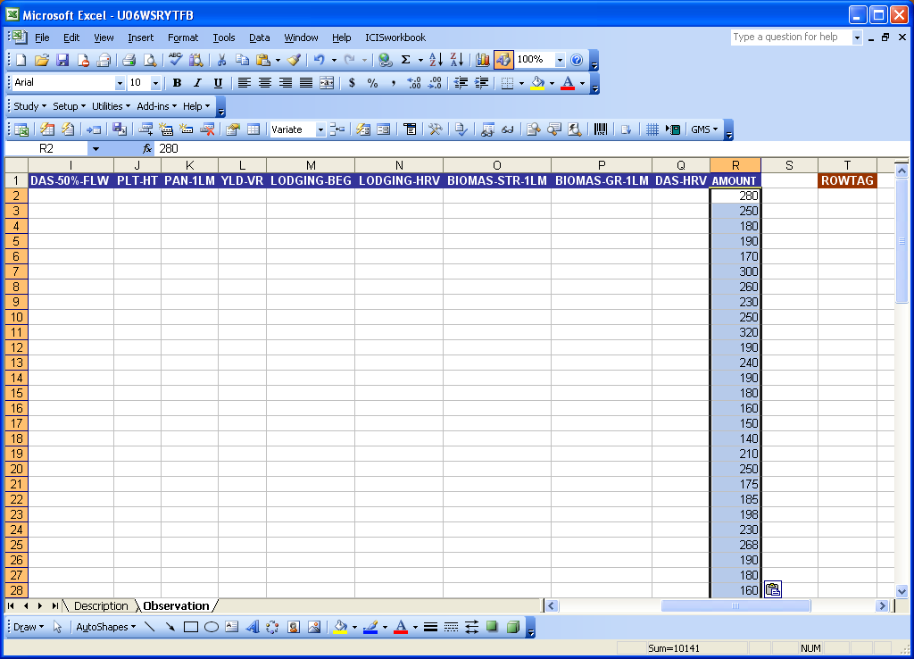

- On the ICIS Workbook menu, click on the Study ► Load or click the icon to upload the data to the DMS local database.

