YEAR 2 TECHNICAL REPORT - 10-PAGE VERSION
Intersection Programming Interface (IPI):
Implementation and Experimental Evaluation
Private-5G Uu and direct PC5 V2X measurements
Prepared for: TIER IV, Inc.
Project period: September 1, 2025-August 31, 2026
Report date: August 19, 2026
Prepared by: University of Delaware, Department of Computer & Information Sciences
Evidence scope. The report uses retained IPI implementation artifacts and field measurements through August 19, 2026. Historical PC5 performance runs used a sequence-matched vendor packet/echo wire object; the formal J2735/IP5X adapter was validated later on the host and was not retroactively fielded in those runs.

Executive Stakeholder Summary
IPI is implemented as a typed, transport-independent CAV communication contract with identity, correlation, sequence, deadlines, sessions, payload validation, progress, terminal outcomes, and fallback semantics. The reference system binds that contract to J2735 messages, private-5G TCP/MQTT/UDP paths, a direct-PC5 adapter, activation-zone logic, tiered policy, offload decisions, and ROS 2 decision publication.
The experiments do not support a single radio, transport, or TDD profile as universally ready. Compact exchanges can be timely in favorable conditions, but representation size, shared demand, path state, application direction, and interruption create distinct latency and availability regimes. Large objects must be prefetched, reduced, or admitted only when predicted completion fits the application deadline and a local fallback remains available.
Evidence | Current result | Meaning
Coverage | 461 conditions; 1,785,863 attempts | 431 Uu and 30 PC5 conditions
PCA | PC1 61.11%; PC2 20.42% | Latency/tail axis is distinct from failure
Matched factors | Payload 6.49x median; direction up to 40.92x | PCA describes outcomes; contrasts identify factors
Successful RTT | 1,765,930 finite responses | Median p95/p50 1.419; delivery reported separately
Latest matched TDD | 24 contrasts; 1.20x median, 4.45x max | Workload-dependent end-to-end effect

Bottom line. IPI supplies the state, timing, outcome, and fallback contract that the measured radio paths do not provide by themselves. The field evidence supports conditional use, not unconditional remote control.

1. How IPI Is Implemented
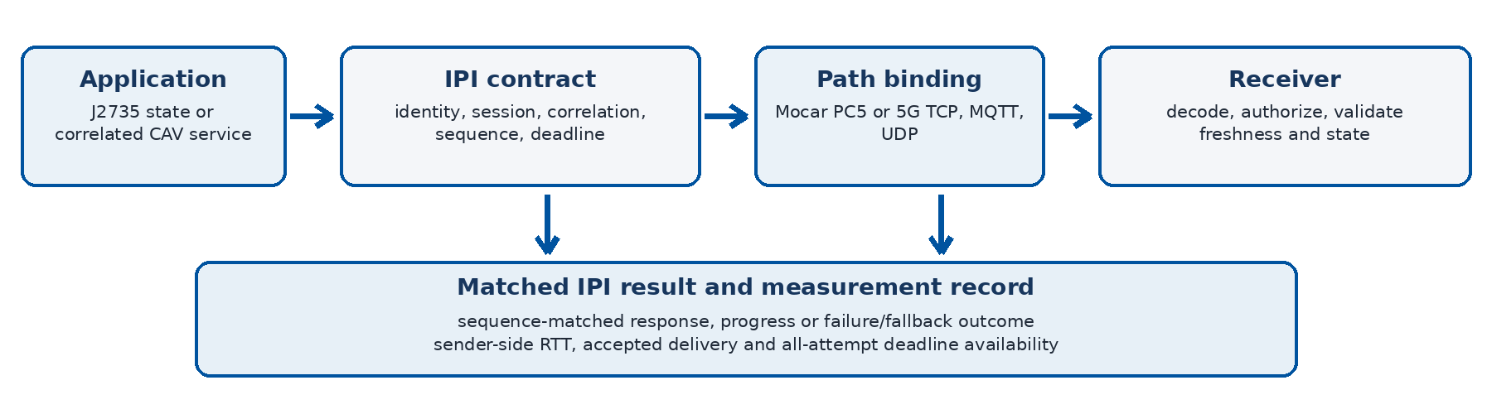
Figure 1. IPI request, path binding, receiver validation, and measurement record.
The C++17 reference implementation separates application meaning from radio transport. An application creates a typed envelope; IPI validates identity, timing, session, and payload rules; a selected binding carries the object; and the receiver returns a correlated state or terminal result. The same request can therefore retain consistent semantics across PC5, TCP, MQTT, UDP diagnostics, and local fallback.

Core contracts and invariants
- Typed messages. J2735 BSM, PSM, MAP, SPaT, SRM, and SSM helpers coexist with IpiServiceRequest and CooperativeServiceMessage. A regional extension carries locally defined IPI content inside a complete MessageFrame.
- Session lifecycle. Registration retains vehicle identity, service grants, subscriptions, fallback preference, lease deadline, and heartbeat state. Ownership, expiry, duplicate, stale, and terminal-state checks close each outstanding request exactly once.
- Wire validation. The session codec validates message kind, version, length, topic, sequence, correlation, expiry, and payload type. The PC5 IP5X envelope adds length, status, expiry, sequence, correlation, and CRC around the J2735 frame.
- Decision path. ActivationZoneTracker emits deterministic zone transitions; TieredServicePolicy never intentionally pauses safety-critical work and selects fallback on link loss; OffloadDecisionEngine compares local, edge, and transfer completion against a deadline.
- Authority boundary. The ROS 2 slice publishes infrastructure information and decisions. It does not directly command Autoware operation mode, steering, braking, or motion; vehicle safety logic remains authoritative.

Implementation and validation surface
Layer | Implemented behavior | Retained validation
API/facade | Typed envelopes, J2735 helpers, result/status model | Interface and message-flow tests
Private session | Register, patch, heartbeat, lease, terminate, request ledger | Lifecycle, wire-codec, broker tests
PC5 | IP5X adapter, J2735 regional payload, sequence/CRC/expiry | Host codec/adapter and cross-build checks
Policy/offload | Activation, tier decision, completion prediction, fallback | Unit tests plus task-offloader checks
ROS 2 | Messages, YAML zones, runtime decisions, clean shutdown | Build and synthetic launch contracts
Stored build record | C++ release and sanitizer matrices | 18/18 tests recorded as passing

What this establishes. The repository demonstrates protocol, lifecycle, codec, decision, and process-level behavior. It does not claim a completed Autoware driving action, production deployment, or measured vehicle-control outcome.

2. Experimental Design and Evidence Boundaries
The evaluation asks whether current direct V2X and private-5G paths can carry IPI-style CAV interactions within application deadlines. The two paths are evaluated separately; they are not presented as one combined end-to-end route. Public CAV datasets provide workload sizes and detector outputs, not a third wireless path.
Property | Private-5G Uu path | Direct-PC5 path
Measured route | Vehicle gateway - Airspan n48 - core/MX250 - d1 | Vehicle OBU - direct sidelink - roadside RSU
Application traffic | IPI frames over TCP/MQTT; UDP used for formation diagnostics | Sequence-matched custom request/echo for historical performance
Timing | Sender-side monotonic request/response RTT | Sequence-matched sender RTT
Workloads | State mirror, 1 B-2 MiB, detector sizes, load, clients, restarts, direction | 0-2 KiB stationary sweeps and 256 B mobile routes
Radio context | One UE, dedicated 40-MHz n48 deployment; handset/DU context where retained | Installed vendor interface; RF counters unavailable
Primary boundary | Endpoint RTT/goodput, not PHY capacity or synchronized one-way delay | Historical wire object is not formal IP5X field evidence

Metrics and denominator discipline
- Issued attempt. Every scheduled request remains in the denominator, including missing, rejected, invalid, and timed-out attempts. Operator-stopped PC5 phases retain planned attempts as analysis timeouts where the stored run protocol requires it.
- Accepted response. The reply must match the expected sequence/correlation and pass the applicable framing, status, length, and CRC checks. RTT percentiles describe only these received responses.
- Deadline availability A(B). The numerator is a valid matched response with RTT at or below budget B; the denominator is all issued attempts. This joins latency and delivery without hiding outages.
- Object semantics. Payload labels refer to complete application objects, not one IP packet. TCP segmentation, MQTT framing, and application-level fragmentation are retained as different formation paths.
- Clock boundary. Private-5G endpoint clocks were generally unsynchronized. The report therefore uses sender RTT and does not infer one-way uplink, downlink, or internal-network delay.

Coverage represented in the refreshed analysis
Family | Conditions | Issued attempts | Purpose
Payload, formation, and detector size | 180 | 172,446 | Scale, formation, and object-completion behavior
Load and logical clients | 90 | 1,176,000 | Shared demand behind one physical UE
Airspan follow-up | 60 | 327,000 | Repeated application/location conditions
Directional TDD | 97 | 77,600 | Uplink/downlink objects and matched profiles
Restart | 4 | 4,000 | Interruption, outage, and response-gap behavior
Direct PC5 | 30 | 28,817 | Stationary payload and mobile route availability
Total | 461 | 1,785,863 | Condition is the analysis unit; attempts are coverage

Interpretation rule. Field conditions are sequential rather than randomized. A result is attributed to a factor only when the repository retains a matched comparison; otherwise it is reported as an operating-condition observation.

3. Direct-PC5 Experiments and Results
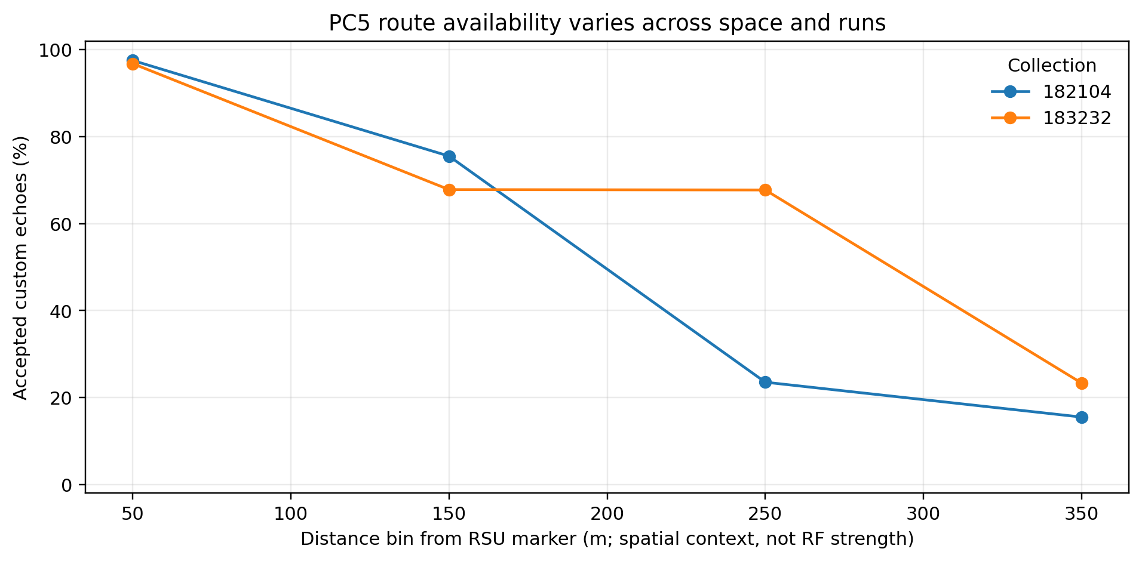
Figure 2. Historical PC5 route availability varies across position and collection.
At the favorable stationary reference, 0-2 KiB conditions returned 99.9-100% of attempts with p50 near 100 ms and p95 near 107-112 ms. Other stationary points exposed a joint payload-and-path boundary: as the path weakened, 2 KiB responses failed first, then 1 KiB, while 256-512 B survived farther into marginal conditions. Point 1 was short but building-obstructed, demonstrating that geometric distance alone is not a radio variable.
Stationary context | 0 B | 256 B | 512 B | 1 KiB | 2 KiB
Stable reference | 100% | 99.9% | 100% | 100% | 100%
P1, building-obstructed | 100% | 99.7% | 95.5% | 0% | 0%
P2, 113 m | 99.9% | 100% | 100% | 100% | 99.8%
P3, 212 m | 100% | 100% | 99.8% | 97.9% | 0.8%
P4, 377 m | 99.9% | 99.1% | 96.9% | 17.1% | 0%
P5, 469 m | 0% | 0% | 0% | 0% | 0%

Mobile-route continuity
Route | Replies / attempts | Delivery | p50 / p95 among replies | Longest noted failure burst
R1 | 515 / 675 | 76.3% | 99.610 / 108.421 ms | 50 attempts
R2 | 731 / 1,000 | 73.1% | 28.326 / 41.887 ms | Not summarized
R3 | 591 / 1,000 | 59.1% | 29.204 / 43.923 ms | 56 attempts
R4 | 716 / 1,000 | 71.6% | 28.276 / 41.621 ms | 41 attempts

Successful mobile packets can have compact RTT while the route still contains long no-response intervals. For safety-relevant use, delivery and consecutive outage length are therefore first-class results; survivor p95 alone is insufficient. The installed interface also limits one application packet to 4,080 B after vendor framing, favoring compact state/control objects and explicit higher-layer reduction or segmentation.
PC5 conclusion. The measured direct path can support compact awareness traffic on favorable links, but route continuity and larger-object availability are not reliable enough to serve as the sole dependency for complex collaborative CAV operation.

4. Private-5G Workload Experiments and Results
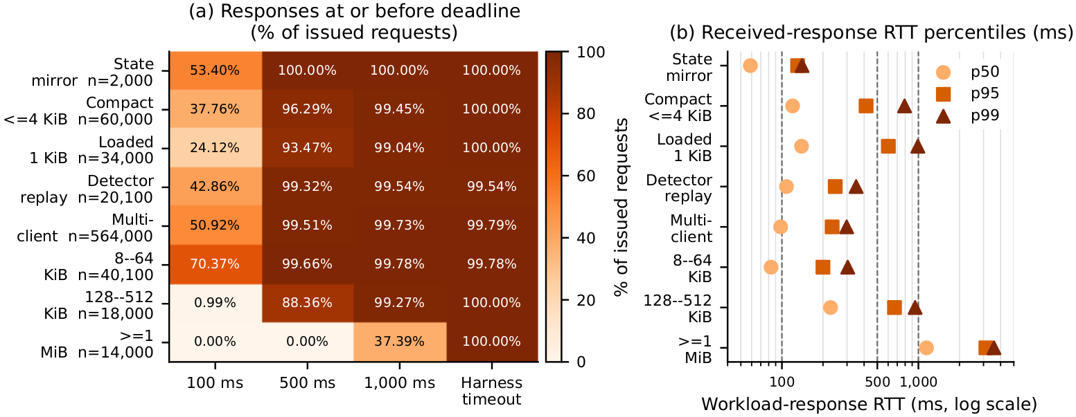
Figure 3. Private-5G deadline availability and received-response tails.
Compact MQTT exchanges can complete in tens of milliseconds under favorable conditions, while TCP adds a larger baseline. Neither behavior is universal: larger objects, adverse placement, shared uplink demand, high logical-client count, and restarts produce large tails or missing responses. The approximately 20 KiB detector-content ceiling for a 500-ms p95 target is a conservative measured boundary across favorable and weak TCP/MQTT replays, not a universal network limit.
Evidence group | Delivery | A(100 ms) | A(500 ms) | Accepted p95 | Use implication
State mirror | 2,000/2,000 | 53.4% | 100% | 130.323 ms | Replaceable state; enforce freshness
Compact <=4 KiB | 60,000/60,000 | 37.8% | 96.3% | 413.725 ms | Conditional at 100 ms
1 KiB under load | 34,000/34,000 | 24.1% | 93.5% | 602.354 ms | Demand enlarges tails
Detector-sized | 99.54% accepted | 42.9% | 99.3% | 245.879 ms | Hundreds-of-ms service
128-512 KiB | 100% accepted | 1.0% | 88.4% | 667.975 ms | Prefetch/reduce/stage
>=1 MiB | 100% accepted | 0% | 0% | 3,122.273 ms | Bulk, not tight response

Stress and failure observations
- Competing uplink load. A configured 25-Mbit/s background generator raised MQTT p95 from about 52-60 ms to 174-176 ms and TCP from about 162-194 ms to 388-420 ms in favorable collections. Achieved load, not only configured offer, is reported.
- Logical clients. At 100 sequential clients behind one host and one UE, adverse-location MQTT/TCP p95 reached 3,814/2,938 ms; UDP p95 stayed lower but accepted only 90,811/100,000 replies.
- Message formation. Raw UDP returned no response at 1,400 B and above in the completed diagnostic. Application fragmentation restored smaller detector-sized transfers but 60 KiB still collapsed under adverse conditions.
- Interruption. Receiver or broker restarts produced 11.7-15.1 s response gaps. Median RTT among survivors did not represent continuity, motivating explicit session state, terminal outcome, and local fallback.
QoS boundary. The 5qi-mapped label was collected, but both observed host captures used IPv4 TOS 0x0. The report does not claim network-enforced priority or a causal 5QI effect.

5. Direction, TDD, and the August 17-19 Campaigns
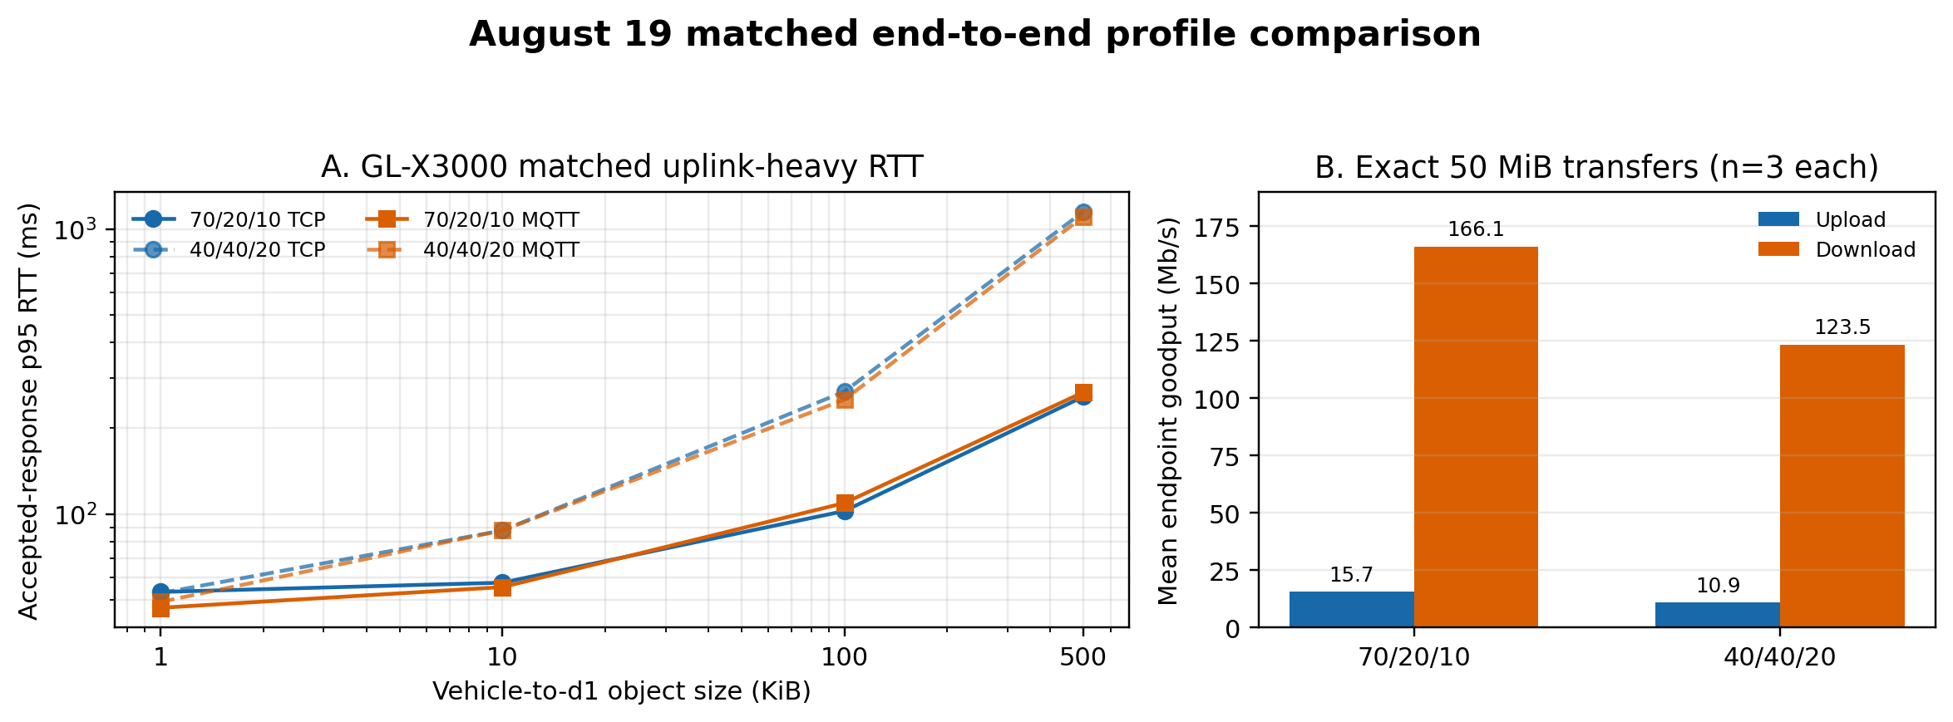
Figure 4. August 19 matched GL-X3000 application RTT and endpoint goodput.
Comparison | Controlled evidence | Primary result | Interpretation
Aug. 17 downlink TDD | Same location, Cell 2, -100 dBm; 8,000/profile | 8 cells: 1.14x median, 1.47x max | Small-object gain can vanish/reverse
Aug. 17 exact 50 MiB | 10 paired transfers/profile | Upload 12.000 vs 2.836; download 126.786 vs 99.756 Mb/s | Endpoint goodput, not PHY capacity
Aug. 18 weak direction | 40/40/20, Cell 2, -115 dBm, MQTT 500 KiB | Uplink/downlink p95 ratio 40.92x | Direction can dominate one large-object condition
Aug. 19 GL-X3000 TDD | Same device/location; 16 conditions/profile | 24 total matched TDD contrasts: 1.20x median, 4.45x max | Sequential end-to-end profile effect
Aug. 19 exact 50 MiB | 3 paired transfers/profile | 70/20/10: 15.691/166.106; 40/40/20: 10.913/123.451 Mb/s | n=3; 40/40/20 repetitions vary

The new GL-X3000 comparison is the cleanest bidirectional profile block in the repository. At 1 KiB, uplink p50 is essentially tied. At 10 KiB and above, 40/40/20 has higher uplink p50 and p95 for TCP and MQTT; every downlink p50 and p95 is also higher. At 500 KiB, uplink p95 is 4.45x higher for TCP and 4.13x higher for MQTT under 40/40/20. The result is directly observed but does not imply that the nominally larger uplink allocation must be slower in general: end-to-end TCP behavior, scheduling, retransmissions, session state, and sequential time remain inside the measurement.
The severe August 18 500-KiB uplink condition did not recur after the gateway was replaced. Under 40/40/20, GL-X3000 p95 is 67.5-88.3% lower from 10 to 500 KiB, and the limited exact-transfer samples show 21.19x higher mean upload and 2.89x higher download. This is not a hardware-only A/B test: the older run reached -115 dBm, the new modem reported a -98 dBm median, and configuration, session, and collection time also changed.
TDD conclusion. There is no universal profile ranking. The evidence supports per-workload, per-direction admission and scheduling decisions using current path measurements rather than a static profile label.

6. Spatial and Radio Context
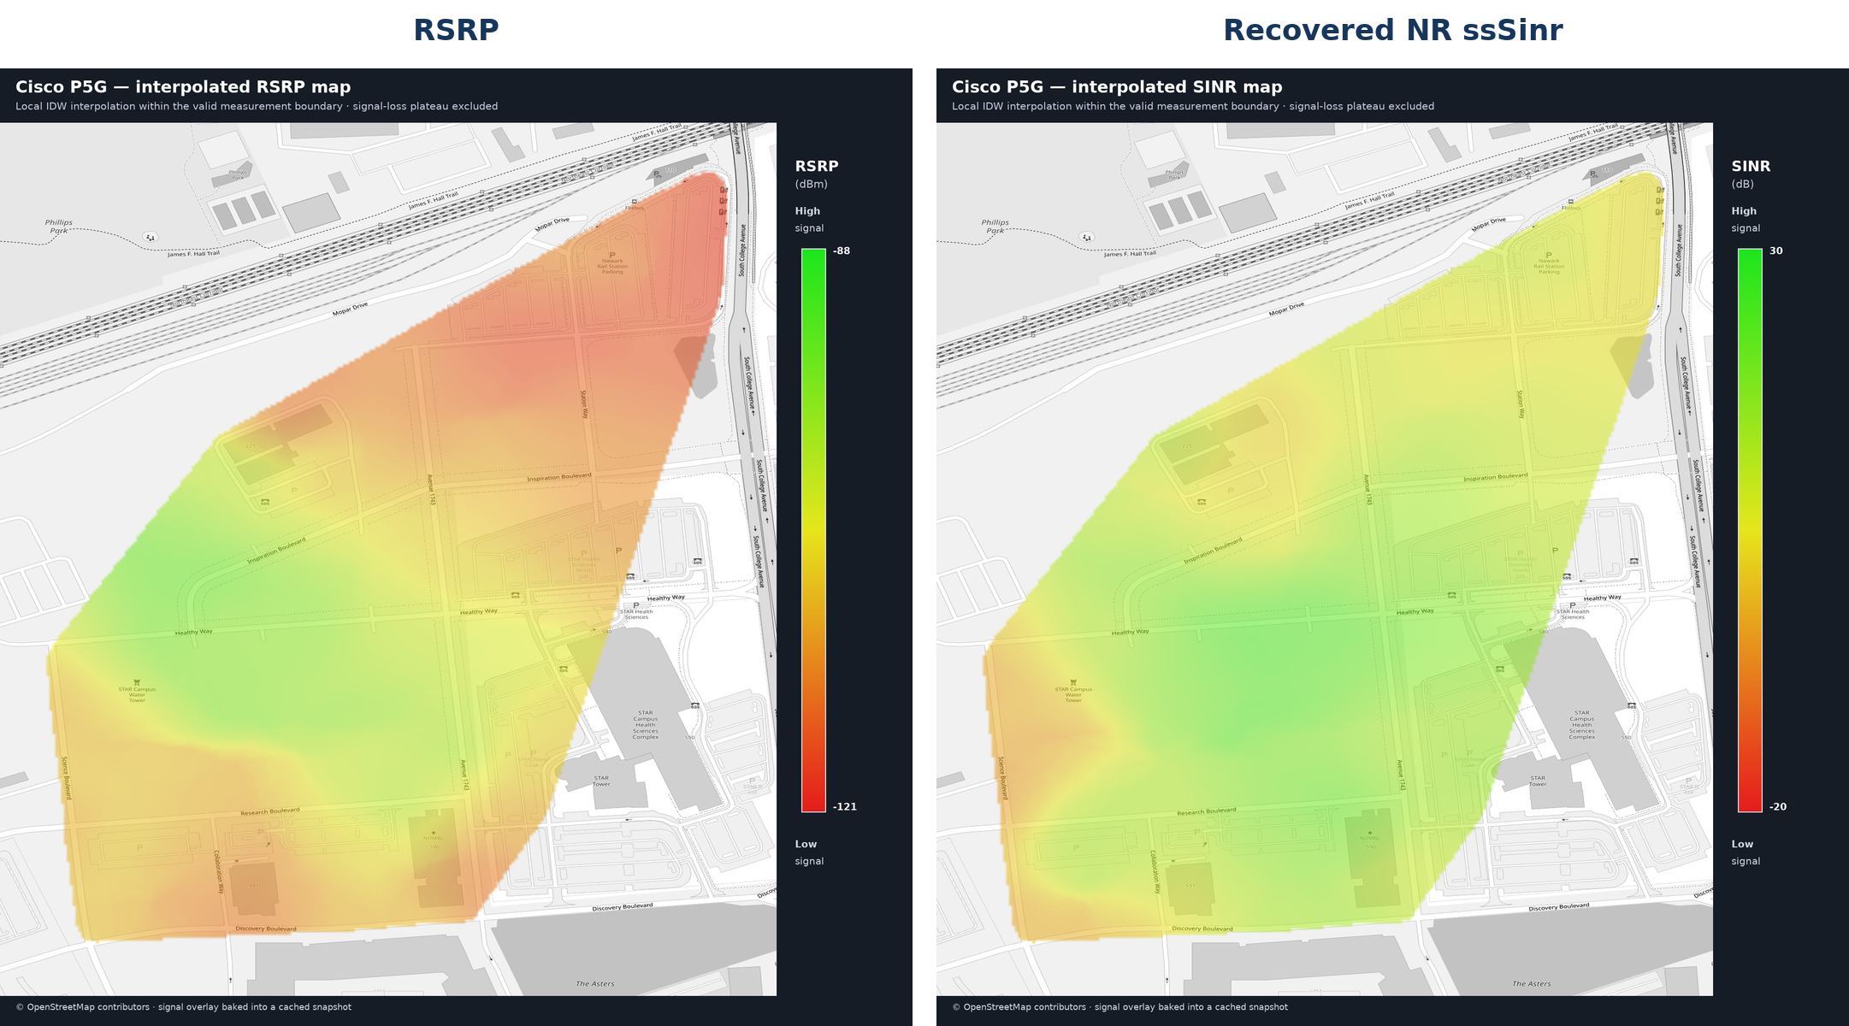
Figure 5. Separate-handset route context for RSRP and recovered NR ssSinr.
Three handset drives contain 1,301 GPS rows. A 123-row frozen-radio plateau lasting more than five seconds is excluded, leaving 1,178 valid nearest-time NR joins. All valid records use band 48; 402 use PCI 1 and 776 use PCI 2. Drive 2 contributes only seven valid rows and is not treated as an independent route distribution.
Route metric | Minimum | p5 | Median | p95 | Maximum / share
NR RSRP | -121 dBm | -118 | -108 | -93.85 | -88 dBm
Recovered NR ssSinr | -20 dB | -6 | 9 | 24 | 30 dB
NR RSRQ | -18 dB | -13 | -11 | -11 | -11 dB
Weak RSRP | < -105 dBm | - | 755 rows | - | 64.1%
Negative ssSinr | < 0 dB | - | 134 rows | - | 11.4%

What the radio data can and cannot explain
- Descriptive relationship. RSRP and recovered ssSinr have Pearson correlation 0.426 across joined route rows. Repeated callbacks and spatial/temporal autocorrelation prevent treating this as an independent-sample causal model.
- Separate UE. The phone and the IPI vehicle gateway are different devices, and route records are not synchronized to individual requests. The map cannot assign a channel state to an IPI RTT or explain a particular failure.
- Cell counters. The August 17 DU comparison uses six complete five-minute Cell 2 bins per profile and reports zero unavailability. DU volume and active time describe cell context, not per-UE rate, endpoint goodput, or maximum capacity.
- PC5 RF gap. The vendor interface did not export received power, MCS, BLER, retransmissions, resource-pool use, or scheduler counters. PC5 location, obstruction, payload, delivery, and RTT remain the defensible variables.
Spatial conclusion. The two field paths are condition-dependent. Geometry and handset signal context help describe exposure, but neither is used as a substitute for synchronized UE telemetry or a controlled radio-mechanism experiment.

7. PCA and the Main Factors Associated with Latency
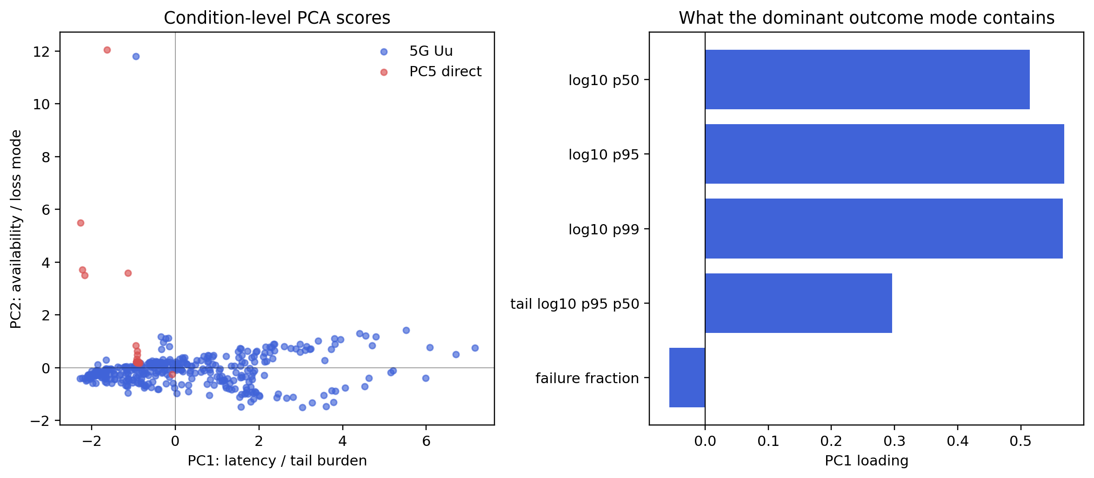
Figure 6. Refreshed PCA across 452 eligible experimental conditions.
PCA uses one equally weighted row per condition and five standardized outcomes: log10 p50, p95, and p99 RTT; log10 p95/p50 tail inflation; and all-attempt failure fraction. Attempt count measures coverage but does not give high-count client runs more statistical weight.
Component | Variance | Dominant loadings | Meaning
PC1 | 61.1106% | p50 0.514; p95 0.569; p99 0.566; tail 0.297 | Accepted-response latency and tail burden
PC2 | 20.4184% | Failure fraction 0.882 | Availability loss largely distinct from survivor latency
PC3 | 17.9105% | Tail 0.795; failure 0.468 | Additional coupled tail/availability mode
First three | 99.44% | Combined | Nearly all standardized outcome variance

Matched contrasts identify factors; PCA does not
Experimental factor | Matched contrasts | Median absolute p95 fold | Maximum | Conclusion
Payload/representation | 45 | 6.49x | 230.92x | Strongest broad regime change
Logical/shared demand | 16 | 2.84x | 55.96x | Large tail amplification
Application direction | 17 | 1.70x | 40.92x | Can dominate large objects
Matched TDD profile | 24 | 1.20x | 4.45x | Workload- and direction-dependent
Spatial/path context | Route/stationary | Availability-dominant | - | Critical, but no single RF cause

Main statistical result. PC1 is the principal latency/tail outcome axis. The matched experiments associate that axis most consistently with representation size, followed by shared demand and spatial/path context; direction and TDD can create large conditional changes. PC2 shows that failure must be reported independently.

8. Successful-Response Variance and Application Decisions
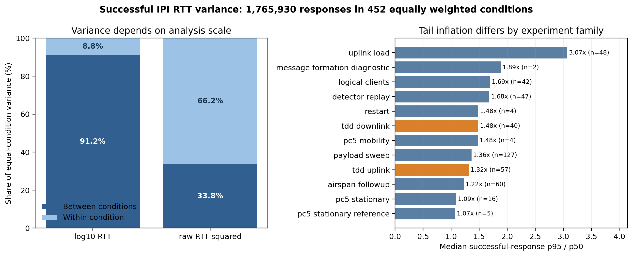
Figure 7. Variance among 1,765,930 finite accepted-response RTTs.
On log10 RTT, 91.206% of equal-condition variance lies between operating conditions and 8.794% within a fixed condition. On raw RTT squared, 66.243% lies within conditions and 33.757% between them because rare seconds-scale tails dominate. These statements answer different questions: the log analysis identifies the latency regime, while raw variance emphasizes extreme successful responses.
Successful-response statistic | Result | Required companion evidence
Finite RTT records / eligible conditions | 1,765,930 / 452 | All-attempt condition ledger
Median coefficient of variation | 0.282 | Failure and timeout counts
Median p95/p50 | 1.419 | Deadline availability A(B)
95th-percentile p95/p50 | 5.539 | Tail and interruption events
Maximum p95/p50 | 12.029 | Raw condition-level distribution
5G / PC5 median p95/p50 | 1.446 / 1.089 | PC5 outages excluded below 20 replies

CAV/ITS use decisions supported by current evidence
Application | Measured evidence | Decision without another experiment
Signal warning | State-mirror p95 130.323 ms; A(100 ms) 53.4% | Use replaceable state and freshness; no path-wide 100-ms guarantee
Blind-spot awareness | Favorable PC5 p95 about 107 ms; mobile delivery 59.1-76.3% | Supplemental awareness only; keep local sensing
Automated intersection | Representative p95/deadline ratios exceed 1 on both paths | Do not place a 10-ms decision solely on remote response
Emergency maneuver | Measured 2-12 KiB paths exceed 3-10 ms envelopes | Local authority; messages inform but do not close the loop
Remote recovery | Loaded tails exceed 100 ms; restart gaps 11.7-15.1 s | Conditional high-level assistance after local slow/stop
Cooperative perception | ~20 KiB supports 500-ms p95 in measured TCP/MQTT replays | Admit only with predicted completion and local fallback
Map/model staging | MiB-scale p95 is seconds; direction/profile effects are large | Prefetch/cache/compress; never block a response-critical path

Variance conclusion. Predictability after success does not equal service reliability. Every CAV claim must pair survivor RTT statistics with delivery, A(B), timeout bursts, and the fallback used when no timely response arrives.

9. Proposal Implementation Status and Conclusions
The Year 2 repository now contains the core WP4-WP6 reference implementation and a broad experimental record. Status below is tied to artifacts in the current checkout; it does not convert an unmeasured driving outcome, undocumented activity, or untagged worktree into completed evidence.
Work package | Implemented and retained | Evidence boundary / remaining acceptance input
WP4: activation | Activation-zone model/tracker; session, policy, and fallback contracts; ROS 2 zone and decision topics | Reference simulation and synthetic ROS contracts are present; no complete CARLA/Autoware driving scenario is retained
WP5: tiered service | TieredServicePolicy uses deadline, link, congestion, service class, and fallback; safety-critical work is not intentionally paused | Host/ROS behavior is validated; no field vehicle controller enacted the policy
WP6: offload | OffloadDecisionEngine predicts transfer, queue, compute, margin, and completion; TaskOffloader enforces session/deadline/terminal results | Decision-level C++/ROS validation; no vehicle trajectory or perception-quality outcome
Software release | Installable CMake package, README/configuration, examples, test suite, ROS packages | No immutable licensed release tag or repository-wide license artifact is evidenced
Education/dissemination | Code, report, runbooks, and analysis artifacts are present | Dated seminars, attendance, recordings, or exercise packages require administrative records

Limits that materially affect stakeholder interpretation
- Radio causality. No synchronized per-request MG52 radio, scheduler, MCS, BLER, HARQ, or bearer evidence is available. Handset surveys and DU counters remain context, not causal joins.
- Field scope. The private network uses one UE and a dedicated 40-MHz n48 deployment. Logical clients share one host and one physical UE; they are not 100 independent vehicles or SIMs.
- Profile and device attribution. The strongest new TDD pair is sequential, and the old/new gateway comparison also changes signal and session context. Neither supports a universal TDD or hardware ranking.
- Application acceptance. Application owners must provide the required deadline B and acceptable probability A(B). The report supplies measured A(B) values but does not invent a Tier IV acceptance threshold.
- Vehicle authority. No retained experiment measures a completed Autoware maneuver, collision avoidance, perception-quality change, or safe trajectory. Communication is an input to vehicle logic, not permission to bypass it.

Evidence and reproducibility
Primary evidence remains under results/real_5g, results/mocar_v2x, and results/v2x_benchmarks. The condition ledger, matched contrasts, PCA loadings, successful-response variance records, JSON summaries, and regeneration scripts are retained under paper/analysis/limiting_factors and scripts. Exact-length/CRC manifests, sender/receiver correlation, GNSS stationarity checks, and raw/public checksum boundaries are preserved where the collection provides them.

Consolidated conclusions
- IPI implementation. The typed contract, session lifecycle, formal codec, PC5 adapter, activation, service policy, offload decision, fallback, and ROS decision path are implemented and host/process validated.
- Communication evidence. Favorable compact exchanges are feasible, but neither measured path supplies a universal low-latency, high-availability envelope across payload, load, clients, direction, mobility, and interruption.
- Design consequence. Pre-stage large objects, select service from measured deadline/path/load state, compare full completion time, preserve replaceable-state semantics where possible, and retain deterministic local fallback for safety-critical behavior.
Final answer. The experiments answer a narrower and more useful question than whether 5G or PC5 is simply ready. They identify which IPI interactions can be supported under measured conditions, the probability and variance of timely response, the factors that change that result, and the fallback that remains necessary when conditions change.

