YEAR 2 TECHNICAL REPORT
Intersection Programming Interface (IPI):
Implementation and Experimental Evaluation
Private-5G Uu and direct PC5 V2X measurements
Prepared for: TIER IV, Inc.
Project period: September 1, 2025–August 31, 2026
Report date: August 14, 2026
Prepared by: University of Delaware, Department of Computer & Information Sciences
Experimental scope. Every field experiment summarized here was conducted as part of the IPI evaluation and used IPI workload semantics at the application layer. The private-5G runs carried encoded IPI cooperative-service frames. The historical PC5 performance sweeps used the Mocar vendor packet-data interface with sequence-matched request/echo transactions; the later formal J2735/IP5X PC5 adapter is host-validated but was not substituted retroactively for those retained radio measurements.

Executive Stakeholder Summary
This summary converts the implemented Year 2 system and retained measurements into decisions. It adds no experiment. Private-5G results use encoded IPI cooperative-service frames. Historical PC5 performance results use sequence-matched vendor packet/echo traffic within the IPI evaluation, while the later formal J2735/IP5X PC5 path is host validated rather than retroactively field claimed.
Stakeholder question | Evidence-backed answer | Decision supported by the report
What is complete? | Typed C++ and ROS 2 reference components cover session lifecycle, J2735 regional encoding, activation, service policy, offload choice, terminal outcome, and fallback. The recorded validation is 18/18 CTests plus ROS and toolchain checks. | Accept the implementation at its recorded validation level; keep decision publication separate from vehicle actuation.
Which exchanges fit the measured paths? | Compact exchanges are feasible in favorable conditions. Private-5G tails change with payload, load, location, formation, direction, and logical demand; PC5 availability changes sharply with location and payload. | Admit a service from payload, deadline availability, direction, path state, and concurrent demand rather than a transport name alone.
What most changes latency? | PCA PC1 captures 62.15% of the standardized latency/tail variation. Matched payload contrasts have an 8.25x median and 86.01x maximum p95 ratio; concurrency is the next broad tail amplifier. | Reduce or pre-stage large representations and bound concurrent work before changing protocol labels.
How should success be reported? | Accepted-response p50/p95/p99 and coefficient of variation describe survivors. Acceptance, A(B), and consecutive no-response gaps describe whether the service was available. | Report delivery, deadline availability, successful-response tails, and outage duration together.
What must remain local? | The measured paths do not satisfy the selected 3-10 ms coordination envelopes. Restart tests contain 11.7-15.1 s response gaps, and PC5 mobile-route delivery is 59.1-76.3%. | Keep safety-critical vehicle authority and deterministic fallback local; use remote service only inside a measured envelope.
Which causal claims are supported? | The data show application-path effects. They do not isolate a causal PC5 RF mechanism, nondefault 5QI treatment, or the effect of one TDD profile. | Use the measured association and sensitivity language recorded in the report; do not infer unavailable bearer or scheduler mechanisms.
Stakeholder inputs still required. Application owners must set the required probability A(B) for each service deadline. Project leads must decide which validation level constitutes acceptance for each proposal deliverable. Release owners must identify an immutable source tag and license before describing the checkout as a curated external release, and the project team must attach seminar or tutorial records if those commitments are part of closeout.

1. How IPI Is Implemented
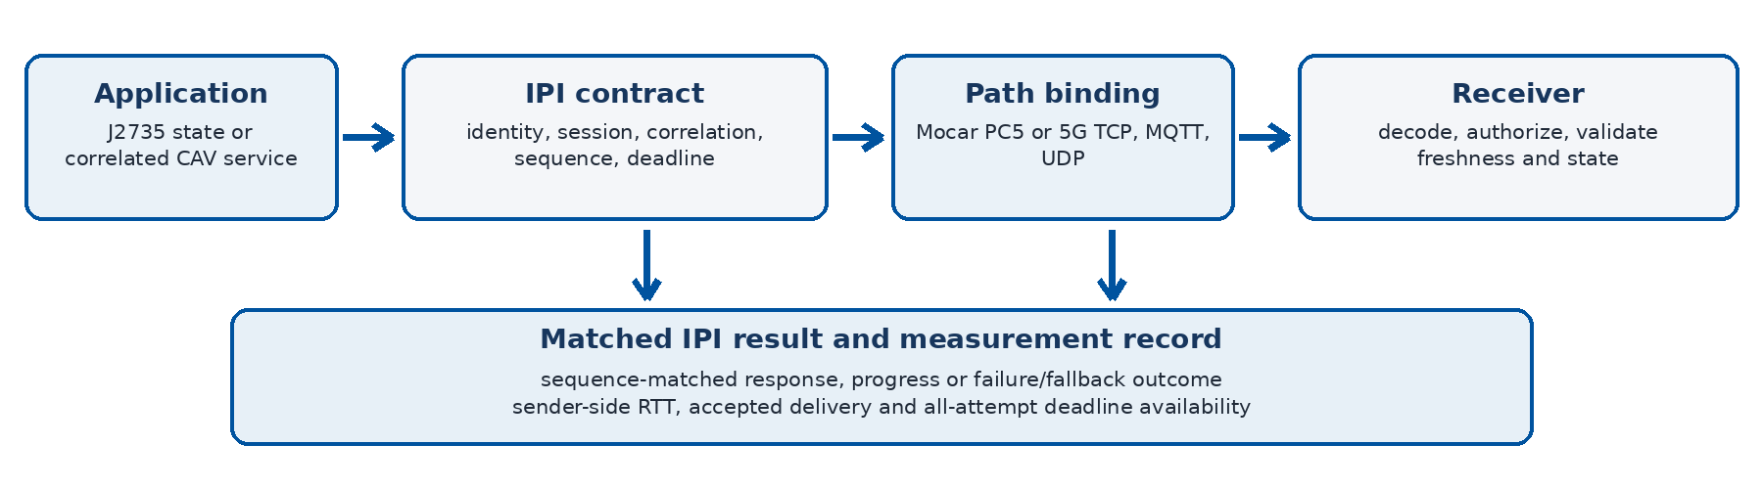
Figure 1. IPI request, transport binding, validation, and measurement path.
The C++17 implementation exposes one contract for conventional connected-vehicle messages and stateful CAV services. Message mode accepts BSM, PSM, MAP, SPaT, SRM, SSM, TIM, and pre-encoded J2735 payloads. Service mode carries planning, perception, control, computation, and map operations through request, update, completion, rejection, telemetry, and termination.
- Common metadata. Every envelope records message identity, source, intersection, transport, send time, and optional session, correlation, sequence, priority, and expiration values.
- State and correlation. SessionLifecycle enforces registration, heartbeat activation, monotonic lease expiry, authorization, outstanding requests, duplicate/stale/correlation checks, termination, and terminal results.
- Encoding and bindings. IpiCooperativeService is encoded as a typed J2735 regional value in reserved TestMessage00 (message ID 240, local RegionId 200). The PC5 binding adds the CRC-protected IP5X correlation/deadline envelope; Uu uses TCP, MQTT, raw UDP, or application-fragmented UDP.
- Outcome model. Responses carry accepted, rejected, in-progress, completed, timed-out, missing, interrupted, unavailable, expired, or fallback outcomes plus a machine-readable failure code.
Measured IPI overhead. A preserved J2735 payload adds 5 bytes. A CAV planning request is 63 bytes before optional task content; with content, IPI adds 78-81 bytes, equal to 7.6-7.9% at 1 KiB and 1.9-2.0% at 4 KiB.
Software validation passed 18/18 CTests in release and ASan/UBSan builds, independent ASN.1 vectors from two compilers, outer-frame checks with the USDOT J2735 package, and warning-as-error AArch64 compilation against the available Mocar SDK.

2. Experimental Design and Measurement Scope
IPI was evaluated as the common request/response interface while the communication binding, workload, and operating condition changed. The private-5G experiments used one vehicle gateway as the network UE and a vehicle-to-edge endpoint. The direct V2X experiments used a Mocar OBU and fixed roadside unit over PC5. The two paths were measured separately; each returned a sequence-matched IPI response to the sender.
Analysis coverage. The joint limiting-factor analysis contains 364 condition-level observations (334 Uu and 30 PC5) representing 1,708,263 application-response attempts from the IPI evaluation. Conditions, not attempts, receive equal statistical weight. PCA uses the 355 conditions with at least 20 accepted replies; complete and near-complete outages remain in the availability and matched-contrast analysis.
Path | Experiment family | Variables and retained measurements
5G Uu | Stationary payload sweeps | TCP/MQTT; 0 B-2 MiB; repeated locations/days; normally 1,000 attempts per condition
5G Uu | Detector-sized IPI replay | 0 B, 4 KiB, 19-25 KiB, 60 KiB; TCP/MQTT/raw UDP/fragmented UDP; favorable and adverse locations
5G Uu | Background load / QoS label | 1 KiB foreground; idle or 1-4 uplink streams; achieved host rate; default or application-level 5qi-mapped label
5G Uu | Logical-client scaling | 1, 2, 5, 10, 20, 50, 100 sequential clients on one UE; TCP/MQTT/UDP; favorable and adverse locations
5G Uu | Failure and continuity | Four 10 s receiver/broker restarts during 1 KiB traffic; missed attempts, tail RTT, and longest response gap
5G Uu | Direction and location | Car-to-edge and edge-to-car host streams; repeated C1-C4 application blocks at typical, weak-candidate, and strong-candidate locations
PC5 | Stationary payload / field points | IPI payloads from 0 B to 2 KiB; LOS, NLOS, obstruction, and increasing route distance; accepted delivery and RTT
PC5 | Mobile-route coverage | Four drives with 675-1,000 attempts; GNSS joins where available; success rate, RTT, distance bins, and failure bursts

Measurement definitions
- RTT. Communication latency is sender-side request/response RTT. Most 5G endpoint clocks were unsynchronized, so one-way delay is not used.
- Latency versus availability. p50, p95, and p99 describe accepted responses. Accepted delivery divides valid matched responses by every issued attempt.
- Deadline availability. A request meets deadline B only if its response is accepted and RTT <= B. Late, missing, rejected, and timed-out attempts remain in the denominator.

Successful-attempt RTT variance
Individual sender records contribute 1,688,330 finite RTTs from the 355 conditions with at least 20 successful IPI responses; every condition receives equal weight.
Path | Conditions | Successful RTTs | Median CV | Median p95/p50
All conditions | 355 | 1,688,330 | 0.282 | 1.427
5G Uu | 330 | 1,665,722 | 0.295 | 1.456
PC5 direct | 25 | 22,608 | 0.226 | 1.089
Successful-attempt variance result. On log10 RTT, differences between condition means explain 89.1% of variance and successful-attempt variation within a fixed condition explains 10.9%. Across conditions, p95/p50 reaches 6.223 at the 95th percentile and 12.029 at the maximum. The PC5 row is survivor-conditioned; outages remain a separate availability result.

Evidence boundaries
The iPhone signal survey is spatial context, not synchronized MG52 telemetry. Host captures showed TOS 0x0 for both default and 5qi-mapped labels, so network-enforced 5QI is unverified. PC5 RF/scheduler counters and a matched same-cell TDD baseline are absent; the report therefore distinguishes observed path/location effects from physical-radio causes.

3. Private-5G IPI Experiments
Under the favorable May 13 condition, compact MQTT IPI exchanges completed 1,000/1,000 attempts with 23.154 ms p50 and 36.620 ms p95 at 0 B; TCP completed 1,000/1,000 with 119.065 ms p50 and 137.970 ms p95. Payload scale changed the regime: at 2 MiB, MQTT reached 2,136 ms p50 and 2,536 ms p95, while TCP reached 3,140 ms p50 and 3,633 ms p95. At a different May 14 location, TCP 2 MiB increased to 8,322 ms p50 and 10,767 ms p95.
IPI workload group | Attempts | p50 ms | p95 ms | Miss >100 ms | Miss >500 ms | Miss >1,000 ms
SPaT/state mirror | 2,000 | 58.748 | 130.323 | 46.60% | 0.00% | 0.00%
Compact service <=4 KiB | 60,000 | 119.739 | 413.725 | 62.24% | 3.71% | 0.55%
Load/QoS, 1 KiB | 34,000 | 139.163 | 602.354 | 75.88% | 6.53% | 0.96%
Detector-output replay | 20,100 | 108.039 | 245.879 | 57.14% | 0.68% | 0.46%
Map/perception, 128-512 KiB | 18,000 | 227.193 | 667.975 | 99.01% | 11.64% | 0.73%
Bulk >=1 MiB | 14,000 | 1,146.068 | 3,122.273 | 100.00% | 100.00% | 62.61%

Load, concurrency, formation, and interruption
- Competing traffic. A modest achieved uplink load of 1.320-2.267 Mb/s still multiplied p95 by 2.17-2.40 for TCP and 2.89-3.38 for MQTT. In the repeated Airspan block, idle-to-uplink-load p95 increased 2.64x, 4.04x, and 4.33x for TCP, MQTT, and UDP.
- Concurrent IPI demand. At the favorable location, 1 to 100 logical clients increased p95 by 1.84x TCP, 2.02x MQTT, and 2.80x UDP. At the adverse location, 100-client p95 reached 2,938 ms for TCP and 3,814 ms for MQTT: 13.49x and 55.96x their one-client values. UDP p95 increased 2.10x while delivery fell to 90.811%.
- Message formation. Raw UDP accepted 1,000/1,000 at 0 B and 300/300 at 1,024 B, but none at 1,400 B or larger in the completed diagnostic. Fragmentation restored 4 KiB and 19-25 KiB exchanges, yet 60 KiB delivered only 20/100 at the favorable location and 0/100 at the adverse location.
- Continuity. Receiver or broker restarts produced 11.7-15.1 s gaps without a successful IPI exchange even though accepted-response p95 outside the gap remained <=161.5 ms. Success ranged from 953/1,000 to 991/1,000.
- Direction. The host-side direction test achieved 13.118 Mb/s car-to-edge versus 25.0 Mb/s edge-to-car against the same 25 Mb/s target. This is measured asymmetry, not proof that a specific TDD profile caused it.
- QoS label. Default and application-level 5qi-mapped IPI runs were completed, but packet captures showed TOS 0x0 for both. The experiment therefore did not verify network-enforced 5QI treatment and is retained as a negative configuration result.
Private-5G conclusion. The measured Uu path supports compact IPI services when deadline, location, load, and client demand are favorable. It does not robustly satisfy a 100 ms service budget, and MiB-scale objects belong in asynchronous transfer or prefetch workflows rather than synchronous control loops.

4. Direct-PC5 V2X IPI Experiments
The historical PC5 performance tests exercised IPI request/response semantics through the Mocar custom packet-data channel between the vehicle OBU and roadside unit. Their on-air object was a vendor packet type with a sequence number and returned echo, not the later formal J2735/IP5X envelope. At the stable stationary reference, successful 256 B-2 KiB exchanges had p50 near 100 ms and p95 near 107-112 ms.
Context | IPI payload | Accepted | p50 ms | p95 ms | What changed
Stable reference | 256 B | 999/1,000 | 99.980 | 106.917 | Compact exchange remained stable
Stable reference | 2,048 B | 1,000/1,000 | 99.958 | 111.663 | Largest tested payload remained stable
P2 field point | 2,048 B | 998/1,000 | ~100 | 110.682 | 0.2% delivery loss
P3 field point | 2,048 B | 8/1,000 | ~100 | 106.210 | 99.2% loss hidden by survivor RTT
P4 field point | 1,024 B | 171/1,000 | ~100 | 111.730 | 82.9% loss
P4 field point | 2,048 B | 0/910 observed | n/a | n/a | No returned response before stop
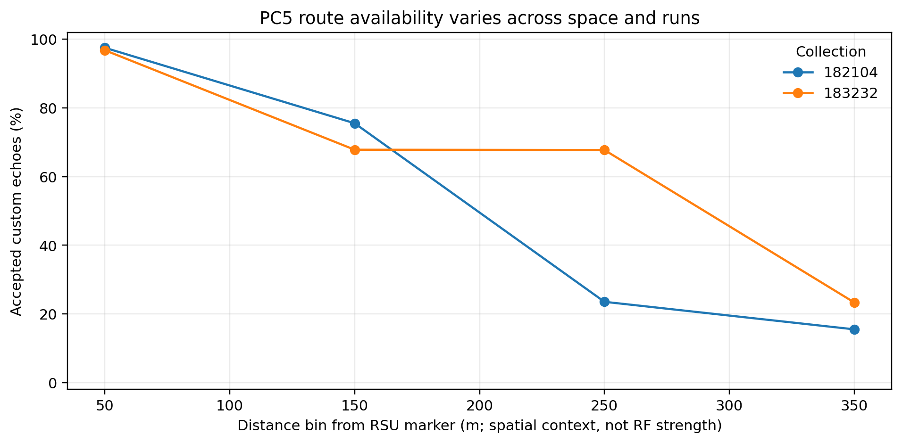
Figure 2. Accepted IPI responses by distance bin for the two GNSS-joined PC5 routes.
Across four mobile routes, all-attempt success ranged from 59.1% to 76.3%. Successful-packet p50 was 28-100 ms, but the two GNSS-joined runs fell from 97.5% and 96.8% accepted delivery in the 0-100 m bin to 15.5% and 23.3% in the 300-400 m bin. Consecutive failure bursts reached 56 and 41 attempts. Point 1 was short-range but building-obstructed NLOS, confirming that distance alone is not the cause.
The deployed vendor interface exposes a 4,080 B application-packet ceiling; the current portable IPI PC5 adapter defaults to 2,048 B including J2735 and IP5X framing. Larger cooperative objects therefore require semantic reduction, segmentation, or another path even before radio availability is considered.
Main PC5 result. Direct V2X has a joint payload-size and spatial-availability limit. Compact IPI messages can be stable on a favorable stationary path, but 1-2 KiB delivery collapses first as the path degrades, and mobile coverage gaps dominate successful-packet latency. The measured PC5 path cannot reliably carry complex multi-packet CAV objects.

5. PCA and Dominant Latency Factors
PCA was applied to five standardized condition-level outcomes: log10 p50, p95, and p99 accepted-response RTT; log10(p95/p50) tail inflation; and all-attempt failure fraction. It describes outcome modes, not physical causes. Matched within-run contrasts and an evidence rubric were then used to rank the experimental factors that move those outcomes.
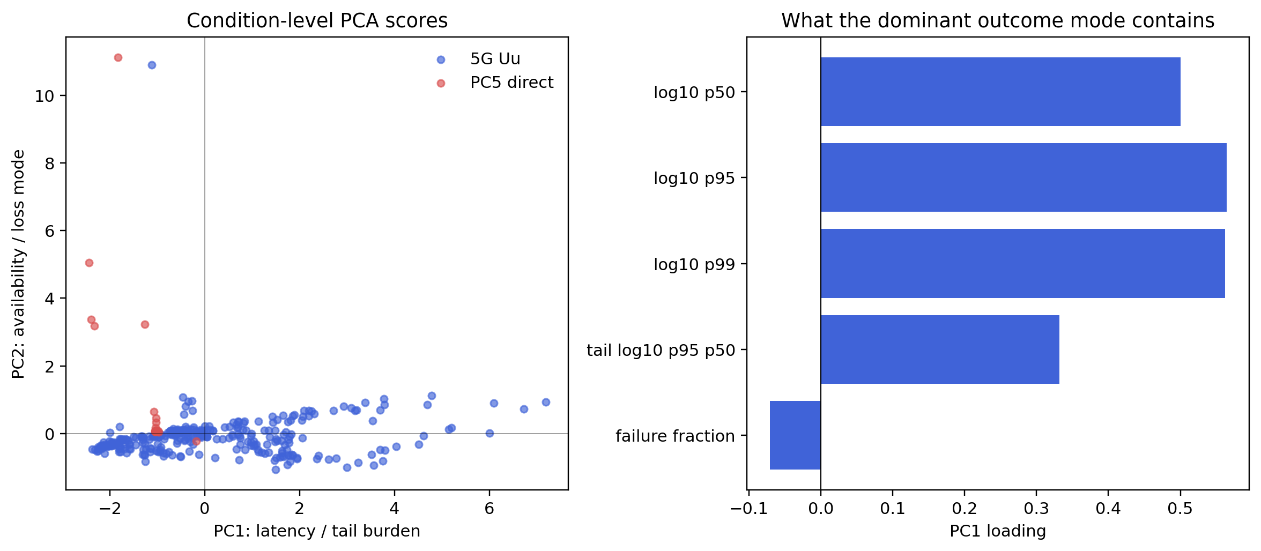
Figure 3. PCA separates latency/tail burden (PC1) from availability loss (PC2).
Direct answer: what most affects latency? PC1 is the dominant outcome axis, explaining 62.15% of variance, with loadings 0.501 on p50, 0.564 on p95, 0.562 on p99, and 0.332 on tail inflation. The strongest experimental factor associated with this burden is payload and representation scale. It ranks first in 99.4% of 20,000 weight-sensitivity trials and never below second.
Rank | Observed limiting factor | Representative evidence
1 | Payload and representation scale | 22 matched contrasts: median p95 ratio 8.25x, maximum 86.01x; seconds-scale MiB transfers and PC5 delivery collapse
2 | Concurrent demand without verified isolation | 16 contrasts: median p95 ratio 2.84x, maximum 55.96x; weak-path 100-client MQTT p95 3,814 ms
3 | Operating path and spatial availability | PC5 loss increased by up to 99.8 percentage points; far-route availability 15.5-23.3%
4 | Service interruption and state continuity | Receiver/broker restarts created 11.7-15.1 s gaps despite ordinary RTT after recovery
5 | Message formation and transport semantics | Raw UDP failed at 1,400 B and above; fragmentation restored smaller objects but not reliable 60 KiB delivery
6 | Directional capacity / frame allocation | 13.118 Mb/s car-to-edge versus 25.0 Mb/s edge-to-car; causal TDD effect remains unisolated
7 | Local perception compute, conditional | One V2X-Radar configuration: 3.570 s median and 4.214 s p95 per sample; not added to network RTT
PC2 explains 20.20% of variance and loads 0.927 on failure fraction, so availability loss is distinct from high RTT. PC3 explains 17.18% and is dominated by tail inflation; the first three components explain 99.53% in total. This is why a low median or even a modest p95 among survivors cannot establish service readiness when most attempts fail.
- Implementation result. IPI made the two paths comparable by preserving workload identity, correlation, deadline, status, and failure semantics across every experiment.
- Communication result. Compact IPI control/state exchanges can be supported under favorable conditions; large perception, map, and model objects should be reduced, prefetched, or transferred asynchronously.
- Design implication. Readiness requires joint control of representation size, concurrency, direction, deadline, path state, message formation, and service recovery—not selection of PC5, TCP, MQTT, or UDP by name alone.
Evidence base: retained IPI sender/receiver artifacts under results/, experiment_summary.md, and paper/analysis/limiting_factors/. Aborted runs and same-host loopbacks were excluded from the joint factor ranking.

6. CAV/ITS Questions, Application Envelopes, and Success Criteria
This expanded portion answers the questions that a CAV or ITS reader needs in order to interpret the five-page experimental summary. It separates measured field results from software-only validation and from application outcomes that were not evaluated. That distinction is essential because a valid communication response, a completed distributed service, and a safe vehicle action are different claims.
Evidence label | Meaning in this report | Examples
Measured field result | Observed in retained sender, receiver, route, or radio-context artifacts. | Private-5G RTT/availability; PC5 vendor-echo RTT/coverage; restart gaps; direction/load measurements.
Implementation-only validation | Exercised in C++ unit/integration tests, independent ASN.1 checks, cross-compilation, or the ROS 2 launch contract. | Session lifecycle; formal J2735 regional codec; IP5X adapter; activation, tier policy, and offload decisions.
Application outcome not measured | Requires a domain-specific downstream result rather than a network acknowledgment. | Collision-free trajectory; successful maneuver; safe stop; perception accuracy; completed Autoware actuation.

6.1 Representative CAV/ITS application classes
The experiments were not arbitrary byte sweeps. Their sizes, directions, deadlines, and state semantics were selected to cover five recurring CAV/ITS communication patterns. The values below are representative analysis envelopes drawn from CAV/V2X requirements and the stored workload inventory; they are not universal certification limits.
Application class | Interaction semantics | Representative traffic | Analysis deadline
Signal warning | Periodic common infrastructure downlink; a newer state supersedes an older state. | About 500 B at 10 Hz | 100 ms
Collision / blind-spot warning | Periodic many-to-many awareness state from multiple sources. | About 200 B per source at 10 Hz | 100 ms
Automated intersection crossing | Common state plus per-vehicle intent uplink, vehicle-specific trajectory downlink, and operation state. | 300 B-1 KiB | 10 ms
Emergency maneuver | Short reciprocal coordination burst while other traffic may be present. | 2-12 KiB | 3-10 ms
Fault-triggered remote recovery | Long-lived correlated session; compact control/state traffic or sustained video uplink with a returned path. | Up to 1 KiB or 32 Mbit/s video | 100-200 ms
Cooperative perception / object transfer | Vehicle-to-edge object list or larger perception object followed by a compact acknowledgment. | 19-25 KiB representative; 60 KiB stress | 100-500 ms analysis points
Map/model/data staging | Delay-tolerant prefetch or asynchronous object movement rather than a control-loop exchange. | 128 KiB-2 MiB | 500 ms-seconds

The timing points also have a physical interpretation. At 25 mph, a vehicle travels about 0.11 m in 10 ms and 1.12 m in 100 ms. If one vehicle travels 35 mph and another travels 25 mph, their separation changes by about 0.45 m in 100 ms. A remote-assisted vehicle limited to 10 km/h travels about 0.278 m in 100 ms and 0.556 m in 200 ms. These values explain why the same measured RTT can be acceptable for state distribution or remote assistance but unusable for a tightly coordinated intersection maneuver.
The perception sizes are grounded in retained data rather than chosen only for convenience. Across 922 V2X-Radar object lists, the encoded size estimate has a 19,648 B median, 23,968 B p99, and 25,024 B maximum. The detector replay filled the IPI content field to those sizes; it did not transmit native detector objects. The 60,000 B object is a deliberate stress condition. Public dataset artifacts motivated the 128 KiB-2 MiB range, but the report does not imply that an entire raw sensor artifact must be sent in every CAV application.

6.2 Four levels of success
Level | Required evidence | What the current work establishes
1. Communication acceptance | A decoded response is accepted and matches the issued message/request/session/sequence/correlation/payload identity. | Measured by the private-5G IPI frames and historical PC5 sequence-matched response harness.
2. Deadline-qualified response | The matched response also arrives with sender-side RTT less than or equal to budget B; all issued attempts remain in the denominator. | Measured as A(B) for retained field experiments.
3. Stateful service completion | A fresh, correlated terminal COMPLETED or valid FALLBACK_COMPLETED result is received. ACCEPTED or IN_PROGRESS alone is not completion. | Validated in host software lifecycle, wire-codec, and task-offloader tests.
4. CAV application outcome | A domain result is correct and useful: e.g., a safe trajectory, warning delivered before it becomes stale, safe fallback, or perception-quality target. | Not measured in a vehicle, CARLA driving scenario, or Autoware control loop.

Interpretation rule. A successful field attempt in this report means a valid correlated communication response. It does not by itself establish correct perception, a feasible trajectory, a safe maneuver, or successful vehicle control. The field CSV service-success flag is configured experiment context, not a measured driving outcome.
For deadline B, the report uses A(B) = N(valid matched responses with RTT <= B) / N(issued requests). Missing, rejected, timed-out, and late requests reduce availability. RTT p50, p95, and p99 are calculated only over received valid responses and must therefore be read together with A(B) or the all-attempt response fraction. This prevents a weak route from appearing fast merely because only its easiest packets survived.

6.3 What was closed loop
The field harness was closed loop at the communication level. Each logical client sent a request, waited for the matching response or timeout, recorded the result, and then began its next interval. Multiple-client runs started concurrent copies of that sequential loop behind one vehicle host and one physical UE. No field experiment passed the returned result through Autoware planning, trajectory execution, vehicle control, or driving behavior. The precise term used in this report is therefore closed-loop request/response communication harness, not closed-loop autonomous-driving validation.

7. Detailed IPI and Proposal Implementation
IPI is implemented as a typed C++17 interface that separates application semantics from the communication binding. One facade covers conventional V2X message exchange and private connected-session services. The same metadata and outcome vocabulary follow an interaction across in-memory tests, broker or MQTT session transport, private-5G probes, and the PC5 integration adapter. This is the implementation property that allows the experiments to compare unlike links without reducing the result to transport-specific packet timing.

7.1 Data model, interaction modes, and transport facade
- Message mode. The interface accepts BSM, PSM, MAP, SPaT, SRM, SSM, TIM, unknown/pre-encoded J2735 messages, and typed cooperative-service content. Broadcast messages can remain pre-encoded so their original bytes are preserved.
- Session mode. A vehicle registers, activates a lease through heartbeat, invokes a granted service, publishes telemetry, receives progress or terminal updates, and can patch or terminate the session.
- Common envelope. Message identity, source, intersection, transport, send time, optional session and correlation identifiers, priority, monotonic sequence, and expiry travel with the object.
- Outcome vocabulary. Accepted, rejected, in-progress, completed, timed-out, missing, interrupted, unavailable, expired, and fallback outcomes have machine-readable failure and fallback result codes.
- Clock discipline. Session leases and RTT use monotonic/steady clocks. Wall time remains presentation metadata. One-way application latency is withheld when clocks are unsynchronized.

7.2 Session lifecycle, freshness, and correlation
The transport-neutral SessionLifecycle component is the session authority for in-memory, broker-backed, and MQTT-backed paths. Registration binds intersection, vehicle, and source identity and retains requested RSU fallback, minimum RSSI, subscription, and granted services. The first valid heartbeat moves a registered session to active. Later heartbeats extend a monotonic lease; stale heartbeats are rejected. Patch operations cannot transfer ownership, and a terminated session cannot be revived.
Invariant | Admission rule | Validated behavior
Active lease | Service or telemetry is admitted only while the session is active and unexpired. | Pre-heartbeat and exact-deadline expiry rejection.
Ownership | Session, intersection, vehicle, and source must match the registration. | Ownership-changing patch denied; terminated session cannot revive.
Service grant | The requested service must be in the session's granted set. | Grant information retained and checked.
Freshness | Request expiry is enforced and sequence numbers must increase. | Stale and nonincreasing inputs rejected.
Correlation | Message and correlation identifiers must identify one outstanding request. | Unknown and duplicate responses rejected.
Terminal uniqueness | Only one valid terminal result may close an outstanding request. | Duplicate result and second terminal result rejected.

The session wire protocol uses a versioned IPIS envelope and strict per-message-kind payload decoders. It rejects unknown enum values, trailing bytes, wildcard identifiers, kind/topic mismatches, registration identity mismatches, and inconsistent status/failure/fallback combinations. The MQTT binding supplies publish/subscribe delivery, reconnect and resubscription behavior, keepalive, clean-session configuration, optional credentials, and an allowed topic prefix. The field private-5G probes used their experiment framing; the session transport is validated as a reference contract rather than treated as a reclassification of historical measurements.

7.3 Formal J2735 regional encoding and PC5 binding
The formal cooperative-service profile uses J2735 MessageFrame carrying TestMessage00 (DSRC message ID 240). A local uncoordinated RegionId 200 carries IpiCooperativeService with planning, perception, control, and offload alternatives. The codec checks the outer message ID, regional identifier, service choice, numerical constraints, extension bits, padding, and maximum frame size. Independent asn1tools and pycrate vectors agree for perception, planning, control, and a minimal request; an outer-frame comparison also uses the USDOT 202409 package.
The PC5 IPI adapter preserves that formal MessageFrame inside an IP5X integration packet containing request/response, correlation, session, sequence, expiry, acceptance, failure, result, length, and CRC fields. It rejects corrupt, mismatched, duplicate, stale, and late packets. Host tests and warning-as-error AArch64 cross-compilation validate the adapter and Mocar sample. The retained PC5 radio sweeps predate this adapter and use the vendor sequence-matched echo, so their latency remains valid as the historical IPI application-response experiment but is not evidence that the formal regional frame crossed the two radios.
Standards boundary. The defensible standards claim is an independently cross-checked local J2735 regional-extension profile. The exact licensed J2735ASN SEP2023 compilation and a two-device cross-vendor interoperability run are separate evidence gates; neither is inferred from the host vectors.

7.4 WP4: geofenced infrastructure activation
WP4 implements a deterministic activation-zone state machine. A zone has an identifier and revision, circular or polygonal geometry, validity interval, entry and exit hysteresis, entry dwell, infrastructure availability, and enumerated actions: model pull, telemetry push, edge perception, edge planning, and service-mode hint. The state progresses through OUTSIDE, ENTERING, ACTIVE, EXITING, and FALLBACK. Stale revisions are rejected, repeated updates are idempotent, the transition sequence advances only on an actual state change, and actions are exposed only while ACTIVE. Infrastructure loss forces FALLBACK and clears active actions.
The activation unit test covers dwell-based entry, exactly one ACTIVE transition, duplicate suppression, infrastructure-loss fallback, recovery through dwell, and zone exit. The ROS 2 contract injects a synthetic NavSatFix into an 80 m reference circle with 5 m hysteresis and 250 ms dwell and confirms the ACTIVE event. This validates the state and message contract; the action identifiers are not evidence that a model was actually downloaded or vehicle telemetry was actually transmitted.

7.5 WP5: tiered service policy
WP5 implements a deterministic policy over safety-critical, real-time, interactive, and best-effort services. Inputs include activation state, service availability, link availability, RTT, packet loss, congestion, capacity, requested rate, application deadline, current activity, and local-fallback availability. Outputs are START, MAINTAIN, THROTTLE, PAUSE, USE_LOCAL_FALLBACK, or REJECT with a selected transport, maximum rate, validity interval, and machine-readable reason.
The key invariant is that safety-critical service is not deliberately paused. If a usable link disappears, the policy chooses local fallback when available or rejects the remote request. Under congestion, best-effort work pauses and interactive work may throttle, while safety-critical work is maintained or started if the link still satisfies the rule. Tests cover healthy start, congestion, link loss, operation outside the activation zone, fallback, and invalid timing. The ROS launch contract injects congestion and confirms that an HD-map best-effort intent pauses, then injects link loss and confirms that a safety-critical intent selects local fallback.

7.6 WP6: offload decision and timeout fallback
WP6 estimates local and edge completion time from local queue and compute delay, upload and download sizes and capacities, network RTT, edge queue and compute delay, uncertainty margin, confidence, service/link availability, minimum required edge benefit, deadline, and local-fallback availability. EDGE is selected only if it is available, sufficiently confident, deadline-safe, and materially faster. Otherwise the model selects LOCAL when viable or explicitly reports that neither path is predicted to meet the deadline. HYBRID is represented in the type system but is not selected by the current engine.
TaskOffloader separately binds session, vehicle, service, task identifier, sequence, payload, and monotonic expiry. It rejects duplicate, mismatched, late, or already-terminal updates. If a remote result has not become terminal at the exact deadline, it activates the retained local payload and reports a machine-readable fallback result. Tests cover correlation, duplicate terminal results, exact-deadline timeout, and successful local fallback. The ROS decision node publishes LOCAL under injected link loss and EDGE under a healthy supplied estimate; it does not execute data migration or remote computation.

7.7 ROS 2 reference path
Process | Input | Output / validated decision
Activation-zone publisher | Reference-zone configuration | Reliable, transient-local activation-zone advertisement.
Activation manager | Activation zone, NavSatFix, infrastructure status | Exactly-once activation transition event.
Tiered service manager | Activation event, LinkStatus, ServiceIntent | PolicyDecision: start/maintain/throttle/pause/local fallback/reject.
Offload decision node | OffloadRequest and LinkStatus | OffloadDecision: local/edge plus predicted completion, deadline status, and reason.

The four-process ROS launch contract validates topic-level behavior and clean shutdown. It intentionally ends at decision publication. No node directly commands Autoware motion or operation mode. This preserves vehicle-side authority while the transport, safety-supervisor, and Autoware-facing adapters are defined separately.

8. Measured Systems, Radio Conditions, and Experimental Procedure

8.1 Physical topology
Element | Private-5G Uu path | Direct PC5 path
Vehicle side | Autonomous-vehicle host over 1 Gbit/s Ethernet to Cisco Meraki MG52-HW; Telit FN990A40 modem; internal antenna face-up on trunk floor. | Commercial Mocar OBU using vendor 2020 J2735/packet-data SDK.
Radio | Airspan AirSpeed 2900 NR n48 gNodeB; 40 MHz; 30 kHz SCS; TDD; 20 ms SSB. | LTE C-V2X PC5 to a fixed HUALI RSU; detailed sidelink counters were not exported.
Infrastructure path | Cisco private-5G system/core to on-site MX250 and directly connected d1 application endpoint. | RSU directly connected to d1 response host.
Application response | d1 decodes an IPI cooperative-service request and returns the matching response over TCP, MQTT, UDP, or fragmented UDP. | Historical sweep returns a sequence-matched vendor packet echo; small functional tests also exercised J2735 callbacks.
Scale unit | One host, one MG52, one SIM, one physical UE; 1-100 logical application clients behind it. | One OBU/RSU pair; stationary points and four driven routes.

The MG52 was the sole experiment UE. Background uplink load and logical-client demand were deliberately introduced behind that one attachment. The private deployment had no other users during collection according to operator/user confirmation, and no interference from other bands was reported. This controlled condition is not a substitute for a retained spectrum scan, per-request scheduler trace, or proof of a specific RLC/HARQ/PRB mechanism. The experiments also exclude public-network handover and roaming.

8.2 Private-5G radio and cell record
Parameter | Retained value | Interpretation boundary
Band/channel | NR n48, 40 MHz; Cell 2 NR-ARFCN 645334; 3669.600 MHz synchronization signal. | Application collections are attributed to Cell 2; Cell 1 was not a second evaluated path.
Numerology / duplex | 30 kHz SCS; TDD; 20 ms synchronization-block period; 10D4G frame-packing label. | The deployment label is reported, not reverse-mapped to undocumented vendor scheduler fields.
Power / antenna | 33 dBm cell transmit power; 34 dBm/MHz EIRP; 17 dBi integrated cross-polar antenna; approx. 65° azimuth x 8° elevation pattern. | Antenna centerline is 20 ft above roof level; installed height above ground, true azimuth, and downtilt are unresolved.
Reported traffic split | Early 40/40/20 DL/UL/dynamic; later Cell-2-locked 70/20/10; attempted 30/60/10 produced no valid experiment. | Collected at different times without matched contemporaneous counters; no causal TDD attribution.
Core / subscription | DNN cisco5g; operator-reported default 5QI 9. | Host captures showed TOS 0x0 for both default and 5qi-mapped labels; nondefault network treatment was not verified.
CBRS context | Category B GAA; one requested and authorized grant; successful SAS heartbeat; Federated Wireless primary SAS. | Individual grant records were not preserved.

A separate 16-point iPhone survey recorded RSRP from -121 to -91 dBm (mean -106.88 dBm), RSRQ from -19 to -10 dB (mean -11 dB), and SNR from 3.5 to 27.5 dB (mean 16.44 dB). It provides spatial context only. It is a different UE and was not synchronized to individual MG52 application attempts; it cannot be used as per-request explanatory telemetry.

8.3 PC5 points, mobility, and known radio limits
Static inspection of the deployed Mocar SDK found a 4,080 B application-packet ceiling. The performance sweep used 0, 256, 512, 1,024, and 2,048 B application payloads. The 4,080 B value is specific to this installed interface, not a universal PC5 limit. The current portable IP5X adapter defaults to a 2,048 B operational packet including J2735 and correlation framing.
Condition | Recorded geometric context | What can be claimed
Stable July 3 reference | Distance not explicitly recorded | Stable payload reference; 256 B-2 KiB p50 near 100 ms and p95 near 107-112 ms.
P1 | 68 m; building-obstructed NLOS | Short distance did not guarantee a good path; obstruction confounds distance.
P2 | 113 m | Stationary distance condition; no retained full RF/scheduler counters.
P3 | 212 m | Stationary distance condition; no defensible LOS/NLOS label in the record.
P4 | 377 m | Stationary distance condition; payload loss increases as the path weakens.
P5 | 469 m | Farthest stationary condition; no mechanism-level MCS/BLER attribution.

The PC5 hardware export does not contain carrier/channel, sidelink resource pool, transmit power, congestion-control settings, MCS, retransmissions, resource blocks, BLER, received power, PC5 RSRP/RSRQ/SNR, or antenna placement/orientation. Empty OBU RSSI captures and unrelated Wi-Fi RSSI logs are not used. Consequently, the report treats distance, obstruction, payload size, and route position as observed contexts and does not name an unmeasured RF mechanism as the cause.

8.4 Probe procedure, workload formation, and timing
Experiment family | Nominal procedure | Key interpretation
Private-5G compact/payload | Usually 1,000 sequential requests per condition at 200 ms interval; sender waits for response/timeout; 0 B-2 MiB content. | Closed-loop latency/availability, not sustained streaming throughput.
Private-5G transport | TCP, MQTT 3.1.1 QoS 0 over TCP, raw UDP, or application-fragmented UDP. | Raw and fragmented UDP are separate message-formation modes.
Private-5G logical clients | 1-100 concurrent sender flows behind one host/UE; each flow remains sequential. | Measures application concurrency and shared-path queueing, not 100 independently scheduled UEs.
Private-5G offered load | Nominal 25 Mbit/s uplink load introduced beside IPI flows. | Offered rate differs from achieved rate; some runs achieved only 1.320-2.267 Mbit/s.
PC5 stationary | Usually 1,000 sequence-bearing requests at 100 ms interval with 1,000 ms timeout. | Vendor packet echo measures application response over the direct link.
PC5 mobile | 256 B every 200 ms; one route stopped at 675 attempts and three retained 1,000. | Speed and route position co-vary; route labels do not prove continuous LOS.

Requested payload bytes denote the IPI content field for private-5G probes; the sender separately records encoded frame size. The detector replay estimates 256 B of header plus 96 B per predicted object, then fills opaque IPI content to the selected size. The large-payload path sends the object vehicle-to-edge and returns a compact acknowledgment; it does not establish large edge-to-vehicle delivery.
Because vehicle and endpoint application clocks were unsynchronized, communication latency is sender-side RTT from a local monotonic clock. The synchronized gNodeB clock does not synchronize those application processes. Timeouts censor the upper RTT distribution, so the timeout and response fraction are retained and p99 is avoided where too few responses support it.

8.5 Collection days, repetitions, and statistical unit
- Private-5G stationary baseline/payload campaigns were collected May 13, 14, 15, 21, and 22, 2026 at five stationary GNSS markers on one private deployment. Date, location, weather, and deployment state co-vary.
- The August direction control occurred August 5. The repeated application/location matrix occurred August 6 in separate five-minute transport bins with two repetitions per transport; bins and locations were sequential, not independent-day replicas.
- The PC5 stable reference was collected July 3. Five stationary locations and four routes were collected July 4 on one OBU/RSU deployment.
- A condition is a combination of path, transport, payload, location, load, client count, or other declared setting. The 364 analysis rows are conditions, not 364 independent field deployments. Thousands of requests improve percentile resolution but do not replace independent run/day replication.

9. Detailed Private-5G Uu Experiments and Results

9.1 Payload and deadline regimes
The favorable May 13 condition establishes the best observed compact baseline, not a network-wide guarantee. At 0 B, MQTT completed 1,000/1,000 attempts with 23.154 ms p50 and 36.620 ms p95; TCP completed 1,000/1,000 with 119.065 ms p50 and 137.970 ms p95. Payload growth moved both transports into new tail regimes, and the pooled deadline analysis shows why accepted-response latency alone is insufficient.
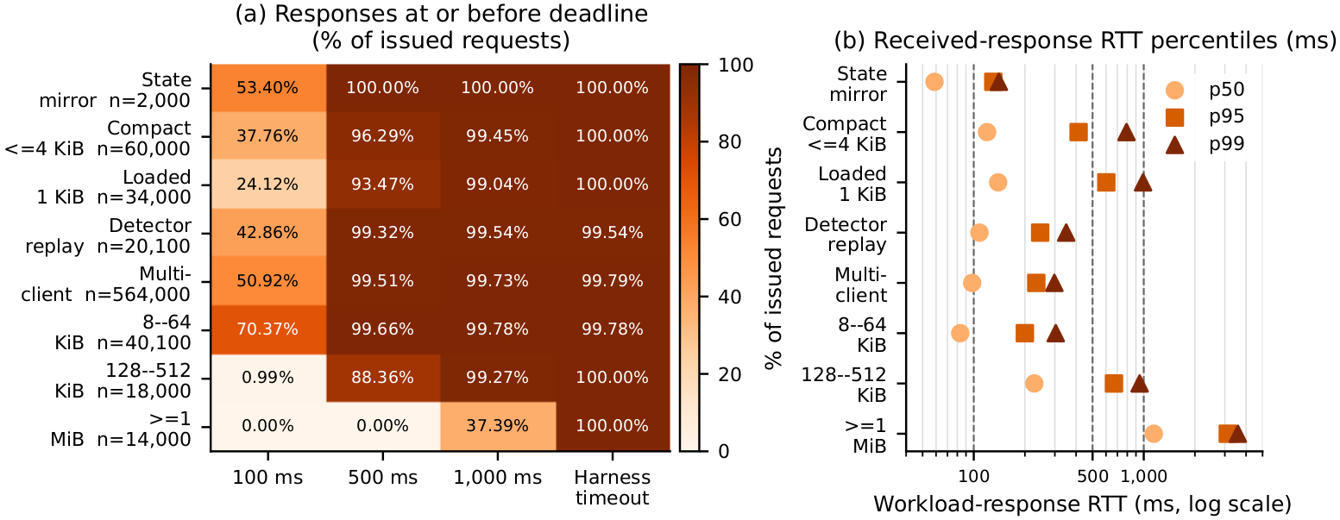
Figure 4. Private-5G deadline availability by workload group. Every issued request remains in the denominator, including late and missing responses.
Workload group | Attempts | p50 / p95 RTT | Miss >100 ms | Miss >500 ms | Miss >1 s
State mirror | 2,000 | 58.748 / 130.323 ms | 46.60% | 0% | 0%
Compact <=4 KiB | 60,000 | 119.739 / 413.725 ms | 62.24% | 3.71% | 0.55%
1 KiB load/QoS | 34,000 | 139.163 / 602.354 ms | 75.88% | 6.53% | 0.96%
Detector-sized | 20,100 | 108.039 / 245.879 ms | 57.14% | 0.68% | 0.46%
128-512 KiB map/perception | 18,000 | 227.193 / 667.975 ms | 99.01% | 11.64% | 0.73%
>=1 MiB bulk | 14,000 | 1,146.068 / 3,122.273 ms | 100% | 100% | 62.61%

These groups answer a practical sizing question. Compact control/state objects may fit a 400-500 ms envelope in many conditions, but the measured Uu path does not robustly satisfy a 100 ms budget. Detector-sized objects are conditionally compatible with a 500 ms analysis envelope, not a tight 100 ms loop. The 128-512 KiB objects are mostly asynchronous, and 1 MiB or larger objects belong in prefetch/staging rather than a response-critical transaction.

9.2 Transport and message formation
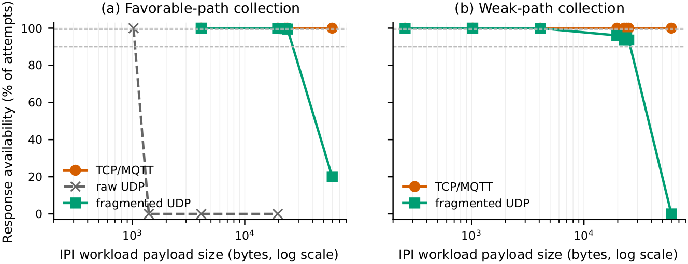
Figure 5. Completion and latency depend on both transport and message formation; raw UDP and application-fragmented UDP are not one protocol condition.
Under the favorable detector-payload condition, MQTT p95 increased from 49.826 ms at 0 B to 183.705 ms around 23-24 KiB and 403.790 ms at 60 KiB. TCP p95 was 151.696 ms at 0 B, approximately 169.540-213.894 ms at 19-25 KiB, and 381.409 ms at 60 KiB. At the weak location, 60 KiB p95/p99 rose to about 770/1,230 ms for MQTT and 662/1,027 ms for TCP.
Raw UDP completed at 0 and 1,024 B but returned no responses at 1,400, 4,096, 19,648, or 60,000 B in the completed diagnostic. Application fragmentation restored 99.5-100% completion through 23,968 B at the favorable location, but only 20/100 at 60 KiB. At the weak location it delivered 93.5-96.1% at 19-25 KiB and 0/100 at 60 KiB. The conclusion is not that UDP is categorically unsuitable; it is that the unfragmented datagram path and the fragment/reassembly path have different operating envelopes and failure modes.

9.3 Load, direction, reported TDD profile, and QoS label
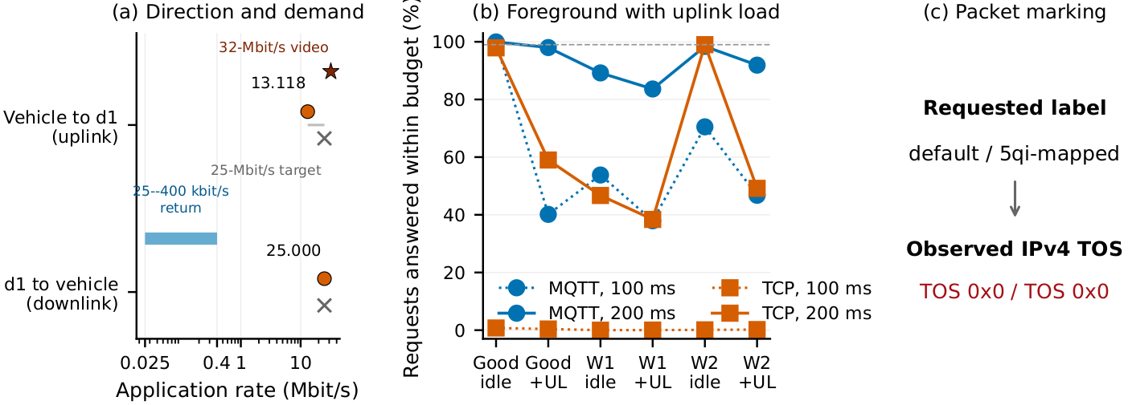
Figure 6. Competing uplink traffic increases IPI tail latency even when the achieved background rate is below its configured offer.
A nominal 25 Mbit/s uplink background flow often achieved only 1.320-2.267 Mbit/s, yet it still multiplied p95 by 2.17-2.40 for TCP and 2.89-3.38 for MQTT in the paired collections. In the repeated Airspan block, idle-to-uplink-load p95 increased 2.64x for TCP, 4.04x for MQTT, and 4.33x for application-fragmented UDP. Offered background rate and achieved background rate are therefore reported separately.
Question | Observed result | Defensible interpretation
Direction | Against a 25 Mbit/s target, car-to-edge reached 13.118 Mbit/s and edge-to-car reached 25.0 Mbit/s. | The measured path is asymmetric; this does not by itself identify scheduler or TDD cause.
Reported profile change | 40/40/20 early campaign; 70/20/10 later Cell-2-locked follow-up; 10D4G unchanged. | Historical sensitivity only: conditions were not a matched same-time causal experiment.
1 KiB MQTT | p95 44.487 -> 41.358 ms; A(100 ms) 100% -> 99.8% across the two reported campaigns. | Small sensitivity in this comparison; time and deployment state also changed.
Detector MQTT | p95 183.705 -> 77.944 ms; A(100 ms) 30.8% -> 98.9%. | Large observed difference, but not attributable solely to TDD without matched counters.
QoS label | Both default and 5qi-mapped host captures had TOS 0x0. | Application labels did not verify nondefault 5QI/QFI treatment; retain as a negative configuration result.

9.4 Logical-client concurrency
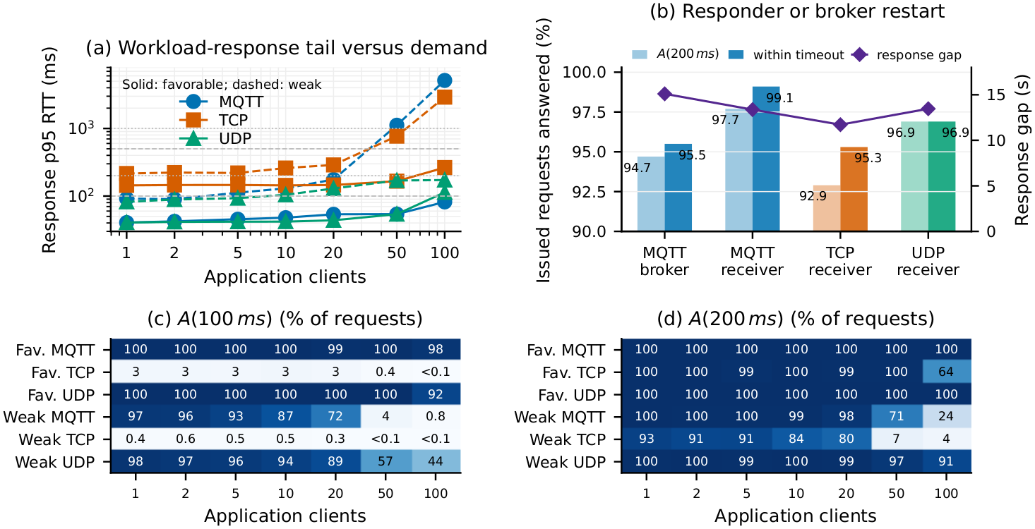
Figure 7. Private-5G latency inflation from 1 to 100 logical IPI clients behind one host and one UE, shown for favorable and adverse locations.
Location / transport | 1-to-100-client p95 change | 100-client result | Meaning
Favorable TCP | 1.84x | Completed logical-client matrix | Shared-path demand increases tail latency even at the favorable location.
Favorable MQTT | 2.02x | Completed logical-client matrix | Broker/client processing and shared-path queues contribute to tail growth.
Favorable UDP | 2.80x | Completed logical-client matrix | Datagram formation does not eliminate shared-path contention.
Adverse TCP | 13.49x | p95 2,938 ms | Weak path plus concurrency creates seconds-scale tail latency.
Adverse MQTT | 55.96x | p95 3,814 ms | Client count and location interact; a protocol name alone does not predict latency.

Scaling boundary. The 100-client condition is not a 100-vehicle test. It consists of 100 logical application flows behind one vehicle host, one gateway, one SIM, and one radio bearer. It measures client concurrency, shared queueing, and transport processing under one physical UE attachment.

9.5 Interruption and recovery
Receiver and MQTT-broker restart tests injected approximately ten seconds of unavailability while the sender continued. The four cases returned 955, 991, 953, and 969 of 1,000 requests. Their longest intervals without a successful exchange were 15.101, 13.367, 11.715, and 13.464 s; A(200 ms) ranged from 92.9% to 97.7%. Accepted-response p95 outside the gap remained at or below 161.5 ms, illustrating why survivor latency cannot describe continuity. These tests exercise interruption, client reconnection, and continuation. They do not demonstrate automatic switching between Uu and PC5.
Private-5G result. The measured Uu path can support compact IPI state and service traffic under favorable location, load, and client demand. It is not robust for a universal 100 ms service budget, and its tails are strongly shaped by representation size, concurrency, uplink competition, location, message formation, and interruptions.

10. Detailed Direct-PC5 Experiments and Results
Protocol provenance. All PC5 measurements belong to the IPI experimental program and use the IPI request/response workload concept, but the historical performance sweep's on-air object is a Mocar vendor sequence/echo packet. The formal J2735/IP5X IPI adapter was implemented later and is validated on the host; it was not used to recollect the historical route and stationary measurements.

10.1 Stationary payload and spatial behavior
At the stable July 3 reference, 256 B-2 KiB successful responses had p50 near 100 ms and p95 near 107-112 ms, showing a tight conditional distribution on that favorable stationary path. The July 4 stationary sweep then exposed a joint payload-and-path boundary: smaller objects survived farther into weak conditions, while 1-2 KiB objects lost responses first. P1, although only 68 m from the RSU, was building-obstructed NLOS and demonstrates that geometric distance alone is not a causal radio variable.
Because the vendor interface did not export PC5 received power, resource-pool use, MCS, BLER, retransmissions, or scheduling counters, the report does not attribute the response collapse to a specific physical-layer mechanism. The directly supported statement is that payload size and spatial context jointly determine response availability on the measured OBU/RSU path.

10.2 Mobile routes
Route | Replies / attempts | Success | p50 / p95 RTT | Median speed | Longest noted failure burst
1 | 515 / 675 | 76.3% | 99.610 / 108.421 ms | 7.131 m/s (16.0 mph) | 50 attempts
2 | 731 / 1,000 | 73.1% | 28.326 / 41.887 ms | 7.541 m/s (16.9 mph) | Not summarized
3 | 591 / 1,000 | 59.1% | 29.204 / 43.923 ms | 8.284 m/s (18.5 mph), recomputed | 56 attempts
4 | 716 / 1,000 | 71.6% | 28.276 / 41.621 ms | 6.162 m/s (13.8 mph), recomputed | 41 attempts

Routes used 256 B requests at 200 ms intervals. Route 1 ended after 675 attempts; the other routes retained 1,000. Route 3 and 4 speeds above were recomputed from the per-request send_horizontal_speed_mps column because their Markdown summaries did not include medians. Speed changes with route position and was not independently controlled, so this table describes exposure rather than a speed effect.
For the two GNSS-joined routes, all-attempt success was 97.5% and 96.8% in the 0-100 m bin but only 15.5% and 23.3% in the 300-400 m bin. The route traces also contain recurring weak- and no-path segments. Their folder label includes 'los', but that label does not prove uninterrupted physical line of sight. Successful-packet RTT remains relatively compact while whole stretches fail, so both distance-binned availability and consecutive failure bursts are necessary to describe the route.

10.3 PC5 interpretation for IPI
- Compact control and awareness objects are the natural fit for the measured direct path; the stable reference shows low conditional tail inflation.
- A p95 computed only on replies does not reveal route outages. For route-level service, availability and the longest no-response interval are first-class results.
- The installed 4,080 B vendor ceiling and 2,048 B portable IP5X operating limit favor semantic reduction, object selection, or higher-layer segmentation for larger cooperative objects.
- A short obstructed path can be worse than a longer clear path. Without RF counters, distance is a context variable rather than the physical cause.
Direct-PC5 result. The measured path offers compact conditional RTT on favorable links, but mobile route coverage and larger-payload availability are the controlling limits. The later IP5X adapter gives IPI the required correlation, freshness, status, CRC, and formal J2735 payload contract; a two-radio run is required before its host validation can be described as fielded interoperability.

11. Cross-Application Interpretation
The purpose of the experiment matrix is not to declare one radio universally ready or unready. It is to map each CAV/ITS interaction to a measured payload, direction, deadline, availability requirement, and fallback obligation. The table below applies the current evidence at the strength it supports.
Application | Representative envelope | Measured evidence | Current interpretation
Signal warning | About 500 B; 100 ms | Favorable compact MQTT can be within 100 ms; pooled state mirror p95 130.323 ms and A(100 ms) 53.4%. | Conditional, not robust across the full private-5G matrix. Use freshness and replacement semantics.
Collision / blind-spot warning | About 200-256 B; 100 ms | Stable PC5 p95 about 107 ms; mobile routes return 59.1-76.3% overall with long failure bursts. | A favorable direct path is near the envelope, but route-level availability is insufficient for sole reliance.
Automated intersection crossing | 300 B-1 KiB; 10 ms | Representative measured p95/deadline is about 4.45x on favorable Uu and 10.69x on PC5. | The measured request/response paths do not meet the selected 10 ms coordination envelope.
Emergency maneuver | 2-12 KiB; 3-10 ms | Representative p95/deadline is about 7.96x on Uu and 11.17x on PC5 at a 10 ms comparison point. | Beyond the tight measured envelope; local vehicle control must remain authoritative.
Remote recovery | <=1 KiB; 100-200 ms; optional 32 Mbit/s video | Loaded 1 KiB p95 can exceed 100 ms; restart A(200 ms) is 92.9-97.7% with 11.7-15.1 s response gaps. | Compact supervisory interaction is conditional; uninterrupted remote control cannot be assumed. Local fallback is required.
Cooperative perception | 19-25 KiB; 100-500 ms | Favorable Uu p95 around 184 ms MQTT and 170-214 ms TCP; detector group has 57.14% misses at 100 ms but 0.68% at 500 ms. | Conditionally compatible with a 500 ms analysis envelope, not a tight 100 ms loop. PC5 requires reduction/segmentation.
Map/model staging | 128 KiB-2 MiB | 128-512 KiB p95 667.975 ms; >=1 MiB p95 3,122.273 ms and 62.61% miss 1 s. | Asynchronous prefetch/staging only; do not place in a response-critical path.

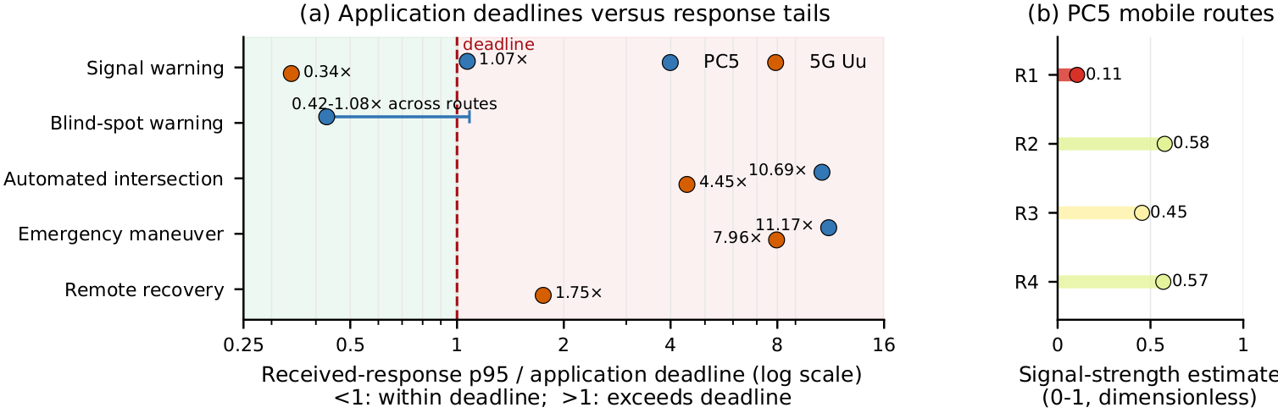
Figure 8. Cross-application context. Panel A shows representative p95-to-deadline ratios; ratios use successful responses and must be read with all-attempt availability, and values above 1 exceed the selected envelope. Panel B shows the stored dimensionless PC5 route-context estimate, not a measured RF signal value.

11.1 Design consequences for WP4-WP6
- Activation should stage large model/map objects before the application becomes time-critical. The payload results support geofenced prefetch more strongly than on-demand MiB transfer at the intersection.
- Tier policy must use deadline availability, payload, direction, client demand, and link/path state. Selecting '5G', 'PC5', 'MQTT', or 'TCP' by name is insufficient.
- Offload selection must include upload, RTT, edge queue/compute, return size, confidence, and a local fallback. A network acknowledgment is not proof that edge execution completed before the vehicle deadline.
- Safety-critical local behavior cannot depend on transport recovery. The 11.7-15.1 s restart gaps and PC5 route failure bursts are longer than the selected CAV envelopes.

12. Successful-Response Variance, PCA, and Factor Ranking

12.1 Exact successful-response variance method
The successful-response analysis returned to individual sender records and retained accepted responses with finite positive RTT. A condition was eligible with at least 20 such responses. It retained 1,688,330 RTT records from 355 conditions and gave each condition equal weight. For each condition it calculated sample standard deviation using n-1, population variance using n, coefficient of variation (sample standard deviation divided by mean), and p95/p50 tail inflation.
For a selected scale, within-condition variance is the mean of condition-level population variances, between-condition variance is the population variance of condition means, and total variance is their sum. Because RTT spans orders of magnitude, log10(RTT) is the primary scale. On log10 RTT, between-condition differences explain 89.082% and successful-attempt variation within a fixed condition explains 10.918%. On raw RTT in ms squared, the split reverses: within-condition tails explain 72.647% and between-condition means explain 27.353%. The two statements are not contradictory; raw squared deviations are dominated by seconds-scale outliers, while the logarithmic scale asks which regime a successful response occupies.
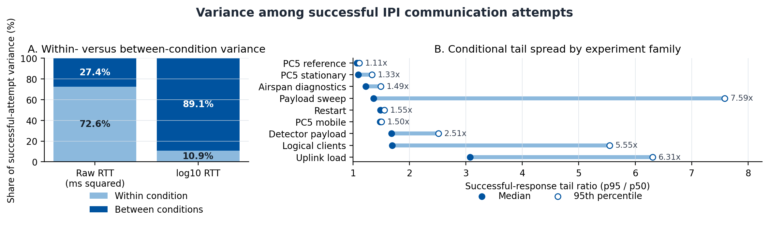
Figure 9. Variance among successful application responses. Panel A shows the scale-dependent within/between decomposition; Panel B shows successful-response p95/p50 spread by experiment family. Outages are excluded and analyzed separately through availability.
Experiment family | Conditions | Median p95/p50 | 95th percentile p95/p50 | Interpretation
PC5 reference | 5 | 1.069x | 1.108x | Tight successful-response distribution.
PC5 stationary | 16 | 1.089x | 1.335x | Tight among survivors; availability may still collapse.
Airspan diagnostics | 60 | 1.224x | 1.490x | Relatively bounded successful tails in declared bins.
Payload sweep | 127 | 1.362x | 7.589x | Payload can create extreme condition tails.
Restart | 4 | 1.485x | 1.552x | Survivors look bounded while interruption gaps appear as missing attempts.
PC5 mobile | 4 | 1.477x | 1.500x | Survivor RTT is compact; route outages dominate service continuity.
Detector payload | 47 | 1.680x | 2.510x | Moderate-to-large successful tail spread.
Logical clients | 42 | 1.693x | 5.548x | Concurrency creates substantial tail inflation.
Uplink load | 48 | 3.073x | 6.308x | Largest family median tail inflation.

Across all eligible conditions, the median coefficient of variation is 0.282 (p25 0.172, p75 0.619, p90 1.353, p95 1.699, maximum 6.413). Median p95/p50 is 1.427; its p75 is 2.077, p90 4.353, p95 6.223, and maximum 12.029. These are survivor-conditioned statistics. Complete and near-complete outages with fewer than 20 replies are excluded by construction and must be read through availability, timeout bursts, and restart gaps.

12.2 PCA method and result
PCA uses one row per experimental condition or valid Airspan sample. The five centered and sample-standardized outcomes are log10 p50, p95, and p99 accepted-response RTT; log10(p95/p50) tail inflation; and all-attempt failure fraction. The covariance matrix is decomposed and eigenvectors are ordered by eigenvalue. The 1,708,263 attempt total is coverage, not statistical weight; each condition receives equal weight. Conditions with fewer than 20 replies are excluded from PCA but remain in availability and matched-contrast analysis.
Component | Explained variance | Dominant loadings | Meaning
PC1 | 62.1508% | log p50 0.501; log p95 0.564; log p99 0.562; tail 0.332 | Overall successful-response latency and tail burden.
PC2 | 20.2038% | Failure fraction 0.927 | Availability loss is largely distinct from high survivor RTT.
PC3 | 17.1769% | Tail-inflation-dominant residual mode | Separates additional tail behavior after overall latency and failure.
First three | 99.53% | Combined | Nearly all standardized outcome variance in the five-feature description.

PCA describes outcome modes; it does not identify physical causes. The later seven-factor ordering is a separate evidence synthesis based on matched within-family contrasts and an explicit five-criterion ordinal rubric. In 20,000 sensitivity trials that perturb the rubric weights, payload ranks first in 99.4% of trials and never below second; concurrency remains in the top three in every trial; spatial context remains top-three in 82.6%. These are weight-sensitivity frequencies under the chosen perturbation distribution, not confidence intervals or sampling probabilities.
Experimental factor | Matched contrasts | Median p95 ratio | Maximum p95 ratio | Conclusion
Payload size | 22 | 8.25x | 86.01x | Strongest and most consistently observed latency regime change.
Logical concurrency | 16 | 2.84x | 55.96x | Large tail amplification, especially at the adverse location.
Spatial context | Route/stationary comparisons | Availability-dominant | Not expressed as one p95 ratio | Critical for PC5 coverage and adverse private-5G conditions, but no RF mechanism is observed.
Competing uplink load | Paired idle/load conditions | Transport-dependent | Up to 4.33x in repeated block | Moderate achieved load can create multi-fold p95 inflation.
Message formation / transport | TCP, MQTT, raw and fragmented UDP | Condition-dependent | Completion failures at larger objects | Formation and reassembly affect completion and tails; protocol name alone is not causal.

Main statistical result. Direct answer to the main PCA question: PC1 is the principal latency/tail outcome axis, but PCA does not name the cause. The repository's matched contrasts identify representation size as the strongest experimental factor associated with that axis, followed by logical concurrency and spatial/path context. Failure is a separate PC2-dominant outcome and must be reported independently.

13. Software Validation, Evidence Traceability, and Conclusions

13.1 Current validation matrix
Validation group | Current result | What it establishes
C++ release build and CTest | 18/18 tests passed in a fresh build on August 14, 2026. | Facade, transports, probes, session lifecycle, wire codec, PC5 adapter, detector result, activation, policy, offload, and task-offloader contracts.
Sanitizer build | 18/18 recorded as passing under ASan/UBSan in the current task record. | No sanitizer-reported issue in the tested paths.
ASN.1 cross-check | Four formal vectors matched independent asn1tools/pycrate encoders; USDOT outer-frame check passed. | Bit-level agreement for the checked local regional profile.
PC5 host integration | IP5X codec/adapter tests passed; warning-as-error AArch64 Mocar cross-build passed. | Packet preservation, size, correlation, CRC, expiry, status, and toolchain compatibility on the host.
ROS 2 Humble | ipi_msgs and ipi_runtime build; two launch xUnit cases pass; repeated contract runs recorded. | Process-level activation, policy, offload decisions, and clean shutdown under synthetic inputs.
Field experiments | Retained private-5G Uu and historical vendor-echo PC5 results summarized in Sections 8-12. | Communication RTT, availability, payload, load, concurrency, spatial, direction, formation, and interruption behavior.

The test suite includes edge4av_interface, private_session_transport, private_5g_latency_probe, j2735_message_flow, j2735_ipi_regional_codec, j2735_schema_prepare, experiment_logging, private_5g_latency_loopback, private_5g_latency_mqtt_loopback, session_lifecycle, session_wire_codec, broker_session_transport, pc5_ipi_adapter, detector_result, activation_zone, service_policy, offload_decision, and task_offloader.

13.2 Repository evidence map
Question | Primary retained evidence
Experiment inventory and condition summaries | experiment_summary.md; results/real_5g/; results/mocar_v2x/
Application workloads, testbed, timing, and deadlines | paper/manuscript/sections/04_system_design_setup.tex; paper/manuscript/sections/08_appendices.tex
PCA, matched contrasts, and factor ranking | paper/analysis/limiting_factors/limiting_factor_analysis.md; analysis_summary.json; pca_loadings.csv
Successful-response variance | paper/analysis/limiting_factors/successful_attempt_variance_summary.json; scripts/analyze_successful_ipi_variance.py
IPI API, sessions, wire codec, and outcomes | cpp/include/ipi/api/; cpp/src/api/; cpp/tests/
Formal J2735 regional profile and PC5 integration | cpp/asn1/IPI.asn; cpp/include/ipi/v2x/; cpp/src/v2x/; cpp/include/ipi/api/pc5_ipi_adapter.hpp
WP4-WP6 reference implementation | cpp/include/ipi/activation/; cpp/include/ipi/policy/; cpp/include/ipi/offload/; cpp/include/ipi/mesh/task_offloader.hpp
ROS 2 decision path | ros2_ws/src/ipi_msgs/; ros2_ws/src/ipi_runtime/

13.3 Reference basis for representative application envelopes
[1] SAE International, J2735_202007, Dedicated Short Range Communications Message Set Dictionary, 2020.
[2] 3GPP/ETSI TS 22.186 V19, Service requirements for enhanced V2X scenarios.
[3] 3GPP TS 23.286 V18, Application layer support for V2X services.
[4] 3GPP TS 23.287 V18, Architecture enhancements for 5G System to support V2X services.
[5] NHTSA, Vehicle Safety Communications Project Task 3 Final Report, DOT HS 809 859.
[6] 5G Automotive Association, C-V2X Use Cases and Service Level Requirements, Volume II, 2021.
[7] FHWA, Speed Concepts: Informational Guide, FHWA-SA-10-001.
[8] Z. He and B. Shi, A Vision for Transformative Intersections, Computer, 2024.
[9] Cisco, Private 5G documentation and deployment records retained with the project.
[10] Airspan, AirSpeed 2900 configuration and antenna documentation retained with the project.

13.4 Consolidated conclusions
- IPI implementation. The typed facade, session lifecycle, outcome model, formal regional codec, PC5 adapter, activation tracker, tier policy, offload estimator, task fallback, and ROS message path are implemented and host/process validated.
- Field communication. Private-5G and direct-PC5 behavior is condition-dependent. Favorable compact exchanges are feasible, but neither path provides a universal low-latency, high-availability envelope across payload, load, concurrency, mobility, and interruption.
- Main latency factor. PCA's PC1 is the dominant latency/tail outcome axis at 62.15%. Matched contrasts associate the largest regime changes with representation size, followed by logical concurrency and spatial/path context.
- Successful-response variance. On log10 RTT, 89.1% of successful-response variance lies between conditions; on raw RTT squared, 72.6% lies within conditions because rare seconds-scale tails dominate. Both scales and the survivor-conditioning boundary are reported.
- Availability. PC2 is dominated by failure fraction, and route outages or restart gaps can coexist with modest survivor p95. Deadline availability and consecutive failure gaps are therefore mandatory alongside latency percentiles.
- CAV/ITS implication. Compact state/warning traffic can be supported under favorable conditions; tight 3-10 ms coordination is beyond the measured request/response paths; detector-scale objects are conditional at hundreds of milliseconds; MiB-scale objects require prefetch or asynchronous staging.
- Proposal implication. WP4 should pre-stage large objects, WP5 should decide from measured deadline/path/load state rather than transport name, and WP6 should compare full completion time and retain deterministic local fallback.
Final answer. The experiments answer a narrower and more useful question than 'is 5G or PC5 ready?' They show which IPI interaction can be supported, under which measured condition, at which payload and deadline, with what probability of a timely response, and what fallback remains necessary when that condition changes.

14. Proposal Commitments and Evidence Closure
The proposal defines implementation, integration, reporting, source-release, education, and dissemination commitments. The matrix below records what the current checkout establishes. Status refers to evidence present in the repository; it does not infer an activity or field result that was not retained.

14.1 WP4-WP6 deliverable status
Item | Promised output | Current artifact and evidence | Status in current evidence
WP4-1 | Infrastructure-activated design, message flows, contracts, state transitions, timing, and fallback. | Activation-zone model and tracker; session, policy, and fallback contracts; Sections 7.1-7.4; C++ activation test and ROS 2 contract. | Implemented and documented; host and ROS decision behavior validated.
WP4-2 | Reusable CARLA/V2X/Autoware simulation environment with reference intersection, launch, configuration, and extension guidance. | ipi_msgs and ipi_runtime provide reference messages, YAML configuration, launch, synthetic NavSatFix input, and runtime-contract testing. This checkout does not evidence a complete CARLA layout and Autoware driving scenario. | Reference ROS 2 slice present; the complete proposed CARLA environment is not evidenced here.
WP4-3 | Infrastructure activation communications and Autoware-consumable behavior integration. | Activation, policy, and offload topics publish deterministic decisions. The reference path intentionally does not command Autoware operation mode or motion. | Decision-publication integration complete; downstream vehicle-action adapter is outside current evidence.
WP5-1 | Tiered real-time service policy using latency, congestion, service priority, and fallback. | TieredServicePolicy and ROS tiered service manager; safety-critical no-pause invariant; congestion and link-loss tests. | Implemented and host/ROS validated.
WP5-2 | Policy architecture and performance report using simulation and real-world latency, loss, and failover evidence. | Sections 9-12 connect load, concurrency, path, interruption, deadline availability, and fallback to policy decisions. | Complete at design/report level; the policy engine itself was not enacted as a field vehicle controller.
WP6-1 | Reusable local/edge/hybrid offload decision model integrated with IPI and service policy. | OffloadDecisionEngine and TaskOffloader use transfer, RTT, queue, compute, deadline, confidence, session identity, expiry, and local fallback inputs. | Implemented and decision-level validated in C++ and ROS.
WP6-2 | Final Year 2 architecture, repository, experiment, limitation, and recommendation report. | This report consolidates implementation, field evidence, successful-response variance, PCA, matched factors, evidence boundaries, and stakeholder closeout. | Complete as the current technical report.
WP6-3 | Curated IPI-Autoware source release with tags, documentation, examples, build checks, license, and contribution information. | Installable IPI::ipi CMake package, READMEs, ROS packages, reference launch/configuration, formal codec, examples, and passing builds are present. No immutable release tag or repository-wide license artifact was found in this checkout. | Implementation and build evidence present; external release closure is not evidenced.

14.2 Supporting commitments and acceptance inputs
Commitment or decision | Current evidence | Closeout treatment
Documentation and reproducibility | C++ and ROS READMEs, launch/configuration, analysis scripts, result paths, tests, and derived CSV/JSON artifacts are present. | Use the manifest in Section 18 to bind reported values to the current source snapshot.
Seminars, tutorials, demonstrations, and guided exercises | No dated event log, slides, recording index, attendance record, or exercise package was found in the current repository. | Attach administrative records if these activities occurred; otherwise do not mark them complete from code evidence.
Application acceptance target | The report gives representative deadlines and measured A(B), but it does not define the probability of deadline compliance required by each Tier IV service. | Application owners must supply the required A(B) before a formal pass/fail label is assigned.
Vehicle authority boundary | The ROS path publishes activation, policy, and offload decisions and stops before an Autoware motion or operation-mode command. | Tier IV must approve the downstream adapter and the actions it may request; local safety behavior remains authoritative.
Source-release identity | The base Git commit is 2b44f352bb45 on main, but the current implementation/report checkout includes uncommitted additions and has no tag at HEAD. | Create an immutable, licensed release snapshot before using the report as a release certificate.

15. Experiment Coverage and Denominator Ledger
The condition-level analysis contains 364 rows and 1,708,263 issued attempts. The attempt count measures coverage, not independent replication. Each condition is the analysis unit so that a high-count logical-client sample cannot dominate a smaller payload or field-location condition.

15.1 Condition-level analysis coverage
Family | Path | Conditions | Issued | Accepted | Interpretation boundary
Payload sweep | 5G Uu | 127 | 124,701 | 124,695 | Multiple days/locations; payload, transport, date, and context may co-vary.
Uplink load | 5G Uu | 48 | 48,000 | 48,000 | Controlled background generator; offered and achieved rates differ.
Logical clients | 5G Uu | 42 | 1,128,000 | 1,116,420 | Application flows behind one host and one physical UE.
Detector replay | 5G Uu | 48 | 46,200 | 45,785 | Opaque prediction-count-derived sizes; not native detector serialization.
Message formation diagnostic | 5G Uu | 5 | 1,545 | 1,300 | Raw UDP diagnostic; unequal denominators are retained.
Injected restart | 5G Uu | 4 | 4,000 | 3,868 | One injected failure per condition; continuity, not replicated fault frequency.
Airspan follow-up | 5G Uu | 60 | 327,000 | 325,655 | Valid declared application samples; radio-causal claims require aligned counters.
PC5 reference | PC5 direct | 5 | 5,000 | 4,999 | Favorable stationary survivor-latency reference.
PC5 stationary | PC5 direct | 21 | 20,142 | 15,064 | PCA-usable raw observations; complete/near-complete outages remain in availability reporting.
PC5 mobility | PC5 direct | 4 | 3,675 | 2,553 | Four routes; route, speed, geometry, and path condition co-vary.
Total | Both | 364 | 1,708,263 | 1,688,339 | Joint analysis coverage; not 364 independent deployments and not one homogeneous wire format.

15.2 Denominator conventions
Reported result | Denominator | Reason for the convention
Complete stationary PC5 availability | 35 planned payload/location phases x 1,000 attempts = 35,000; 24,037 matched replies and 10,963 timeouts. | Operator-stopped or skipped remainders after timeout-dominant behavior count as analysis timeouts so all planned phases remain visible.
Condition-level PCA/factor ledger | 364 observed condition rows and 1,708,263 issued attempts. | Uses raw observed denominators and excludes aborted runs, local loopbacks, smoke tests, and conditions without stable latency summaries from PCA.
Successful-response variance | 1,688,330 finite positive RTT records in 355 conditions with at least 20 accepted responses; each condition has equal weight. | Answers predictability after success. Nine accepted replies from below-threshold conditions are outside this analysis; complete outages remain in delivery evidence.
Deadline availability A(B) | All issued attempts. | Only a valid matched response with RTT at or below B enters the numerator; late, missing, rejected, and timed-out attempts remain in the denominator.
Logical-client aggregation | All per-client sender files within the declared run and client-count condition. | Aggregation is by run/campaign plus client count, preventing repeated per-client files from being mistaken for independent physical UEs.

15.3 Collection and repetition context
Collection block | Coverage already retained | Replication meaning
Private-5G stationary baseline | May 13, 14, 15, 21, and 22, 2026; five stationary markers; 0 B-2 MiB TCP/MQTT workloads. | Mostly 1,000 sequential attempts per completed condition; day, location, weather label, and deployment state are not independent.
Private-5G stress campaigns | July 1-6; offered load, QoS label, detector sizes, raw/fragmented UDP, 1-100 logical clients, and injected restarts. | Repeated requests characterize each selected condition; only the declared paired comparisons isolate a changed input.
Private-5G follow-up | August 5 direction controls and August 6 repeated C1-C4 application/location blocks; 60 valid analysis samples. | Two repetitions per transport in separate time bins; sequential bins do not create simultaneous randomized treatments.
PC5 stationary | July 3 reference plus July 4 continuous and five-point sweeps; 35 planned payload/location phases. | Planned attempts preserve complete outage conditions; successful RTT statistics exist only when replies occur.
PC5 mobility | Four July 4 routes; 3,675 attempts and 2,553 replies at 256 B. | One physical deployment and route family; speed and geometry are context, not independent randomized factors.

16. Application Decisions, Success, and Statistical Interpretation
Sections 9-12 report the measurements. This section states the corresponding use decision without introducing a new application requirement. A formal pass/fail decision still requires the application owner to supply the required A(B).

16.1 Application use decisions from current evidence
Application | Existing evidence | Decision supported without another experiment
Signal warning | State-mirror p95 is 130.323 ms and A(100 ms) is 53.4%; favorable compact MQTT conditions are better. | Use replaceable-state and freshness semantics. Treat 100 ms support as condition-specific, not a path-wide guarantee.
Collision / blind-spot warning | Stable PC5 p95 is near 107 ms, but mobile delivery is 59.1-76.3% with long no-response bursts. | Use the direct path as conditional/supplemental awareness; do not infer route continuity from survivor RTT.
Automated intersection crossing | Representative favorable p95/deadline ratios are about 4.45x on Uu and 10.69x on PC5 for a 10 ms comparison. | Do not place a 10 ms vehicle decision solely on the measured request/response path; precompute or retain local control.
Emergency maneuver | The selected 3-10 ms envelope is below measured 2-12 KiB response times. | Keep maneuver authority local; remote messages may inform state but cannot be the sole tight-loop dependency.
Remote recovery | Loaded compact p95 can exceed 100 ms, and restart tests have 11.7-15.1 s no-response gaps. | Use remote service for conditional high-level assistance after local slow/stop behavior, with explicit session termination and fallback.
Cooperative perception | Favorable 19-25 KiB p95 is about 170-214 ms; detector-group misses are 57.14% at 100 ms and 0.68% at 500 ms. | Admit only when predicted full completion fits the selected budget; reduce or prioritize useful objects for shorter budgets.
Map/model staging | 128-512 KiB p95 is 667.975 ms; at least 1 MiB p95 is 3,122.273 ms and 62.61% miss 1 s. | Prefetch, cache, compress, or transfer asynchronously; do not place bulk staging in a response-critical path.

16.2 Delivery and successful-response timing must be read together
Evidence group | Delivery | Deadline availability | p95 among accepted responses | Joint interpretation
Uu state mirror | 2,000/2,000 | A(100 ms) 53.4%; A(500 ms) 100% | 130.323 ms | No packet loss, but almost half the issued exchanges exceed 100 ms.
Uu compact <=4 KiB | 60,000/60,000 | A(100 ms) 37.76%; A(500 ms) 96.29% | 413.725 ms | Reliable eventual response does not imply a robust 100 ms service.
Uu 1 KiB load/QoS | 34,000/34,000 | A(100 ms) 24.12%; A(500 ms) 93.47% | 602.354 ms | Competing demand primarily enlarges tails even when replies eventually arrive.
Uu detector-sized | 99.54% accepted | A(100 ms) 42.86%; A(500 ms) 99.32% | 245.879 ms | Conditionally compatible with hundreds of milliseconds, not a universal 100 ms loop.
Uu 128-512 KiB | 100% accepted | A(100 ms) 0.99%; A(500 ms) 88.36% | 667.975 ms | Completion is common, but the object is late for short deadlines.
Uu >=1 MiB | 100% accepted | A(100 ms) 0%; A(500 ms) 0%; A(1 s) 37.39% | 3,122.273 ms | This is bulk/prefetch behavior despite eventual delivery.
PC5 stationary reference | 4,999/5,000 | 99.98% all-attempt delivery | 106.691-111.661 ms across payloads | Tight survivor distribution on the favorable stationary path.
PC5 mobile routes | 2,553/3,675 (69.5%) | Route delivery 59.1-76.3% | 41.621-108.421 ms by route | Low survivor RTT can coexist with substantial route outages.
Successful-response variance. Across 355 eligible conditions, the median coefficient of variation is 0.282 and the median p95/p50 ratio is 1.427. The median p95/p50 ratio is 1.069 for the PC5 reference family and 3.073 for the uplink-load family. These values describe latency predictability after a response is received and never replace the delivery and A(B) columns above.

16.3 PCA, matched factors, and ranking robustness
Analysis | Existing result | What a stakeholder may conclude
PCA outcome structure | PC1 explains 62.15% and represents accepted-response latency/tail burden; PC2 explains 20.20% and is dominated by failure fraction. | High survivor latency and missing service are distinct outcome modes. PCA does not identify a physical cause.
Matched experimental contrasts | Payload has an 8.25x median and 86.01x maximum p95 ratio; logical concurrency has a 2.84x median and 55.96x maximum. | Representation scale is the strongest observed latency regime change; shared demand is the next broad tail amplifier.
20,000 ranking-weight sensitivity trials | Payload ranks first in 99.4% of trials and never below second. Concurrency remains top-three in every trial. Spatial/path context is top-three in 82.6%. | The top two design priorities are robust to reasonable scoring-weight changes; the order of spatial context and interruption is less fixed.

17. End-to-End Implementation Trace and Authority Boundary
The table connects the individually implemented modules into one reference operation. Evidence level is stated at every step so that host validation is not mistaken for an Autoware driving outcome or a fielded end-to-end application.
Step | Component and input | Output or invariant | Evidence level
1. Advertise zone | Reference-zone publisher reads YAML configuration. | Reliable transient-local ActivationZone advertisement with identifier, revision, geometry, validity, hysteresis, dwell, and actions. | ROS 2 build and launch contract.
2. Detect transition | ActivationZoneTracker consumes zone, NavSatFix, time, and infrastructure status. | Exactly-once OUTSIDE/ENTERING/ACTIVE/EXITING/FALLBACK transition event; invalid or unavailable infrastructure cannot silently preserve ACTIVE. | C++ unit test and synthetic ROS transition test.
3. Express service intent | TieredServicePolicy consumes service tier, activation state, link state, latency, loss, congestion, and fallback availability. | Start, maintain, throttle, pause, use-local-fallback, or reject; safety-critical work is not intentionally paused. | C++ policy tests and ROS decision publication.
4. Select execution site | OffloadDecisionEngine consumes transfer sizes/rates, RTT, queues, compute times, uncertainty, deadline, confidence, and availability. | Local, edge, or hybrid decision with predicted completion, deadline result, reason, and fallback. | C++ offload tests and ROS decision publication.
5. Establish session | SessionLifecycle receives registration and heartbeat metadata. | Active monotonic lease, retained grants, ownership, subscription, fallback preference, outstanding-request ledger, patch, and termination rules. | C++ lifecycle, wire-codec, in-memory broker, and MQTT integration tests.
6. Encode and bind | Edge4AvInterface plus J2735 regional codec and the selected PC5/private-session adapter. | Typed envelope, complete MessageFrame or session wire record, sequence/correlation/expiry fields, strict decoder, CRC for IP5X. | Independent ASN.1 vectors, CTests, installed-package test, and Mocar AArch64 cross-build.
7. Exchange | Private-5G sender/receiver or historical PC5 vendor request/echo harness. | Matched response RTT, acceptance, deadline availability, and failure record. | Field measured for Uu encoded IPI frames and historical PC5 vendor echo; formal IP5X remains host validated.
8. Complete or fall back | SessionLifecycle and TaskOffloader validate progress/terminal result, identity, sequence, deadline, and task state. | One valid terminal completion or explicit rejection/timeout/fallback; duplicates, stale updates, and mismatches are rejected. | Host lifecycle/task tests; no vehicle trajectory, perception, or motion outcome measured.
Authority boundary. The reference integration publishes infrastructure information and decisions; it does not directly invoke Autoware operation-mode or motion control. Communication success is therefore an input to vehicle behavior, not authorization to bypass the vehicle's safety checks, local fallback, or minimal-risk response.

18. Negative Results, Reproducibility, and Definitions

18.1 Negative results and interpretation limits
Observed negative or boundary | What it prevents the report from claiming | How it is used
Unsynchronized private-5G endpoint clocks | Valid one-way application latency or internal path decomposition. | Use sender-side monotonic request/response RTT only.
Default and 5qi-mapped captures both show TOS 0x0 | A verified nondefault QFI/5QI or network-enforced priority effect. | Retain the QoS-label experiment as a negative verification result.
The attempted 30/60/10 profile was unsupported | A third measured TDD condition. | Record a platform constraint; do not place it in performance comparisons.
Historical 40/40/20 and later 70/20/10 collections are not same-time matched | A causal TDD explanation for the observed performance difference. | Report deployment-level sensitivity with date/state confounding.
PC5 diagnostic RF files are empty | Causal received-power, MCS, BLER, retransmission, scheduler, or resource-pool attribution. | Report location, obstruction, payload, route, availability, and RTT.
The 16-point radio survey used a separate iPhone UE | Per-request MG52 radio telemetry or a causal join to application RTT. | Use as spatial context only.
Raw UDP returns no response at 1,400 B and above in the completed diagnostic | A generic statement that UDP supports the tested object sizes. | Separate raw datagram and application-fragmented message formation.
One hundred clients share one host and one physical UE | A 100-vehicle, 100-SIM, or independently scheduled multi-UE scaling result. | Use as logical application concurrency and shared-path queueing evidence.
Restart conditions contain 11.7-15.1 s response gaps | Continuity from ordinary transport reconnection or a modest survivor p95. | Require application state, terminal outcome, and local fallback semantics.
Licensed J2735ASN SEP2023 module compilation and two-device formal IP5X field exchange are not retained | Formal certification or retroactive standards conformance of the historical PC5 sweep. | Claim independent local regional-profile checks and host adapter validation only.
No CARLA/Autoware control-loop result is retained | A collision-free trajectory, safe maneuver, perception-quality result, or completed Autoware action. | Keep application outcome distinct from communication and software validation.

18.2 Reproducibility manifest
The raw result trees remain the primary evidence. The files below provide the current analysis ledger and regeneration path. Short hashes are the first 12 hexadecimal characters of SHA-256 calculated for this report revision.
Purpose | Artifact | SHA-256 prefix
Experiment inventory | experiment_summary.md | 959ce0ce2391
Complete direct-PC5 table | paper/analysis/v2x_experiment_summary.md | 893aebac7e0b
Condition-level ledger | paper/analysis/limiting_factors/condition_level_metrics.csv | b399267f2915
Matched comparisons | paper/analysis/limiting_factors/matched_contrasts.csv | c1e6a01895b6
PCA loadings | paper/analysis/limiting_factors/pca_loadings.csv | b1a5b6d0e9fb
PCA/factor summary | paper/analysis/limiting_factors/analysis_summary.json | 8a4e951627fa
Successful RTT records | paper/analysis/limiting_factors/successful_attempt_variance.csv | 2633d153b78c
Successful variance summary | paper/analysis/limiting_factors/successful_attempt_variance_summary.json | 6bf69f993250
Factor-analysis generator | scripts/analyze_cav_limiting_factors.py | 1b1375d4d1ab
Variance generator | scripts/analyze_successful_ipi_variance.py | 8c2a2b0b1ed
Private-5G raw/derived evidence | results/real_5g/ | Directory tree; retained manifests apply
Direct-PC5 raw/derived evidence | results/mocar_v2x/ | Directory tree; retained summaries apply
Regeneration commands. From the repository root, run python3 scripts/analyze_cav_limiting_factors.py and python3 scripts/analyze_successful_ipi_variance.py. The generators read retained evidence and rewrite derived CSV, JSON, Markdown, and figure outputs; they do not modify raw result artifacts.

18.3 Glossary and measurement notation
Term | Meaning in this report
IPI | Intersection Programming Interface: the typed application contract and reference implementation evaluated here.
PC5 | The direct cellular vehicle-to-everything sidelink between the vehicle on-board unit and roadside unit; no cellular base-station user-plane hop is required for that exchange.
Uu | The 3GPP radio interface between user equipment and the cellular radio access network; here it is the private-5G vehicle-to-edge path.
OBU / RSU | On-board unit in the vehicle / roadside unit at the infrastructure endpoint.
UE | User equipment. The private-5G logical-client experiments use one physical UE even when many application clients run.
RTT | Round-trip time from request issuance to receipt of the matching response, measured by the sender's local monotonic clock.
p50 / p95 / p99 | The 50th, 95th, and 99th percentiles among accepted responses unless the text explicitly states another denominator.
CV | Coefficient of variation: successful-response standard deviation divided by mean within a condition.
A(B) | Deadline availability: valid matched responses with RTT at or below budget B divided by all issued attempts.
Success-conditioned / survivor-conditioned | Calculated only from attempts that returned a valid accepted response; failures and timeouts must be reported separately.
Logical client | One application sender flow. It is not necessarily a separate vehicle, SIM, UE, or radio bearer.
TDD | Time-division duplex operation. The report retains operator profile labels but does not infer their causal effect without matched evidence.
5QI / QFI | 5G quality-of-service identifier / QoS flow identifier. An application label does not prove that a particular bearer treatment was applied.
J2735 regional extension | A standards mechanism for carrying locally defined content within a J2735 MessageFrame; the report states the exact local-profile and validation boundary.
IP5X | The project integration envelope used by the formal PC5 adapter for correlation, sequence, expiry, status, length, and CRC around the J2735 frame.
Terminal result | A final completed, rejected, timed-out, unavailable, expired, interrupted, or fallback outcome that closes one outstanding request.
NLOS | Non-line-of-sight geometry. It is used only where obstruction is recorded; it is not inferred from distance alone.
Closeout interpretation. This report supports technical acceptance at the implementation, software-validation, and field-communication levels explicitly recorded above. It does not convert an unmeasured application outcome, an undocumented educational activity, or an untagged working tree into completed evidence.

