E:\Git>git clone https://wackerow@bitbucket.org/wackerow/ucmis.m2t.git
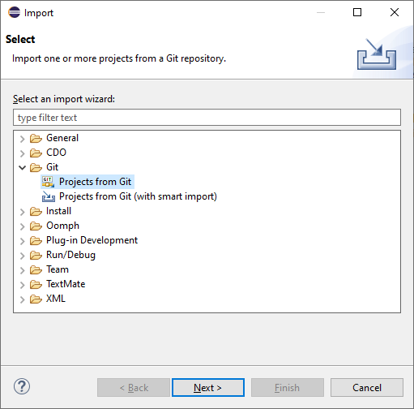
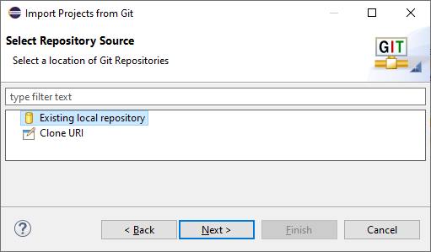
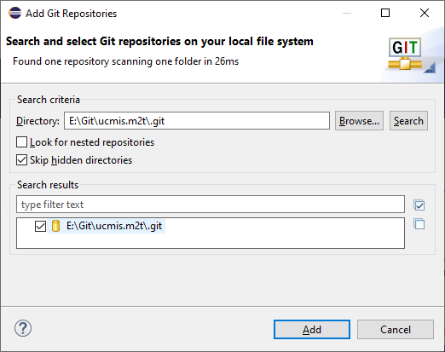
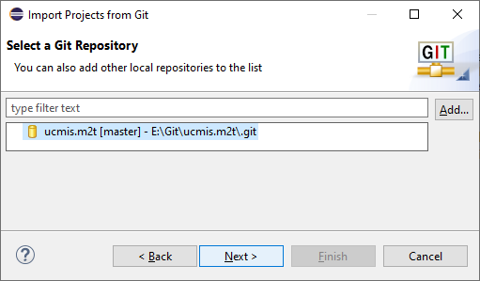
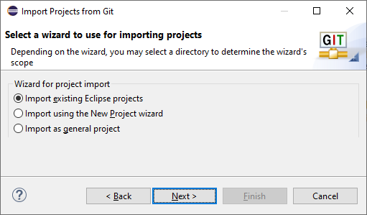
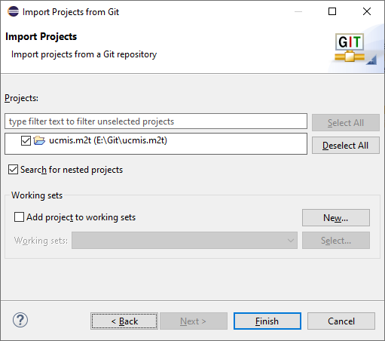
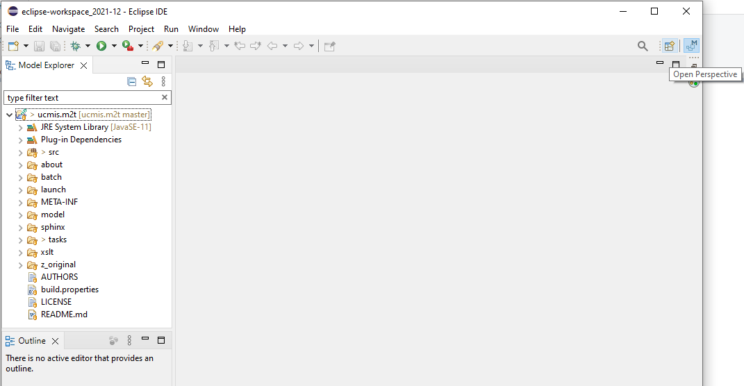
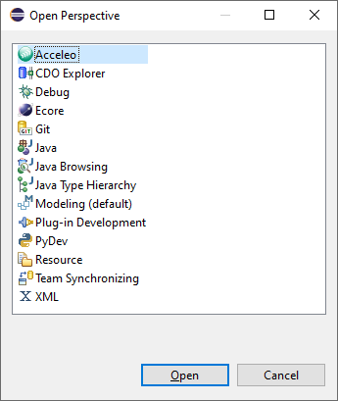
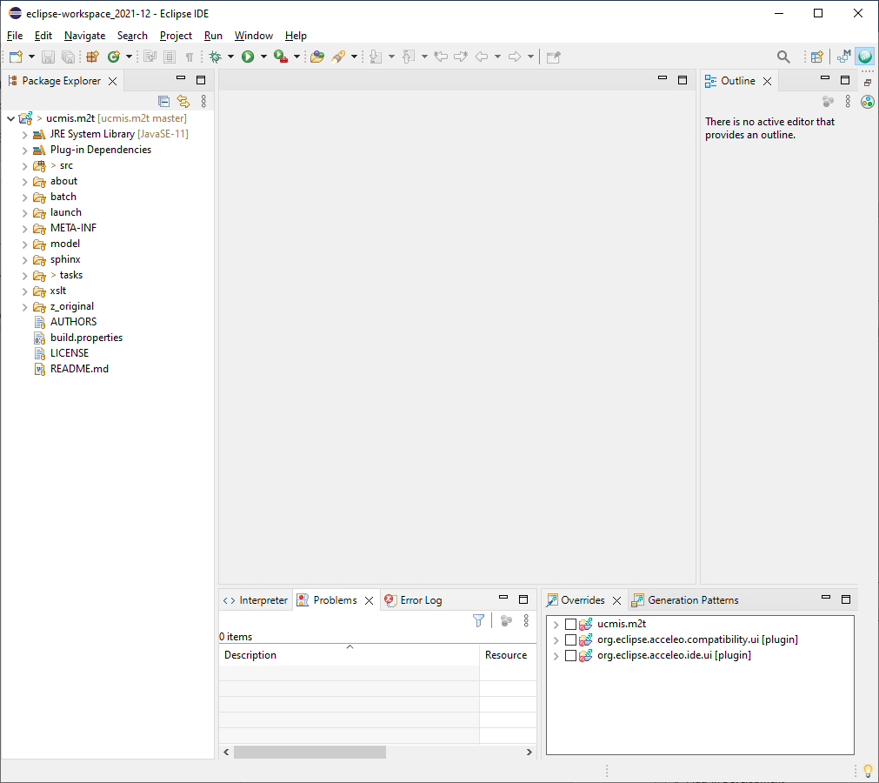

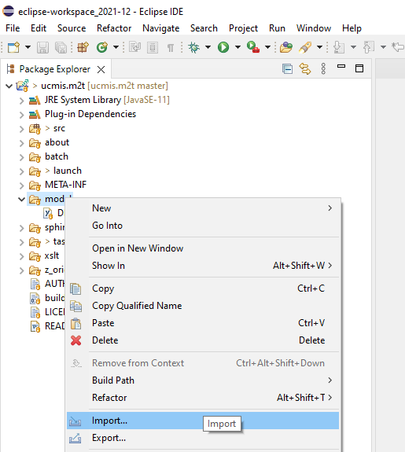
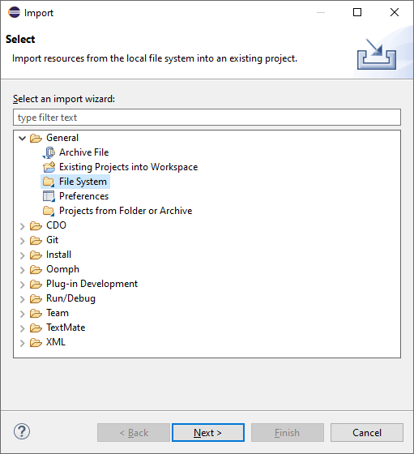
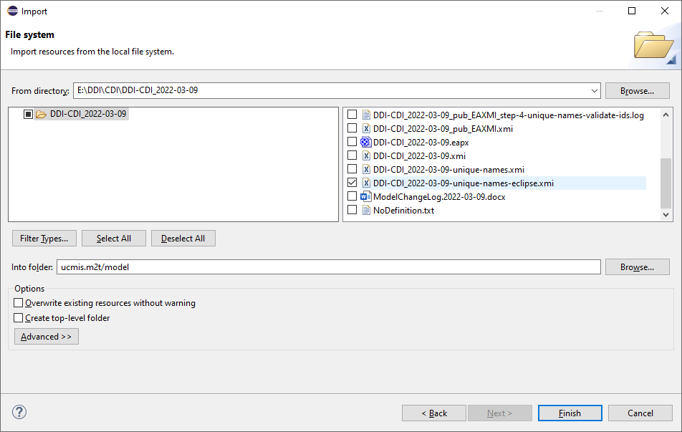
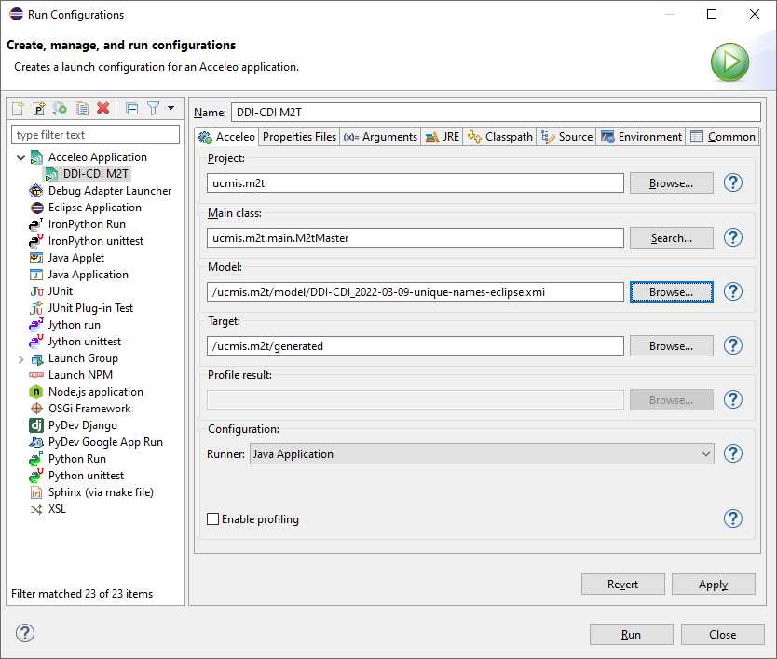
Windows > Show View > Other > Git > Git Staging
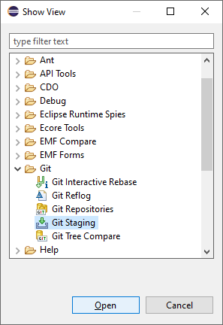
Drag ‘Git Staging’ to left bottom corner of main window.
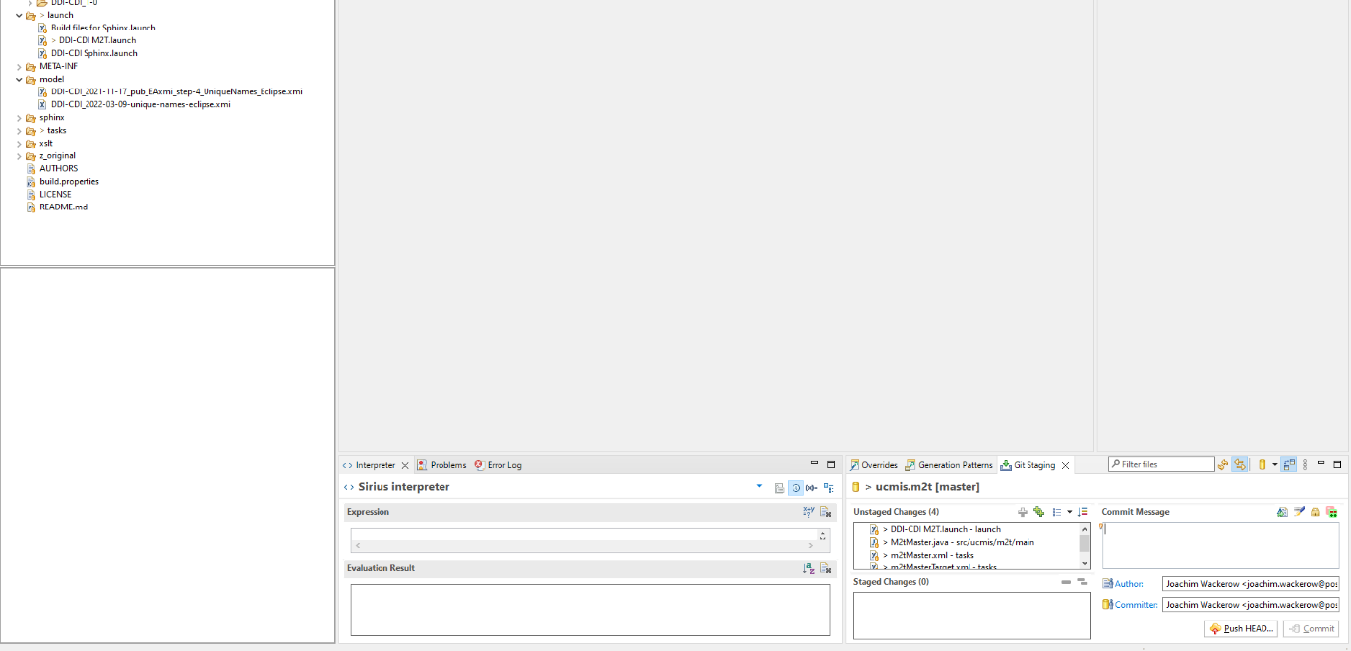
Git staging
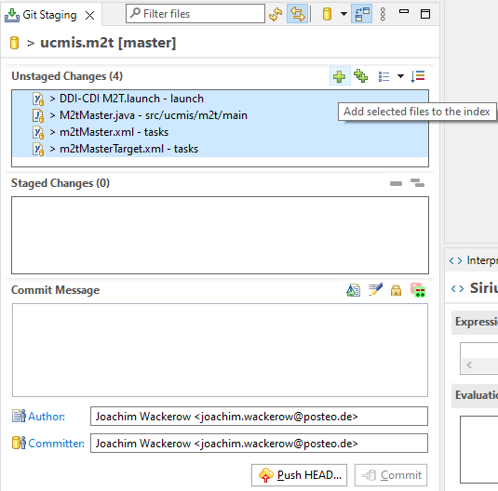
Git commit and push
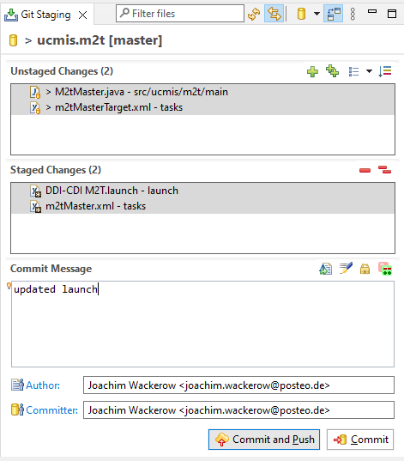

Graphviz: windows_10_cmake_Release_graphviz-install-3.0.0-win64.exe

python-3.10.2-amd64.exe
Installation of Python and extensions as administrator
Python 3, for all users, add to PATH
python.exe -m pip install --upgrade pip
pip install sphinx
pip install sphinxcontrib-contentui
pip install sphinxcontrib.plantuml
pip install sphinx_panels
pip install sphinx_rtd_theme
PlanUML put
C:\Programs\PlantUML\plantuml-1.2022.2.jar
Restart Eclipse (Python can then be found in PATH)

Sometimes this error occurs:
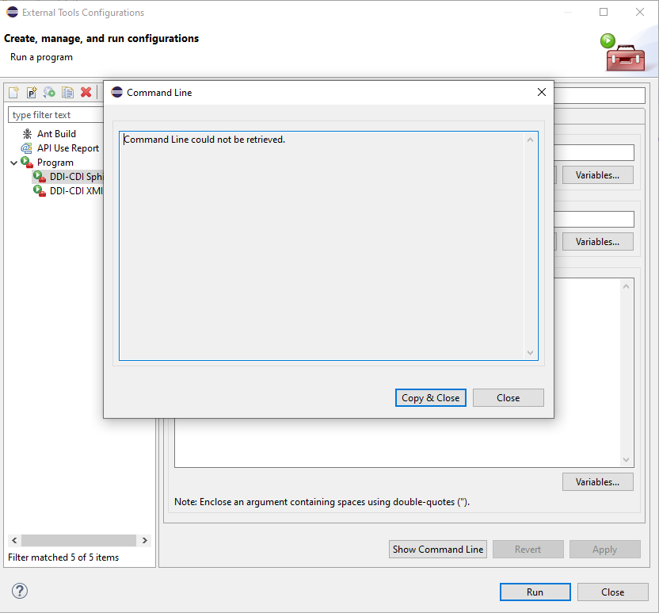
Solution: click on project root in package explorer and try again.

