The Cross-Domain Interoperability Framework (CDIF) DDI-CDI Data Description Profile
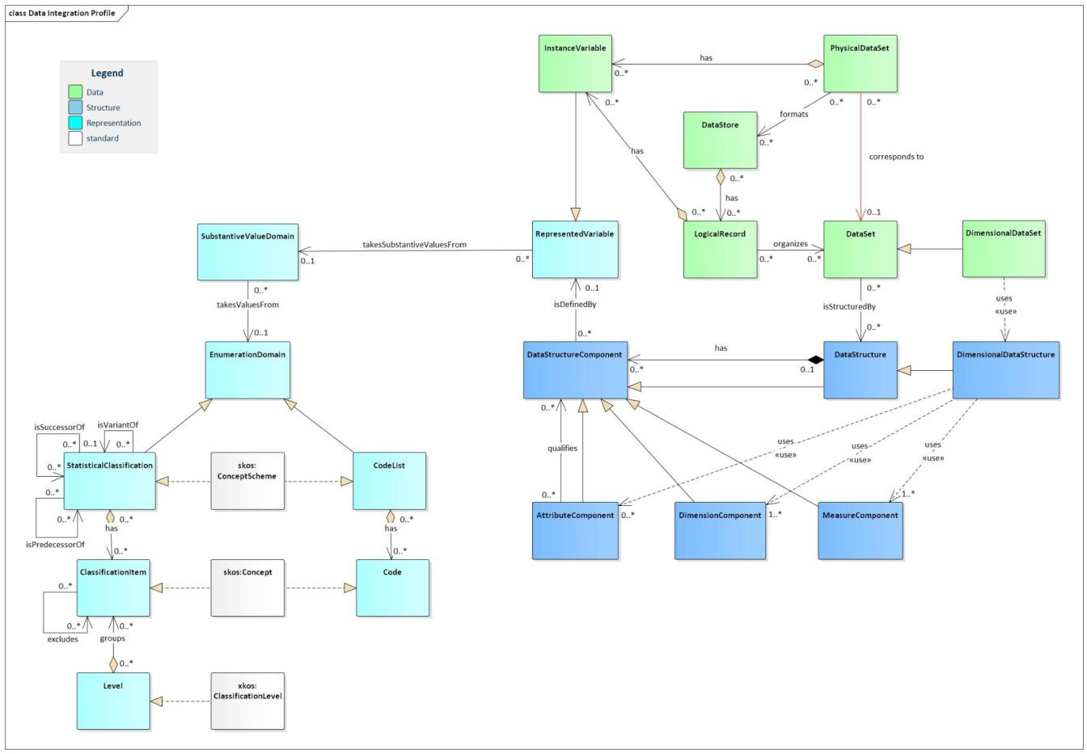
Figure 12. Prototype of a minimum DDI-CDI profile for data integration purposes.

Describing data to make it 'integration-ready'

CDIF data description steps
This section explains how to describe a data set or a service providing data so that it can be used for integration and similar purposes. CDIF uses a subset of the classes in the DDI-CDI specification to do this. We will introduce the classes needed for each step, with more detail provided on the full set of needed properties in Appendix 4.
For a data set — that is, a static set of data — there are four steps. For a service, where the structure and physical format of the data will depend on the service, the last two steps are not required.
The steps are:
- Describe the Data Set or Service;
- Describe the Variables;
- Describe the Data Structure;
- Describe the Physical Format of the Data.

        - Describe the data set or service
The class used here will depend on what is being described. For Data Sets, the cdi:DataSet class is used. For services — that is, queryable sources of data — the cdi:DataStore class is used. The difference between them is that a Data Set object in DDI-CDI is static, with a fixed set of records (similar to what is seen in DCAT for a Distribution), a Data Store is more flexible: while it always contains the same logical

records, their expression (and the set of units measured) may change. These can be seen in the diagram below:
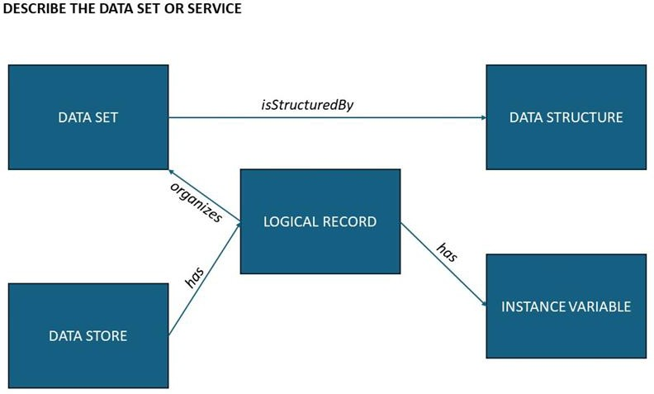

Figure 13. Describe data set or service.

A Data Set and a Data Store both have Logical Records: arrays of variables which make up the records in the data. The Logical Record has a set of Instance Variables, described more completely in the next step. These are the different fields which are used to hold the data (like the columns in a SQL table). A Logical Record is not a physical arrangement of the data – it is simply a set of related fields, all of which will potentially exist in a single record.
An additional class may be associated with the Logical Record if desired: a Population, Universe, or Unit Type may have an isDefinedBy association with it. These classes are concepts which can be used to associate the Logical Record with the thing it measures. The use of this class is always optional: we will describe these when we talk about variables, below.
A Data Set has a Structure, which can be described — a Data Store ( a ‘service’) does not have such a fixed structure, as this will generally be dependent on how it is queried. The Structure description varies according to what type of data set is being described — whether it is organised as a 'wide' table, as a ‘long’ stream of data, or as a cube. Each of these types of data structure will be described separately.
While not shown in this diagram, the variables will be used as ‘components’ in the description of the data structure. A component is the role played by a variable in the context of a specific data structure: it is an identifier? A measure? A descriptor? The use of components for different kinds of data structures is detailed for each type of data structure in turn, as these are discussed below.

        - Describe the variables
In order for data to be easily reused, it is important for both users and machines to have details about the variables themselves. In DDI-CDI, there are several types of variables, each performing a different function. (This is termed the ‘variable cascade’, and may be of interest, but is out of scope for our immediate purposes.) Only two of the DDI-CDI variables are used here: the cdi:InstanceVariable class and the cdi:RepresentedVariable class.
The Instance Variable is the variable as it is used in the context of a Data Set. The Represented Variable is a variable used as a template across multiple Data Sets or Data Stores. It is worth considering the value of providing this additional metadata around Represented Variables.
To describe a single data set, we do not need to provide information on Represented Variables - the fact that a variable is reused elsewhere is not necessary for someone to process the single data set.
However, in cases where a data set re-uses a variable to promote comparison between data sets, this becomes very important. In many scenarios, the same variable is used in many different data sets to provide a point of comparison or integration. A typical case is that of repeat data collection across time, where we want to take a series of measurements to produce a time series.
Often, although the measurements are identical, they are given different names for the purposes of data management, typically by appending the time of data collection (such as a year) or a number indicating the wave (e.g., a repeated measurement of education level might have variables
‘educ_level_95’, ‘educ_level_96’, ‘educ_level_97’, and so on). In such cases, a Represented Variable can be extremely useful because it indicates without any ambiguity that two variables are in fact the same. This information can be very valuable to users performing integration or harmonisation of the data, or producing their own times series from it.
The DDI-CDI model uses Represented Variables when describing structures, and for many other purposes, but uses Instance Variables when describing physical layout of the data records. This can seem confusing. In the DDI-CDI model, we can avoid the complexity of this arrangement, however, because according to the DDI-CDI model the Instance Variable is a sub-class of Represented Variable, meaning that any given Instance Variable can also be treated as a Represented Variable, and inherits all its associations and properties.
For our profile, Represented Variables are always optional. When present, they should be declared in addition to Instance Variables, and the Instance variables which are based on them should have a uses association declared with the corresponding Represented Variable. Their representations will always be the same. In the diagrams, Represented Variable is presented in grey, to indicate this special, optional status.
In the diagrams below, we always show the Instance Variable being used, as that is required. Note that if Represented Variables are present, these may be the ones which appear in the full DDI-CDI model, as for describing the representations of variables and their use as components in structures.
The diagram below shows the basic class structure for variables:

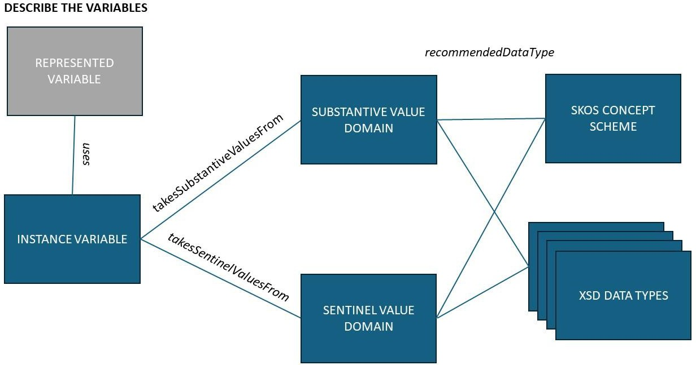

Figure 14. Basic class structure for variables.

Any given variable has a set of possible values, each of which comes from either a Substantive Value Domain (the meaningful values) or a Sentinel Value Domain (the flags for things like “missing” values). It is required to have an instance of the cdi:SubstantiveValueDomain class when describing a variable. It is not required to have an instance of the cdi:SentinelValueDomain class, although it is recommended if these are present in the data, as this enhances the practical reusability of the data. It is always the case that all possible values for the variable be described in one or the other of the value domains, however.
Both the Substantive Value Domain and the Sentinel Value Domain take their data types from either a reference to a skos:ConceptScheme (for enumerated values) or an XSD data type. The list below shows the valid XSD data types (XSD types available in RDF – see https://www.w3.org/2011/rdf-wg/wiki/XSD_Datatypes):
xsd:anyURI xsd:base64Binary xsd:boolean xsd:byte xsd:date

xsd:dateTime xsd:decimal xsd:double xsd:float xsd:gDay xsd:gMonth xsd:gMonthDay xsd:gYear xsd:gYearMonth xsd:hexBinary xsd:int xsd:integer xsd:language xsd:long xsd:Name xsd:NCName xsd:NMTOKEN
xsd:negativeInteger xsd:nonNegativeInteger xsd:nonPositiveInteger xsd:normalizedString xsd:positiveInteger xsd:short
xsd:string

xsd:time xsd:token xsd:unsignedByte xsd:unsignedInt xsd:unsignedLong xsd:unsignedShort
The definitions of variables are described in Appendix 4, below — these are provided as literal definitions but can also make reference to concepts defined elsewhere. Note that some variables may hold more complex values such as arrays. We do not cover this case in the current profile, but this is a subject which will be addressed in future.
It is also possible to instantiate classes which represent the subject of the data. This is possible at both the variable level and the Logical Record level. These classes include cdi:UnitType, cdi:Universe, and cdi:Population. A Unit Type is the most general class: it differentiates the top-level category of entity being observed, and is often implicit in the more-detailed classes (Universe and Population). Typical Unit Types are ‘person’, ‘organism’, ‘chemical compound’, ‘water’, and similar very broad categories. While conceptually always present, it is not always useful to describe these, as they are often implicit in the more-detailed (and more useful) Universe and Population descriptions. A Universe is a qualified Unit Type, but without specifics about time and place. For a Unit Type of ‘person’, I might have ‘student’ as a Universe. For a Unit Type of ‘organism’ I might have ‘dipterids’ as a Universe. A Population further qualifies the Universe by specifying time and place. These classes are instantiated with formal, textual definitions, which may be included as literal or by reference to an external source.
The diagram below shows how the variables and Logical Records can be associated with Unit Types, Universes, and Populations. The use of Unit Type, Universe, and Population is always optional, but may be useful, especially when variable-level searches are being made across broad sets of data for comparable measures on comparable populations.

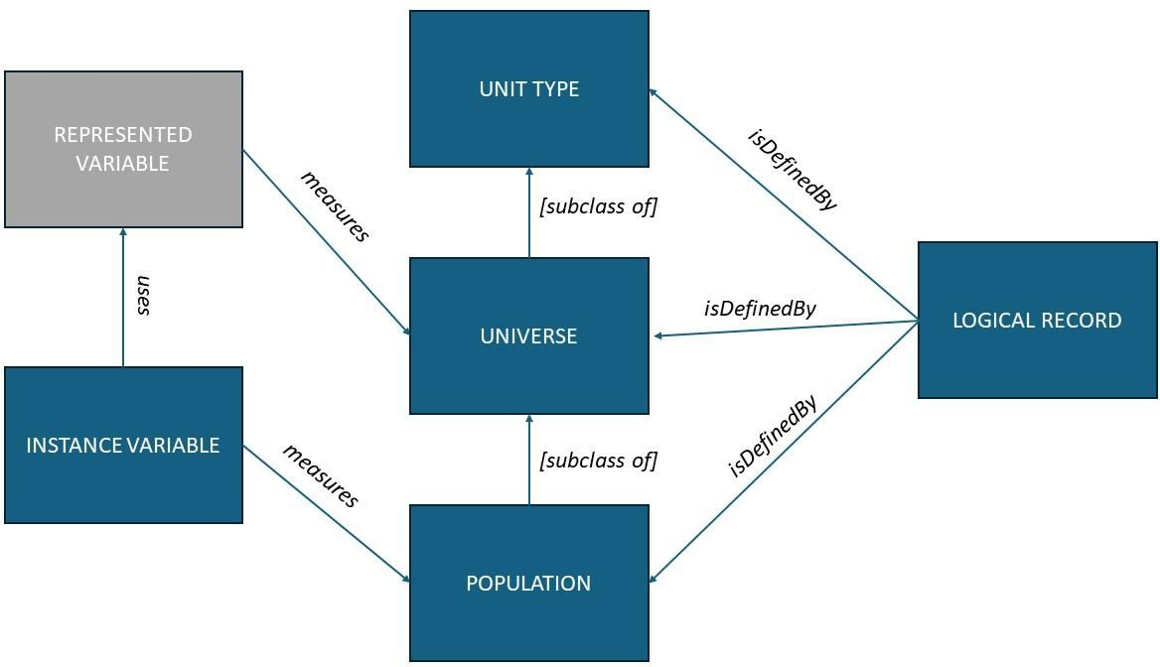

Figure 15. Unit, universe, and population.
        - Describe the data structure
For Data Sets (which always have a fixed structure – and these may include the results of querying services, with the Data Structure generated when the query is executed along with the resulting data), DDI-CDI gives us a model for describing the details. There are three types of Data Set: Wide, Long, and Dimensional. The descriptions of these are very similar, differing mainly in the way they identify specific data cells.
Variables are described separately from the Data Structure, because variables can be re-used across many different structures. I could, for example, have a ‘Nation’ variable which is always represented with a two-character ISO Country Code. This variable might be reused across a wide body of different data sets (think of data in the SDG Indicators and the Minimum Set of Gender Indicators - both have such a Country variable, and share some others, but are mostly different structures). The role of a variable within a specific Data Structure is represented by the cdi:Component class. There are several specific types of Components: identifiers, measures, attributes, and so on. These are described as appropriate for each of the three types of data structure.
Most data sets can be described as Wide Data Sets in DDI-CDI – these are those cases where each row in a tabular view of the data is a record, and each column is a single variable. (When in doubt, this is the place to start in most cases.) Long Data Sets are often seen in cases where there is a stream of data, and the measured values are accompanied by another field which tells you which type of measurement they are. This case is important, although probably less common. Dimensional Data Sets are ‘cubes’ where

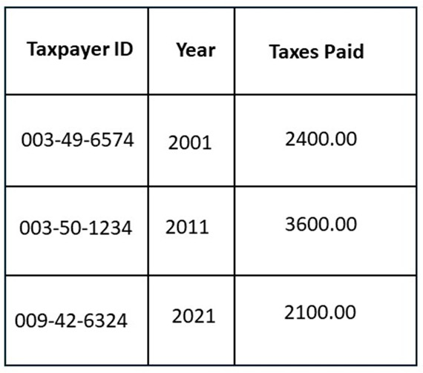
the data points are addressed with the coordinates of a matrix, along different dimensions. This is a very common case for aggregated data.

Wide Data Structures
To describe a Wide Data Structure, each variable (here we use Instance Variables, acting in their capacity as Represented Variables) is assigned as defining a specific type of Component. In Wide Data Structures, the only Component classes we need are Identifier Components (cdi:IdentifierComponent), Measure Components (cdi:MeasureComponent), and Attribute Components (cdi:AttributeComponent). The diagram below shows how these and other classes are related.
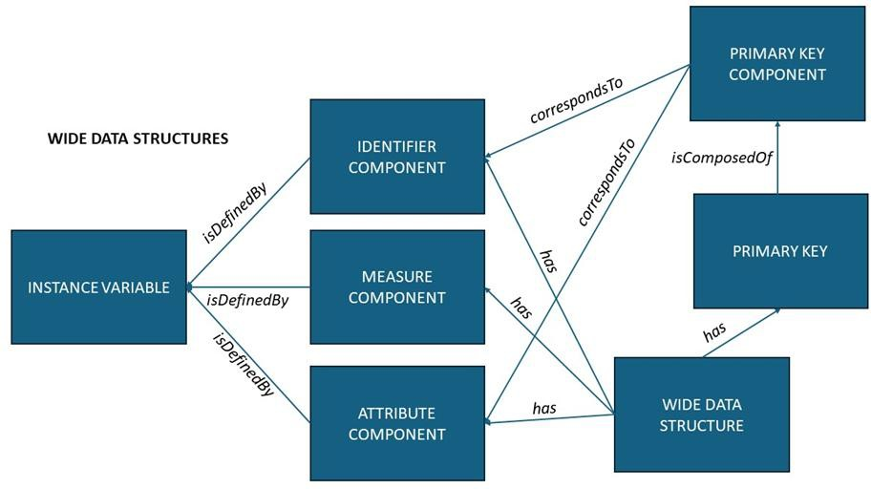

Figure 16. Wide data structures.

Measure Components hold the observed or measured values in our data. Identifier Components hold specific identifiers assigned to the cases in our data: each record is about a single ‘case’, and these are sometimes assigned identifiers to distinguish them.
As in the example provided to the right, this could be a tax-payer ID for a person, for example, or might be a randomly assigned number in the case where the cases have been anonymised to protect their identities.

It is sometimes the case that an identifier Component is sufficient to disambiguate all the records in the data set: Identifier indicating the row/case, and the variable telling you which value in that record.
Often, however, there will be additional fields which are needed (like a timestamp, in the case where the same case was measured/observed on more than one occasion). Attribute Components contain additional information about the measurements/observations which are applicable to each case. Typical Attribute Components are time stamps, geographical coordinates, statuses, or other data related to the context of the measurement or observation.
The Primary Key is the set of Components needed to uniquely identify each record in the data set. It is not typically the case that the Measure Components form part of the Primary Key.
Long vs. Wide Data Sets: If a Measure Component in a data set cannot be clearly associated with a single variable, but relies on the value of another variable to indicate which variable it measures, then you have a Long Data Set, and not a Wide one.
To illustrate the difference, some examples may be helpful. The table below is a simple example of a typical Wide Data Set:
Here, the Taxpayer ID is an Identifier Component (it gives the unique ID of each case), the Taxes Paid column is a Measure Component, and the Year is an attribute. If the cases are restricted to one entry per taxpayer, then the Primary Key will need only the Taxpayer ID field, but if (as is likely, given the need to pay taxes annually) there was more than one entry per taxpayer, then the Primary Key would also need to contain the Attribute Component Year. Compare this to the example in the Long Data Structures section below.

Long Data Structures
Long Data Sets are typically coming from sensors, administrative registers, or systems which contain
‘spell data’. These forms of data are structured differently than what we see in most SQL-based systems, and they have a different relationship to the logical contents of data.
A second example can help to illustrate the difference between Wide and Long Data Sets. Long Data Sets use additional Components, as they have a more complex relationship to logical variables.

The table to the right shows a simple Long Data Set. Here, we have an Identifier Component (Patient ID), a column giving us the test performed (Test), a column with a measurement (Reading), and a column with a unit of measure for the reading (UoM). The UoM column is an Attribute Component: each entry provides a value that represents a Unit of Measure, and we can easily describe a ‘Unit of Measure’

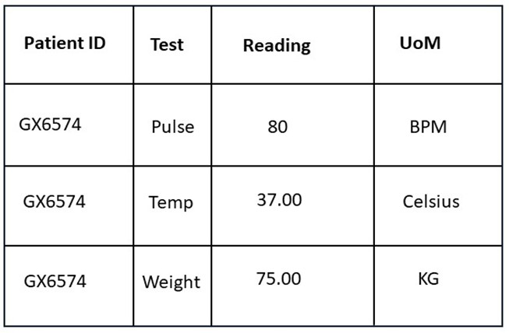
variable (even though that can be inherent in the definition of a variable as is often seen in data sets today.)
The Reading column is more problematic: each cell contains a measurement, but they are different types of measures. In order to understand the measurement, you have to consult the Test column, which tells you whether it is a pulse, a temperature, or a weight. This dependency is the characteristic feature of Long Data Sets.
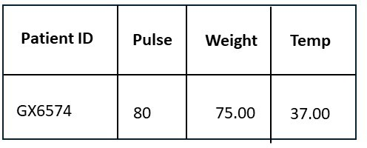
When we describe a Long Data Structure, it is important to distinguish between the logical content and the presentation of it. Consider this re-structuring of the information shown in the example to the right.
The values in the Test column have been broken out into separate columns which cleanly align with the measurements being taken, containing the values
formerly held in the Reading column. The UoM column is now part of the definition of each of these variables, and so does not need to be included here. Logically, however, this is the same data as that shown above. (This re-structuring is illustrative – we are not recommending that Long Data Sets be re-structured as Wide Data Sets for publication.)
In order to describe my Long Data Structure, I need to define the logical variables, as seen in this re-working of the table, so that each variable can have a single, ‘clean’ definition, containing a single type of measurement. Each becomes an Instance Variable in my metadata. I would then go back and identify the additional variables needed to support the original presentation of the data: the Test column, the Reading column, and the UoM column.
UoM would be described as an Instance Variable, but Test becomes a special type: a Descriptor Variable (cdi:DescriptorVariable), and Reading becomes a Reference Variable (cdi:ReferenceVariable), which is the name for a variable which combines measurement values from several logical Instance Variables.
These new types of presentational variables have different component types. The UoM column is still an Attribute Component, but the other columns introduce new ones: a Variable Descriptor Component (cdi:VariableDescriptorComponent), which is defined by a Descriptor Variable (Test), and a Variable Value Component (cdi:VariableValueComponent), which is defined by a Reference Variable (Reading).
Thus, my resulting metadata will have descriptions of both my logical (Patient ID, Pulse, Weight, Temperature) and presentational (Test, Reading, UoM) variables. The Components in my Long Data Structure would reference the presented variables: Patient ID (an Identifier Component), Test (a VariableDescriptorComponent), and Reading (a VariableValueComponent) but the logical variables in turn would all be referenced from the VariableDescriptorComponent and associated classes, as described below.

VariableDescriptorComponents have a refersTo association with a VariableValueComponent (in this case, Test will associate itself with Reading in this way).
Descriptor Variables – the only variables which act as Variable Descriptor Components – do not have the same type of representations as other variables. Instead, they will always take their values from a Descriptor Value Domain (cdi:DescriptorValueDomain). This is a class which associates with a set of Descriptors (cdi:Descriptor), which are codes that refer to logical Instance Variables using an identifies relationship. The code in the Descriptor Component indicates which Instance Variable the value provided in the corresponding Reference Variable should be associated with. Thus, in our example above, when the :Test” column has a value of ‘Temp’, we know that the value in the “Reading” field is a measurement of temperature, associated with the temperature logical variable.
Reference Variables always have a representation which is the super-set of the values of the variables for which they can hold measures. They are thus often declared as generic types such as XSD string. The specific types of any value can be determined from the description of the associated Instance Variable (the logical variable) and do not rely on the Reference Variable. Figure 17 shows how these new presentational classes are connected.
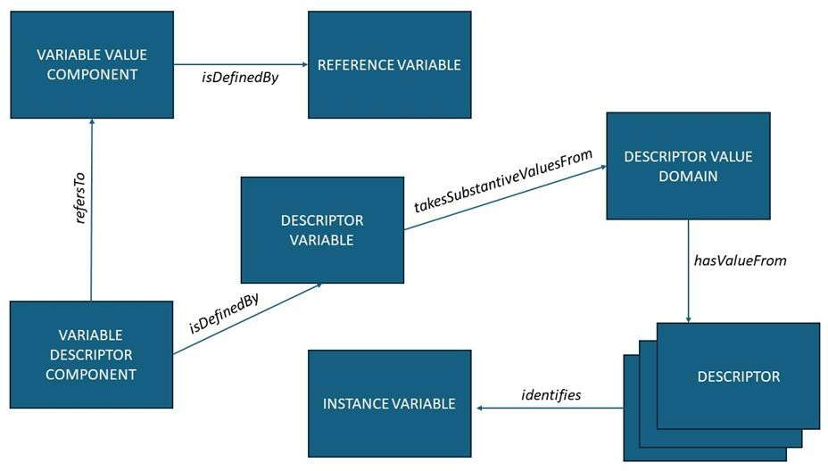

Figure 17. Long data structures - presentational elements.

The Primary key will be assembled from the presentational variables, however: in this case, a combination of the Patient ID and the Test.
The point of having this additional structural metadata for a Long Data Structure is that by providing logical Instance Variables, we are able to reassemble the values in the data set according to other structural arrangements (typically Wide or Dimensional), and to do so programmatically. Although we

could have described the example table as a Wide Data Set, the actual variables in the data could not then be re-arranged or re-used: they would be specific to the structure of the data set they appeared in.

Dimensional Data Structures
Dimensional Data Sets have a Dimensional Data Structure which is similar to the Wide Data Structure, but has a different kind of Primary Key. The diagram below shows the set of classes which are needed.
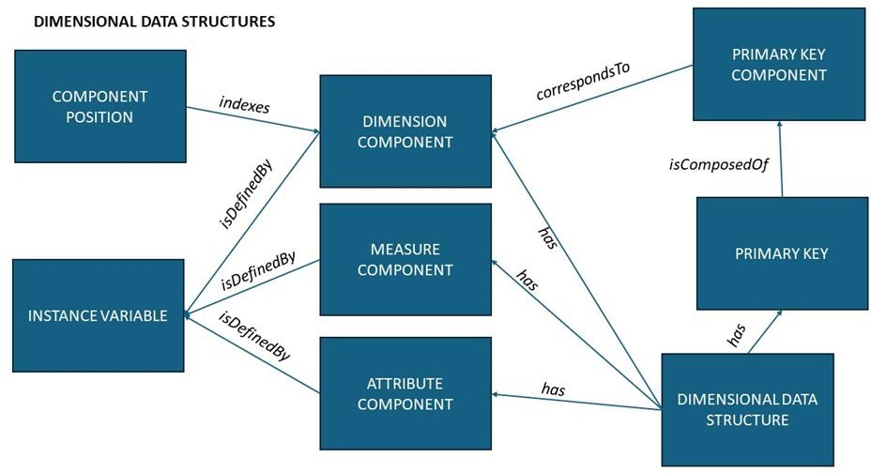

Figure 18. Multidimensional data structures.

In describing a Dimensional Data Structure, our Primary Key is only made up of Dimension Components. Taken together, these address not an entire record, but an individual cell with a cube – a multi-dimensional matrix. That cell holds the value of the Measure Component. Attribute Components are associated with the Measures at the cell level, not at the level of an entire record.
The exception to this is if a ‘cell’ has more than one Measure Component, in which case the set of Measure Components requires further disambiguation. This can be specified by qualifying the Primary Key values with the Measure Component/Variable. (It is recommended that only a single Measure Component be used if practical — cells should, if possible, hold simple values such as a string/code, a date-time, or a number.)
In some cases — notably in the DataCube Vocabulary from W3C and the SDMX specifications on which it is based — the dimensions in a key are ordered. In DDI-CDI, specifying an order is done using the Component Position (cdi:ComponentPosition) class. (In fact, you are always allowed to use

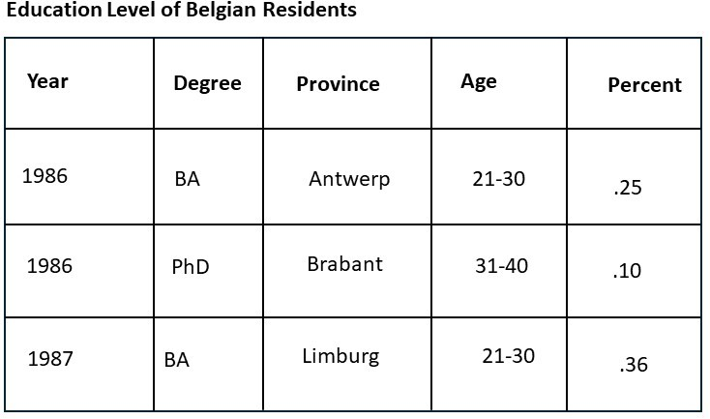
cdi:ComponentPosition for any type of Data Structure, but in this profile we only recommend it for Dimensional Data.)
The table, ‘Education Level of Belgian Residents’, provides a simple example of a Dimensional Data Set, and how its structure can be described.
In this example, the first four columns act as dimensions for addressing the value given in the last column. There would be five Instance Variables described: Year, Degree, Province, Age, and Percent. The representations of these variables would be enumerated using SKOS Concept
Schemes (see above) except for Year, which would be an XSD gYear, and the Percent variable, which would have a numeric type.
Year, Degree, Province, and Age would all be used to define Dimension Components, which could be indexed using instances of the Component Position class, assigning them a ranking from 1 to 4 (ordered low-to-high). Taken together, these four Dimension Components would form the Primary Key. Percent would be a Measure Component.

Notes on Data Structures and reuse
It is evident that many different types of Components are shared between different Data Structures. It is important to understand that although this is true – and that any given set of data may be organised according to more than one type of Data Structure, the instances of Components themselves are not reusable by definition. A Component is the specific role played by a variable in the context of a data structure. Each Component appearing in a Data Structure is specific to that Data Structure, and should have its own identity. The variables are the reusable form of the information in describing the same thing used across different structures.
Remember, too, that while the DDI-CDI model uses Represented Variables – the reusable part of a variable description – in modelling Data Structures, for the purposes of CDIF we rely on the fact that Instance Variables are a subclass of Represented Variables, and can thus be used as Represented Variables. (This is expressed with the rdf:instanceOf relationship on the instances of cdi:InstanceVariable – see Appendix 4, below.)

Describe the physical format of the data
DDI-CDI separates the logical and physical organisation of data. The way that data is stored in a system or recorded in a file has no necessary relationship to the way in which the data is logically structured.
In this initial version of CDIF, we are only describing data that is expressed in a textual format such as a CSV file, fixed-width tabular files, or the query result from a relational system. (This is a limitation which

will be addressed moving forward.) Further, the assumption is made that any Data Set uses only one structure for all of its records, and that these are organised in a uniform way.
These recommendations pertain to data that can be represented in a tabular data structure, packaged in datasets that consist of a set of records that all have the same set of fields. Figure 19 shows the classes which are needed for describing the physical encoding of the data.
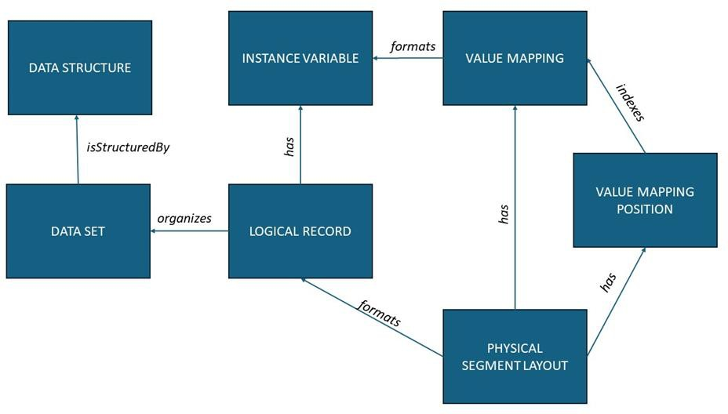

Figure 19. Describing physical layouts.

The Logical Record (cdi:LogicalRecord) references all of the Instance variables used within the Data Set. A Physical Segment Layout (cdi:PhysicalSegementLayout) describes the way in which that Logical Record is expressed in the physical file. It has a set of Value Mappings (cdi:valueMapping) instances and corresponding Value Mapping Position (cdi:ValueMappingPosition) instances, which provide the links between the physical layout and the values of the Instance Variables. Physical Segment Layout instances contain much of the information needed by machines to read the data (i.e., character encodings, delimiters, line-end characters, etc.).
(Note that the formats relationship between Value Mapping and Instance Variable has been collapsed from what is presented in the DDI-CDI model by omitting the intervening Data Point, as Data Points are not instantiated in this profile.)

Describing the integration of data sets
This version of the CDIF recommendations does not contain a full profile for the description of data integration, but this topic has received a lot of attention from the working group. An exploration into different data integration scenarios has been conducted, notably an effort to integrate data from ILO,

the World Health Organization (WHO), and the SDG Indicators, with a goal of publishing this data into Google Data Commons and the knowledge graph model used there. This work is on-going, but it has demonstrated the set of metadata needed to fully describe a data integration.
This set of metadata requirements can be summarised as follows, based on the assumption that there is access to the data being integrated:
- Detailed data description (variable-level)
- Structural metadata of the data sets
- Enumerated values (codelists and classifications)
- Mappings between sets of enumerated values
- Processing description, indicating how mappings were implemented in transformations, and what other operations were performed for data integration
While this seems like a daunting set of information, the exploratory work has shown that if the metadata are available in a sufficiently detailed form, then the actual integration itself is straightforward.

Appendix 4. Metadata for making data ‘integration-ready’: DDI-CDI classes and properties
This appendix lists the classes discussed in the text above, and indicates which properties must or may be used when these classes are instantiated.
It should be noted that while the Data Set and Data Structure classes appear in the DDI-CDI model, and are used in the diagrams above, these are never directly instantiated. Instead, their sub-classes will be used: Wide Data Set/Wide Data Structure, Long Data Set/Long Data Structure, and Dimensional Data Set/Dimensional Data Structure. For this reason, Data Set and Data Structure are not listed here.
The identifiers of each metadata declaration (or instance) are assumed to be the URI used in the JSON-LD. If other identifiers are to be associated with the instances, all of the classes listed can also use an identifier property as per the DDI-CDI specification. This is not required, however, as it is assumed that consumers of CDIF metadata will typically not be interested in non-public identifiers of this type.

Properties and associations are listed as “Required” or “Optional”, followed by “Multiple” if more than one is allowed. Language-specific strings are allowed to be multiple, specific to language-locale pairs, using language maps as described in Example 71 of the JSON-LD specification¹².
All metadata instances will have @type referencing the DDI-CDI class, given in the “Type” field. Some instances will declare multiple types where appropriate. The classes are grouped by type, largely in the order they are mentioned in the steps above.
Note that associations and properties are distinct in DDI-CDI, because it is based on a UML formalisation where such a distinction is important (associations never link to literal values). They are listed separately here, for ease of reference to the DDI-CDI documentation.

Data Store
This represents a queryable service.
Type: cdi:DataStore
Properties:
name (Required) – a string assigning a name to the service. More complete description of the service can be provided using the fields in the CDIF Discovery recommendations.
Associations:
has (Required, Multiple) – links the Data Store to a Logical Record.

Logical Record
This describes the set of variables available in the service or data set at a logical level.

Type: cdi:LogicalRecord

Properties:
None.

Associations:
- organizes (Optional, Multiple) – points to a Wide Data Set, Long Data Set, or Dimensional Data Set.
- has (Required, Multiple) – points to the Instance Variables making up the Logical Record.

- isDefinedBy (Optional, Multiple) – points to a Unit Type, Universe, or Population which provides a description of the subject of the Logical Record.

Wide Data Set
This represents a data set where each row in the table is a record, holding a set of values for variables, represented by columns.

- https://w3c.github.io/json-ld-syntax/#string-internationalization

Type: cdi:WideDataSet, cdi:PhysicalDataSet

Properties:
  - name (Required) – a string value holding the name of the data set. May be provided in multiple, language-specific versions.
  - physicalFileName (Required) - a URL providing the location of the data set.

Associations:
  - isStructuredBy (Required) – points to an instance of cdi:WideDataStructure describing the structure of the data set.

Long Data Set
This represents a data set where each row in the table is one or more measurements, with another column for each measure in the row that indicates which logical variable is being measured. The variable being measured is specified for each row, and can vary from row to row.
Type: cdi:LongDataSet, cdi:PhysicalDataSet

Properties:
  - name (Required) – a string value holding the name of the data set. May be provided in multiple, language-specific versions.
  - physicalFileName (Required) - a URL providing the location of the data set.

Associations:

  - isStructuredBy (Required) – points to an instance of cdi:LongDataStructure describing the structure of the data set.

Dimensional Data Set
This represents a data set where each measurement and associated attributes are defined by a set of dimensions. The data set can be understood as a “cube”. (See the DDI-CDI documentation for a more complete description.)
Type: cdi:DimensionalDataSet, cdi:PhysicalDataSet

Properties:

  - name (Required) – a string value holding the name of the data set. May be provided in multiple, language-specific versions.
  - physicalFileName (Required) - a URL providing the location of the data set.

Associations:

  - isStructuredBy (Required) – points to an instance of cdi:DimensionalDataStructure describing the structure of the data set.

Wide Data Structure
This is a description of the structure of a Wide Data Set.

Type: cdi:WideDataStructure

Properties:

  - None.

Associations:

  - has (Required) – Points to the cdi:PrimaryKey used to identify records in the data set.

  - has (Required, Multiple) – References the components (variables) which make up the records: links to cdi:IdentifierComponent, cdi:AttributeComponent, cdi:MeasureComponent.

Long Data Structure
This is a description of the structure of a Long Data Set.

Type: cdi:LongDataStructure

Properties:

  - None.

Associations:

  - has (Required) – Points to the cdi:PrimaryKey used to identify records in the data set.

  - has (Required, Multiple) – References the components (variables) which make up the records: links to cdi:IdentifierComponent, cdi:AttributeComponent, cdi:MeasureComponent, cdi:DescriptorComponent, cdi:VariableValueComponent. Note that the components describe only the variables which are part of the presentation of the data set - other purely logical variables are referenced from the LogicalRecord associated with the Long Data Set and its components (see above).

Dimensional Data Structure
This is a description of the structure of a Dimensional Data Set.

Type: cdi:DimensionalDataStructure

Properties:

  - None.

Associations:

  - has (Required) – Points to the cdi:PrimaryKey used to identify records in the data set, made up of a set of cdi:DimensionComponents.
  - has (Required, Multiple) – References the components (variables) which make up the records: links to cdi:DimensionComponent, cdi:AttributeComponent, cdi:MeasureComponent.
  - has (Optional, Multiple) – Points to the cdi:ComponentPosition instances used to order the instances of cdi:DimensionComponent when the Primary Key is ordered.

Instance Variable
This represents a variable used in a data set. The full set of logical variables must always be described, so that every value in the data set is accounted for.
Type: cdi:InstanceVariable, cdi:RepresentedVariable [only if Represented Variables are not instantiated separately]

Properties:

  - name (Required) – a string value holding the name of the variable. May be provided in multiple, language-specific versions.
  - definition (Required) – a string value holding the definition of the variable. May be provided in multiple, language-specific versions.
  - describedUnitOfMeasure (Optional) - a specification of the UOM, specified according to the
“defined term” implementation pattern specified in Appendix 1.

  - unitOfMeasureKind (Optional) - a specification of the quantity-kind for the UOM, specified
according to the “defined term” implementation pattern specified in Appendix 1.

Associations:

  - measures (Optional) – a link to an instance of cdi:Population.

  - takesSubstantiveValuesFrom (Required) - a link to an instance of cdi:EnumeratedValueDomain, which in turn provides information about the typing of the recorded values for the variable.

  - takesSentinelValuesFrom (Optional) - a link to an instance of cdi:SentinelvalueDomain, which in turn provides information about how flags, missing values, and similar notations are typed in the variable.

Represented Variable
This represents a reusable variable description.

Type: cdi:RepresentedVariable

Properties:

  - name (Required) – a string value holding the name of the variable. May be provided in multiple, language-specific versions.
  - definition (Required) – a string value holding the definition of the variable. May be provided in multiple, language-specific versions.
  - describedUnitOfMeasure (Optional) - a specification of the UOM, specified according to the
“defined term” implementation pattern specified in Appendix 1.

  - unitOfMeasureKind (Optional) - a specification of the quantity-kind for the UOM, specified
according to the “defined term” implementation pattern specified in Appendix 1.

Associations:

  - measures (Optional) – a link to an instance of cdi:Universe.

  - takesSubstantiveValuesFrom (Required) - a link to an instance of cdi:SubstantiveValueDomain, which in turn provides information about the typing of the recorded values for the variable.
  - takesSentinelValuesFrom (Optional) - a link to an instance of cdi:SentinelvalueDomain, which in turn provides information about how flags, missing values, and similar notations are typed in the variable.

Reference Variable
Reference Variables are presentational variables used only in the description of Long Data Sets. They contain values from the set of logical variables held in the data, and must have a representation which supports the full range of possible values from them.
Type: cdi:ReferenceVariable

Properties:

  - Name (Required) – a string value holding the name of the variable. May be provided in multiple, language-specific versions.

Associations:

  - takesSubstantiveValuesFrom (Required) - a link to an instance of cdi:SubstantiveValueDomain, which in turn provides information about the typing of the recorded values for the variable.
  - takesSentinelValuesFrom (Optional) - a link to an instance of cdi:SentinelvalueDomain, which in turn provides information about how flags, missing values, and similar notations are typed in the variable.

Descriptor Variable
Descriptor Variables hold values which reference the logical variables in the data set, indicating which one the associated value in the corresponding Reference Variable is a measure/value for. Descriptor Variables are presentational variables found only in Long Data Sets.
Type: cdi:DescriptorVariable

Properties:

  - Name (Required) – a string value holding the name of the variable. May be provided in multiple, language-specific versions.

Associations:

  - takesSubstantiveValuesFrom (Required) - a link to an instance of cdi:DescriptorValueDomain, which in turn provides information about logical variables to which each enumerated value corresponds, using the cdi:Descriptor class.

Substantive Value Domain
Substantive values reflect the definition of the variable which they populate, as opposed to being an
indication of a process or system status (“missing,” etc.). They may be enumerated or otherwise typed.

Type: cdi:SubstantiveValueDomain

Properties:

  - None.

Associations:

  - recommendedDataType (Required) - provides a link either to a skos:ConceptScheme (for enumerated values) or an XSD data type (see list in the text above). This describes the datatype of the values permitted as valid for populating the fields described by the variable.

Sentinel Value Domain
Sentinel values are those which indicate some process or system status or value which is not directly meaningful in terms of the variable definition of the field they populate. A typical example is flags for missing values.
Type: cdi:SentinelValueDomain

Properties:

  - None.

Associations:

  - recommendedDataType (Required) - provides a link either to a skos:ConceptScheme (for enumerated values) or an XSD data type (see list in the text above). This describes the datatype of the sentinel values permitted as valid for populating the fields described by the variable.

Descriptor Value Domain
This provides a list of instances of the Descriptor class, connecting the values found in a Long Data Set’s
Descriptor Variable with the logical variables for which values are provided in the Reference Variable.

Type: cdi:DescriptorValueDomain

Properties:

  - None.

Associations:

  - None.

Descriptor
An instance of the cdi: Descriptor class

Type: cdi:Descriptor

Properties:

  - content (Required) - the value appearing in the Long Data Set, expressed as a string.

Associations:

  - identifies (Required) – reference to the cdi:InstanceVariable which corresponds to the content
property.

Unity Type
A Unit Type is the object or phenomenon serving as the subject of a data record, identified at a general level. If the values in a data set are “Age,” “Sex”, and “Occupation” the Unit Type would be “person”. If the values are a measure of salinity and depth, the Unit Type might be “sea water”. The value of an instance of cdi:UnitType is the general term for the unifying subject of a data record (an instance of cdi:LogicalRecord).
Type: cdi:UnitType

Properties:

  - name (Required) – a string value holding the name of the variable. May be provided in multiple, language-specific versions.
  - descriptiveText (Optional) – a textual description of the Unit Type. May be provided in multiple, language-specific versions.

Associations:

  - None.

Universe
An instance of cdi:Universe qualifies a Unit Type, to provide a more-specific description of the subject of the data, but excluding time and geography. If the Unit Type is “person,” the Universe might be “adults”. If the Unit Type is “sea water,” the Universe might be “sea water in temperate oceans”.
Type: cdi:Universe

Properties:

  - name (Required) – a string value holding the name of the variable. May be provided in multiple, language-specific versions.
  - descriptiveText (Optional) – a textual description of the Unit Type. May be provided in multiple, language-specific versions.

Associations:

  - uses (Optional) – a reference to the instance of cdi:UnitType which the Universe qualifies.

Population
This is a fully qualified description of the subject of the data in a field or record. It extends the description provided by Unit Type and Universe by adding geographical and temporal bounds.
Type: cdi:Population

Properties:

  - name (Required) – a string value holding the name of the variable. May be provided in multiple, language-specific versions.
  - descriptiveText (Optional) – a textual description of the Unit Type. May be provided in multiple, language-specific versions.

Associations:

  - uses (Optional, 2 Maximum) – a reference to the instance of cdi:Universe and/or cdi:UnitType which the Universe qualifies.

Identifier Component
The instance of cdi:IdentifierComponent is a reference to a variable which provides a unique identifier for the case being observed in the Logical Record. It is typically an assigned or official identifier for the unit, according to an external scheme (e.g., a taxpayer ID for a person, a sample identifier, etc.). The Identifier Component is a role attached to the variable to describe its function within the data structure
- it is usually part of (and may be the entire) key for the record.

Type: cdi:IdentifierComponent

Properties:

  - None.

Associations:

  - isDefinedBy (Required) – A reference to an instance of cdi:InstanceVariable (or, if present, cdi:RepresentedVariable) which defines the Identifier Component variable.

Measure Component
The instance of cdi:MeasureComponent indicates that the referenced variable contains a measurement or observation value, or a derived value, within the Logical Record. Bote that cdi:MeasureComponent

might be a simple value (string, number, term), or an object (e.g. an array of spectral values). For this profile, we are restricting discussion to simple values.
Type: cdi:MeasureComponent

Properties:

  - None.

Associations:

  - isDefinedBy (Required) – A reference to an instance of cdi:InstanceVariable (or, if present, cdi:RepresentedVariable) which defines the Measure Component variable.

Attribute Component
Each instance of cdi”AttributeComponent indicates that the referenced variable holds a value which describes the values in the Measure Components or otherwise provides information which is not itself a measure/observation or derived value.
Type: cdi:AttributeComponent

Properties:

  - None.

Associations:

  - isDefinedBy (Required) – A reference to an instance of cdi:InstanceVariable (or, if present, cdi:RepresentedVariable) which defines the Attribute Component variable.

Dimension Component
The instances of cdi:DimensionComponent are references to the variables which are the components of a compound identifier, in which each variable is a single field - an axis - in a coordinate system addressing a location in a matrix. These variables are often categorical, but also commonly include time. Unlike other Components, they may be ordered using instances of cdi:ComponentPosition.
Type: cdi:DimensionComponent

Properties:

  - None.

Associations:

  - isDefinedBy (Required) – A reference to an instance of cdi:InstanceVariable (or, if present, cdi:RepresentedVariable) which defines the Attribute Component variable.

Component Position
Each instance of cdi:ComponentPosition indexes a Dimension Component within the Primary Key of a Dimensional Data Structure, by assigning an incrementing value to it (lowest number comes first in the sequence).
Type: cdi:ComponentPosition

Properties:
  - value (Required) - An integer indicating the position of the Dimension Component within the sequence of the Primary key for the referencing Dimensional Data Structure.

Associations:
  - indexes (Required) – a reference to the instance of cdi:DimensionComponent which is being ordered. Assigns the value to it as a position within the Primary Key.

Primary Key
The instance of Primary Key defines the set of Components which, taken together, provide the identifying values for a single logical record within a data structure. The values of the Primary Key are used to reference the non-Primary Key fields within the Logical Record, by additionally specifying the Component/Instance Variable wanted. Such fields include the Measure Components and non-identifying Attribute Components.
Type: cdi:PrimaryKey

Properties:

  - None.

Associations:

  - isComposedOf (Required, Multiple) – References to the instances of cdi:PrimaryKeyComponent making up the Primary Key.

Primary Key Component
Instances of cdi:PrimaryKeyComponent reference the Components which make up the primary Key in a Data Structure.
Type: cdi:PrimaryKeyComponent

Properties:

  - None.

Associations:

  - correspondsTo (Required) – A reference to the instance of cdi:IdentifierComponent, cdi:AttributeComponent, cdi:DimensionComponent, or cdi:VariableDescriptorComponent used as a Primary Key Component.

Variable Value Component
Each instance of a cdi:VariableValueComponent points to a Reference Variable, which holds the values of several logical variables combined into a single field within a Long Data Structure. This Component is part of a presentational structure, as opposed to a logical one.
Type: cdi:VariableValueComponent

Properties:

  - None.

Associations:

  - isDefinedBy (Required) – A reference to an instance of cdi:ReferenceVariable.

Variable Descriptor Component
Instances of cdi:VariableDescriptorComponent are fields in a Long Data Structure which indicate the logical variable with which the value of the Variable Value Component/Reference Variable are associated.
Type: cdi:VariableDescriptorComponent

Properties:

  - None.

Associations:

  - refersTo (Required) – A reference to an instance of cdi:DescriptorVariable.

Physical Segment Layout
Each instance of cdi:PhysicalSegmentLayout describes the physical expression of a record in a data file or other storage expressed as a textual format. The Logical Record encoded is referenced. There is only a

single Physical Segment Layout used to describe data files - all records are assumed to have the same layout.
Type: cdi:PhysicalSegmentLayout

Properties:

  - arrayBase (Optional) - This is a literal value of either “0” or “1” indicating the starting number for the sequence of variables in the record as indexed by instances of cdi:ValueMappingPosition for each variable.
  - commentPrefix (Optional) - A string used to indicate that a line in the input is a comment.

  - delimiter (Optional) - The character used to separate fields in a delimited file (for example, the comma in a CSV file),
  - encoding (Required) - A string specifying the character encoding (typically UTF-8). Values are the same as those used for the HTML charset attribute.¹³
  - escapeCharacter (Optional) - Provides the string which is used to escape the quote character.

  - hasHeader (Optional) - A boolean value indicated as “true” or “false” (case sensitive) which indicates that the number of initial rows in headerRowCount should be skipped, as they do not contain data values.
  - headerRowCount (Optional) - An integer which indicates now many initial rows to skip as containing header information. Only used if hasHeader has a value of “true”.
  - isDelimited (Optional) - A boolean value indicated as “true” or “false” (case sensitive) which says whether the file is delimited. If “true”, then the delimiter property will provide the delimiter. If “true” then isFixedWidth must have a value of “false” if provided.
  - isFixedWidth (Optional) - A boolean value indicated as “true” or “false” (case sensitive) which
says whether the file has fixed-width fields. If “true” then isDelimited must have a value of
“false” if provided. The starting and ending positions of each field are provided by the instances of cdi:ValueMapping associated with each variable in the record, in relation to the arrayBase property.
  - lineTerminator (Optional) - The character sequence used to terminate rows. Defaults to the array [CRLF, LF] as per the Metadata Vocabulary for Tabular Data.¹⁴

13 See https://www.w3schools.com/html/html_charset.asp.
- https://www.w3.org/TR/tabular-metadata/

  - quoteChatacter (Optional) - The string that is used around escaped cells, or null, set by the quoteChar property of a dialect description. The default is “.”. See W3C Recommendation “Model for Tabular Data and Metadata on the Web”.¹⁵
  - skipInitialSpace (Optional) - A boolean value expressed as “true” or “false” (case-sensitive) indicating that - if “true” - white space at the beginning of a row or following a delimiter should be ignored.
  - trim (Optional) - This field takes the values “Both”, “End”, “Neither”, and “Start” describing the places where white space can be trimmed from rows. Default is “Neither”.

Associations:

  - Formats (Required) - specifies an instance of cdi:LogicalRecord.

  - has (Required, Multiple) – A reference to an instance of cdi:ValueMapping.

  - has (Required, Multiple) - A reference to an instance of cdi:ValueMappingPosition, one per Value Mapping.

Value Mapping
Instances of cdi:ValueMapping are used to indicate the connection of variables with a Physical Segment layout.
Type: cdi:ValueMapping

Properties:

  - decimalPositions (Optional) - An integer indicating the number of decimal positions when the decimal separator is implied.
  - defaultDecimalSeparator (Optional) - A string providing the character used as a decimal separator.
  - length (Optional) - An integer specifying the length of a fixed-width field.

  - maximumLength (Optional) - An integer indicating the maximum length of the field value.

  - minimumLength (Optional) - An integer expressing the maximum length of the field value

Associations:

- https://www.w3.org/TR/tabular-data-model/#parsing

  - formats (Required) - specifies an instance of cdi:InstanceVariable, cdi:RepresentedVariable, cdi:ReferenceVariable, ot cdi:DescriptorVariable.

Value Mapping Position
Instance of cdi:ValueMappingPosition provides the sequence of the mapped variables within the Physical Segment Layout.
Type: cdi:ValueMappingPosition

Properties:

  - value (Required) – An integer indicating the relative position of the mapped variable in the sequence of the Physical Segment Layout. Uses the arrayBase property of the Physical Record Segment as a starting point.

Associations:

  - indexes (Required) – A reference to an instance of cdi:ValueMapping

