Croissant, Graphs and AI
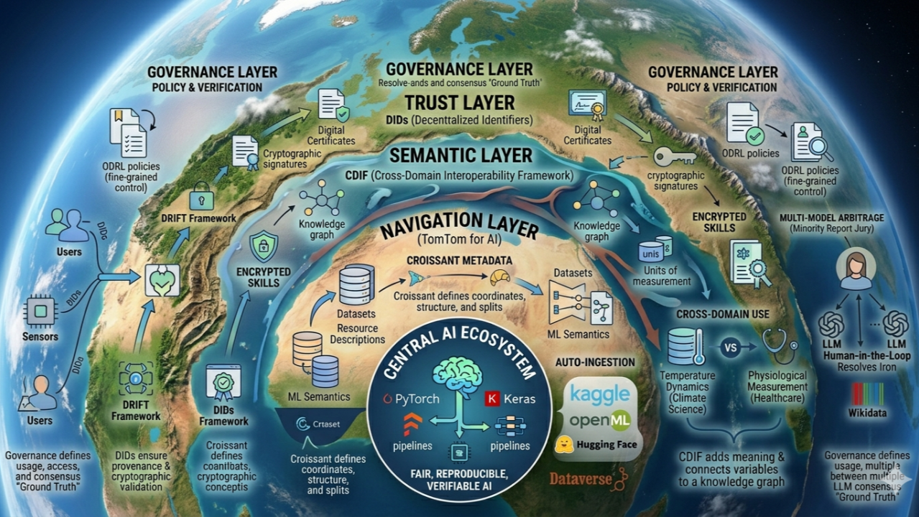
Semantic Croissant infrastructure
Building Data Infrastructure for Agentic AI


Slava Tykhonov
Head of AI at CODATA | Harvard Dataverse Ambassador | CroissantML | R&D | Linked Data
April 16, 2026

data landscape
designed to support the next generation of Responsible AI systems and power AI Agents.This is not just a technical architecture. It is a shift in how we think about data, meaning, trust, and machine intelligence on the web.As you probably know, the most modern AI systems are trained on vast amounts of data, yet they often lack three essential properties:
- Context: what the data actually means in the real world
- Provenance: where the data comes from and who created it
- Governance: how the data can be used responsibly
As a result, AI systems may generate fluent and useful outputs—but they struggle with consistency, traceability, and accountability. We call this non-deterministic output.
If we want Responsible AI to move from principle to practice, we need to rethink the foundation: not just models, but the data infrastructure underneath them should have all provenance information about every single resource in the AI pipeline.
Semantic Croissant vision
The Semantic Croissant architecture redefines this foundation by weaving together four distinct dimensions of intelligence into a unified, interconnected landscape. It begins with a navigation layer that directs the system to the precise location of data, followed by a semantic layer that defines exactly what that data means in a real-world context.
This is reinforced by a trust layer that verifies the identity of the creator and a governance layer that dictates how that information can be used responsibly. By integrating these layers into a single, cohesive framework, we enable AI to transcend simple pattern recognition and achieve true structured understanding.
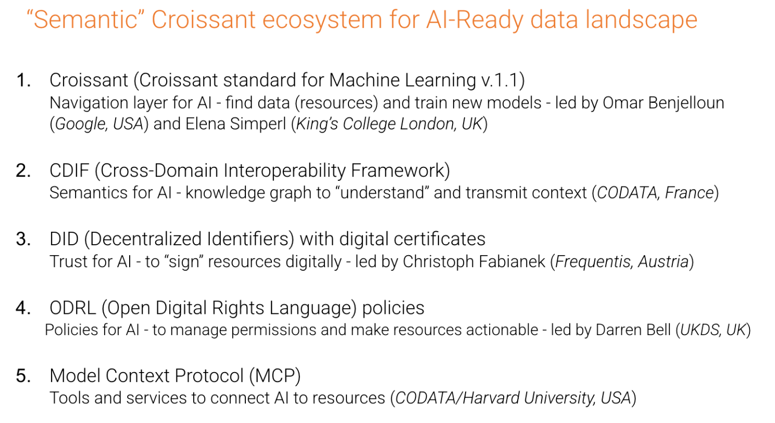
Layer 1: Croissant as the navigation layer
At the base of this system is the Croissant standard for Machine Learning. I've got invited to join the group by Harvard and got the opportunity to work on the standard with folks from Google, Meta, NASA and others. CroissantML was published in 2024 and acts as the navigation layer for AI, functioning much like a car’s GPS.
Just as a navigation device provides coordinates, routes, and structure for physical movement, Croissant defines the "coordinates" for AI. It's giving back dataset structure, resource organization, and specific splits for training, validation, and testing. By extending schema.org with responsible AI elements, it offers machine-readable metadata that allows frameworks like PyTorch or Keras to directly consume datasets from platforms such as Kaggle, Hugging Face, or Dataverse without manual preprocessing.
However, "navigation" alone is not solving the problem of "understanding". While Croissant can tell a system exactly where a variable is located, defining the "city, street, and building number", it often cannot explain what that variable means in a broader context. Without additional semantic layers, the standard might only identify a variable as a simple "string," causing LLM models to get lost in the meaning of the data they are navigating.
Layer 2: CDIF as the semantic layer
This is exactly where the Cross-Domain Interoperability Framework (CDIF) comes in, introducing a necessary layer of semantic structure directly on top of data navigation. Rather than allowing an AI to treat variables as abstract types like a simple "string" or "number," CDIF anchors them to real-world concepts and domain-specific definitions. By providing precise units of measurement and mapping even very complex relationships between different entities, CDIF effectively transforms raw data into actionable, meaningful knowledge.
This depth of detail enables a critical capability known as cross-domain interoperability. In this configuration, a single dataset can be interpreted with complete accuracy even when viewed through the lenses of different industries.
For instance, a specific data point might represent temperature dynamics in climate science, shift to represent system load in an engineering context, or be understood as a vital physiological measurement in healthcare. By providing this clarity, CDIF ensures that data can be safely and correctly reused across diverse domains without the risk of losing its original meaning or introducing dangerous ambiguity for the AI models involved.
Croissant + CDIF: When Navigation meets meaning
The synergy between Croissant and CDIF creates a powerful evolution in data processing where Croissant tells the AI exactly where the data is located and CDIF explains precisely what that data means. This "partnership" between layers allows AI systems to transcend simple data ingestion and move into the realm of true contextual understanding.
By merging these standards, we unlock a richer level of dataset interpretation and create reusable semantic mappings that function across various domains. This leads to more reliable machine learning pipelines and significantly improved consistency across different AI systems. Ultimately, this integration fundamentally changes our approach to metadata, shifting it from being merely descriptive text to becoming actionable intelligence that an AI can reason with effectively.
From data to structured intelligence
With this foundation, datasets are no longer static files; they evolve into structured knowledge systems that lay the groundwork for a new Web. This transformation begins as Croissant facilitates the automatic ingestion of datasets directly into machine learning frameworks, while CDIF simultaneously ensures that every variable within those sets is semantically grounded in real-world meaning, and if it's #FAIR, global and externally resolvable.
Furthermore, this integrated approach allows for the automatic generation of training, validation, and testing splits, while domain-specific interpretations can be applied dynamically to the same data. The ultimate result is a shift toward building pipelines where data is not merely processed as raw input, but is fully understood in context from the very moment of ingestion.
Responsible AI starts at the data layer
When discussing Responsible AI, the focus is often placed primarily on the models themselves, specifically regarding bias mitigation, interpretability, and safety alignment. However, these concerns actually emerge much earlier in the pipeline at the level of data definition and structure. If data lacks a clear meaning, consistent units, verified provenance, or accurate contextual mapping, then no model trained on it can be truly reliable or accountable. By introducing semantic structure through CDIF and navigational structure through Croissant, we establish a foundation for Responsible AI that begins at the point of ingestion rather than waiting until the inference stage.
We are now seeing the emergence of a true Responsible AI infrastructure that can support a wide range of implementations, including the rise of Agentic AI. A critical gap in current platforms, such as OpenClaw and other agent frameworks, is the total absence of a dedicated identity layer. As it stands, it is virtually impossible to issue an agent a digital passport or the formal authority to act on your behalf in a verifiable way. Without this layer, we lack the mechanism to assign clear responsibility if an agent performs an incorrect or harmful action, making the integration of Decentralized Identifiers (DIDs) essential for creating agents that are not only capable but also legally and ethically accountable.
Moving towards deterministic knowledge systems
This shift toward accountability leads to a key implication of this approach: the transition from purely probabilistic outputs to more deterministic AI behavior in constrained contexts. When a variable is clearly defined, properly validated, and consistently reused, it can finally be treated as trusted knowledge rather than uncertain input.
This structural change allows systems to cache validated knowledge and reuse semantic definitions across different tasks, which drastically reduces redundant computation while improving both speed and consistency. Instead of repeatedly "guessing" or predicting the next token based on probability, systems can simply retrieve these previously validated knowledge structures. Ultimately, this shifts the nature of AI from purely generative behavior toward structured reasoning over verified data. We need new layer here - "trust", with fully functional identity and governance.
This is where additional layers become essential:
Decentralized identity
Building on this deterministic foundation, Decentralized Identifiers (DIDs) provide a critical layer of cryptographic identity for datasets, models, and outputs. This identity layer enables verifiable authorship and robust provenance tracking, providing complete lifecycle visibility for all data used by an AI. Because each dataset becomes traceable like a "digital passport," it ensures the total auditability of AI outputs by making it possible to understand exactly where information originated and how it evolved over time. This transforms the data from an anonymous resource into a secure, authenticated asset that an AI agent can reliably use to act with authority.
Policy and usage control
Building on the identity layer, the Open Digital Rights Language (ODRL) introduces a vital policy layer that governs exactly how data and AI capabilities can be used. This framework enables fine-grained access control and precise usage restrictions for sensitive data, allowing for the creation of encrypted or restricted AI "skills" and the controlled execution of complex workflows.
For example, a sensitive AI workflow can now be fully encrypted, shared only with specifically authorized agents, executed in total isolation, and then automatically deleted after execution. This level of rigorous control makes it possible to deploy AI within highly sensitive domains, such as healthcare or finance, while maintaining the strict governance necessary to protect privacy and security.
Human-in-the-loop validation
A critical component of this system is the oversight mechanism that handles uncertainty. When an AI cannot confidently map a concept to an existing semantic structure, such as an external knowledge base like Wikidata, the system escalates the issue for validation.
Crucially, that "expert" role is not limited to human oversight alone, it can also be a higher-level AI model designed specifically for auditing and verification. These experts, whether human or advanced AI, can refine variable definitions, correct units or classifications, create new semantic entries, and ultimately validate or reject machine-generated mappings. See below the validation workflow of our AI Assistant trying to link variable to known Wikidata concepts, sometimes variable description and vocabulary concept are "close" in the vector space but not really the same, and second model is indicating about this in the "Relevance Note", and asking human to validate again.
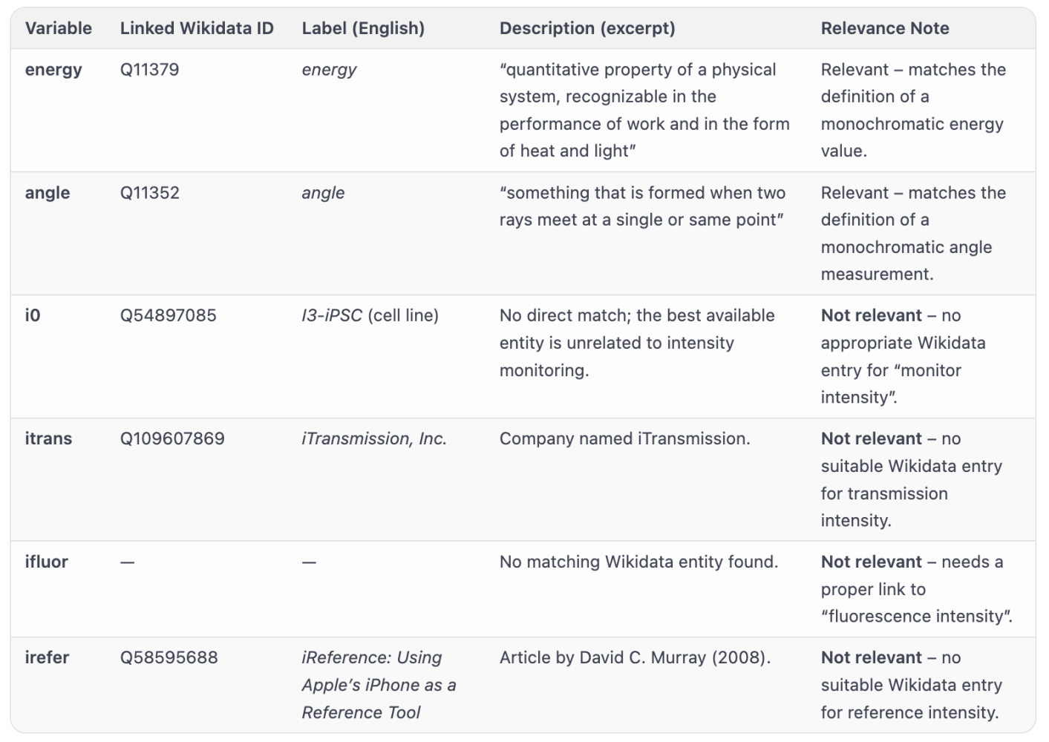
Once this knowledge is verified, it becomes part of a trusted, reusable system. In this way, expertise is not replaced, it becomes encoded into the very architecture of the system itself. As soon as it's complimentary, we are helping experts, not replacing them with AI.
Multi-model consensus as validation
This approach has a lot of applications. In our collaboration with the United Nations , we are building translation framework for their materials being translated in other languages with the help of AI. We aren't just translating words; we are building a fortress against AI "hallucinations." I call this a "Minority Report" arbitrage system as this approach looks like Philipp Dick novel (you can also watch famous movie with Tom Cruise). This mechanism can transform transient AI guesses from different models into a permanent, structured reality.
The story begins by placing different Large Language Models (LLMs) into a high-stakes pipeline. When the system faces a challenge like translating a technical term like "temperature" from English to French, it doesn't just ask one AI and hope for the best. Instead, it forces three separate models to generate their answers in isolation. They then act as a jury, voting on the correct interpretation. The moment a majority consensus is reached, such as two out of three models agreeing on a specific term, that translation is crowned as the "ground truth."
But we don't let that truth evaporate. Once consensus is achieved, the result is captured as a structured artifact and stored in a triple store as confirmed knowledge. This allows validated information to be redistributed across the entire digital network to other inference engines. By moving from "prediction" to "retrieval," we achieve something staggering: Deterministic Reliability. Once the system has mapped the correct path for a variable, it stops making probabilistic guesses and starts pulling from a cache of absolute certainty.
This shift isn't just about accuracy; it's about raw power. By retrieving validated knowledge instead of recalculating it, processing speeds scream from a modest 50 tokens per second to an incredible 800,000 tokens per second. To ensure this framework remains infallible, we always keep a seat at the table for the human expert. If the AI "judges" find themselves deadlocked, or if they cannot find a matching concept in databases like Wikidata, the system triggers an alert. Watch this demo below if you don't believe me, I've also shared some details on how we've implemented this in the Ollama, popular local AI inference engine.
If you're still concerned about the quality of translation, we have extended interface like Nectar Publisher with AI support and a human can step in to manually refine a definition or correct a unit of measurement. This human-validated data is then fed back into the repository, ensuring that the UN's translation framework is not only lightning-fast but remains both precisely documented and cryptographically trusted.
And by the way, Maria Carmen Staiano is still looking for volunteers to assist with validation of translations for United Nations Hazard Information Profile, don't hesitate to contact her if you have time and want to help!
What this enables in practice
For developers and organizations building Responsible AI applications, this architecture provides a concrete path forward.
It enables systems that are:
- Explainable: because meaning is explicitly encoded
- Auditable: because identity and provenance are verifiable
- Interoperable: because semantics are standardized
- Secure: because access is policy-controlled
- Reusable: because knowledge is structured and cached
Most importantly, it allows AI systems to be built on foundations that are not only technically scalable—but socially and ethically robust.
Closing thoughts
The AI-Ready data landscape is not a single technology.
It is a layered approach to rethinking how AI interacts with data:
- Croissant defines structure and navigation
- CDIF defines meaning and semantics
- DIDs define identity and provenance
- ODRL defines governance and control
Together, they form a system where AI is not just powerful, but grounded—capable of operating within a framework of trust, transparency, and responsibility.
This is the direction I believe we need to move toward:
AI systems that do not merely generate outputs, but understand the data they are built upon - and can be trusted to act accordingly.
Thanks for your attention and see you next time,
Slava

