- Recommendation Algorithms
Recommendation can be done in various ways. Recommendation algorithms in general are subdivided into 3 categories based on the aforementioned criteria:
- Content-Based Filtering
- Collaborative Filtering
- Hybrid Recommender Systems
  - Content Based Filtering
Content-Based filtering is the type of recommendation where the properties of the items themselves are used for the purpose of recommendation and nothing more. For instance if we consider a movie then the attributes or properties of the movie would include ‘movie-title’, ‘director name’, ’lead actor’, ‘production’, ‘genre’ and so on. All these attributes play a significant role in recommending movies to users. For instance a person who has watched ‘horror’ movies and likes the ‘horror’ genre in general would also like another movie from the same genre.
  - Collaborative Filtering
Collaborative Filtering is the type of recommendation where the users of the items come into play and the preferences of individual users play a vital role in the recommendation. It is called collaborative because we are taking into account the preferences (for instance for movies, the previously watched and rated movies) of the same and like-minded users to recommend items to a particular user. For instance if user A likes movie X and the same movie is also liked by user B then chances are that user A and user B are alike in some respects and the movies watched and/or rated by user B will also be liked by user A. It is a based on a simple idea that users who have expressed same interests in the past will express similar interests in the future. Collaborative Filtering can be used across multiple domains. Involving multiple domains in recommendation gives us a better chance at recommending items effectively. For instance if we use movies and books as the 2 domains then we can recommend movies that have the same genre as the books that the user has rated well and vice-versa. That’s why cross-domain collaborative filtering is powerful in improving recommendations.
  - Hybrid Recommender Systems
Hybrid recommendation as the name suggests consists of using the pros of both content based filtering and collaborative filtering. For instance in the example of movies, if we have the data corresponding to the attributes of the movies along with the likes and dislikes of users, we can not only recommend movies rated well by like-minded users but also recommend movies similar to that movie.

- Experiments
  - Datasets used
For the purposes of experimenting with our methodology we used datasets from 2 different sources. The item chosen for experimentation was movies.
Table 1. Datasets used and their specifications
Dataset | Source | Size | Unique Entries | Columns | Description
Movies | MovieLens (domain 1) | 15.4 MB | 10197 | 33 | Movies vs Movie attributes
Movies | Kaggle (domain 2) | 1.44 MB | 5043 | 28 | Movies vs Movie attributes
Users | MovieLens | 26.7 MB | 2114 | 9 | Users vs user ratings for movies in MovieLens
  - Methodology
The process of recommendation was divided into 2 main parts:
- Preprocessing
- Querying

Preprocessing

Why?
Recall that our objective was to tackle scalability through partitioning the datasets effectively. To address this issue of scalability of large recommender systems due to their enormous data we need to partition the data so that at a time we can work with smaller portions of the data.

How?
Various techniques were used and analyzed for various ways of partitioning the data. These techniques are illustrated in the various experiments that follow.

Querying

After preprocessing, querying would imply that we query the partitions of the data for similar items which in our case are movies. Since now we are searching for similar movies within a small portion with respect to the entire dataset, our query will be both faster and more effective.

  - Experiment 1: Genre and Rating Based Partitioning

As a rather naive approach to solve the problem of scalability we used the genre of movies in order to partition the entire data and within each genre ratings of movies were used to create another level of partitions. Each movie in the dataset had a number of genres. So if a genre signified one partition, a movie can be in more than one partition at the same time. To represent the idea graphically:
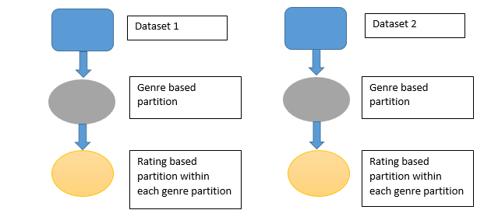
Fig. 1. Genre clustering
So, as represented in the figure itself, the partitioning was done at 2 levels, at the first level each unique genre was considered one partition and all movies were segregated in this way. The next level of partitioning was rating based and in this case each genre was further sub-divided into various rating based partitions, similar rated movies were partitioned into the same partition.
Partitions chosen for ratings for the dataset MovieLens
[0 – 1.5): Partition A
[1.5 – 3): Partition B
[3 – 5]: Partition C
Partitions chosen for ratings for the dataset Kaggle:
[0 – 2.5): Partition A
[2.5 – 5): Partition B
[5 – 7.5): Partition C
[7.5 – 10]: Partition D

Results. Since genre was the only criteria used for the partitioning of data into partitions, the results were consistent only with respect to the genre and their corresponding rating.

Drawback. One important drawback of this approach is the lack of usage of data from the datasets. The dataset from MovieLens had 33 attributes of which we were using only the genre attribute for the purpose of partitioning the data. Although choosing too many attributes for making proper partitions can actually degrade the quality of partitions (or clusters) instead of improving them even then selecting too few (one in this case) can also hamper partition quality. Similarly the Kaggle dataset had 28 attributes of which we were once again using only one.
  - Experiment 2: Numeric Data Clustering
In an attempt to use maximum possible number of relevant fields to partition the data, we had to come up with a proper partitioning scheme that would use a number of fields together. We therefore turned our attention to information retrieval techniques.

Classification techniques in Information Retrieval
- Supervised
- Unsupervised

Supervised. In case of supervised classification technique, the classes or labels as they are more formally called, appear within the data itself and hence there is no need of external classification of the data into classes. Supervised classification dictates that some portion of the data (referred to as the training set or training data) is already classified and some portion of the data (referred to as the test set or test data) is not classified. This means that some portion of the data that is not classified is classified using machine learning. It is called a test set because it is traditionally meant for testing the machine learning algorithm applied.

Unsupervised. In case of unsupervised classification technique, the classes are not already present in the data itself and needs to found out using an appropriate technique. Here is where Clustering comes into the picture. There are various forms of clustering which classify unclassified data into classes following, the strict assumption, ‘Items in the same cluster are as similar as possible and items in different clusters are as dissimilar as possible’.
Clustering is done in such a way that all attributes of an item in a dataset essentially become, dimensions in an n-dimensional hyperspace where n is the number of attributes, thus each item becomes a point in that n-dimensional hyperspace. After that any number of different clustering techniques can be applied to classify the points (which actually represent items) into clusters.

Method. Following the clustering technique, we first considered it appropriate to consider all the numeric data present in the datasets as it would be easy to consider them as dimensions in the n-dimensional hyperspace. These points can be thought of as n-dimensional vectors. In our case after conversion of the items to vectors we normalize the vectors and then we used K Means clustering algorithm to cluster those points (representative of the items present in the dataset).

K-Means Clustering Algorithm. K-Means is one of the many clustering algorithms available to cluster the points in an n-dimensional hyperspace. It follows the basic assumption in clustering that ‘points in the same cluster should be as similar as possible and points in different clusters should be as dissimilar as possible’. K-means clustering aims to partition x observations (where x is the total number of observations or in our case the total number of movies present in one dataset) into k clusters where each observation belongs to the cluster with the nearest mean, serving as the prototype of the cluster. This results in a partitioning of the data space into ‘voronoi cells’. The problem is computationally difficult (NP-hard), however there are efficient heuristic algorithms that are commonly employed and converge quickly to a local optimum.
The first step of the algorithm involves choosing an initial set of centroids for the clusters. These centroids would represent the clusters throughout the whole algorithm. These initial centroids are typically actual data points in the n-dimensional space. This initial selection of the centroids can be done in any number of ways starting from a random point selection to a more definite point selection that will yield a better result. To lower the number of iterations for the algorithm the typically method is to select the initial centroids as points in the n-dimensional hyperspace that are far apart in terms of Euclidean distance.
After the initial selection of centroids, the next step is to compute the Euclidean distance of each and every point in the space to the centroids. Next each point is assigned to the cluster from which it has the least distance to the centroid of that cluster.
Once all points are assigned to their respective clusters, for each group of points (basically all points belonging to one cluster), the mean is calculated.
For instance if the points in one such group are the following:
(x₁, y₁), (x₂, y₂), (x₃, y₃), (x₄, y₄)
Then the mean of all these points would be:
X_{mean} = (x₁ + x₂+ x₃ + x₄) / (number of points in the group) = (x₁ + x₂+ x₃ + x₄) / 4 (1)
Y_{mean} = (y₁ + y₂ +y₃ +y₄) / (number of points in the group) = (y₁ + y₂ +y₃ +y₄) / 4 (2)
Now this (X_{mean}, Y_{mean}) becomes the new centroid of the cluster.
Once again the Euclidean distance in calculated from the each point to the k new centroids formed. Each point is once again assigned to the cluster from which the point has the least Euclidean distance. This time the allocation of the points to the clusters may change that is a point that was assigned to one cluster initially may now be assigned to a different cluster.
This whole process is repeated until there is no change in the cluster allocations, i.e. the points that were assigned to one cluster in the previous step, are assigned to the same cluster in the next step and this holds true for all data points in the n-dimensional hyperspace. We can then say that the clustering has been completed.
In the above description of the k-means clustering algorithm, the metric that was used to decide whether a point belonged to a cluster was the ‘Euclidean distance’. This is called the objective function. There are other objective functions available that can also be used for this purpose.
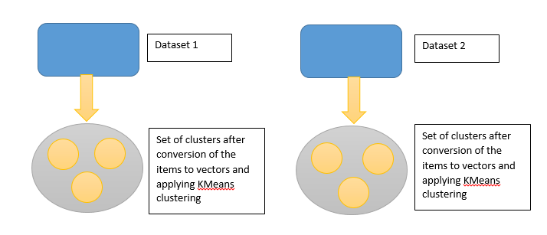
Fig. 2. Numeric clustering
From each dataset we got a set of clusters. The following section illustrates how clustering was actually done in individual datasets.

Numeric Clustering in MovieLens Dataset. The attributes used for the Numeric clustering of the MovieLens dataset are the following. Here ‘rt’ denotes metrics from ‘rotten tomatoes’
- rtAllCriticsRating
- rtAllCriticsNumReviews
- rtAllCriticsNumFresh
- rtAllCriticsNumRotten
- rtAllCriticsScore
- rtTopCriticsRating
- rtTopCriticsNumReviews
- rtTopCriticsNumFresh
- rtTopCriticsNumRotten
- rtTopCriticsScore
- rtAudienceRating
- rtAudienceNumRatings
- rtAudienceScore
- TotalScore
Total number of attributes: 14

All these attributes are considered for the purpose of vectorizing each item. This means that each attribute essentially become a dimension in the n-dimensional hyperspace where n is the total number of attributes which in our case is 14.
For instance if for any movie (an item in our dataset), the attribute measures are the following: (14, 15, 14.5, 18, 19, 14, 12, 17, 19, 19, 15, 17, 12, 12), then the point exactly becomes:
(14, 15, 14.5, 18, 19, 14, 12, 17, 19, 19, 15, 17, 12, 12)
The scale of all the dimensions may not be the same and hence it is necessary to apply a normalization of the vectors. In our case we applied L2-normalization in order to normalize the vectors.
In case of L2-normalization if the initial vector is:
(14, 15, 14.5, 18, 19, 14, 12, 17, 19, 19, 15, 17, 12, 12)
then the normalization is applied in the following way. Each and every coordinate of a point divided by the total sum of all coordinates of that point. i.e. the sum of all coordinates is:
14 + 15 + 14.5 + 18 + 19 + 14 + 12 + 17 + 19 + 19 + 15 + 17 + 12 + 12 = 217.5.
Hence the coordinates after normalization would be:
14/217.5 = 0.064, 15/217.5 = 0.068 (3)
and so on for all coordinates. After all points are found and normalized the k-means algorithm is applied in this 14-dimensional hyperspace in order to cluster the points and hence the movies into clusters.

Numeric Clustering in Kaggle Dataset. The attributes used for numeric clustering are the following:
- Duration
- DirectorFacebookLikes
- Actor3FacebookLikes
- Actor1FacebookLikes
- Actor2FacebookLikes
- ImdbScore
- MovieFacebookLikes
Number of attributes: 7

All these attributes are considered for the purpose of vectorizing each item. This means that each attribute essentially become a dimension in the n-dimensional hyperspace where n is the total number of attributes which in our case is 7.
For instance if for any movie (an item in our dataset), the attribute measures are the following:
(14, 15, 14.5, 18, 19, 14, 12)
then the point exactly becomes,
(14, 15, 14.5, 18, 19, 14, 12)
The scale of all the dimensions may not be the same and hence it is necessary to apply a normalization of the vectors. In our case we applied L2-normalization in order to normalize the vectors.

In case of L2-normalization if the initial vector is
(14, 15, 14.5, 18, 19, 14, 12, 17, 19, 19, 15, 17, 12, 12)
then the normalization is applied in the following way. Each and every coordinate of a point divided by the total sum of all coordinates of that point. i.e. the sum of all coordinates is:
14 + 15 + 14.5 + 18 + 19 + 14 + 12 + 17 + 19 + 19 + 15 + 17 + 12 + 12 = 217.5. (4)
Hence the coordinates after normalization would be:
14/217.5 = 0.064, 15/217.5 = 0.068 (5)
and so on for all coordinates. After all points are found the k-means algorithm is applied in this 7-dimensional hyperspace in order to cluster the points and hence the movies into clusters.

Results and Drawbacks of this Approach. After the clustering of the 2 datasets into 2 separate set of clusters, clusters were stored in a csv file. Although no querying was done on this dataset it was quickly clear that the optimum result could not be achieved by just using the numeric data present in the datasets. We initially had taken the numeric data because it could be easily converted to vectors without any prior processing. The fields or attributes chosen for numeric data clustering were simply not sufficient to produce clusters such that similar movies were clustered into the same cluster. We were not considering some of the more potent fields like actors in the movie, director, location of shoot, year, genre and so on. Since we were not taking into consideration the non-numeric fields as mentioned above, we could not hope to achieve a good and definite result with the clustering.
  - Experiment 3: Non-Numeric Data Representation and Nearest Neighbor Approach
In search of finding a way to convert non-numeric data to some form of numeric data for the purpose of appropriately representing items in the dataset, we turned to information retrieval techniques. The technique we used was tf-idf vectorization. tf-idf vectorization stands for term-frequency document-frequency vectorization. These are information retrieval techniques used in order to retrieve relevant data from documents (unstructured data).
A document consists of terms which are unique words present in the document.

Term Frequency. Term frequency refers to the number of terms present in a document. Let’s say we have the following document:
‘The quick brown fox jumps over the lazy dog’.

The term frequency for the following terms in this document are as follows:
tf(‘the’) = 2, tf(‘quick’) = 1 (6)
and likewise. The term frequency weight is given by:
w_{t,d} = 1 + log₁₀ tf_{t,d} if tf_{t,d} > 0 (7)
or,
w_{t,d} = 0 otherwise (8)
Tf _{t,d} refers to to the term frequency for a term t for a document d. The log value is used as a scale down operator. Typically the number of terms for a document may be very high and in order to scale down the weight for the term the log operator is used.

Document Frequency. Document frequency refers to the number of documents in the entire collection that has a particular term in it. For instance if a term ‘quick’ occurs in 18 documents in a collection then the document frequency of ‘quick’ is 18.
It is worth noting that document frequency is one for a term in the entire collection, however the term frequency for a term varies with each document. i.e. if the term ‘quick’ occurs 8 times in a document d1 and the same term ‘quick’ occurs 18 times in another document d2 then 2 separate term frequencies exists for 2 documents and 2 terms. However the document frequency is not valid document wise. It is one for one term in the entire collection.

Inverse Document Frequency. The inverse document frequency is the inverse of the document frequency. It is given by:
idf_{t} = log₁₀ $\frac{N}{dft}$ (9)
Here N is the total number of documents in the collection. df_{t} represents the document frequency for a term in the collection. Once again the log operator is used in order to scale down the values.
In general inverse document frequency is used in order to reduce the weightage of frequent terms in the collection.

Conversion of Non-Numeric Data to vectors. Non-numeric fields considered in the MovieLens Dataset:
- ActorName
- Genre
- DirectorName

The other non-numeric fields were not chosen as such they had little relevance with respect to similarity of movies and what a typical viewer with a specific would like to see. A typical viewer would generally want to watch movies that are similar with respect to such fields as actors present in the film, the genre of the movie and the director name. Among the attributes that were present in the dataset, these should best promise.
Non-numeric fields considered in the Kaggle Dataset.
- DirectorName
- Actor2Name
- Genre
- Actor1Name
- Actor3Name

The other non-numeric fields were not as relevant and a typical viewer would like to watch movies that are similar with respect to such fields as the same director, similar genre and same actors. Among the attributes that were present in the dataset, these are the ones that showed most promise.

Conversion of data in fields to vectors:
Conversion of field values to documents. For each item (movie), the values present in the fields were converted to paragraphs such that each value in the field becomes one term in the paragraph and the paragraph essentially became a document. For instance considering the MovieLens Dataset.
Table 2. Sample data from dataset
movieName | ActorName | Genre | DirectorName
Titanic | Leonardo di Caprio, Kate Winslet | Drama, Romance | James Cameron

Document Name: Titanic
Document contents: LeonardodiCaprio<space>KateWinslet<space>Drama<space>
Romance<space>JamesCameron

Note that spaces in names were trimmed and considered as one term.
Hence the document consists of 5 terms: LeonardodiCaprio, KateWinslet, Drama, Romance and JamesCameron. This was done with each and every movie and hence each movie was considered to be one document.

Generation of a term document matrix. The term document matrix can then be generated in the following manner. For instance considering the MovieLens dataset:
Table 3. Sample data from dataset
MovieName | ActorName | Genre | DirectorName
Titanic | LeonardodiCaprio, Kate Winslet | Drama, Romance | James Cameron
Tomorrow Never Dies | Colin Salmon, Geoffrey Palmer | Action, Romance, Thriller | Roger Spottiswoode
Twisted | Richard T Jones, Andy Garcia | Comedy, Drama | Philip Kaufman

The term document matrix for the above dataset would be:
Term 1: LeonardodiCaprio
Term 2: KateWinslet
Term 3: ColinSalmon
Term 4: GeoffreyPalmer
Term 5: RichardTJones
Term 6: AndyGarcia
Term 7: Drama
Term 8: Romance
Term 9: Action
Term 10: Thriller
Term 11: Comedy
Term 12: JamesCameron
Term 13: RogerSpottiswoode
Term 14: PhilipKaufman

Mind you that the total number of terms (even for a single movie) here is 14. Needless to say that we are getting an extremely sparse matrix here.
Table 4. Term document matrix
MovieName | T1 | T2 | T3 | T4 | T5 | T6 | T7 | T8 | T9 | T10 | T11 | T12 | T13 | T14
Titanic | 1 | 1 | 0 | 0 | 0 | 0 | 1 | 1 | 0 | 0 | 0 | 1 | 0 | 0
TomoroowNeverDies | 0 | 0 | 1 | 1 | 0 | 0 | 0 | 1 | 1 | 1 | 0 | 0 | 1 | 0
Twisted | 0 | 0 | 0 | 0 | 1 | 1 | 1 | 0 | 0 | 0 | 1 | 0 | 0 | 1

Once we get these term frequencies for each movie (here document) these can be considered as coordinates for an n-dimensional hyperspace where n is the number of terms present in the entire collection and the vectors are documents themselves. Now after getting such documents (movies) as vectors we can then plot them in an n-dimensional hyperspace.

Normalization of the vectors. The vectors are next normalized following the L-2 Normalization technique or Euclidean normalization technique.
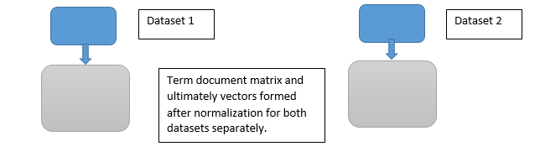
Fig. 3. Vectorization of movies

Querying of movies using nearest neighbor approach. After normalization of the vectors using the L-2 normalization, all vectors are transformed into unit length vectors. Now since all vectors are unit length the similarity of 2 items (movies) can simply be computed by figuring out the dot product between the 2 items. The dot product of 2 unit vectors is equal to the cosine of the angle between the vectors. This means the similar the movie with respect to another movie, the lower the angle between them, the higher the cosine of the angle and hence higher the dot product.
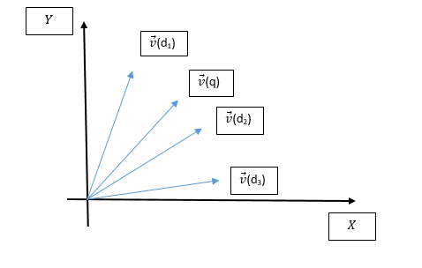
Fig. 4. Nearest neighbor approach
Note in the above diagram, if the query document vector is $\vec{v}$ (q), then $\vec{v}$ (d₂) is closer to the query document than $\vec{v}$ (d₁) and hence would have a higher dot product.
Similarly now we can use a query movie and find out movie the query is most similar to by finding out the dot product of that movie with every other movie.
This querying of movies was done in both datasets separately and the final result was simply the combination of the 2. If dataset 1 returned 3 movies : movie1, movie2 and movie3 and dataset 2 returned 3 movies movie4, movie5 and movie6 then the final result was simply shown as movie1, movie2, movie3, movie4, movie5 and movie6.

Results and Drawback of this approach. The results obtained were not as convincing as the expected. For instance when the query movie Spiderman was given the top 5 most similar movies were expected to be sequels of Spiderman. However that was not the case.
Although it seems to be an excellent approach time is a major factor in reducing the importance and relevance of this approach. Partitioning the data was required especially in order to tackle scalability. However we were unable to tackle scalability as we were not partitioning the data into appropriate partitions. We were simply searching in the entire collection for better results. This was causing an O(n) algorithm at a high level even during the querying phase. This would quickly become an unfeasible solution when the dataset would be large.
  - Experiment 4: Non Numeric Data Clustering and Subsequent Querying
The next obvious approach was to amalgamate the ideas of both non-numeric data representation and clustering for tackling the scalability issue. Hence we considered K-Means clustering to cluster the data.

Conversion of data to vectors. The conversion of data to vectors was done in exactly the same way as the previous experiment, hence we are not reiterating the explanation here.

Generation of term document matrix. The term-document matrix was generated in exactly the same way as the previous experiment.

Normalization of vectors. Once again we used l2 normalization for the normalization of the vectors in exactly the same way as the previous experiment.

Application of K-Means Clustering. The difference between the previous approach and this one comes here. Here we apply K Means clustering to the formed vectors in order to cluster the data. Recall that specifics of K Means clustering have already been discussed in a previous experiment. Once the clusters are formed it is now easy to search the similar movies among the specific cluster movies. This solution would therefore tackle the issue of scalability.

Storage of Clusters. All the movies present in a specific cluster were stored in a csv file where each row of the file was one cluster and the ids of the movies were stored in each row.

Number of Clusters (size of K). Many articles on K means clustering denote that the number of clusters to be formed or the value of k depends on the data itself. In our case we found that for the Kaggle dataset number of clusters = 100 yielded optimum results and in the case of MovieLens dataset it was also found that number of clusters = 100 yielded optimum results.
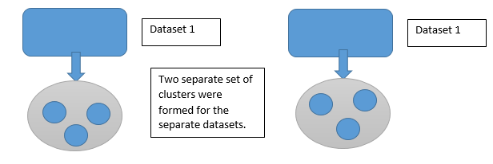
Fig. 5. Clustering of the 2 datasets separately

Results: Querying and Cluster Evaluation
We have a total of 3 datasets: the movies dataset of MovieLens, the movies dataset of Kaggle and the user dataset of MovieLens. For the purposes of querying and cluster evaluation, the following steps were employed:
- A user was selected from the user dataset
- The top 3 highest rated movies were selected for that user
- The clusters of those movies were found in both datasets separately
- For the purposes of cluster evaluation, we return the intersection of the movies that the user has watched and rated and the movies that are present in that cluster. This was done separately for both datasets and for all three movies.

Illustration. If a user A has watched and rated the following movies:
userA: {m1: 2.5, m2: 3.5, m3: 3.5, m4: 2.5, m5: 4, m6: 4, m7: 5, m8: 4, m9: 4, m10: 5, m11: 4.5}
and the top 3 highest rated movies are:
{m7: 5, m10: 5, m11: 4.5}
Let the clusters for these 3 movies be:
{cluster7, cluster88, cluster94}
Let the movies in the clusters for the MovieLens dataset be the following:

Cluster 7. Contents of this cluster are:
m1, m2, m4, m7, m15, m88, m54

Cluster 88: Contents of this cluster are:
m10, m78, m41, m6, m84

Cluster 94: Contents of this cluster are:
m11, m3, m44, m71, m89, m27, m26, m35
Recall that the user set was:
Table 5. User set sample
Movies | Ratings
m1 | 4
m2 | 3.5
m3 | 3.5
m4 | 3.5
m5 | 4
m6 | 4
m7 | 5
m8 | 4
m9 | 4
m10 | 5
m11 | 4.5

Hence for the first movie m7 the movies we get after querying is the intersection of the movies the user has watched and rated and the movies present in the cluster of movie m7, in this case cluster 7. Therefore we get movies:
{m1, m2, m4, m7, m15, m88, m54} ∩ {m1, m2, m3, m4, m5, m6, m7, m8, m9, m10, m11}.
Which is movies:
{m1, m2, m4, m7}
The same approach was also followed for Kaggle Dataset
After we get the required movies we compute the average rating of all movies that we have got as results. Here rating is the user’s rating of the movies. Now if the cluster quality is good enough the clusters should contain movies which that same user has preferably rated well which in turn means that when we compute the average rating for each and every movie that we queried, in this case movies:
{m7, m10, m11}

Illustration. For the first movie m7 we got movies:
{m1, m2, m4, m7}
These movies have the following ratings given by the user:
{m1: 4, m2: 3.5, m4: 3.5, m7: 5}
Averaging these ratings we get:
$\frac{(4+3.5+3.5+5)}{4}$ = 4 (10)
The ratings are computed out of 5 hence 4 turns out to be a pretty good for a rating.
This measure gives us an idea of the cluster quality, there may be movies with lower ratings given by the user. But since the cluster should contain similar movies to the movies that the user has rated high, it is obvious that the average rating we got should also be high enough. Therefore a rating of 4/5 is pretty good for cluster quality.
The above average rating was computed for all three top movies separately to evaluate cluster quality. This same approach was also followed to evaluate cluster quality of the Kaggle dataset.
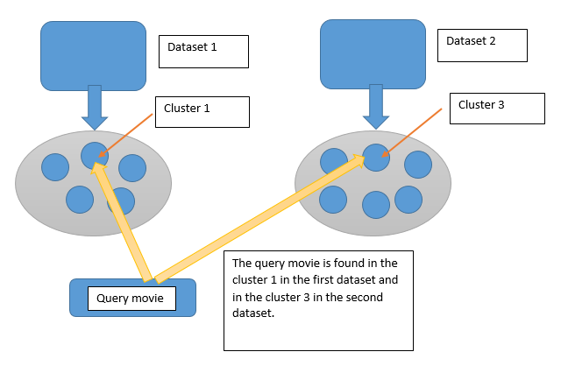
Fig. 6. Cluster Evaluation

cluster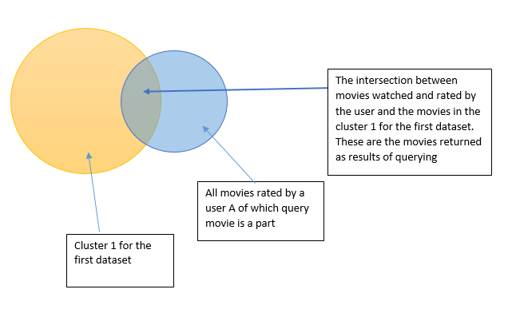
Fig. 7. How the clusters results were merged

Fine Tuning Experiment 4: Inclusion of numeric data. A drawback of the previous approach was that we were using only non-numeric data in the previous experiment. This is not leading to full utilization of the datasets we had as we were not using the numeric data.
This approach involved 2 levels of clustering. At the first level clusters were formed using non-numeric data just like in the previous experiment. At the next level sub-clusters were formed using the numeric data of the movies present in each cluster. Numeric data was done in exactly the same way which is described in Experiment 2.
This was done in both datasets separately
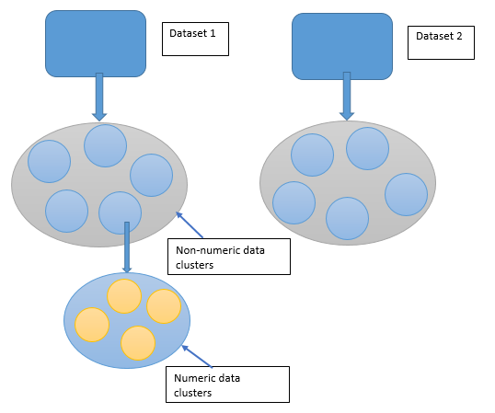
Fig. 8. Including both numeric and non-numeric clustering

