Andrew Hautau
Intro to Data Science
Week 3 Assignment
- K-Means Clustering
  - Data normalization is important for K-means clustering because it puts the data on equal terms.
  - K-means methods necessarily rely on numerical data, since the method relies on finding the means of data points. Encoding categorical data as Booleans or continuous data would be necessary for K-means to use categorical data.
  - Clustering is un-supervised learning because the task focuses on learning the structure of a given dataset. The task does not involve inference of a desired function from training data, as in supervised learning
- R Code and Mammographic Masses Dataset:

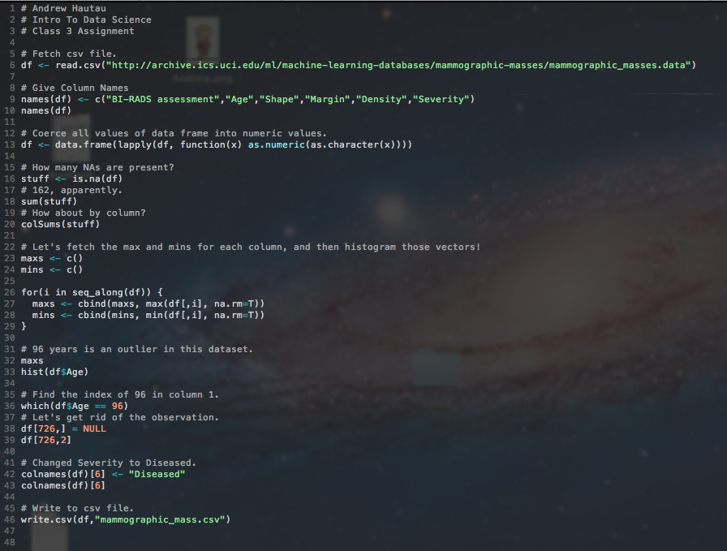
  - https://github.com/CrossTheStreams/data_science/blob/master/class_3/hautau_week_3.r
  - https://raw.github.com/CrossTheStreams/data_science/master/class_3/mammographic_mass.csv
- Predixion Insight: After attempting into the wee-hours, I’m putting up the white flag on this one. I setup a Windows VM with Excel (also with PowerPivot), but the Predixion installation wizard would always blow up, complaining about not having an install of SQL Server. This all seems to clash with the comments on the LinkedIn group. My one theory is that SQL Server is a dependency for Insight with Excel 2010, but not other versions.
- Playing with Octave (following tutorials from (http://en.wikibooks.org/wiki/Octave_Programming_Tutorial).

