TeamSpeak 3 G-Key Plugin

Table of Contents
Plugin Installation 2
Tutorial 3
Logitech Gaming Software 3
GamePanel Software (Legacy) 7
Advanced scripting 11
Examples 12
Push-to-talk 12
Non-keyboard devices 12
Input mute 13
Output mute 13
Away status 14
Command reference 15
Changelog 16
Version 0.5.0 16
Version 0.4.4 16
Version 0.4.3 16
Version 0.4.2 16
Version 0.4.1 16
Version 0.4 16
Version 0.3 16
Version 0.2 16
Version 0.1 16

Plugin Installation
- Open and install the package.
Note for 64-bit users: If you are using a 64-bit operating system you will need to use the 64-bit version of TeamSpeak 3.
- Start TeamSpeak 3 and open the “Plugins” dialog (Ctrl+Shift+P).
- Make sure the “G-Key Plugin” is checked.
- Now to configure the G-Keys for usage with the plugin refer to the Tutorial section.

Tutorial
This section will explain how to configure your Logitech software for use with the G-Key plugin, most users should refer to the Logitech Gaming Software tutorial. These are the latest drivers released by Logitech and a lot of devices are supported by it. You should update if you're still using older software.
However if you have a keyboard the old software is still supported for now, refer to the GamePanel Software (Legacy) tutorial if you do not want to update.
Note for G930 users: The previously supported G930 software has been replaced with the Logitech Gaming Software. Users of the G930 should make sure their drivers are up to date and refer to the Logitech Gaming Software guide.

Logitech Gaming Software
- Open the Logitech Gaming Software
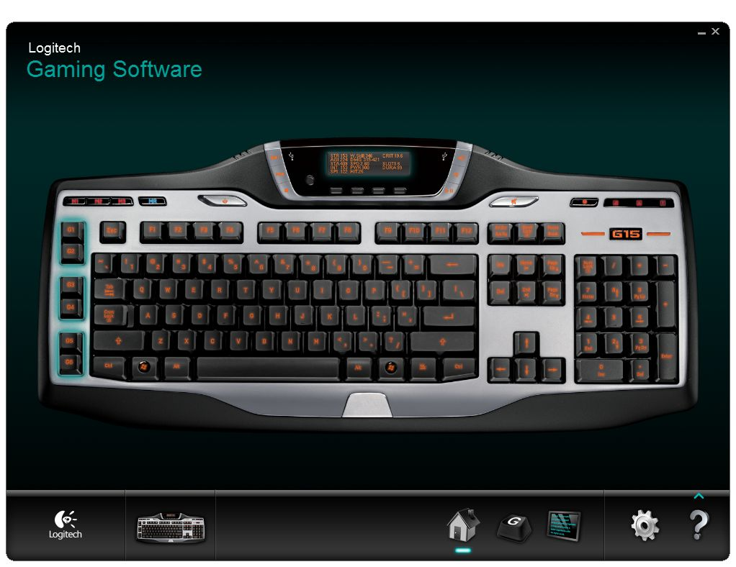

- Open the “Customize G-keys” tab
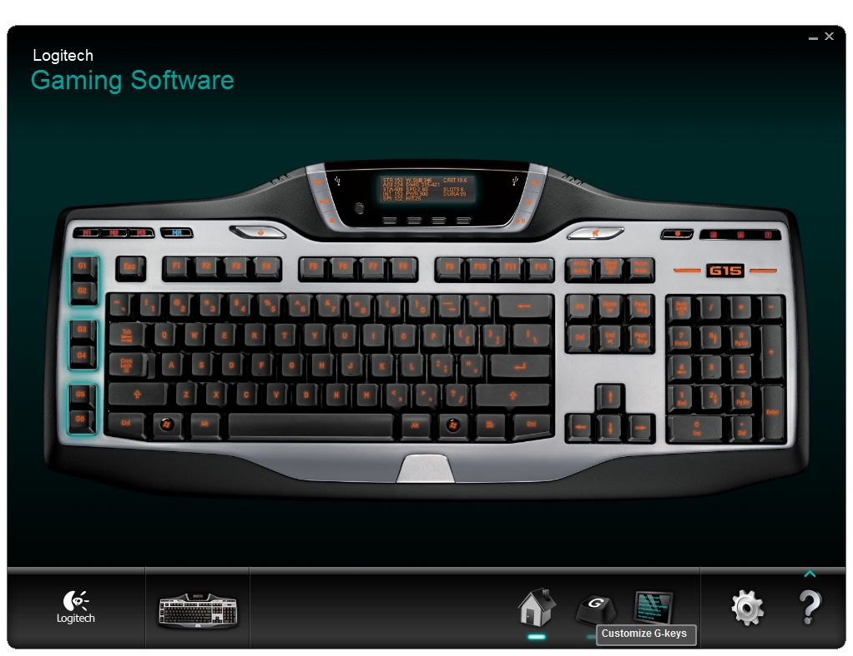

- Open the script for your configuration by right-clicking on the icon.
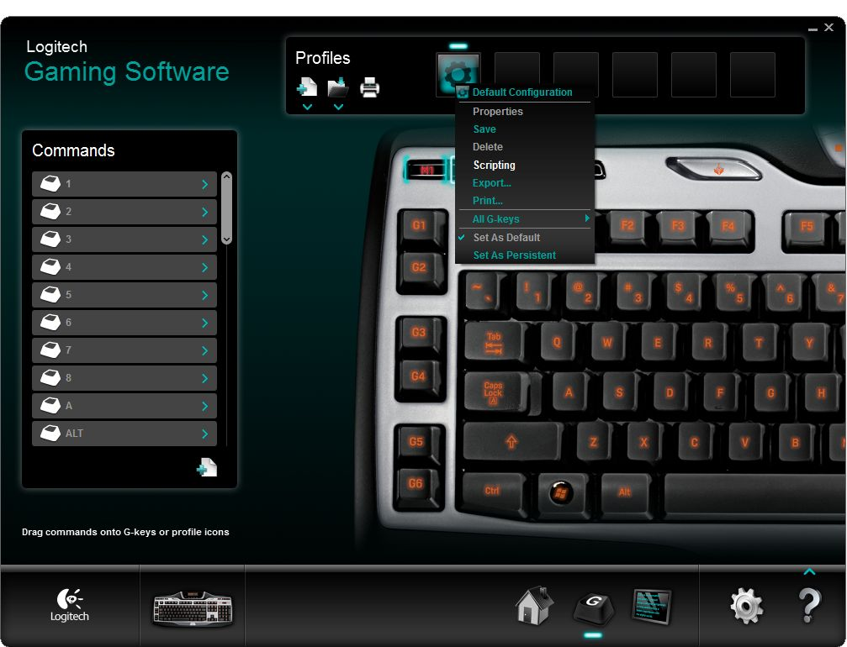

- Now enter the script, the simplest script that only supports push-to-talk is this:
function OnEvent(event, gkey, family)
mkey = GetMKeyState()
if gkey == 3 and mkey == 1 then
if event == "G_PRESSED" then
OutputDebugMessage("TS3_PTT_ACTIVATE")
end
if event == "G_RELEASED" then
OutputDebugMessage("TS3_PTT_DEACTIVATE")
end
end
end

With this script G3 will trigger Push-to-talk regardless of your currently assigned hotkey in TeamSpeak 3.
To change Push-to-talk key you only have to change the following line:
if gkey == 3 and mkey == 1 then
In that line gkey == 3 determines which G-Key activates push-to-talk, for example to change the key to G5 you change it to gkey == 5.
The mkey == 1 part is meant for keyboards that have M-Keys and can be changed in the same way as the G-Key. If you don't have M-Keys or you don't use them you can just leave it at mkey == 1.
You have now successfully configured your drivers for use with the plugin. For more functions and advanced scripting examples, refer to the Advanced scripting section.

GamePanel Software (Legacy)
This is a guide for the old keyboard driver, while the plugin still supports this driver for now, it is recommended that you update to the new Logitech Gaming Software.
- Open the Logitech G-series Key Profiler
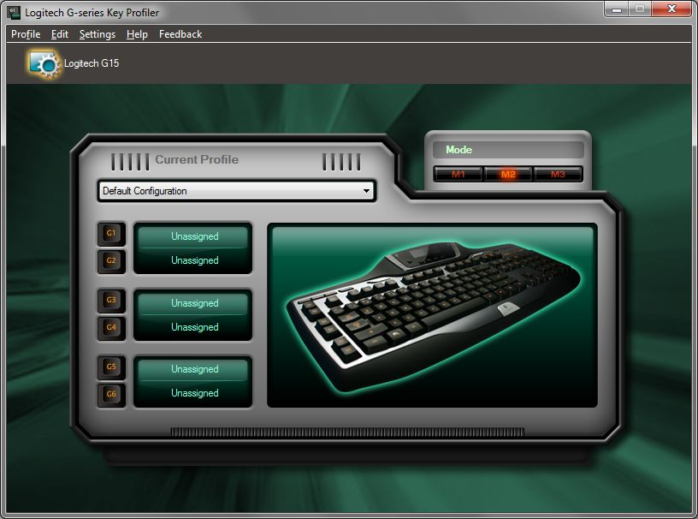

- Assign the G-keys you want to use to control TeamSpeak 3 to “Script”. Note the G-keys and Mode you've set here, as we will need them later.
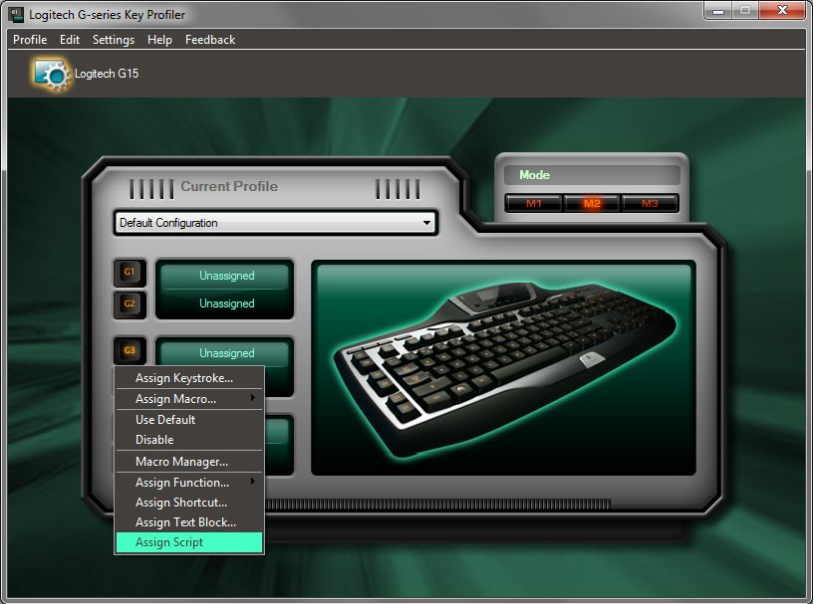

- Open the Script Editor

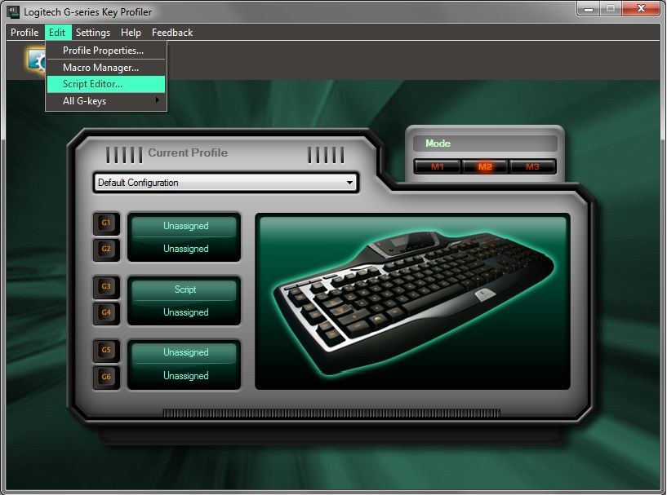

- Now enter the script, the simplest script that only supports push-to-talk is this:
function OnEvent(event, gkey, family)
mkey = GetMKeyState()
if gkey == 3 and mkey == 1 then
if event == "G_PRESSED" then
OutputDebugMessage("TS3_PTT_ACTIVATE")
end
if event == "G_RELEASED" then
OutputDebugMessage("TS3_PTT_DEACTIVATE")
end
end
end

With this script G3 will trigger Push-to-talk regardless of your currently assigned hotkey in TeamSpeak 3.
To change Push-to-talk key you only have to change the following line:
if gkey == 3 and mkey == 1 then
In that line gkey == 3 determines which G-Key activates push-to-talk, for example to change the key to G5 you change it to gkey == 5.
The mkey == 1 part is meant for keyboards that have M-Keys and can be changed in the same way as the G-Key. If you don't have M-Keys or you don't use them you can just leave it at mkey == 1.
You have now successfully configured your drivers for use with the plugin. For more functions and advanced scripting examples, refer to the Advanced scripting section.

Advanced scripting
This section contains explanations and example scripts for advanced users. If you just want to use Push-to-talk you should refer to the tutorial above.
All scripts should have the following layout:
function OnEvent(event, gkey, family)
mkey = GetMKeyState()

if gkey == 1 and mkey == 1 then
if event == "G_PRESSED" then
...
end
if event == "G_RELEASED" then
...
end
end
end

You can change gkey == 1 and mkey == 1 to the G-key and mode you want to use. The G_PRESSED event should contain all the commands you want executed on pressing the key and G_RELEASED the commands on releasing the key. You can send a command to the plugin using OutputDebugMessage refer to the Command reference for a full list of commands.
If you use a G930 headset or any other non-keyboard device that uses the Logitech Gaming Software you can let some commands only be triggered if the key is pressed on those devices. In which case your script should use the following layout:
function OnEvent(event, gkey, family)
mkey = GetMKeyState()

if family == "kb" or family == "lhc" then
if gkey == 1 and mkey == 1 then
if event == "G_PRESSED" then
...
end
if event == "G_RELEASED" then
...
end
end
else
if gkey == 1 then
if event == "G_PRESSED" then
...
end
if event == "G_RELEASED" then
...
end
end
end
end

The first section should contain the commands intended for the keyboard, while the second section should contain commands for non-keyboard devices. Refer to the Push-to-talk example script to for an example.

Examples

Push-to-talk
The command this plugin was written for, push-to-talk with just G-keys.
function OnEvent(event, gkey, family)
mkey = GetMKeyState()
if gkey == 1 and mkey == 1 then
if event == "G_PRESSED" then
OutputDebugMessage("TS3_PTT_ACTIVATE")
end
if event == "G_RELEASED" then
OutputDebugMessage("TS3_PTT_DEACTIVATE")
end
end
end

Non-keyboard devices
If you use a non-keyboard device like the G930 headset in combination with a keyboard and you want to differentiate between keys pressed on the headset or on the keyboard use the following variation on the script:
function OnEvent(event, gkey, family)
mkey = GetMKeyState()

if family == "kb" or family == "lhc" then
if gkey == 1 and mkey == 1 then
if event == "G_PRESSED" then
OutputDebugMessage("TS3_PTT_ACTIVATE")
end
if event == "G_RELEASED" then
OutputDebugMessage("TS3_PTT_DEACTIVATE")
end
end
else
if gkey == 2 then
if event == "G_PRESSED" then
OutputDebugMessage("TS3_PTT_ACTIVATE")
end
if event == "G_RELEASED" then
OutputDebugMessage("TS3_PTT_DEACTIVATE")
end
end
end
end

Command reference
This is a full list of commands supported by the plugin with a description about their function. You can send these commands to the plugin with OutputDebugMessage.
Some commands need a parameter, enter a value for the parameter after the command separated by a space. Values themselves may contain spaces.

Communication
TS3_PTT_ACTIVATE
TS3_PTT_DEACTIVATE
TS3_PTT_TOGGLE
TS3_VAD_ACTIVATE
TS3_VAD_DEACTIVATE
TS3_VAD_TOGGLE
TS3_CT_ACTIVATE
TS3_CT_DEACTIVATE
TS3_CT_TOGGLE
TS3_INPUT_MUTE
TS3_INPUT_UNMUTE
TS3_INPUT_TOGGLE
TS3_OUTPUT_MUTE
TS3_OUTPUT_TOGGLE

Server interaction
TS3_AWAY_ZZZ
TS3_AWAY_NONE
TS3_AWAY_TOGGLE
TS3_ACTIVATE_SERVER
TS3_ACTIVATE_SERVERID
TS3_ACTIVATE_CURRENT
TS3_SERVER_NEXT
TS3_SERVER_PREV
TS3_JOIN_CHANNEL
TS3_JOIN_CHANNELID
TS3_CHANNEL_NEXT
TS3_CHANNEL_PREV
TS3_KICK_CLIENT
TS3_KICK_CLIENTID
TS3_CHANKICK_CLIENT
TS3_CHANKICK_CLIENTID

Whispering
TS3_WHISPER_ACTIVATE
TS3_WHISPER_DEACTIVATE
TS3_WHISPER_TOGGLE
TS3_WHISPER_CLEAR
TS3_WHISPER_CLIENT
TS3_WHISPER_CLIENTID
TS3_WHISPER_CHANNEL
TS3_WHISPER_CHANNELID
TS3_REPLY_ACTIVATE
TS3_REPLY_DEACTIVATE
TS3_REPLY_TOGGLE
TS3_REPLY_CLEAR

Miscellaneous
TS3_MUTE_CLIENT
TS3_MUTE_CLIENTID
TS3_UNMUTE_CLIENT
TS3_UNMUTE_CLIENTID
TS3_MUTE_TOGGLE_CLIENT
TS3_MUTE_TOGGLE_CLIENTID
TS3_VOLUME_UP
TS3_VOLUME_DOWN
TS3_VOLUME_SET

Communication

Push-to-talk
Commands
- TS3_PTT_ACTIVATE
- TS3_PTT_DEACTIVATE
- TS3_PTT_TOGGLE
Description
Turns Push-to-talk on/off on the currently active server. When Push-to-talk delay is enabled in the default capture profile deactivation is delayed by the configured value.

Voice activation
Commands
- TS3_VAD_ACTIVATE
- TS3_VAD_DEACTIVATE
- TS3_VAD_TOGGLE
Description
Turns Voice activation on/off on the currently active server.

Continuous transmission
Commands
- TS3_CT_ACTIVATE
- TS3_CT_DEACTIVATE
- TS3_CT_TOGGLE
Description
Turns Continuous transmission on/off on the currently active server.

Changelog

Version 0.5.4
- Removed debug message in log
- Updated to API 18

Version 0.5.3
- Fixed two occurrences of incorrect connection status checking
- Added new command:
  - TS3_ACTIVATE_CURRENT

Version 0.5.2
- Switching servers no longer clears whisper list
- Added functionality to reply to whispers
- Fixed numerous bugs and problems from the previous beta release
- Added new commands:
  - TS3_ACTIVATE_NEXT
  - TS3_ACTIVATE_PREV
  - TS3_CHANNEL_NEXT
  - TS3_CHANNEL_PREV
  - TS3_REPLY_ACTIVATE
  - TS3_REPLY_DEACTIVATE
  - TS3_REPLY_TOGGLE
  - TS3_REPLY_CLEAR
  - TS3_VOLUME_UP
  - TS3_VOLUME_DOWN
  - TS3_VOLUME_SET
  - TS3_VAD_ACTIVATE
  - TS3_VAD_DEACTIVATE
  - TS3_VAD_TOGGLE
  - TS3_CT_ACTIVATE
  - TS3_CT_DEACTIVATE
  - TS3_CT_TOGGLE
- Renamed commands:
  - TS3_JOIN_CHAN to TS3_CHANNEL_JOIN
  - TS3_JOIN_CHANID to TS3_CHANNEL_JOINID
  - TS3_WHISPER_ADD_CLIENT to TS3_WHISPER_CLIENT
  - TS3_WHISPER_ADD_CLIENTID to TS3_WHISPER_CLIENTID
  - TS3_WHISPER_ADD_CHAN to TS3_WHISPER_CHANNEL
  - TS3_WHISPER_ADD_CHANID to TS3_WHISPER_CHANNELID

Version 0.5.1
- Added new commands:
  - TS3_ACTIVATE_SERVER
  - TS3_ACTIVATE_SERVERID
  - TS3_JOIN_CHAN
  - TS3_JOIN_CHANID
  - TS3_WHISPER_ACTIVATE
  - TS3_WHISPER_DEACTIVATE
  - TS3_WHISPER_TOGGLE
  - TS3_WHISPER_CLEAR
  - TS3_WHISPER_ADD_CLIENT
  - TS3_WHISPER_ADD_CLIENTID
  - TS3_WHISPER_ADD_CHAN
  - TS3_WHISPER_ADD_CHANID
  - TS3_MUTE_CLIENT
  - TS3_MUTE_CLIENTID
  - TS3_UNMUTE_CLIENT
  - TS3_UNMUTE_CLIENTID
  - TS3_MUTE_TOGGLE_CLIENT
  - TS3_MUTE_TOGGLE_CLIENTID
  - TS3_KICK_CLIENT
  - TS3_KICK_CLIENTID
  - TS3_CHANKICK_CLIENT
  - TS3_CHANKICK_CLIENTID

Version 0.5.0
- Added support for PTT delay

Version 0.4.4
- Updated API version

Version 0.4.3
- Updated API version
- Removed support for the old G930 plugin system.

Version 0.4.2
- Updated API version
- More log messages
- Added package installer support

Version 0.4.1
- Updated API version
- Added log messages

Version 0.4
- Added support for the Logitech G930 Headset
- Added support for Continues Transmission (No longer cuts it off)
- Added support for Push-To-Talk in combination with Voice Activation

Version 0.3
- Fixed a crash while activating Push-to-talk when the client hasn't joined any server yet

Version 0.2
- Changed the way debug messages are caught
- Beta release

Version 0.1
- Internal development release

