Software Requirements Specification
Task Manager Application

1. Introduction

1.1 Purpose
This Software Requirements Specification (SRS) defines the functional and non-functional requirements for the Task Manager Application, a web-based system that lets individuals and teams create, assign, track, and collaborate on tasks. It is intended for the development team, project reviewers, and course evaluators as the authoritative reference for what the system shall do.

1.2 Scope
The Task Manager Application ("the system") allows a registered user to create projects, add tasks to those projects, assign tasks to project members, track task status, comment on tasks, search and filter tasks, and receive due-date reminders. Administrators can manage user accounts; Team Managers can manage project membership. The system is delivered as a web client backed by a REST API and a relational database. Out of scope for this release: native mobile apps, third-party calendar sync, and billing/subscription management.

1.3 Definitions, Acronyms, and Abbreviations
Term | Definition
FR | Functional Requirement
NFR | Non-Functional Requirement
RBAC | Role-Based Access Control
JWT | JSON Web Token, used for session authentication
Task | A single unit of work with a title, due date, priority, and status
Project | A named collection of tasks and its member list (a "board")
Assignee | A user responsible for completing a task

1.4 References
- IEEE Std 830-1998, IEEE Recommended Practice for Software Requirements Specifications.
- IEEE Std 829-2008, IEEE Standard for Software and System Test Documentation.

1.5 Overview
Section 2 gives an overall description of the product and its users. Section 3 states specific functional, non-functional, and security requirements. Section 4 presents a UML use-case diagram summarizing system interactions.

2. Overall Description

2.1 Product Perspective
The Task Manager Application is a new, self-contained web system. It follows a client-server model: a browser-based single-page client communicates with a REST API over HTTPS, which in turn persists data to a relational database and dispatches asynchronous notification jobs.

2.2 User Classes and Characteristics
Role | Characteristics
Member | A standard authenticated user who creates, is assigned, and updates tasks within projects they belong to.
Team Manager | A Member with additional rights to manage membership of the projects they manage.
Admin | A superuser who can deactivate user accounts and has visibility across all projects.

2.3 Operating Environment
Web client: latest two major versions of Chrome, Firefox, and Safari, on desktop and tablet viewports. Server: Node.js runtime, PostgreSQL 14+, deployed to a Linux container environment.

2.4 Design and Implementation Constraints
- All client-server communication shall use HTTPS/TLS 1.2+.
- Authentication shall use JWT bearer tokens; the system shall not implement custom session cookies.
- The relational schema shall be normalized to at least 3NF for core entities (users, projects, tasks, comments).

2.5 Assumptions and Dependencies
- Users have a modern browser and a stable internet connection.
- Outbound email/push delivery depends on a third-party notification provider being reachable.

3. Specific Requirements

3.1 Functional Requirements
Each functional requirement is uniquely identified, stated using "shall" for a mandatory, testable behavior, and is traced to test cases in the Test Plan (Section 5) and to components in the Architecture & Design Specification.
ID | Requirement
FR-01 | The system shall allow a visitor to register a new account by providing a unique email address, a display name, and a password.
FR-02 | The system shall allow a registered user to log in using a valid email/password combination and receive a session token.
FR-03 | The system shall allow an authenticated user to create a task with a title, optional description, due date, and priority (Low/Medium/High).
FR-04 | The system shall allow the task owner or an assignee to edit a task's title, description, due date, priority, and status.
FR-05 | The system shall allow the task owner or a project Admin/Team Manager to delete a task.
FR-06 | The system shall allow a task to be assigned to one or more registered project members.
FR-07 | The system shall allow an assignee to change a task's status among To Do, In Progress, and Done.
FR-08 | The system shall allow a user to create a project (board) and group tasks under it.
FR-09 | The system shall allow a user to add a text comment to a task they can view.
FR-10 | The system shall send a reminder notification to each assignee at least 24 hours before a task's due date.
FR-11 | The system shall allow a user to search tasks by keyword across title and description within projects they belong to.
FR-12 | The system shall allow a user to filter the task list by status, assignee, priority, and due-date range.
FR-13 | The system shall display a dashboard summarizing the count of tasks per status for the logged-in user.
FR-14 | The system shall allow a user with the Admin role to deactivate another user's account.
FR-15 | The system shall allow a user with the Team Manager role to add or remove members of a project they manage.

3.2 Non-Functional Requirements
Each NFR states a measurable, verifiable target rather than a vague quality goal.
ID | Category | Requirement
NFR-01 | Performance | The system shall respond to 95% of API requests within 300 milliseconds when under a load of 100 concurrent users.
NFR-02 | Availability | The system shall be available at least 99.5% of the time per calendar month, excluding announced maintenance windows.
NFR-03 | Usability | A first-time user shall be able to register, create a task, and assign it within 3 minutes without external assistance, verified via a usability test with at least 5 participants achieving an 80% task-completion rate.
NFR-04 | Scalability | The system shall support at least 10,000 registered users and 100,000 stored tasks with less than 10% degradation in average API response time relative to a 1,000-user baseline.
NFR-05 | Maintainability | The backend codebase shall maintain at least 80% automated unit-test line coverage, measured by the CI coverage report.
NFR-06 | Reliability | The system shall not lose any committed task data following a single application-server crash, verified by a recovery test that restarts the server and confirms data integrity.
NFR-07 | Portability | The web client shall render and operate correctly on the latest two major released versions of Chrome, Firefox, and Safari.
NFR-08 | Accessibility | The web client shall conform to WCAG 2.1 Level AA for its core task-management workflows (login, task board, task detail), verified by an automated accessibility audit reporting zero critical or serious violations.

3.3 External Interface Requirements

3.3.1 User Interfaces
A responsive web UI providing: authentication screens, a project/board view, a task detail view, a dashboard, and account/admin management screens.

3.3.2 Software Interfaces
A JSON-over-HTTPS REST API (see Architecture & Design Specification, Section "API Design", for the endpoint catalog). Outbound integration with an email/push notification provider for reminders (FR-10).

3.4 Use Case Diagram
Figure 1 summarizes the system's actors (Member, Team Manager, Admin, and the automated Notification Service) and their use cases.
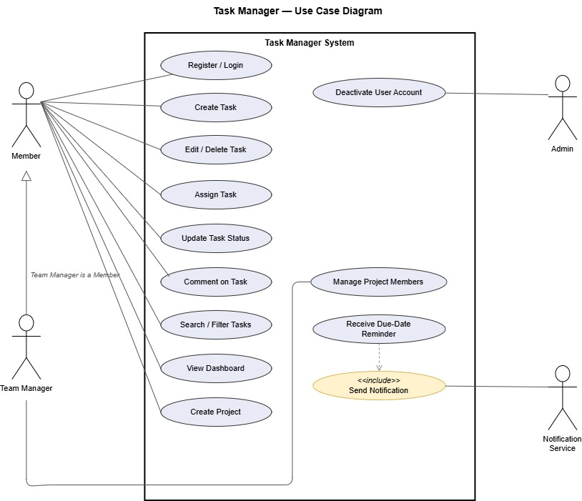
Figure 1: Task Manager — Use Case Diagram

3.5 Security Requirements

3.5.1 Security Objectives
ID | Objective | Description
SEC-OBJ-01 | Confidentiality | Protect user credentials and personal data from unauthorized disclosure, both at rest and in transit.
SEC-OBJ-02 | Integrity | Protect task, project, and comment data from unauthorized or unintended modification.
SEC-OBJ-03 | Availability / Abuse Prevention | Protect authentication endpoints from automated credential-guessing abuse.

3.5.2 Security Requirements
ID | Requirement | Traces to
SEC-REQ-01 | The system shall store user passwords using a salted adaptive hash (bcrypt, cost factor >= 10) and shall never store or log passwords in plaintext. | SEC-OBJ-01
SEC-REQ-02 | The system shall encrypt all client-server traffic using TLS 1.2 or higher; plaintext HTTP requests shall be rejected or redirected. | SEC-OBJ-01
SEC-REQ-03 | The system shall enforce role-based access control (RBAC) so that only a task's owner, its assignees, or a project Admin/Team Manager may modify or delete it. | SEC-OBJ-02
SEC-REQ-04 | The system shall lock an account for 15 minutes after 5 consecutive failed login attempts within a 15-minute window. | SEC-OBJ-03

Section 5 of the Test Plan (Test Cases) includes a dedicated Section 5.1, Security Validation, that verifies SEC-REQ-01 through SEC-REQ-04.

4. Appendix — Requirements Traceability Summary
Full traceability from each requirement to architecture components and test cases is maintained in the Software Architecture & Design Specification (traceability table) and the Test Plan (traceability matrix, Section 4.3), so that every FR/NFR/SEC requirement is designed for and tested at least once.

