Software Architecture & Design Specification
Task Manager Application

1. Introduction
This document describes the architecture and detailed design of the Task Manager Application, elaborating on the requirements defined in the Software Requirements Specification (SRS). It covers system decomposition, the chosen architectural pattern, security architecture, key interaction sequences, the REST API design, and error-handling strategy.

2. Architecture

2.1 Component Diagram and Description
The system is decomposed into a web client, an API gateway, three backend services, a relational database, a message queue, and an outbound notification provider. Figure 1 shows these components and their principal dependencies.
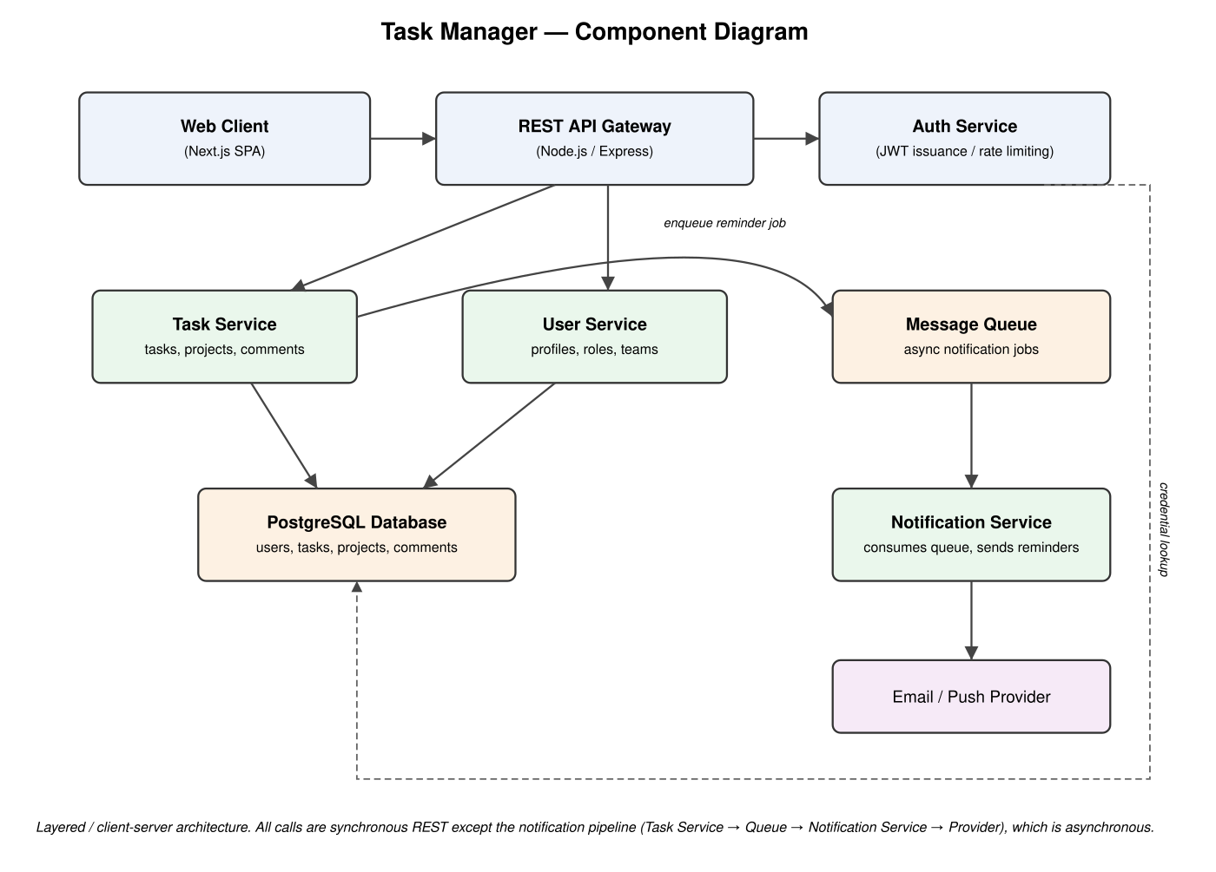
Figure 1: Task Manager — Component Diagram
Component responsibilities:
- Web Client (Next.js SPA) — renders the UI and calls the REST API over HTTPS.
- API Gateway (Node.js/Express) — terminates TLS, authenticates JWTs, validates requests, and routes to backend services.
- Auth Service — issues and verifies JWTs, hashes/verifies passwords, and enforces login rate-limiting.
- Task Service — owns task, project, and comment business logic.
- User Service — owns user profile, role, and team-membership logic.
- Notification Service — schedules and dispatches due-date reminders via a message queue.
- PostgreSQL Database — durable storage for all entities.
- Message Queue — decouples slow/asynchronous notification delivery from the request/response path.

2.2 Architecture Pattern
The system follows a layered client-server architecture with a service-oriented backend: a presentation layer (Web Client), an API/orchestration layer (API Gateway), a service layer (Task/User/Notification Services), and a data layer (PostgreSQL, Message Queue). This pattern was chosen because it (a) cleanly separates concerns so each service can be developed and tested independently, (b) keeps synchronous request paths fast by pushing notification delivery onto an async queue (supporting NFR-01), and (c) is a well-understood, low-risk pattern appropriate for a team-scale mini-project, avoiding the operational overhead of a full microservices deployment.

2.3 Traceability to Requirements
The Web Client and API Gateway are cross-cutting layers: every request for every functional requirement (FR-01–FR-15) passes through both, so listing them against individual requirement IDs would be redundant. The table below instead traces each requirement to the service that owns its business logic — the more meaningful mapping for design and test purposes.
Component (business-logic owner) | Functional Requirements Owned | Security Requirements Enforced
Auth Service | FR-01, FR-02, FR-14 | SEC-REQ-01, SEC-REQ-02, SEC-REQ-04
Task Service | FR-03, FR-04, FR-05, FR-06, FR-07, FR-08, FR-09, FR-11, FR-12 | SEC-REQ-03
User Service | FR-01, FR-14, FR-15 | SEC-REQ-03
Notification Service | FR-10 | —
PostgreSQL Database | Persists all entities owned by the services above | SEC-REQ-01 (hashed passwords at rest)
Message Queue | Decouples FR-10 delivery from the request path (supports NFR-01) | —

The API Gateway additionally enforces SEC-REQ-03 (RBAC) uniformly on every route before forwarding to the owning service below, regardless of which requirement the route implements.

2.4 Security Architecture
Security is enforced at three layers, corresponding to the SRS security requirements (Section 3.5):
- Transport: all traffic between Web Client, API Gateway, and downstream services uses TLS 1.2+ (SEC-REQ-02).
- Authentication: the Auth Service issues short-lived JWT access tokens and longer-lived refresh tokens; passwords are hashed with bcrypt (cost factor ≥ 10) and never logged (SEC-REQ-01).
- Authorization: the API Gateway enforces role-based access control (RBAC) on every request, checking the caller's role and relationship to the resource (owner, assignee, Team Manager, Admin) before forwarding to a backend service (SEC-REQ-03).
- Abuse prevention: the Auth Service tracks failed login attempts per account and applies a 15-minute lockout after 5 consecutive failures (SEC-REQ-04).

2.5 Deployment View
The Web Client is served as static assets from a CDN. The API Gateway and backend services run as containerized processes behind a load balancer. PostgreSQL runs as a managed database instance with automated backups. The Message Queue runs as a managed broker (e.g., a hosted Redis/RabbitMQ instance). This separation lets the API tier scale horizontally to meet NFR-04 (scalability) independently of the database.

3. Design

3.1 UML Sequence Diagrams
Two representative flows are detailed below: user login (security-critical) and task creation (the system's core write path).

3.1.1 User Login
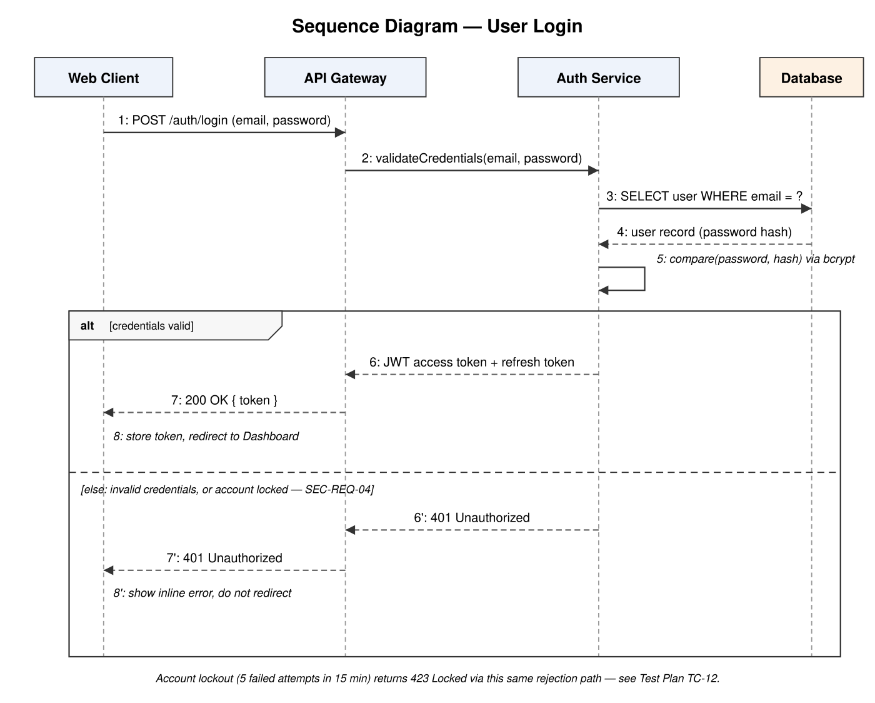
Figure 2: Sequence Diagram — User Login

3.1.2 Create Task
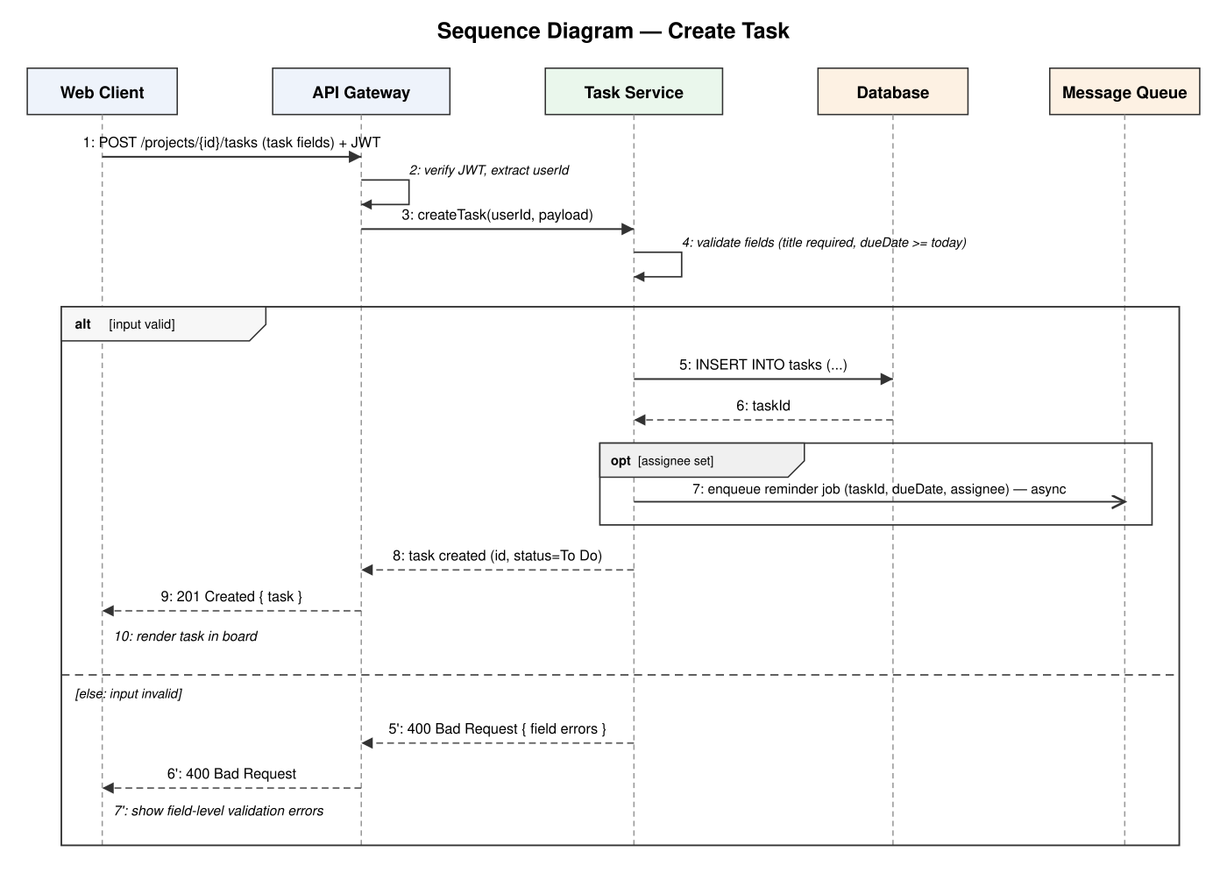
Figure 3: Sequence Diagram — Create Task

3.2 API Design
The API is a JSON-over-HTTPS REST interface. All endpoints except registration and login require a valid JWT bearer token. Each endpoint below is traced to the SRS requirement(s) it fulfills.
Method | Path | Description | Traces to
POST | /auth/register | Register a new user account. | FR-01
POST | /auth/login | Authenticate and receive a JWT access/refresh token pair. | FR-02, SEC-REQ-01, SEC-REQ-04
GET | /projects | List projects the authenticated user is a member of. | FR-08
POST | /projects | Create a new project. | FR-08
POST | /projects/{id}/members | Add a member to a project (Team Manager only). | FR-15, SEC-REQ-03
DELETE | /projects/{id}/members/{userId} | Remove a member from a project (Team Manager only). | FR-15, SEC-REQ-03
GET | /projects/{id}/tasks | List tasks in a project; supports query params for search/filter. | FR-11, FR-12
POST | /projects/{id}/tasks | Create a task within a project. | FR-03
GET | /tasks/{id} | Get a single task's details, including comments. | FR-04
PATCH | /tasks/{id} | Update task fields (title, description, due date, priority, status, assignees). | FR-04, FR-06, FR-07, SEC-REQ-03
DELETE | /tasks/{id} | Delete a task (owner or Admin/Team Manager only). | FR-05, SEC-REQ-03
POST | /tasks/{id}/comments | Add a comment to a task. | FR-09
GET | /dashboard | Get the current user's task-count summary by status. | FR-13
POST | /admin/users/{id}/deactivate | Deactivate a user account (Admin only). | FR-14, SEC-REQ-03

3.3 Error Handling
The API uses conventional HTTP status codes and a consistent JSON error envelope: { "error": { "code": string, "message": string, "details": object? } }.
Status | Meaning / Usage
400 Bad Request | Request failed validation (e.g., missing task title, past due date). `details` lists the offending field(s).
401 Unauthorized | Missing, expired, or invalid JWT; also returned for invalid login credentials.
403 Forbidden | Authenticated but the caller lacks permission for the resource (RBAC check failed, SEC-REQ-03).
404 Not Found | The requested task, project, or user does not exist or is not visible to the caller.
409 Conflict | A concurrent update conflict, e.g., two clients editing the same task simultaneously.
423 Locked | Account temporarily locked after repeated failed login attempts (SEC-REQ-04).
429 Too Many Requests | General rate limit exceeded on an endpoint.
500 Internal Server Error | Unexpected server failure; the response omits internal details and is logged server-side with a correlation ID.

Client-side, the Web Client surfaces field-level validation errors inline on forms and shows a toast notification for 401/403/5xx responses, redirecting to the login page on 401.

3.4 Data Model (Other Sections)
Core entities: User (id, email, passwordHash, displayName, role, isActive), Project (id, name, ownerId), ProjectMember (projectId, userId, role), Task (id, projectId, title, description, dueDate, priority, status), TaskAssignee (taskId, userId), Comment (id, taskId, authorId, body, createdAt). Foreign keys enforce referential integrity; task deletion cascades to its comments and assignee rows.

3.5 Other Sections — Technology Stack Summary
Layer | Technology
Frontend | Next.js (React) single-page application
API / Backend | Node.js with Express
Database | PostgreSQL 14+
Auth | JWT (access + refresh tokens), bcrypt password hashing
Async Messaging | Message queue (e.g., Redis-backed job queue) for notification delivery

