**实验八 利用四节拍顺序脉冲发生器显示学号**

**姓名 侯少森 学号 18340055**

1. **检查节拍发生器的循环设计**

**1.实验内容**

**将74LS194按照四节拍顺序脉冲发生器接好,使用示波器检查QA-QD是否符合节拍发生器0111->1011->1101->1110**

**2.仿真电路与结果**

**(1)在proteus上设计好仿真电路图:**

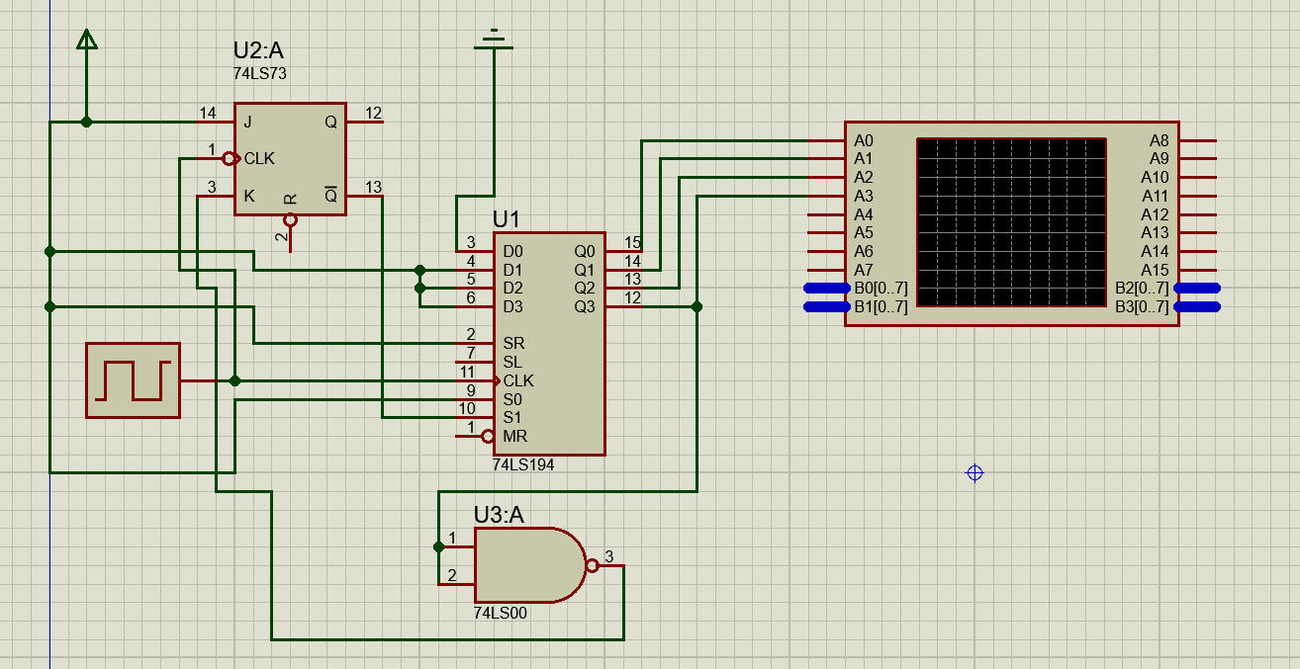

**(2)仿真结果图如下:**

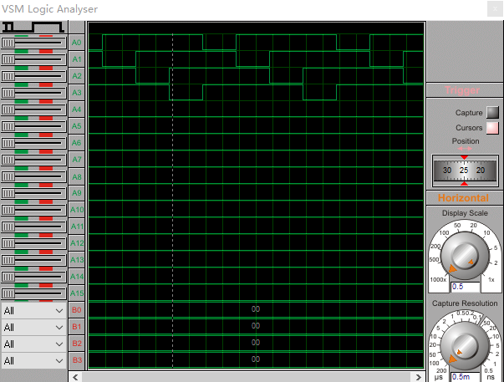

**3.实验结果与分析**

**(1)在实验箱上连接好设计的电路**

**(2)实验结果图如下:**

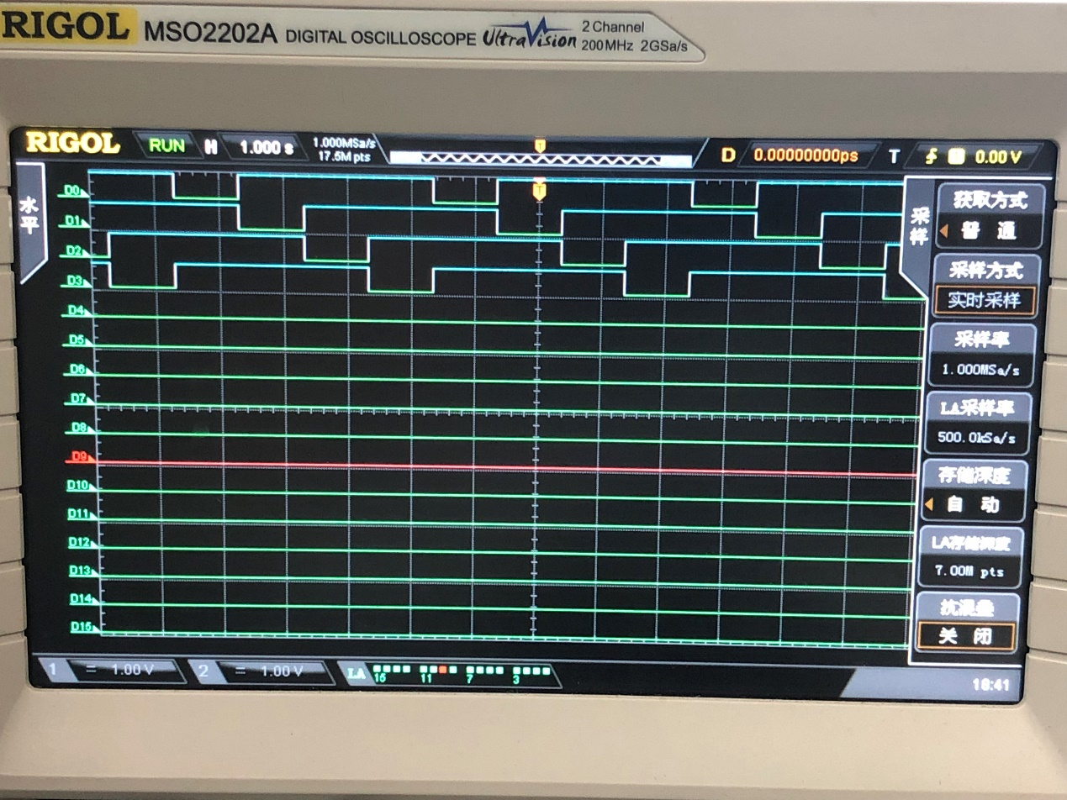

**可以看出符合节拍发生器0111->1011->1101->1110的循环.**

**二、显示八位学号设计**

* 1. **实验内容（不限但包括真值表构建、函数表达式）**

**该实验要用到移位寄存器74LS194.**

**(1)将74LS194接成四节拍顺序脉冲发生器，接入数码管位选通端DIG1~DIG4同时也接入DIG5~DIG8，注意74LS194的时钟要接高频信号，以使数码管同时显示8位数字。**

**(2)列出真值表，输入为DIG1~DIG8，输出为2组4联装7段数码管BCD码输入端P13、P12、P11、P10、P23、P22、P21、P20。八输入八输出真值表格式见下页：(当前显示的八位学号是18340055)**

|  |  |  |  |  |  |  |  |  |  |  |  |  |  |  |  |
| --- | --- | --- | --- | --- | --- | --- | --- | --- | --- | --- | --- | --- | --- | --- | --- |
| **输入** | | | | | | | | **输出** | | | | | | | |
| **DIG1** | **DIG2** | **DIG3** | **DIG4** | **DIG5** | **DIG6** | **DIG7** | **DIG8** | **P13** | **P12** | **P11** | **P10** | **P23** | **P22** | **P21** | **P20** |
| **0** | **1** | **1** | **1** | **0** | **1** | **1** | **1** | **0** | **0** | **0** | **1** | **0** | **0** | **0** | **0** |
| **1** | **0** | **1** | **1** | **1** | **0** | **1** | **1** | **1** | **0** | **0** | **0** | **0** | **0** | **0** | **0** |
| **1** | **1** | **0** | **1** | **1** | **1** | **0** | **1** | **0** | **0** | **1** | **1** | **0** | **1** | **0** | **1** |
| **1** | **1** | **1** | **0** | **1** | **1** | **1** | **0** | **0** | **1** | **0** | **0** | **0** | **1** | **0** | **1** |

**(3)画出相应的卡诺图:**

**P10:**

|  |  |  |  |  |
| --- | --- | --- | --- | --- |
| **DIG3DIG4**  **DIG1DIG2** | **00** | **01** | **11** | **10** |
| **00** | **X** | **X** | **X** | **X** |
| **01** | **X** | **X** | **1** | **X** |
| **11** | **X** | **1** | **X** | **0** |
| **10** | **X** | **X** | **0** | **X** |

**P11:**

|  |  |  |  |  |
| --- | --- | --- | --- | --- |
| **DIG3DIG4**  **DIG1DIG2** | **00** | **01** | **11** | **10** |
| **00** | **X** | **X** | **X** | **X** |
| **01** | **X** | **0** | **0** | **X** |
| **11** | **X** | **1** | **X** | **0** |
| **10** | **X** | **X** | **0** | **X** |

**P12:**

|  |  |  |  |  |
| --- | --- | --- | --- | --- |
| **DIG3DIG4**  **DIG1DIG2** | **00** | **01** | **11** | **10** |
| **00** | **X** | **X** | **X** | **X** |
| **01** | **X** | **X** | **0** | **X** |
| **11** | **X** | **0** | **X** | **1** |
| **10** | **X** | **X** | **0** | **X** |

**P13:**

|  |  |  |  |  |
| --- | --- | --- | --- | --- |
| **DIG3DIG4**  **DIG1DIG2** | **00** | **01** | **11** | **10** |
| **00** | **X** | **X** | **X** | **X** |
| **01** | **X** | **X** | **0** | **X** |
| **11** | **X** | **0** | **X** | **0** |
| **10** | **X** | **X** | **1** | **X** |

**P20/P22:**

|  |  |  |  |  |
| --- | --- | --- | --- | --- |
| **DIG3DIG4**  **DIG1DIG2** | **00** | **01** | **11** | **10** |
| **00** | **X** | **X** | **X** | **X** |
| **01** | **X** | **X** | **0** | **X** |
| **11** | **X** | **1** | **X** | **1** |
| **10** | **X** | **X** | **0** | **X** |

**P21/P23:**

|  |  |  |  |  |
| --- | --- | --- | --- | --- |
| **DIG3DIG4**  **DIG1DIG2** | **00** | **01** | **11** | **10** |
| **00** | **X** | **X** | **X** | **X** |
| **01** | **X** | **X** | **0** | **X** |
| **11** | **X** | **0** | **X** | **0** |
| **10** | **X** | **X** | **0** | **X** |

**(4)根据卡诺图得出对应的表达式(因为Word有些符号无法表示,故在下边的表达式中将DIG缩写为D):**

**P10 =‾D1+‾D3**

**P11 =‾D3**

**P12 =‾D4**

**P13 =‾D2**

**P20 = P22 = D1D2**

**P21 = P23 = 0**

* 1. **仿真电路与结果**

**(1)根据上面得到的表达式,在 proteus 上设计出仿真电路图:**

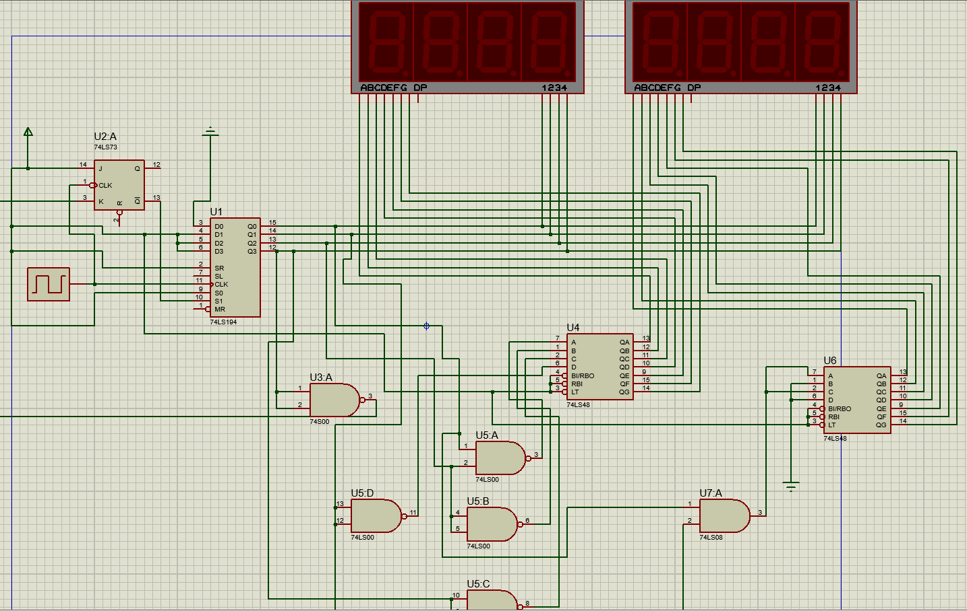

**(2)点击运行,开始运行仿真电路图,得到的结果图如下:**

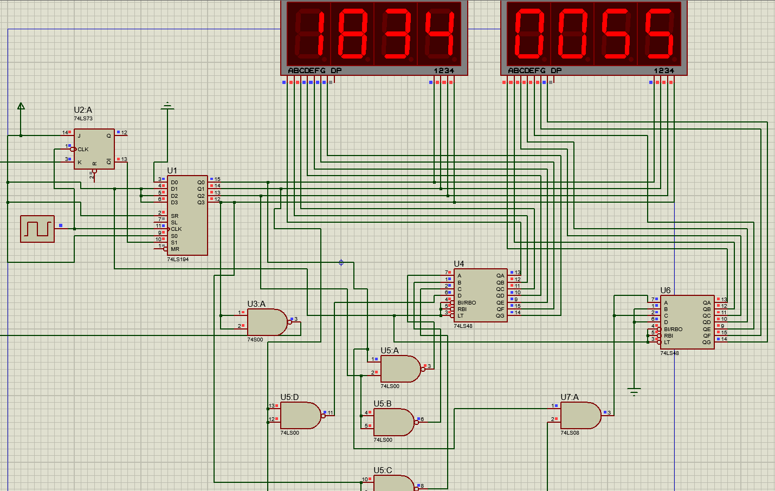

* 1. **实验结果与分析**

**(1)在实验箱上连接好设计的电路**

**(2)实验结果图如下:**

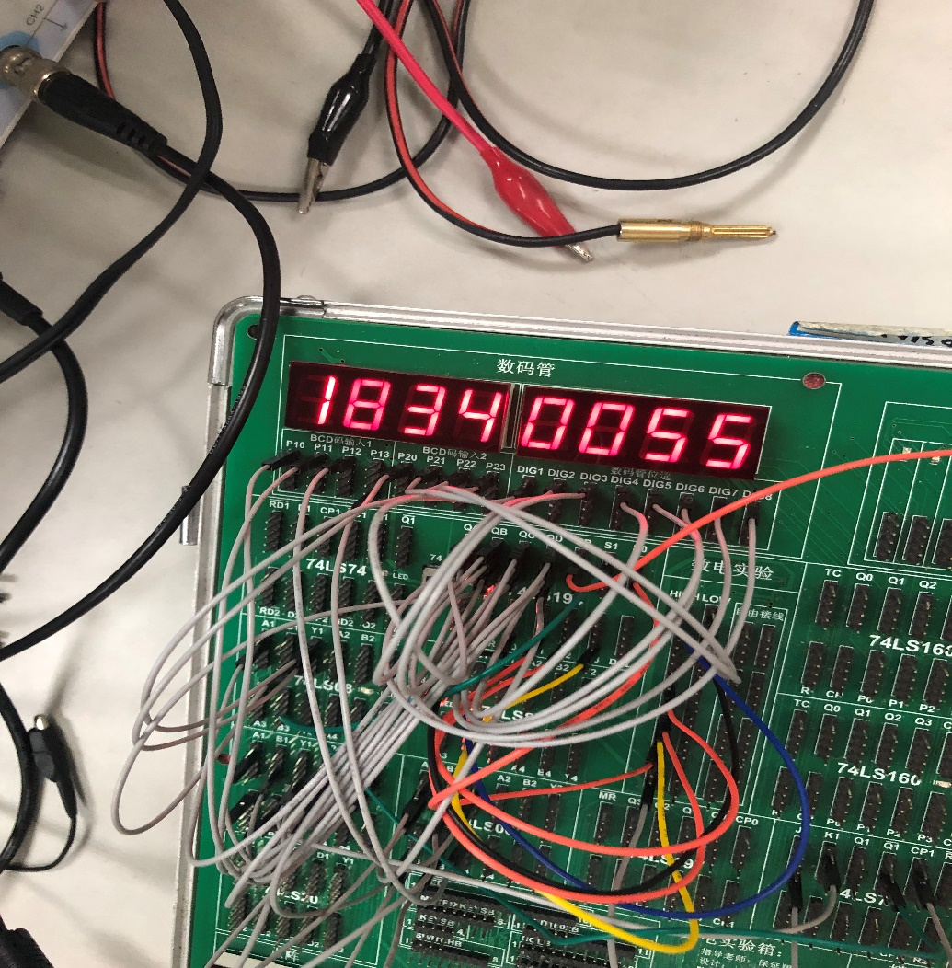

**三、实验总结**

**(1)74LS194是上升沿触发,74LS73是下降沿触发.所以在功能测试时要按手动正脉冲使得74LS194的CP端收到上升沿.**

**(2)掌握了移位寄存器的逻辑功能和使用方法**

**(3)掌握了J-K触发器的应用**