CPE 301 Final Team Project Documentation
Holden Bowman
Nathaniel Woods

Overview

The system functions as a swamp cooler. It works by blowing a fan over water. This cools the air down. This works because the air blowing across the surface of the water evaporates some of the water and helps to keep the water cool and continuing to work. That is why they do not work too well in humid environments.

It has 4 main sections. The control, Display, sensors, and motors.

Control
-Has two potentiometers and a button
-P1 controls the contrast
-P2 controls the set angle of the stepper motor
-B1 turns the system on and off.
Display
-Has 4 LEDs and an LCD
-LCD displays current temperature (C) and humidity
-Blue LED turns on when the system is running
-Green LED turns on when the system is idling
-Yellow LED when the system has been disabled by the button
-Red LED when the system is not running due to being in an error state
Sensors
-The system has 2 sensors a DHT11 and a Water Level sensor
-The water level sensor sends an analog signal and the ADC converts to a digital value from
0 to 255
-The DHT 11 detects temperature and humidity and its operating temperature range is 0C to 50C.
Motors
-The system has 2 motors. The Fan Motor and a stepper motor.
-The purpose of the stepper motor is to control the direction of a vent in front of the main fan.

Pictures

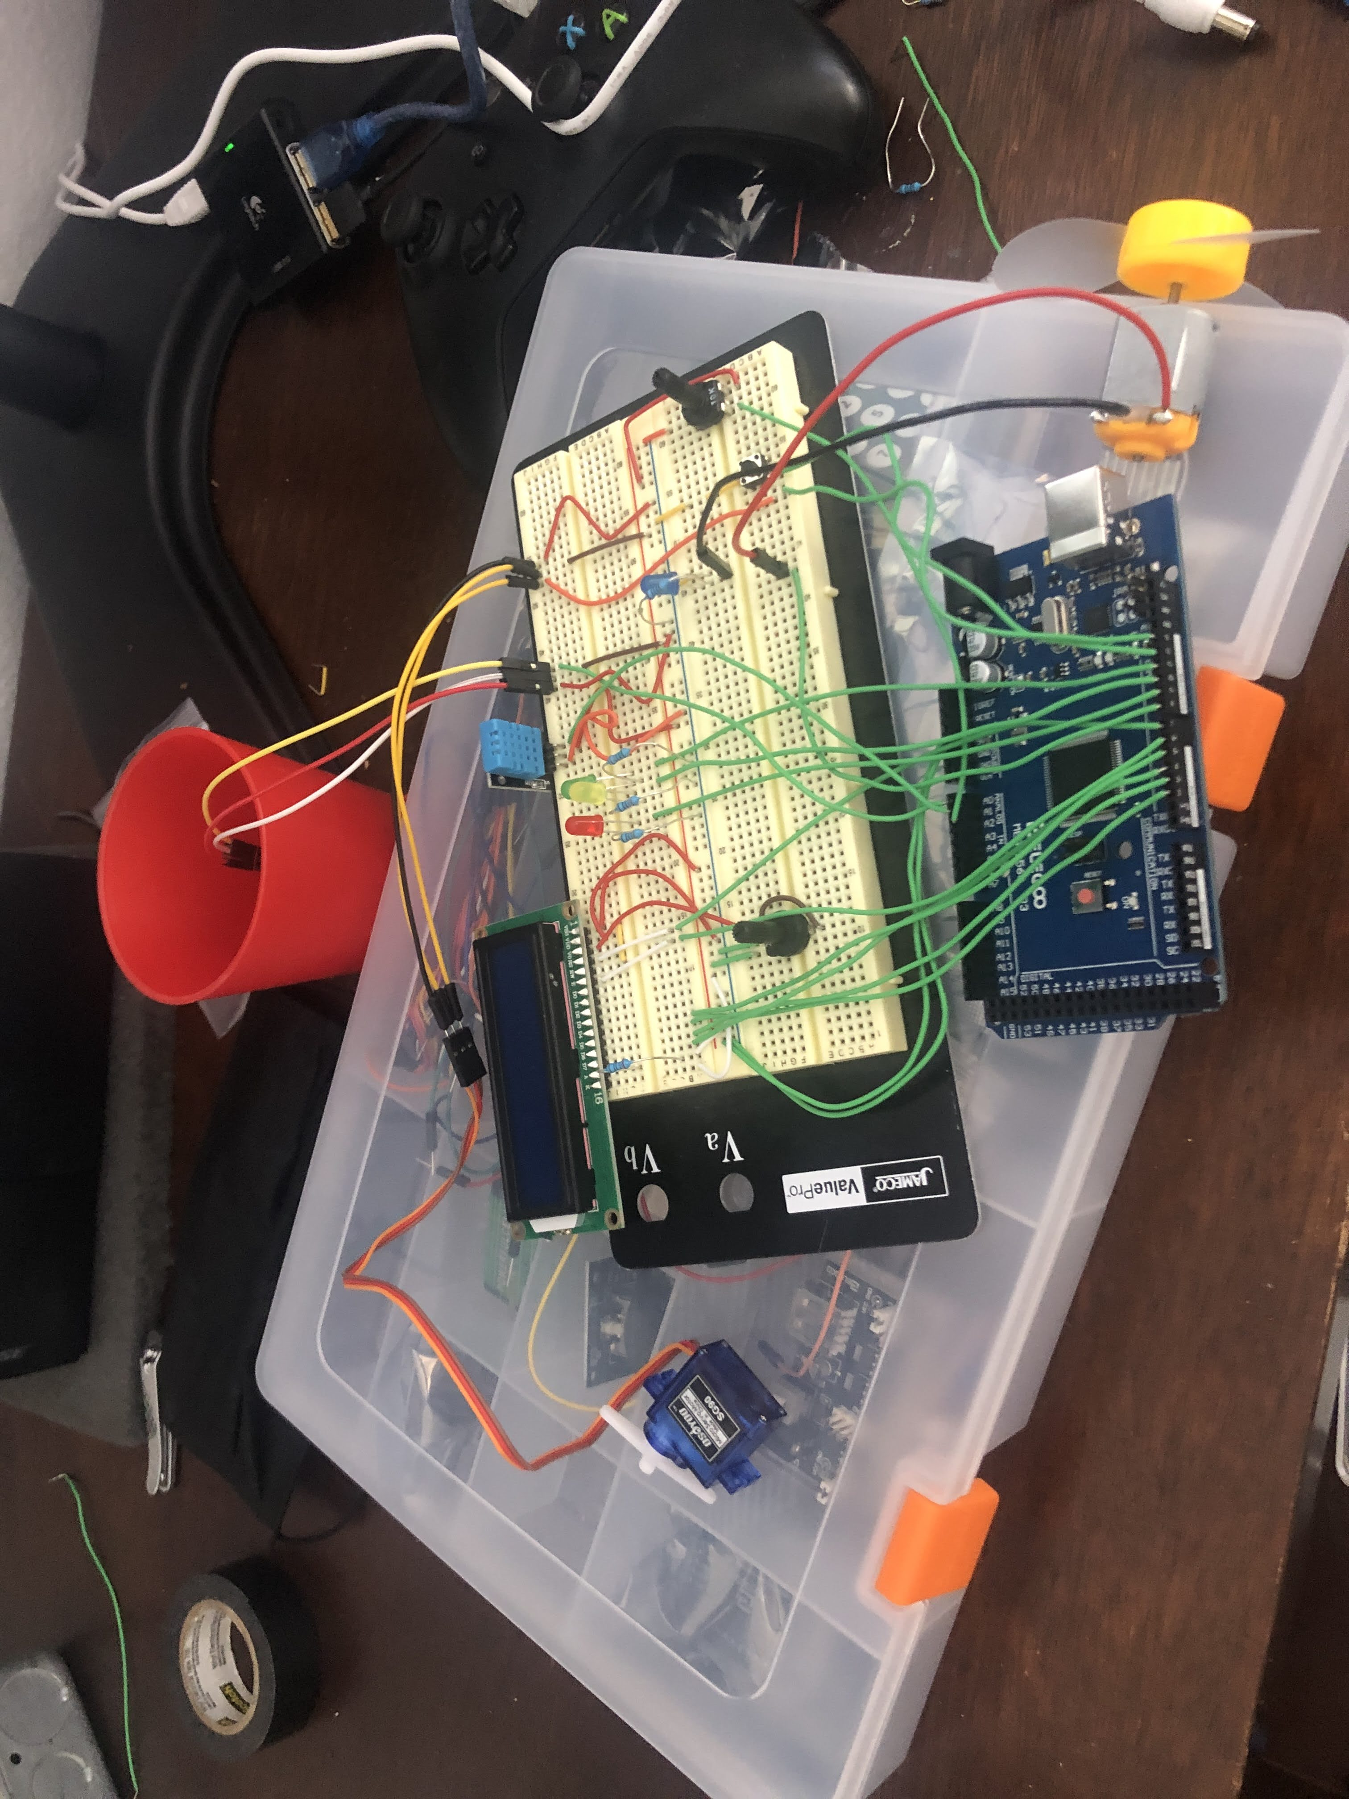
Figure 1: The circuit with its components

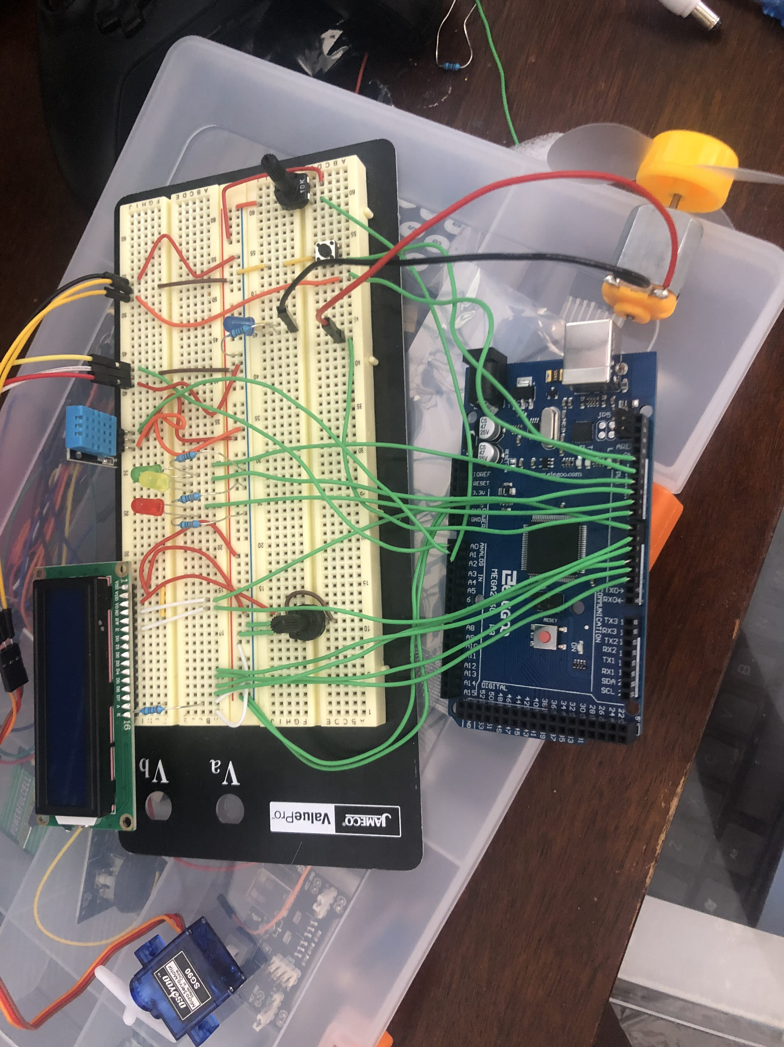

Figure 2: Main part of the Circuit close up

Test Plan

There are a 3 main test areas. Normal function, controls, and sensors. For the first test we just turn it on and see if it behaves as expected for the environment it is present in. Then we should adjust the dials and see if the contrast of the LCD change and if the stepper motor changes its angle. Then we should check if the systems yellow light turns on when we press the button. Next we test the water sensor. If we pull the water sensor below its threshold does it turn off and turn on the red error light? Next we need to test the DHT if it is covered with a hand it should turn on and the blue light should come on. If we place a piece of metal inside the fridge for a long time and place it on the sensor it should turn off and the green light should turn on.

Links

-Github Repository
-DHT11 Data Sheet
-SG90 Stepper motor Data Sheet
-Link to the Arduino Kit data shee

