14:08 2019/11/19 Wednesday

**Labyrinth Playtest Notes Summary**

**Play testers: Woke Cheese (Reinhold, Mantas, Adrian)**

Understood Setup, and showed use of counter play.

***Setup took 10mins.***

Stacking counters results in harder enemies, although useless stacking occurred.

(Multiple of the same counter doesn’t result in a stronger enemy)

Understood invasion mechanic.

***30mins before starting to play after setup, (clarify rules).***

Skeleton fighting not clear enough;

*Skeleton attacks are based on turns, i.e. they have 1 AP. They though they attack 2 times, however they thought they attacked 2 times a round.*

Clarify the calculation sheet, they thought they could take negative damage. Specify the base damage is ‘true’ damage.

Clarify that you take a minimum damage.

Clarify overall damage model and the armour bonuses.

Didn’t fight skeletons on green, specify that skeletons spawn on all coloured triangles, just different equipment.

***Getting to the middle triangle took 40mins.***

Clarify the minotaur only attacks when in the middle triangle.

**Recommendations**

Simply elements of the game, they felt overloaded.

Re-arrange rules to appear as they would come up in-game.

**Labyrinth Rush Play Test Questions**

1. How long did it feel you played for?
2. What was your strategy?
3. Did anything hold you back from your plans going through?
4. Name the most similar game you played?
5. What was the biggest challenge you faced?
6. Was there any confusion when you were playing?
7. What was your objective at any given time?
8. Is there anything you think should be changed/added to enhance the game?
9. How did you find the random elements of the equipment/consumable cards?
10. How involved in trading were you?
11. Were you engaged on another person’s turn?

**Adrian’s Questionnaire**

1. Played for what felt like 15 mins playing; 7 minutes rules
2. Killing every skeleton for loot
3. Nothing apart for the time maybe
4. Personally haven’t played anything like it.
5. Understanding the damage calculation
6. Is the calculation the same for player and skeleton (minimum 2 damage for both)
7. Getting as much loot as possible to fight the minotaur.
8. Maybe change the AP to 3 max but you replenish 2 at the start of the turn. (so you start with 2 if you end with 1; 2 if you end with 0), something to encourage minotaur rushing.
9. Some imbalance between the consumable cards
10. Not at all because we didn’t meet
11. I was engaged by trying to figure out the rules with them.

**Reinhold’s Questionnaire**

1. About half an hour. Felt longer at the beginning and shorter later on.
2. Gathering starter items to be prepared for more difficult encounters.
3. Could progress nicely as the challenges are not too hard at first.
4. Binding of Isaac
5. The rules or rather the uncertainties
6. See 5
7. Survive and gear up
8. For the time playing I felt like the game was balanced
9. The cards encountered were not overpowered, posed a challenge and a reward.
10. Not yet because I didn’t have items to trade.
11. Yes, on the outcome to plan further on.

**Mantas’ Questionnaire**

1. 20 mins
2. Get 1st item (armour), rush the boss.
3. No
4. None
5. The other players
6. The combat for the first time.
7. Rush some items.
8. Keeping track of the boss, 3 per turn, ballista shot.
9. Too little encounters to tell for now.
10. We did not get to that part.
11. Not really.

**Screenshot of the Finish Playtest Session**

**Red**: Reinhold

**Green**: Mantas

**Blue**: Adrian 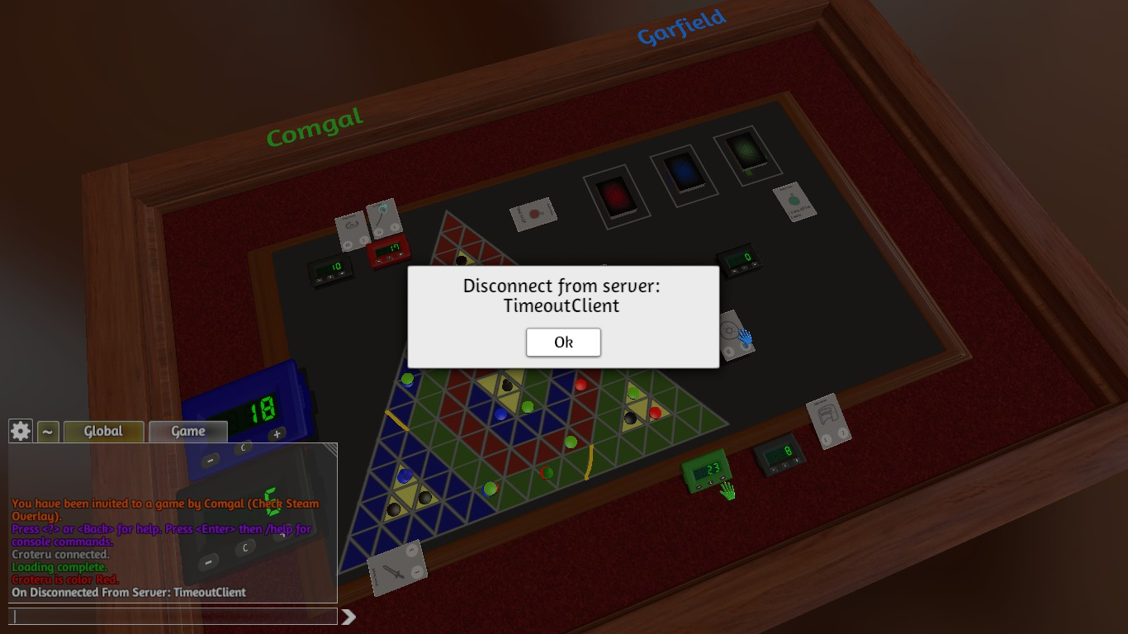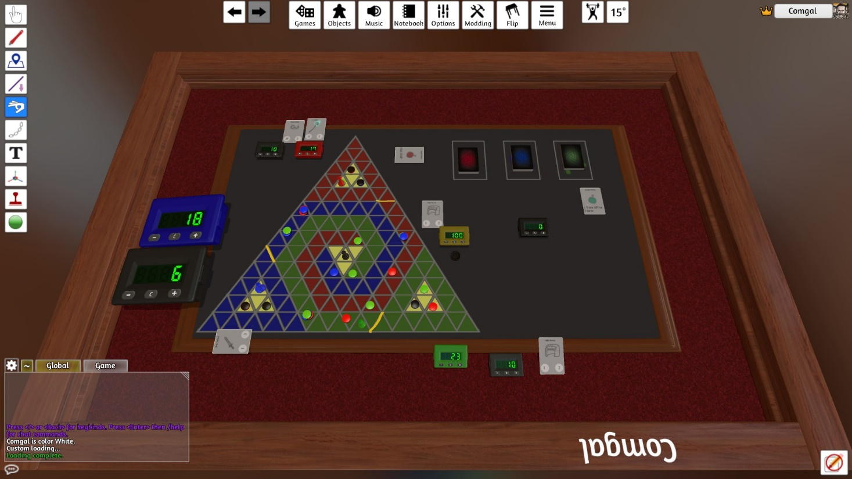

**Workshop download for playtest**

https://steamcommunity.com/sharedfiles/filedetails/?id=1916552701