Linux:

Q1

2)

Product of four nums

read -p "Enter num 1: " a

read -p "Enter num 2: " b

read -p "Enter num 3: " c

read -p "Enter num 4: " d

prod=$((a\*b\*c\*d))

echo " The product of all 4 nums is : $prod"

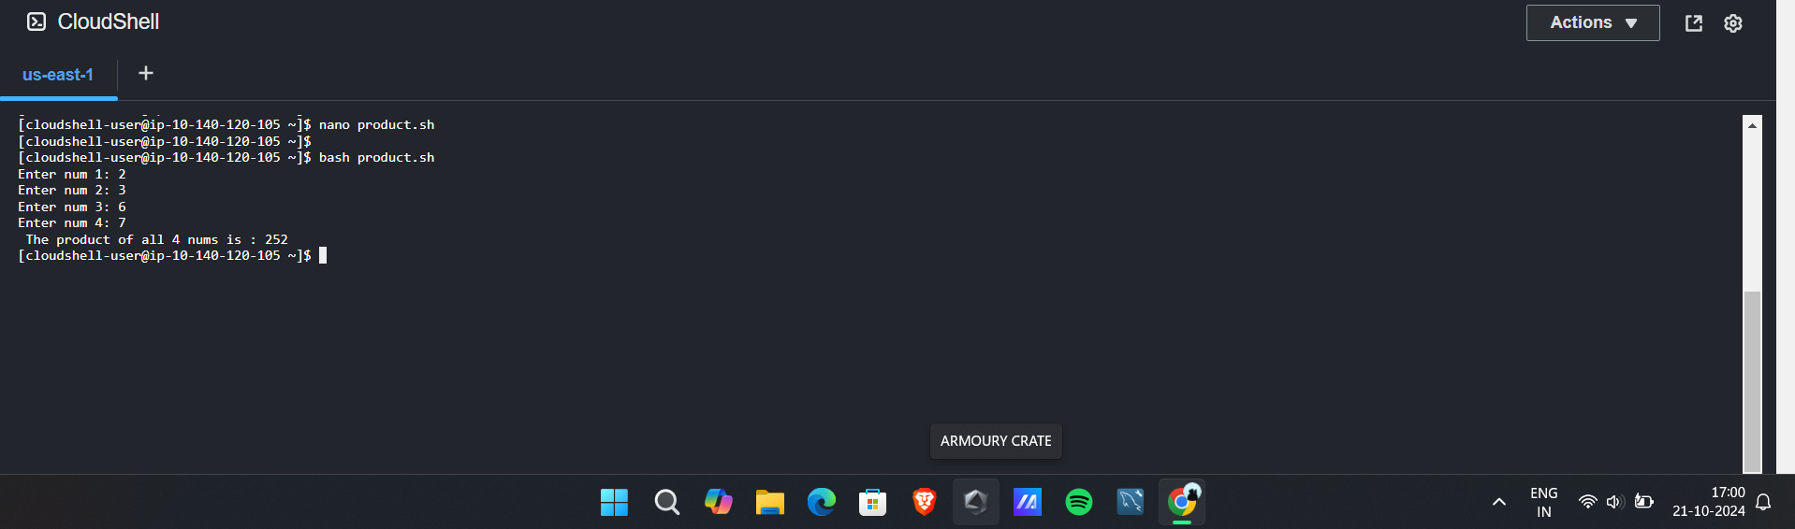

3) average of four nnos

read -p "Enter num 1: " a

read -p "Enter num 2: " b

read -p "Enter num 3: " c

read -p "Enter num 4: " d

avg=$((a+b+c+d/4))

echo "The avgeragee of four numbers is : $avg "

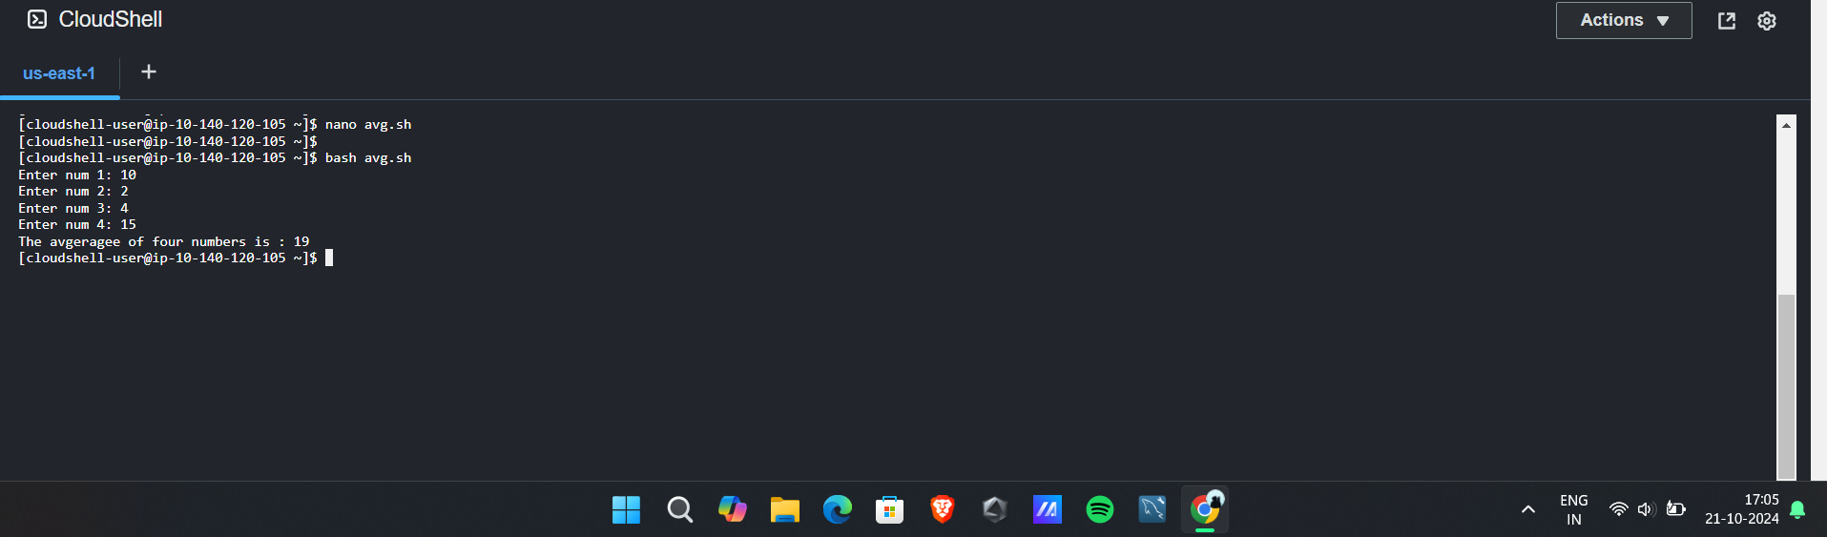

—---------------------------------------------------------------------------------------------------

Cloud

Iam user with full ec2 access:

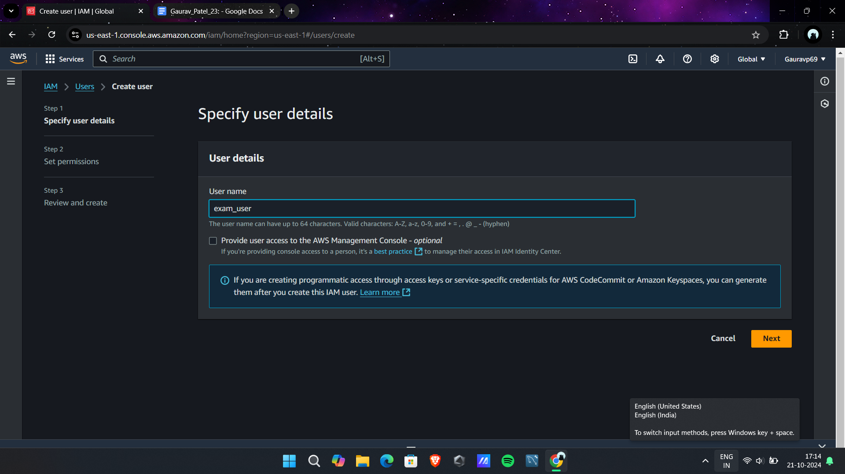

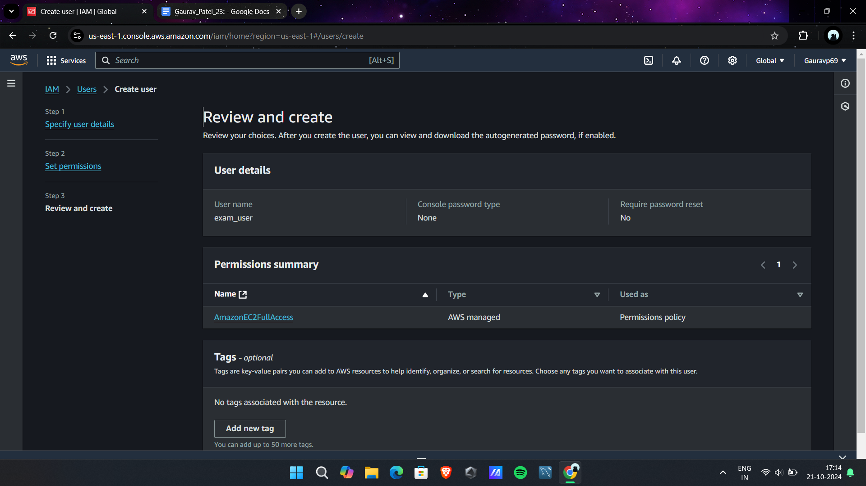

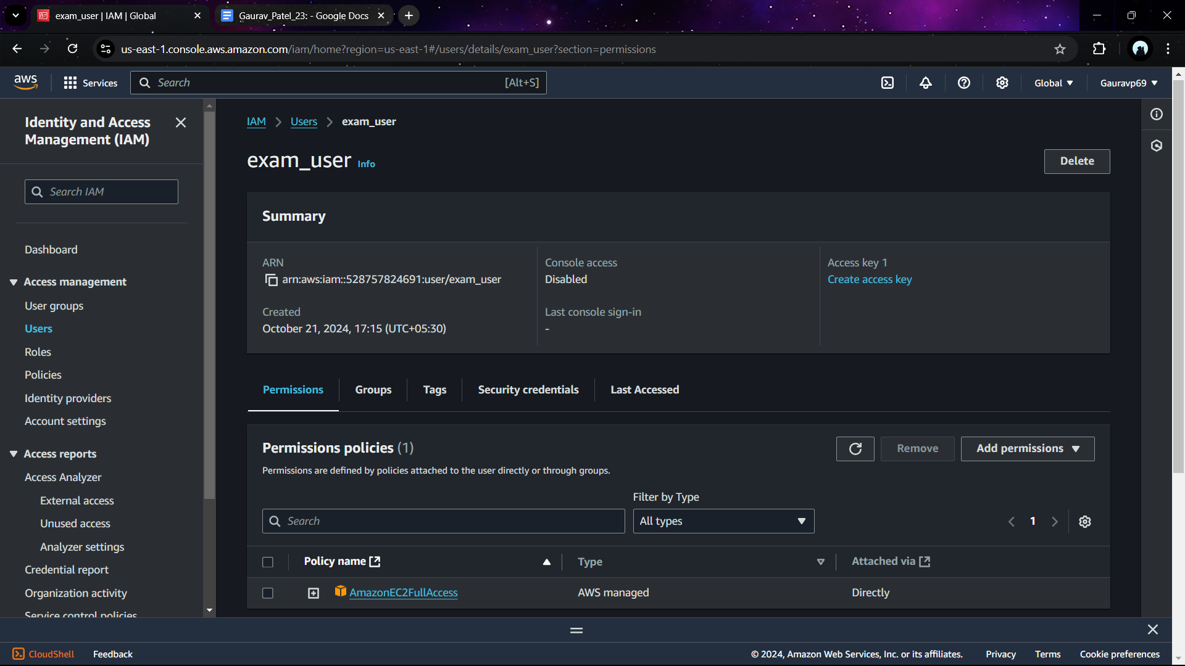

Step 2:

Login with user and launch the instance

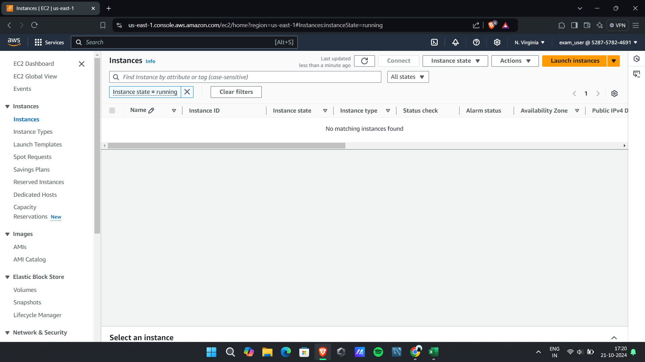

Create an instance

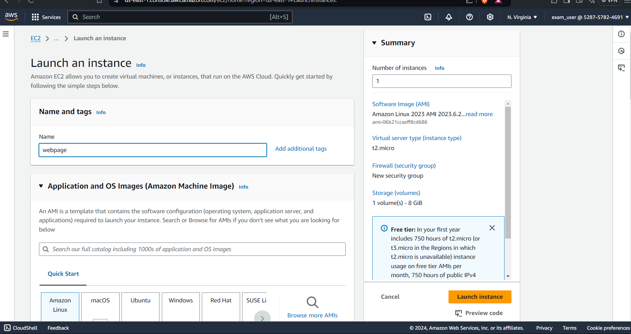

Assign key pair

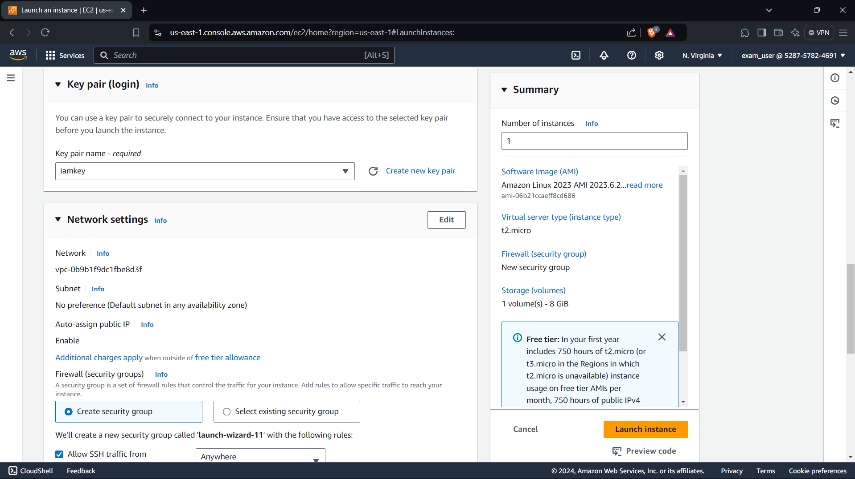

Allow all network setting for public access

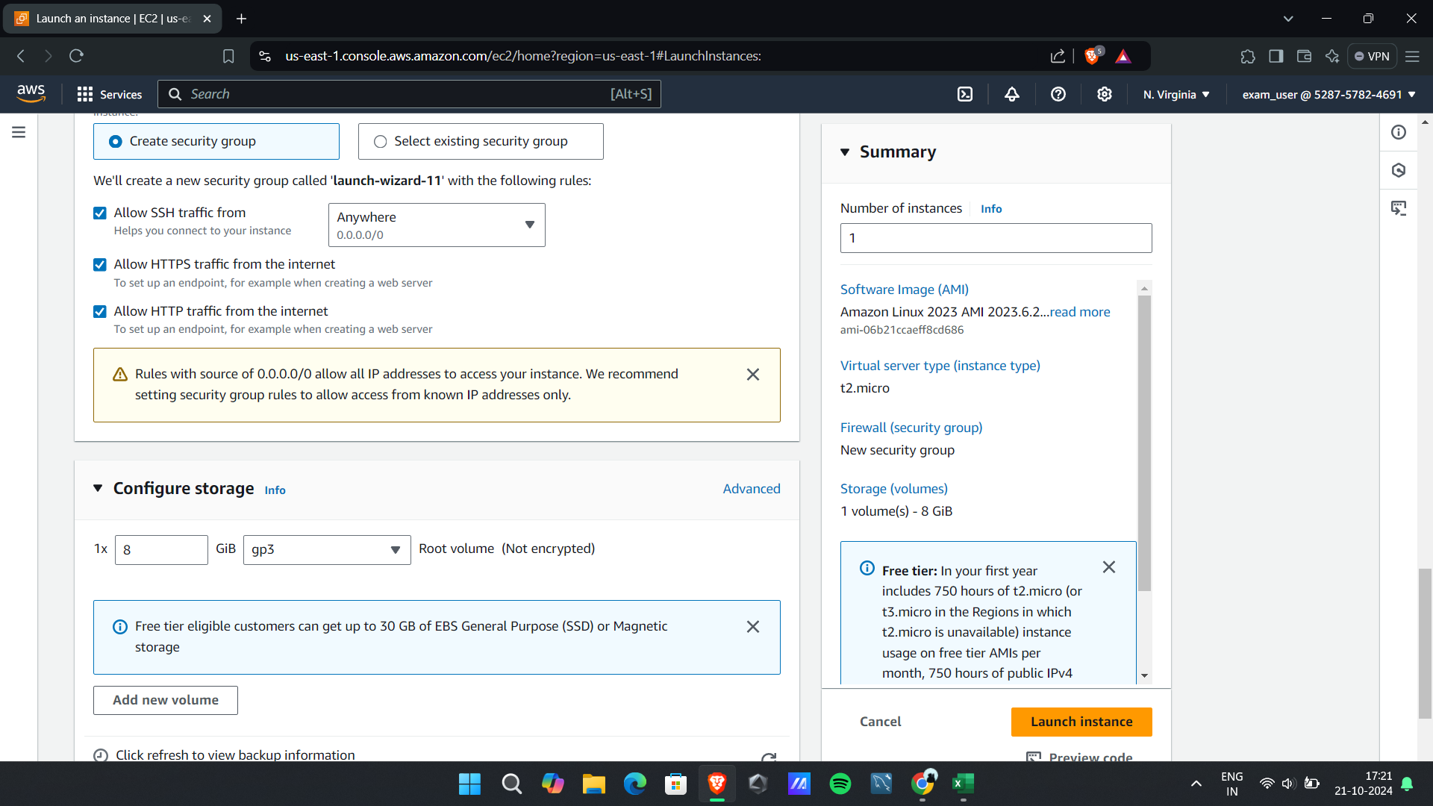

Instance launched successfully

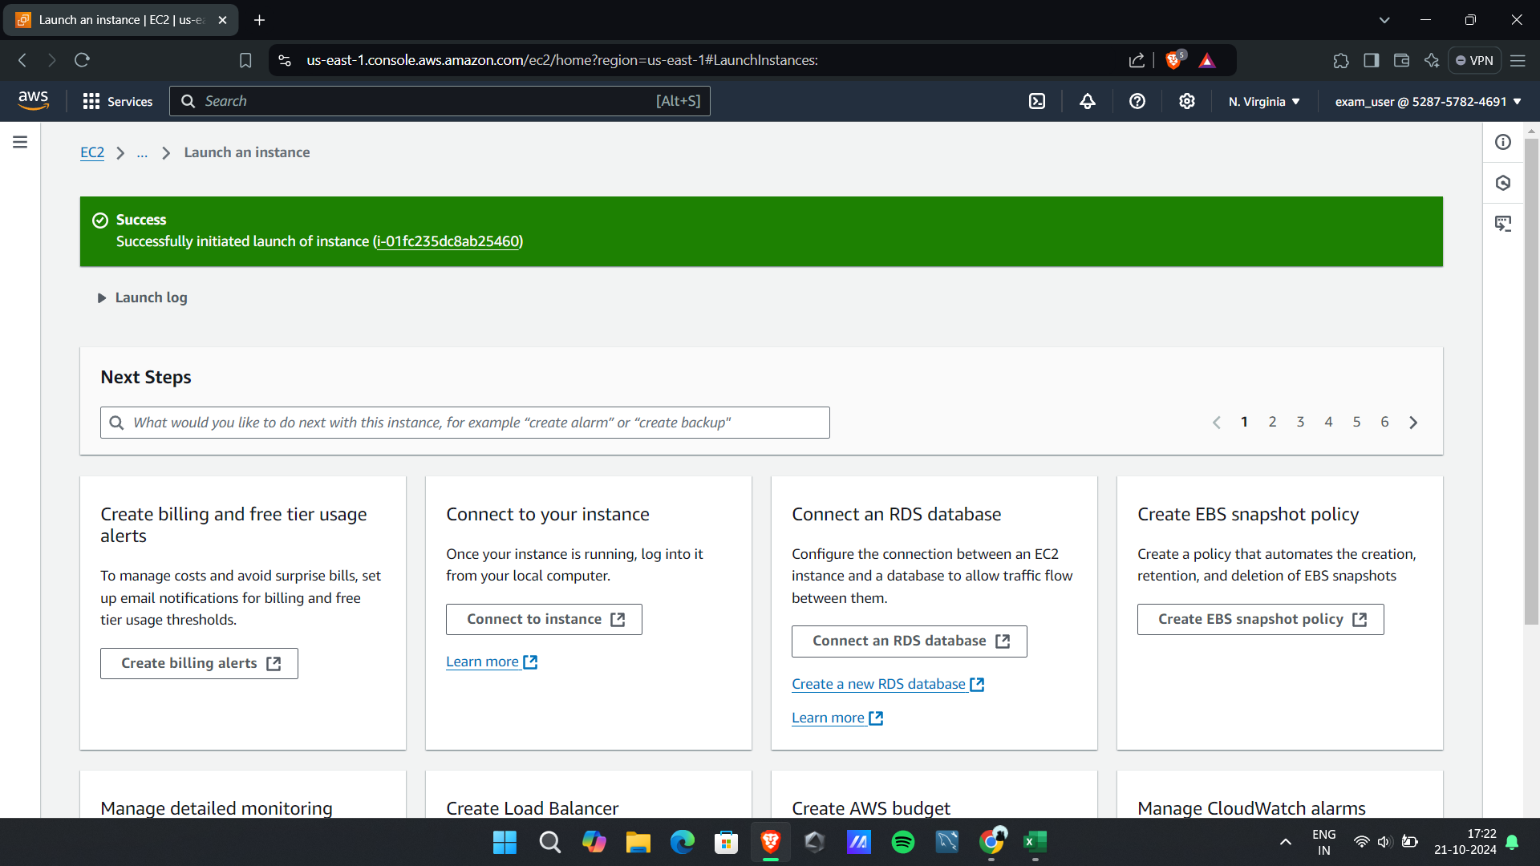

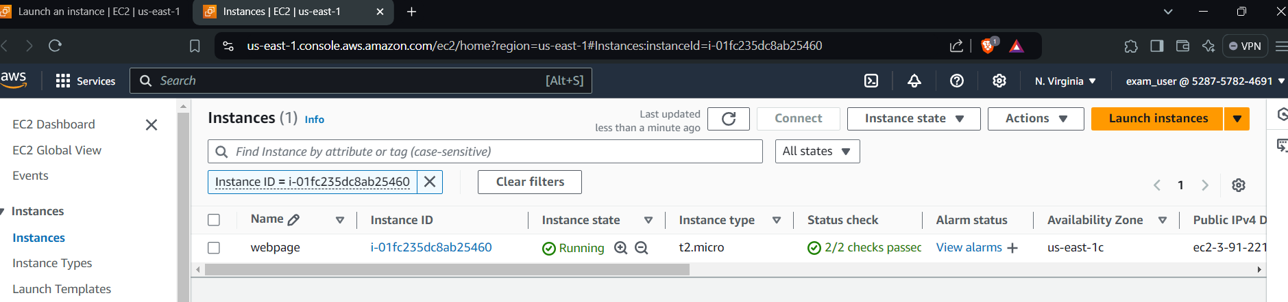

Step 3)

Create bucket

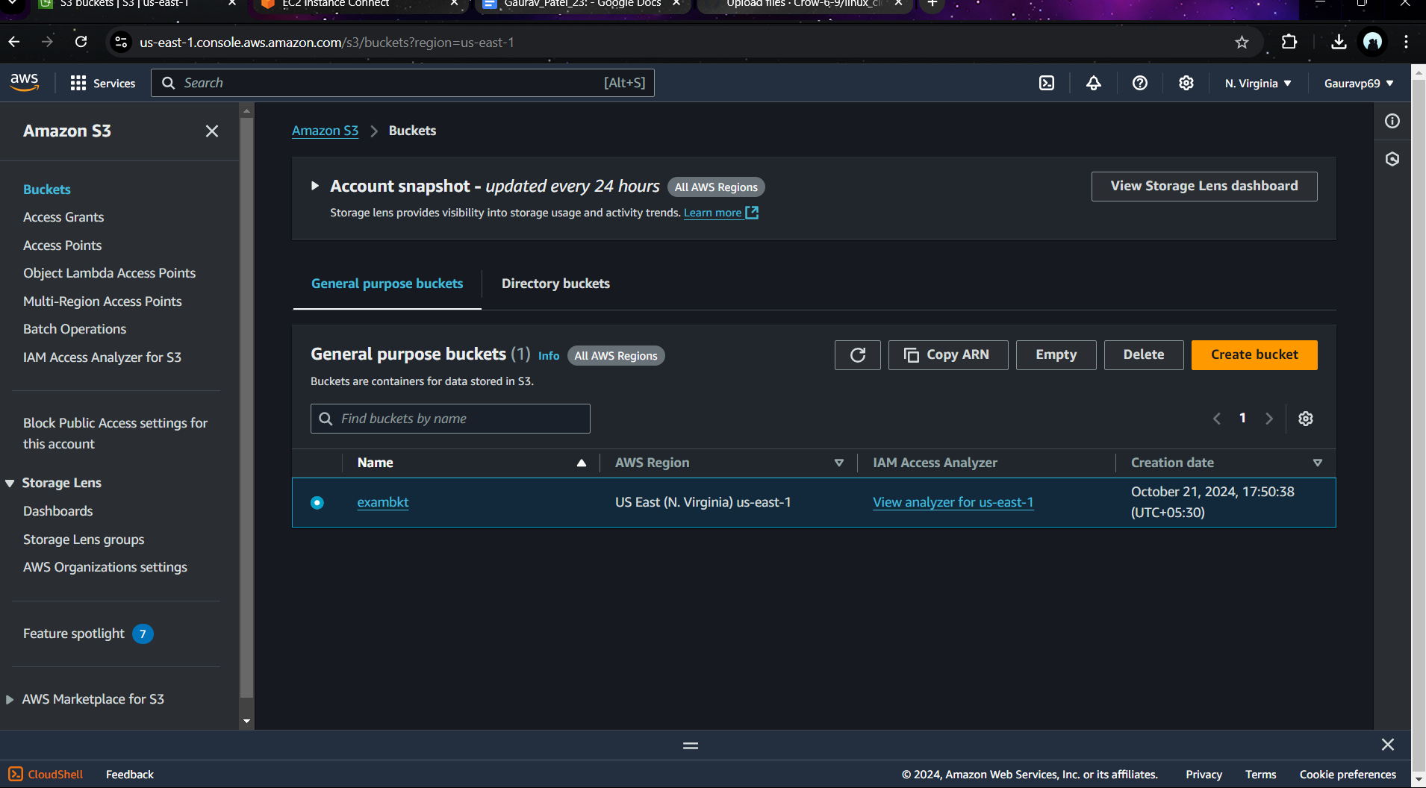

Step 4:

Create a html file with msg “Hello, welcome to my page.”

1. Connect to instance and create html file

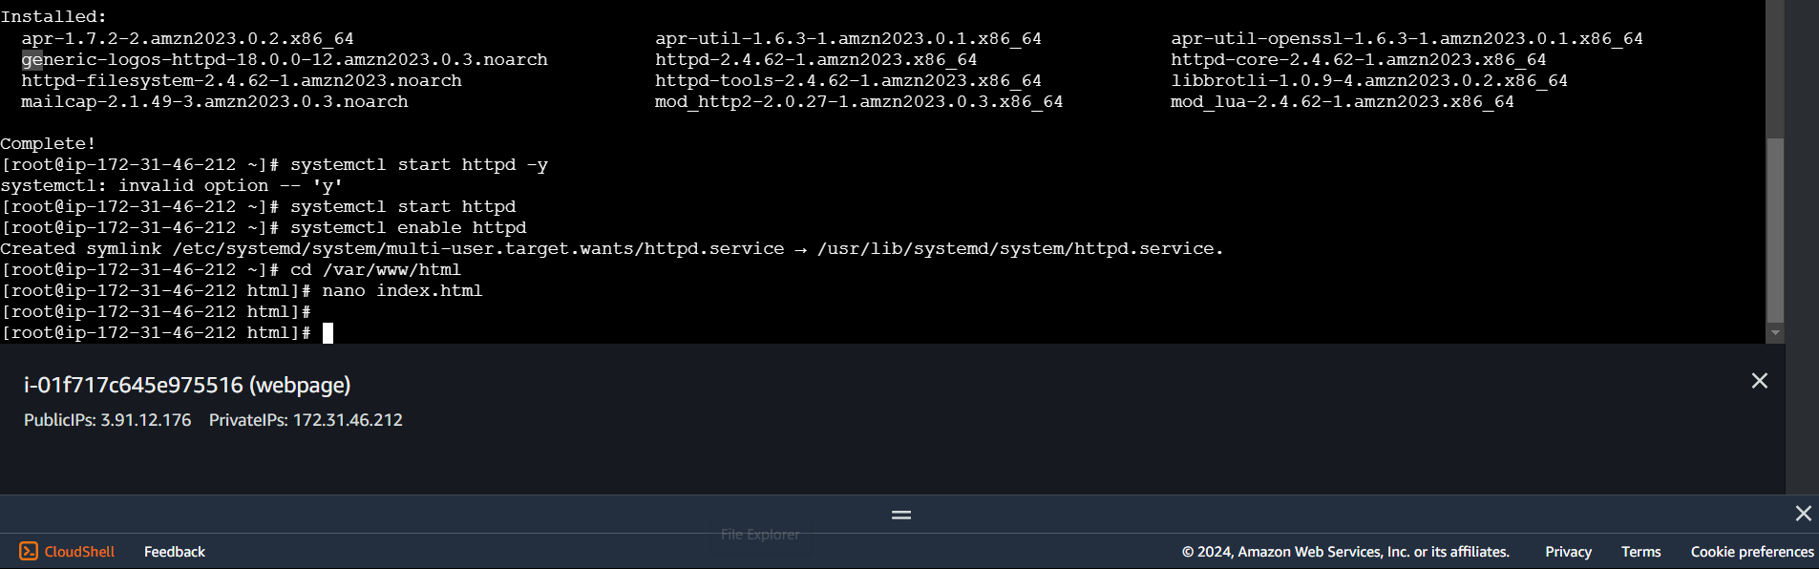

Create buckte

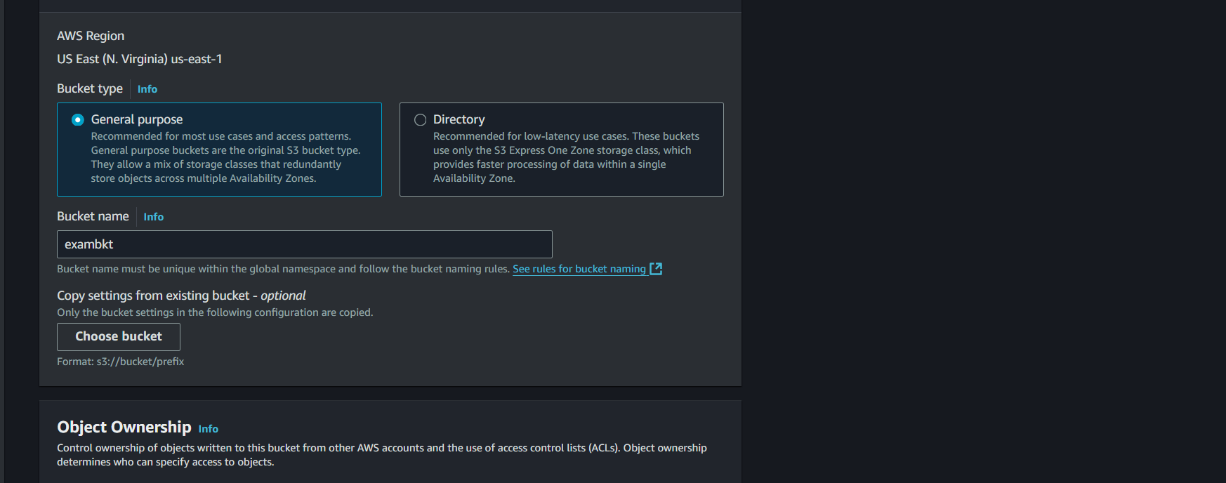

Allow public access

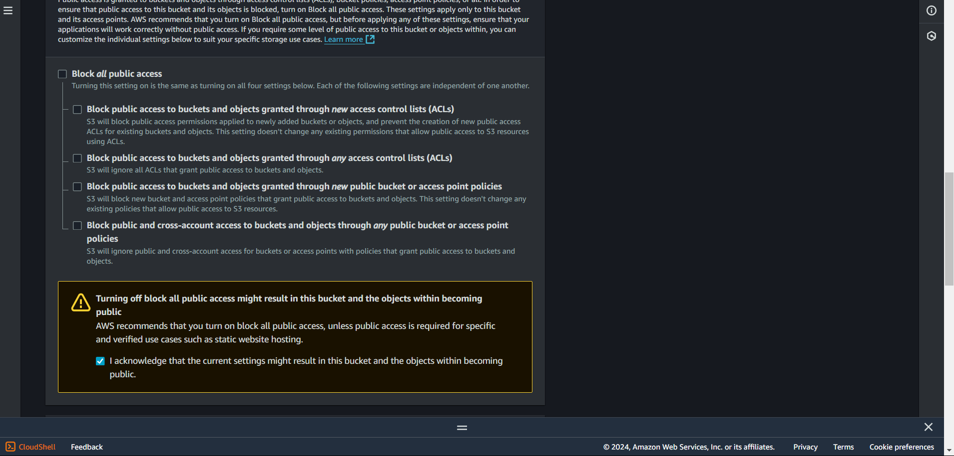

Enable versioning

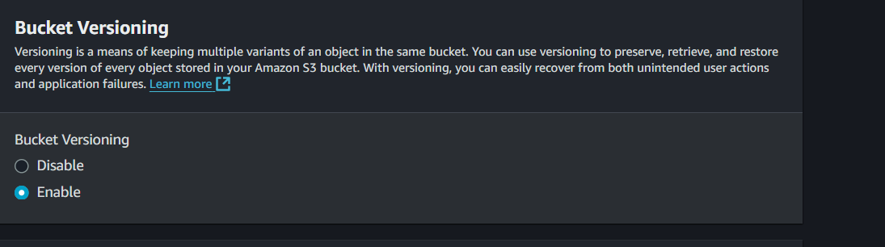

3) upload html file to bucket

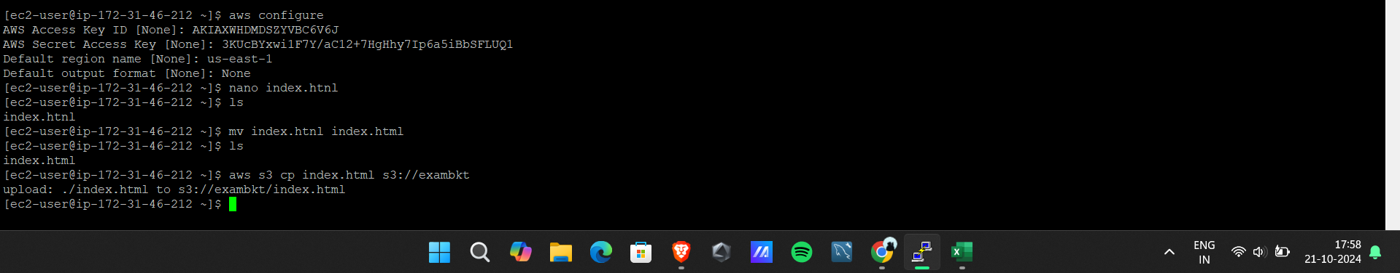

Visible for iam uer also

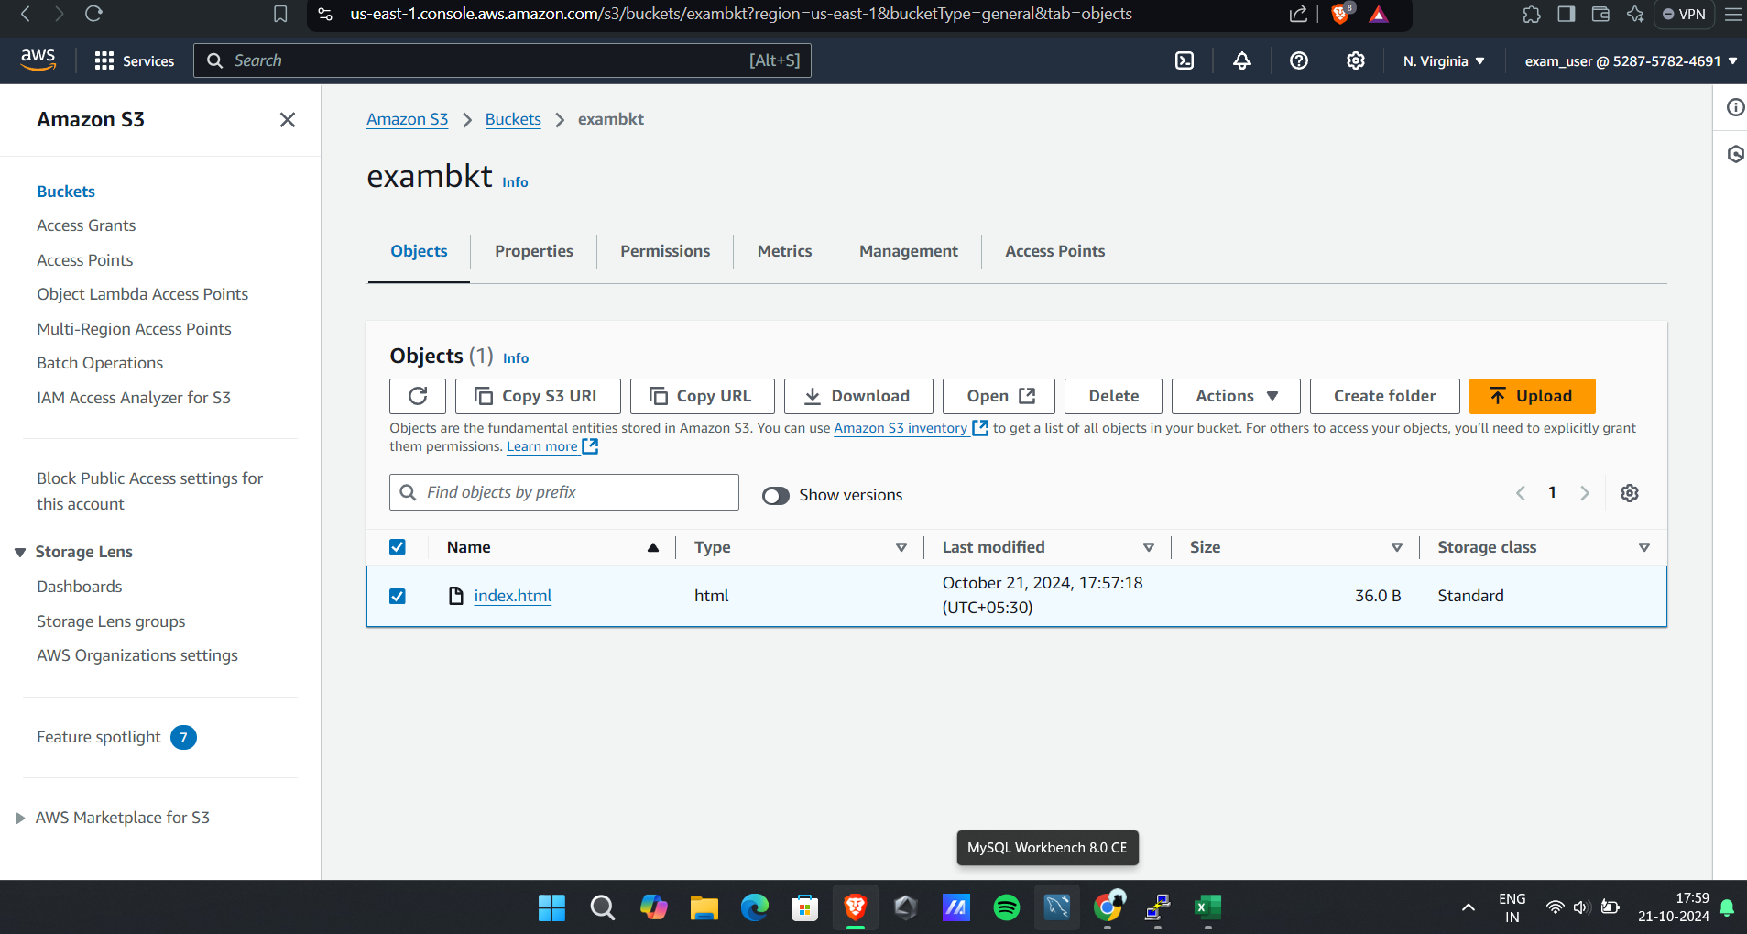

Allow public access:

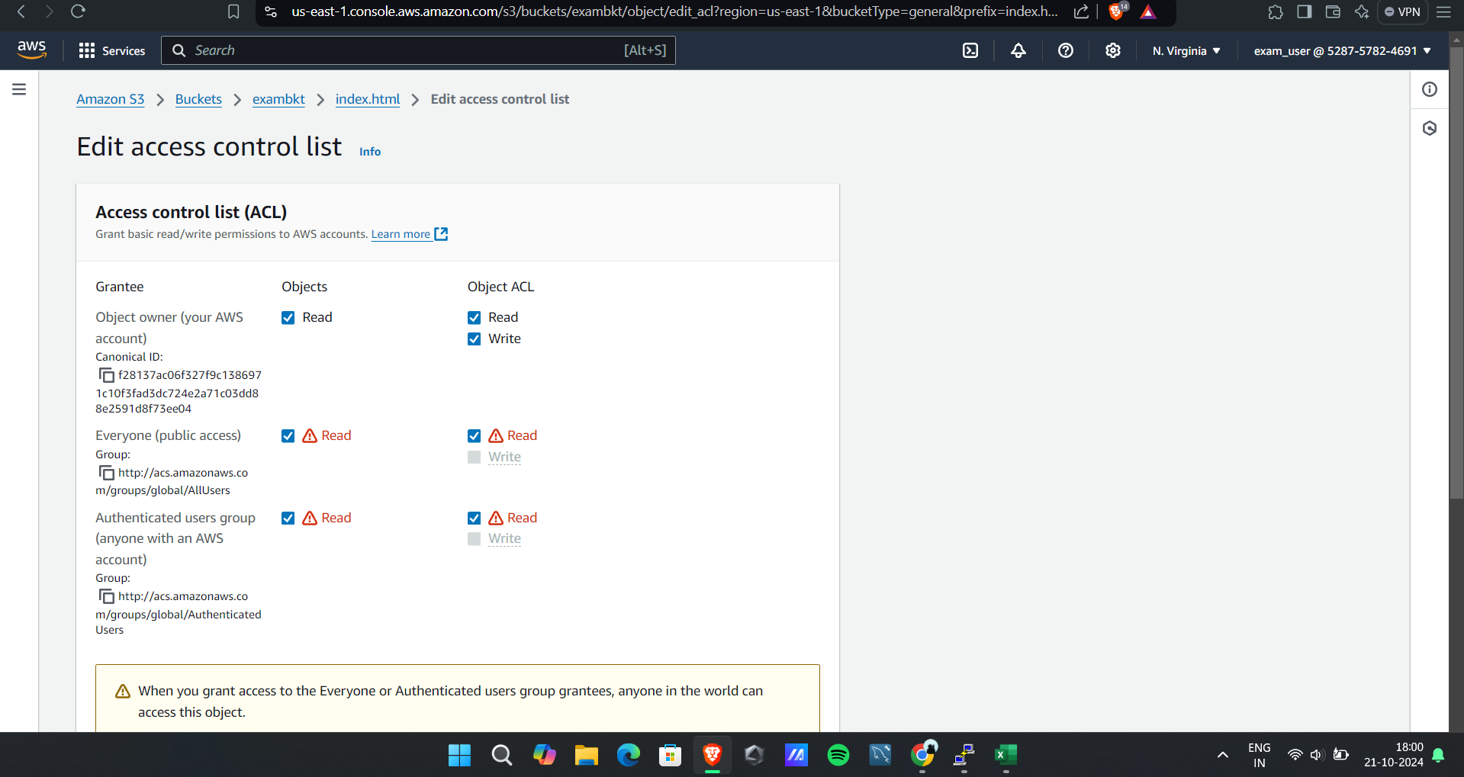

Page visible

