**WebstaurantStoreOutletPageTest**

**Performance Test Report**

**Version 1.0**

**06/07/2023**

**Table of Contents**

**1. Executive Summary 2**

1.1 Performance Test Objectives 3

1.2 Results summary. 3

1.3 Performance Test Approach 4

1.3.1 Performance Testing and Monitoring Tool Details 4

1.3.2 Performance Test Script Steps 4

**2. Performance Test Result 4**

2.1 Performance Test Result Summary 5

2.2 Performance Test Result Description 5

2.2.1 Load Test Result 5

2.2.2 Performance Test Results 6

Statistics 6

Response Times Over Time 6

Active Threads Over Time 7

Bytes Throughput Over Time 7

Latency over time 8

Hits Per Second 8

Appendix A: Glossary 8

# **Executive Summary**

As part of the WebstaurantStore interview process we were tasked with creating a performance test for the outlet product pages. A performance test was created in Jmeter to simulate 5 iterations per minute for 15 minutes on random product pages for the outlet shop page.

## **Performance Test Objectives**

Gauge Jmeter test creation and reporting skills as well as the performance of product pages in the Webstaurant outlet website.

## **Results summary.**

Response times for the test were stable with Outlet page being the slower of the two pages with a response time of 1.604 seconds and the random product page taking .493 seconds on average. Test completed with no errors and a latency of the virtual users between 20 and 45 milliseconds throughout the entire test duration. **Performance Test Planning**

## **Performance Test Approach**

For the performance testing of this project one scenario was created and executed in Jmeter with a single user visiting the outlet page and then a random product page after that. The pacing was set for 5 iterations a minute with a test duration of 15 minutes.

### **Performance Testing and Monitoring Tool Details**

**Table 6: Description of Performance Testing Tool**

| **Tool Name** | **Licensed / Open-Source?** | **No. of licenses** |
| --- | --- | --- |
| Apache Jmeter | Open-Source | 1 |

### **Performance Test Script Steps**

**Table 7: Performance Test Script Details**

| **Script #** | **Name of the script** |
| --- | --- |
| 1 | Outlet |
| 2 | Random Product Page |

# **Performance Test Result**

## **Performance Test Result Summary**

**Table 9: Performance Test Result Summary**

| **Test Run** | **Date** | **Test Scenario Summary** | **Status** |
| --- | --- | --- | --- |
| Random Product Page test | 06/12 | Validate the jmeter test as well as gather metrics for the random outlet product pages. | Pass |

## **Performance Test Result Description**

### **Load Test Result**

**Table 10: Load Test Result**

|  | **Test Details** |
| --- | --- |
| **Test ID** | Random Product Page test |
| **Purpose** | Validate the jmeter test as well as gather metrics for the random outlet product pages. |
| **No. of Tests** | 1 |
| **Duration** | Ramp-up:1 sec  Steady State:15 minutes  Ramp-down:1 sec |
| **Scripts** | 1. Outlet 2. Random Product Page |
| **Scenario Name** | Load Test Scenario |
| **User Load / Volume** | 1 Vusers (Threads) Load |
| **Test Status** | 1. Cycle 1-Run 1 – Passed |
| **Overall RAG status** | GREEN |
| **Result Location** | https://github.com/Crow891/WebstaurantStoreOutletPageTest/tree/main/Results |

### **Performance Test Results**

#### **Statistics**

Test statistics for the entire test duration. Showing number of executions, Error rate, Min Average, Median and Maximum values for response times. 90th%tile is included to show that 90% of transactions had a response time of less than 1.8 seconds for the outlet page and .6 seconds for our random product page.

| **Requests** | **Executions** | | | **Response Times (ms)** | | | | | **Throughput** | **Network (KB/sec)** | |
| --- | --- | --- | --- | --- | --- | --- | --- | --- | --- | --- | --- |
| **Label** | **#Samples** | **FAIL** | **Error %** | **Average** | **Min** | **Max** | **Median** | **90th pct** | **Transactions/s** | **Received** | **Sent** |
| outlet | 75 | 0 | 0.00% | 1604.85 | 1352 | 2291 | 1566.00 | 1806.00 | 0.09 | 355.92 | 4.36 |
| Random Product Page | 75 | 0 | 0.00% | 493.87 | 320 | 781 | 485.00 | 606.40 | 0.09 | 45.45 | 0.74 |

#### Response Times Over Time

Response times stayed mostly stable and consistent throughout the entire test duration with a deviation of one second for the outlet page and .5 seconds on our random product page.

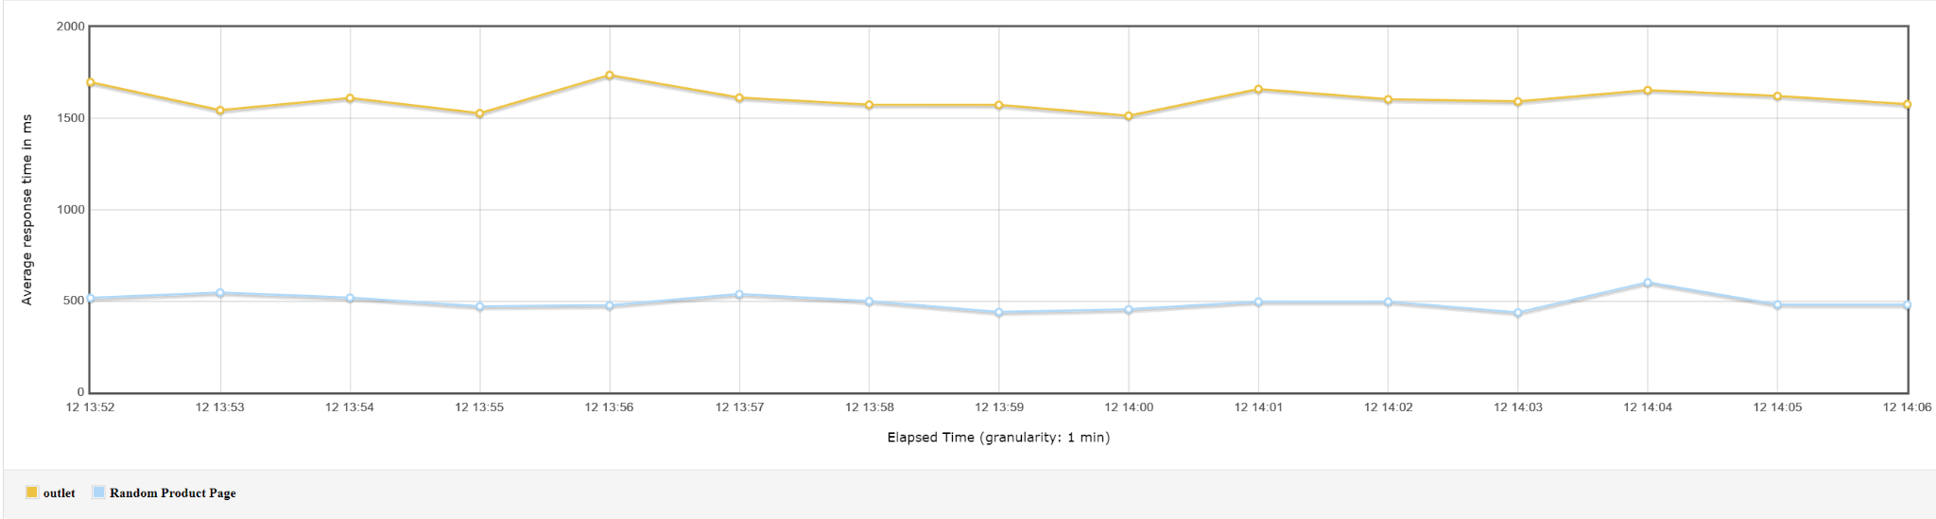

#### Active Threads Over Time

Number of threads (Virtual Users) that were active throughout the test duration.

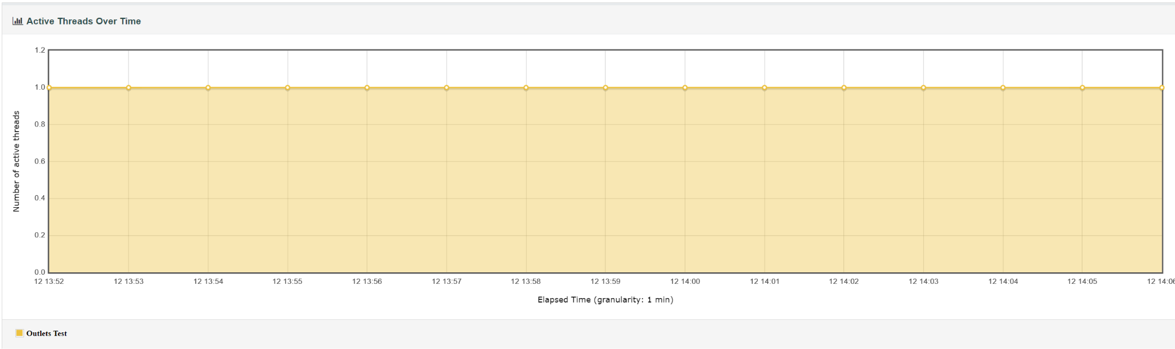

#### Bytes Throughput Over Time

Aggregated view of bytes sent and received during the test duration.

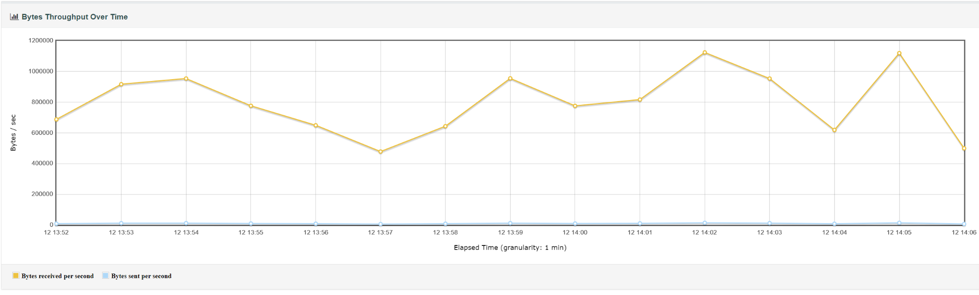

#### Latency over time

View of recorded latency (time from immediately before sending the request until the time just after receiving the first byte of the response) during the test duration.

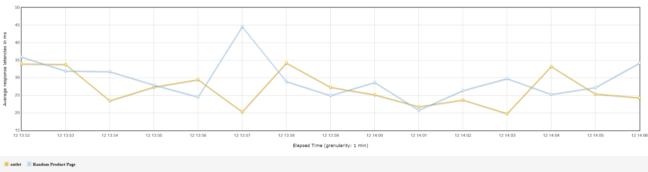

#### Hits Per Second

View of total hits per second aggregated during the test execution.

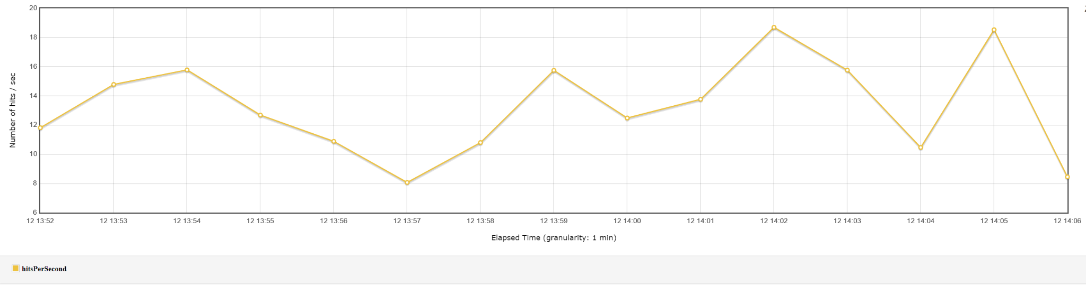

### Glossary

**Table 21: Glossary**

| **Term** | **Definition** |
| --- | --- |
| Pacing | The delay between two iterations or runs of the virtual user. |
| Latency | Time from immediately before sending the request until the time just after receiving the first byte of the response |
| Response Times | Time from immediately before sending the request until the time just after receiving the last byte of the response from the server. |
| Threads | Number of virtual users that are running. |