agentinfo:

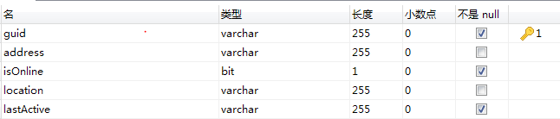

guid: JADE global unique id.

address: JADE agent address.

Location: preserved.

lastActive: in the format of “yyyy-MM-dd HH:mm:ss”.

microtask：

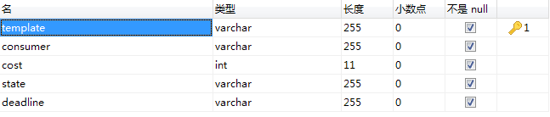

template: XML file of the micro-task.

consumer: consumer id(seems useless).

Cost: reserved.

State: initial, creating or finished.

Deadline: in the format of “yyyy-MM-dd HH:mm:ss”.

workerresponse:

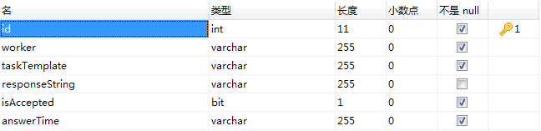

Id: worker guid.

responseString: XML string of the response to the task.

answerTime: in the format of “yyyy-MM-dd HH:mm:ss”.

XML template:

<task>

<question></question>

<attachment></attachment>

<option value="true" />

<option value="false" />

</task>

XML template send to the worker:

<task>

<question></question>

<attachment></attachment>

<option value="true" />

<option value="false" />

<XMLpath></XMLpath>

</task>

answer XML template:

<task>

<XMLpath></XMLpath>

<response></response>

</task>