Omigo Graph Visualizations

**Graph hierarchy (graphviz)**

<https://observablehq.com/@d3/hierarchy-traversal-animated?collection=@d3/d3-hierarchy>

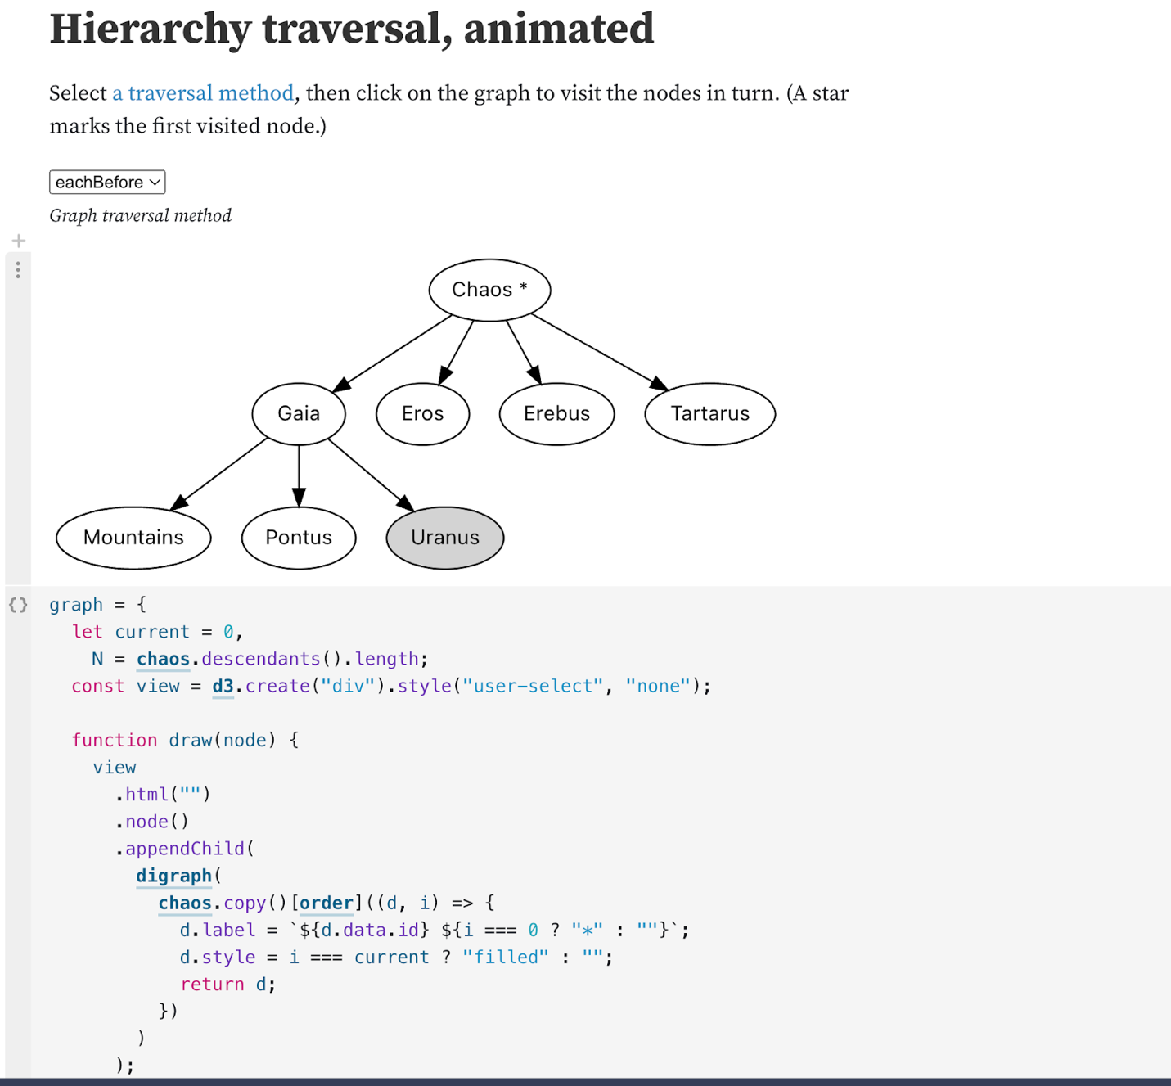

Apache ECHARTS

<https://echarts.apache.org/en/index.html>

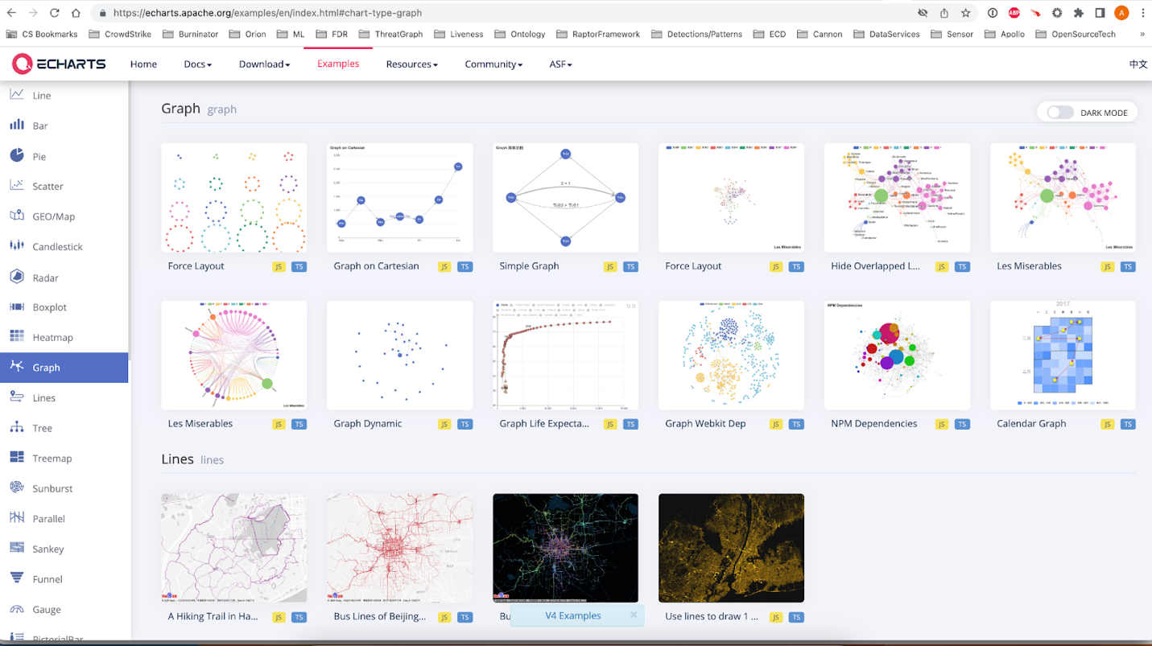

**D3 Timeline**

<https://github.com/denisemauldin/d3-timeline>

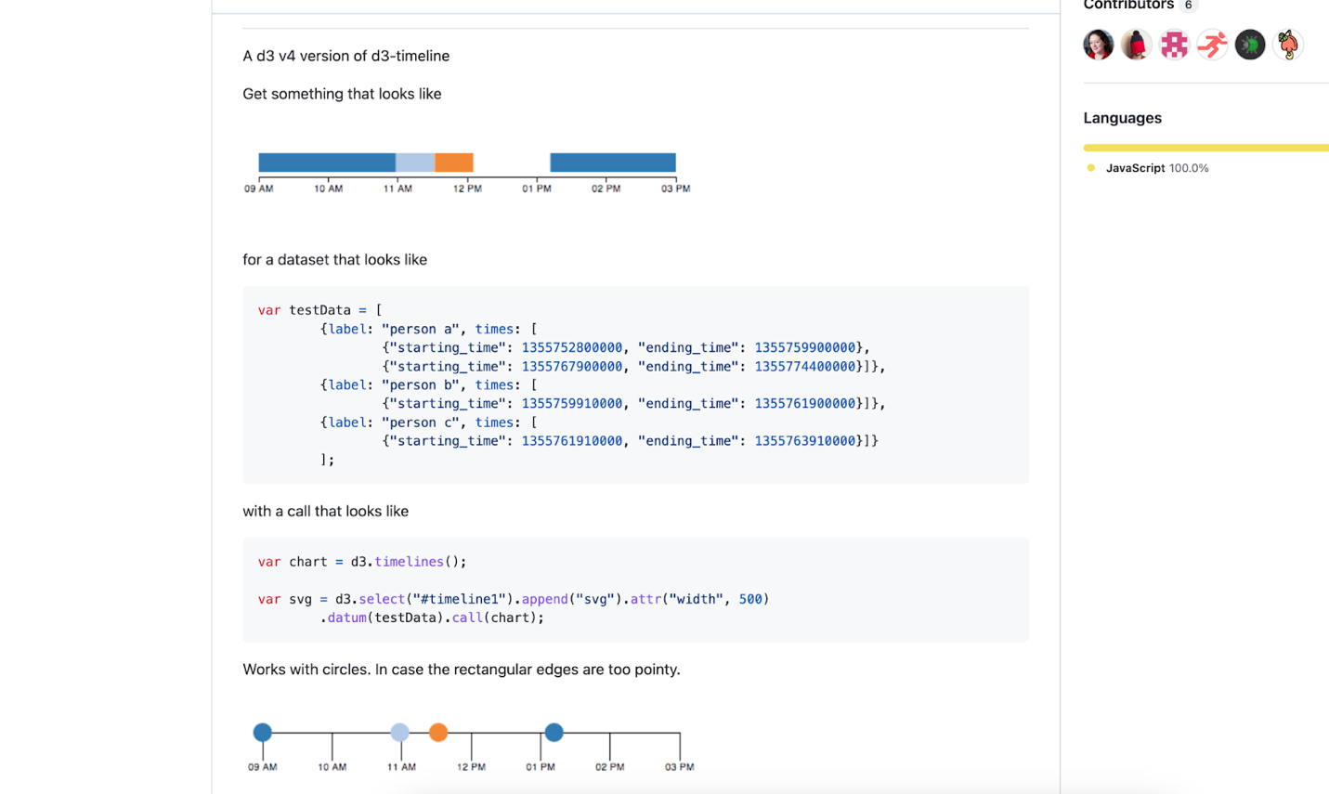

ECHARTS Community Repo

<https://github.com/ecomfe/awesome-echarts>

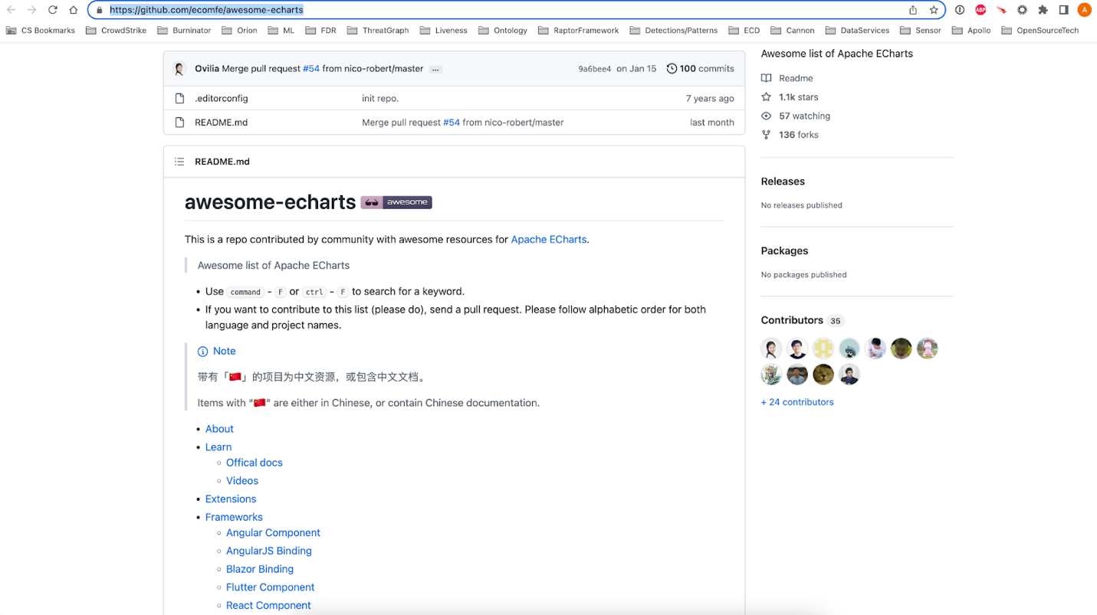

<https://stackoverflow.com/questions/6344318/pure-javascript-graphviz-equivalent>

