References for Lokki (Java, Spark, Go)

<https://hadoop.apache.org/docs/stable/hadoop-aws/tools/hadoop-aws/index.html>

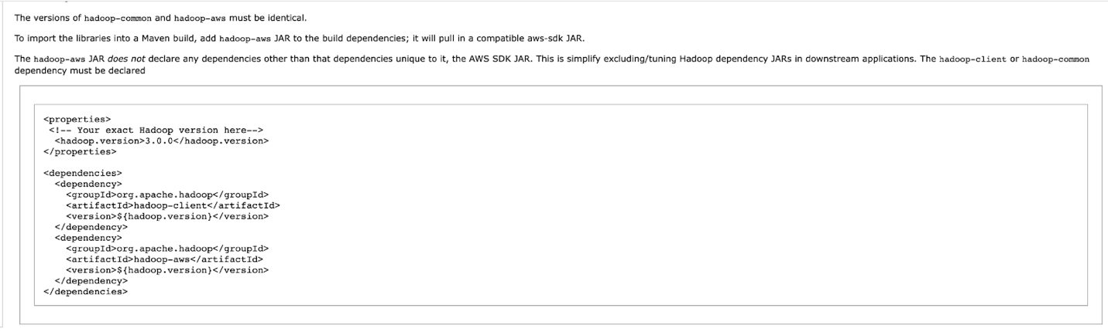

<https://stackoverflow.com/questions/58415928/spark-s3-error-java-lang-classnotfoundexception-class-org-apache-hadoop-f>

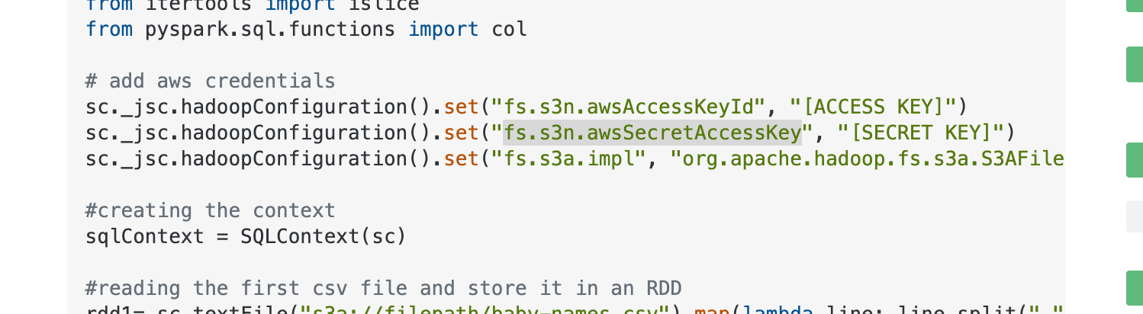

<https://github.com/aws/aws-sdk-java-v2/#using-the-sdk>

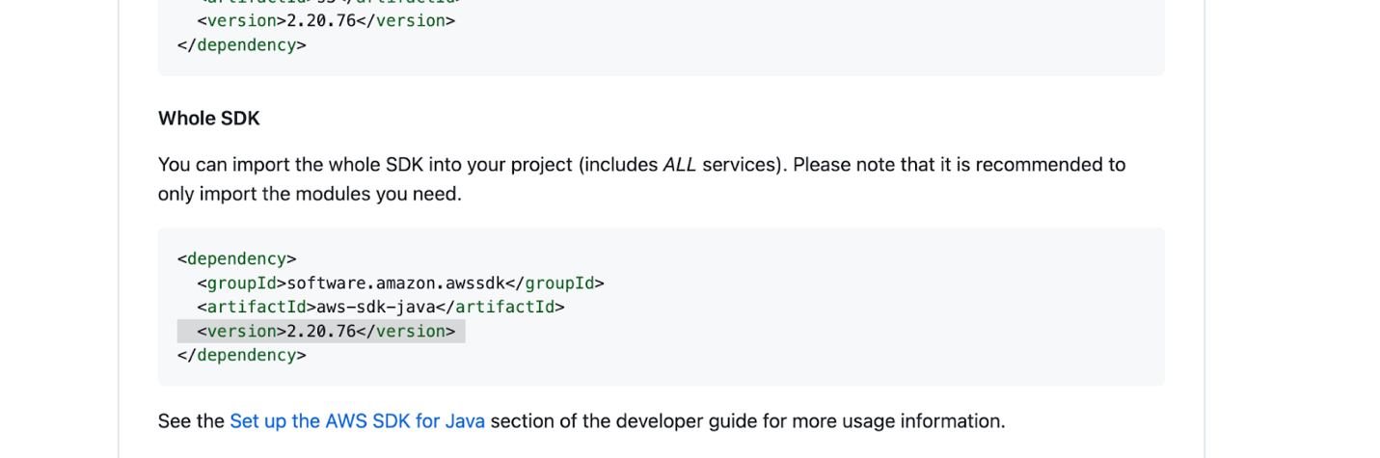

<https://stackoverflow.com/questions/47456479/hadoop-distcp-no-aws-credentials-provided>

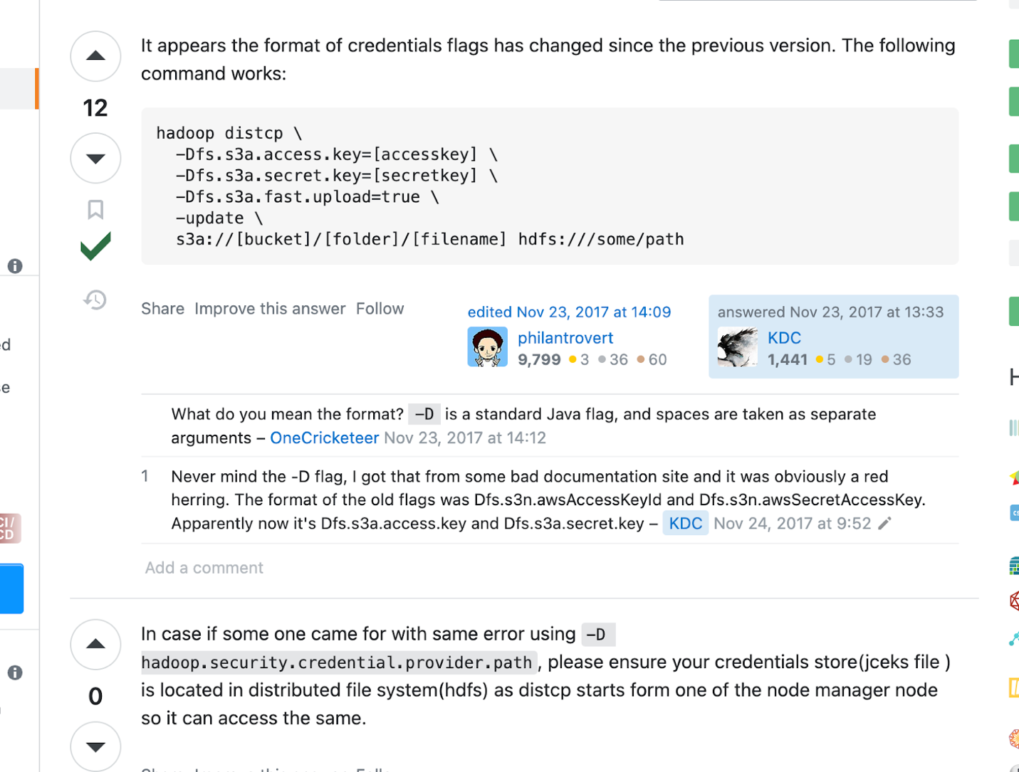

<https://hadoop.apache.org/docs/stable/hadoop-aws/tools/hadoop-aws/index.html#Introducing_the_Hadoop_S3A_client>.

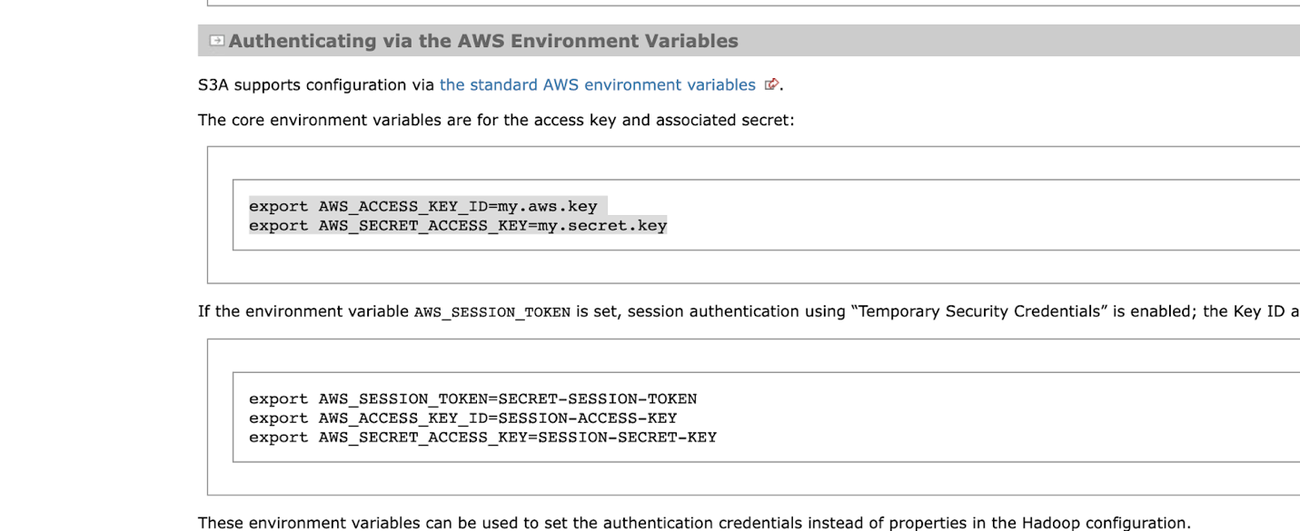



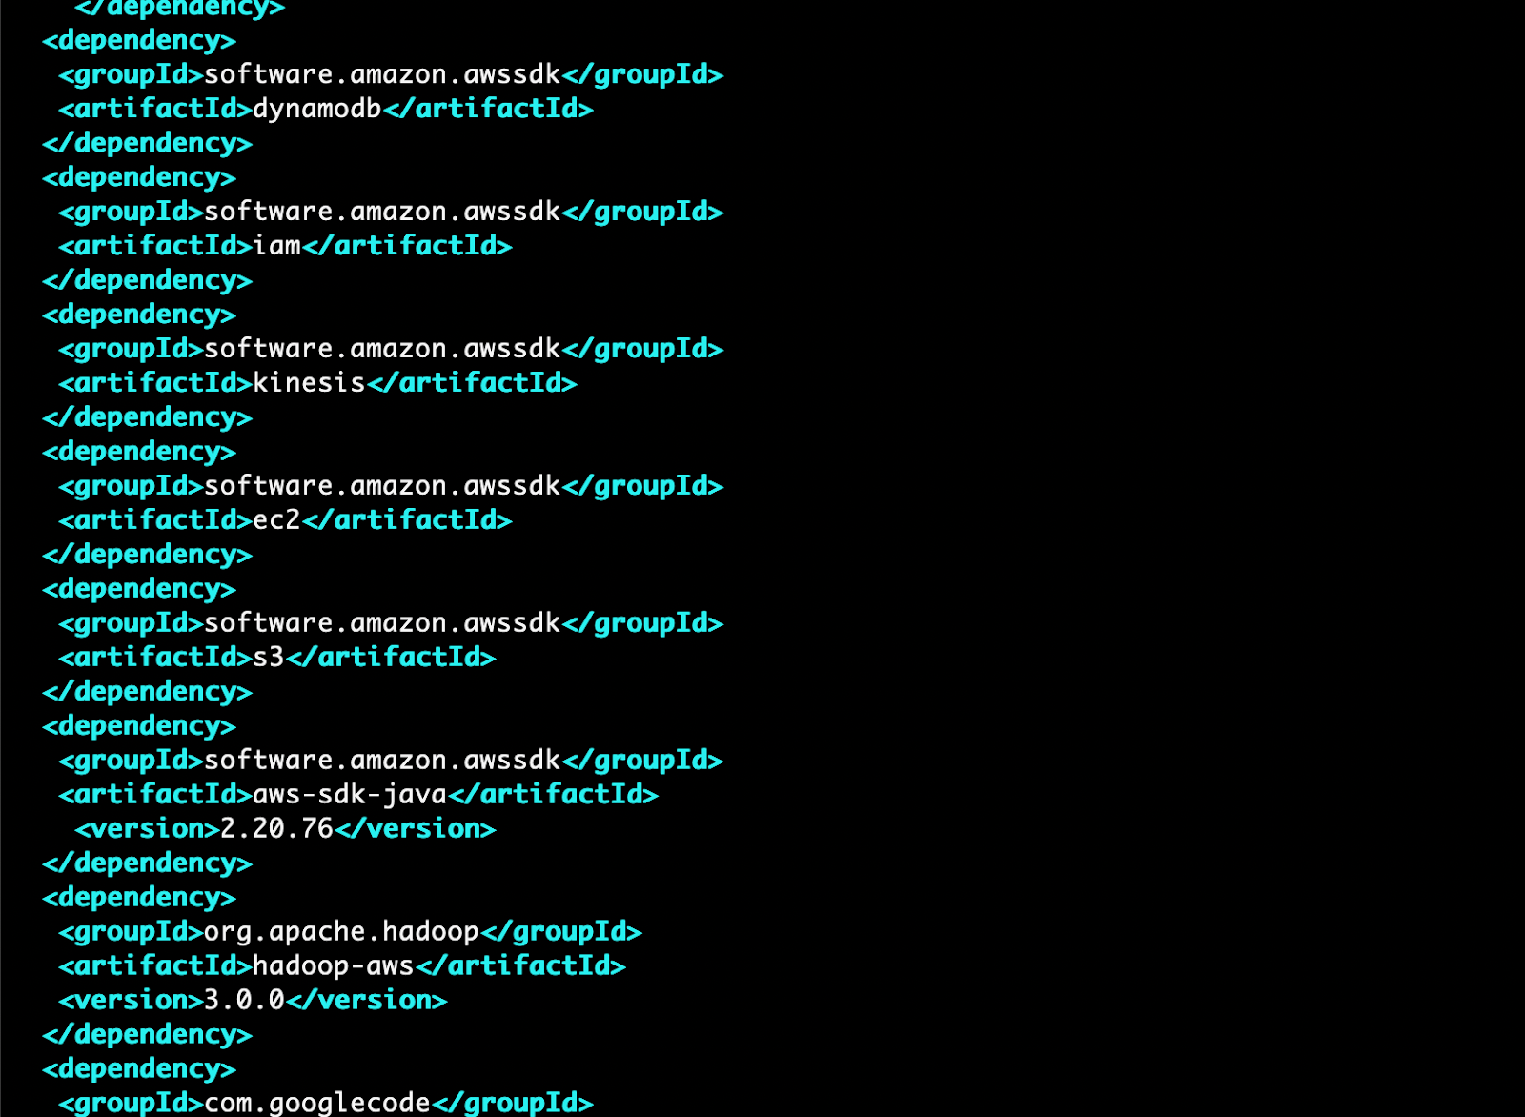

Spark Create DataFrame

<https://sparkbyexamples.com/spark/different-ways-to-create-a-spark-dataframe/>

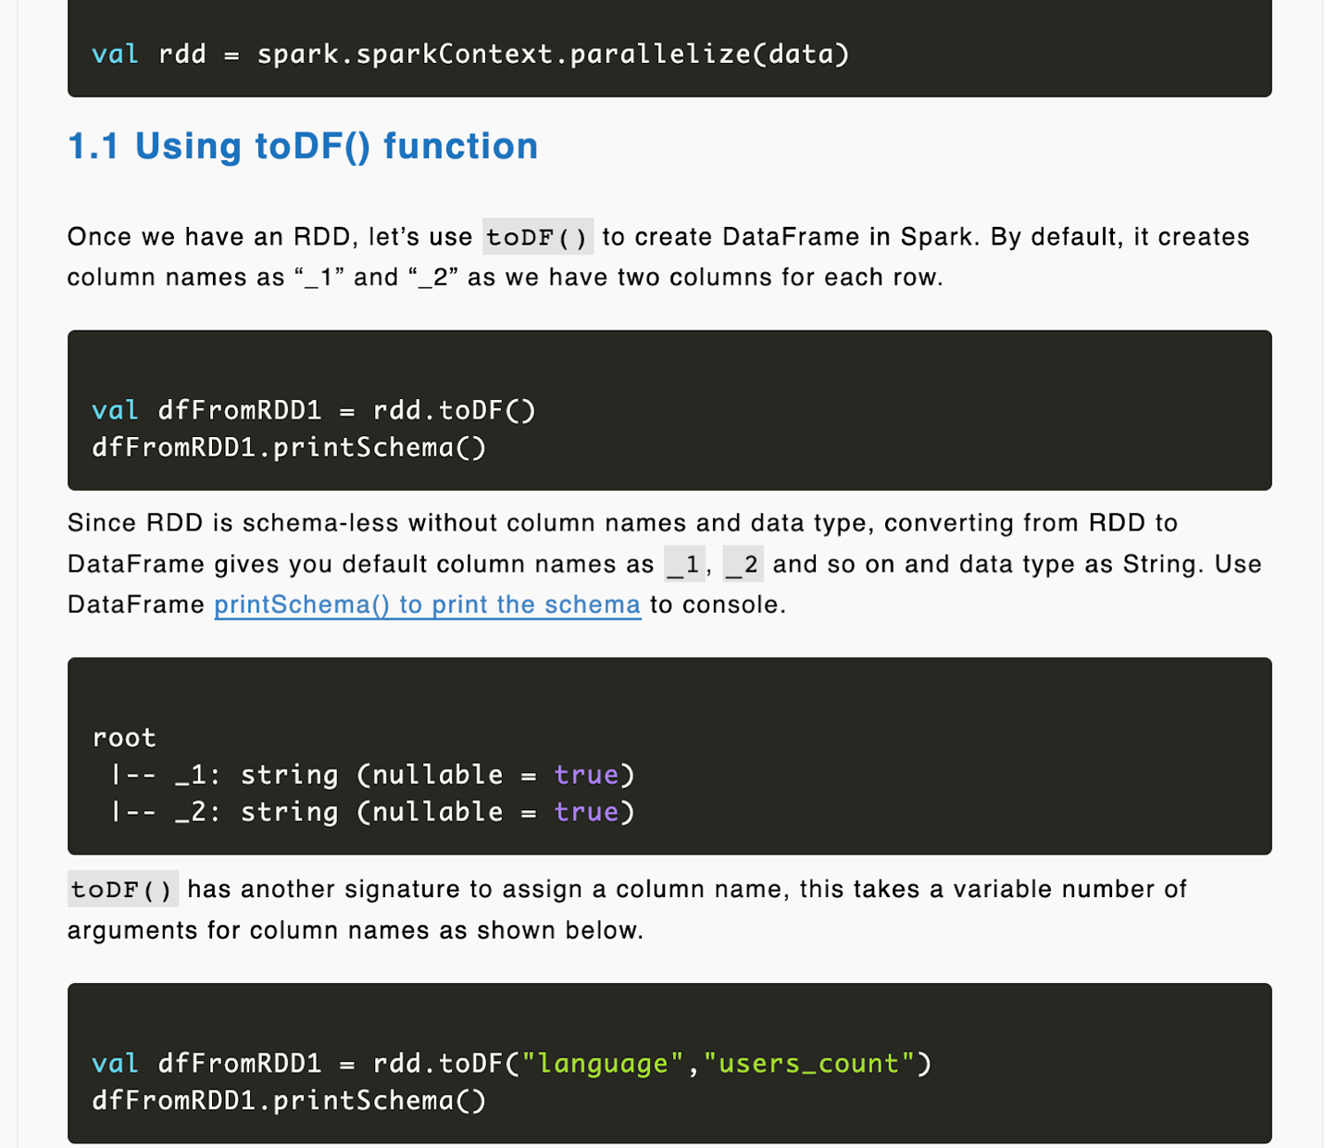

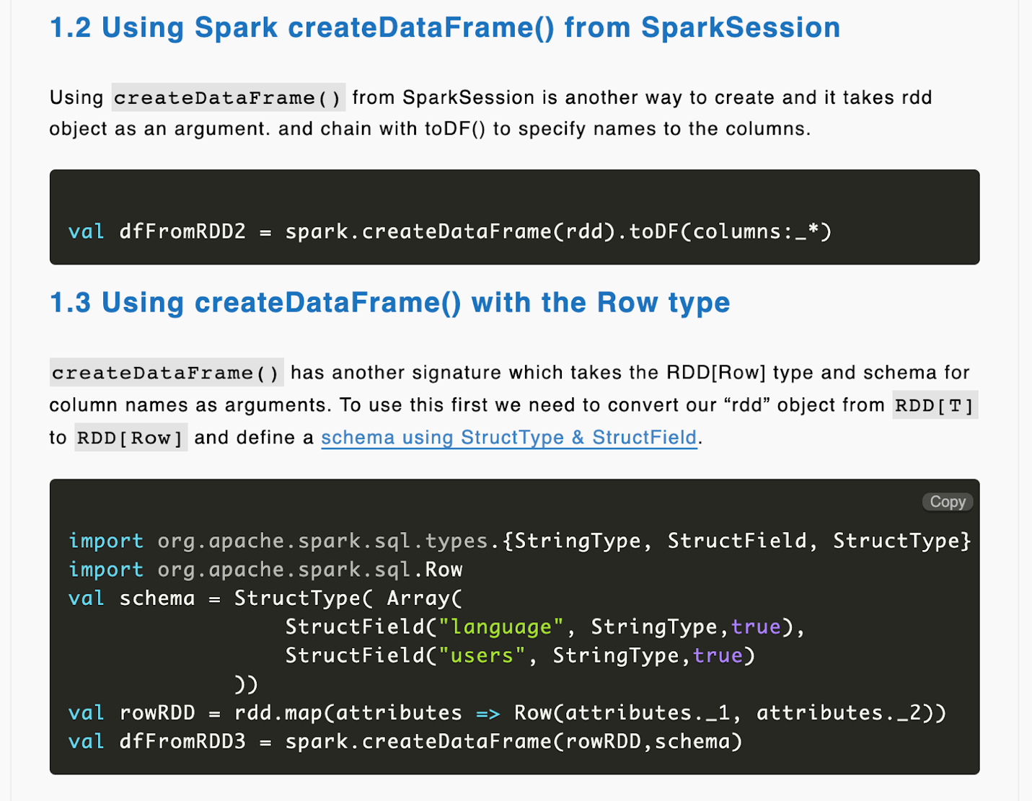

Run Spark Local

<https://stackoverflow.com/questions/40384592/how-do-i-run-a-local-spark-2-x-session>

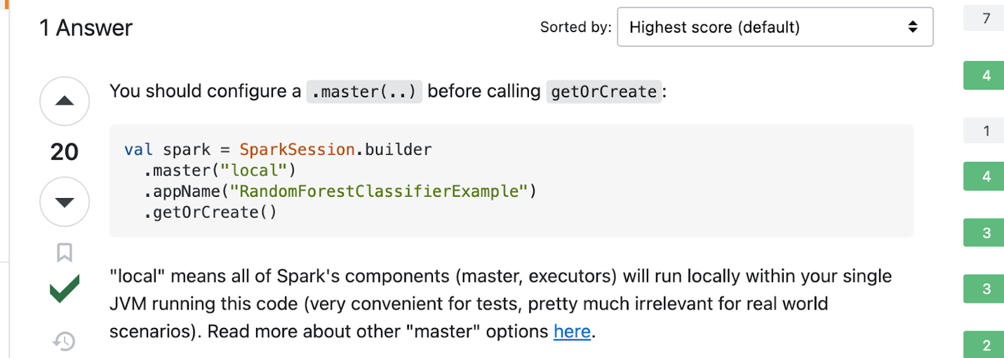

**Spark Hive Dependencies**

<https://sparkbyexamples.com/apache-hive/spark-unable-to-instantiate-sparksession-with-hive-support-because-hive-classes-are-not-found/>

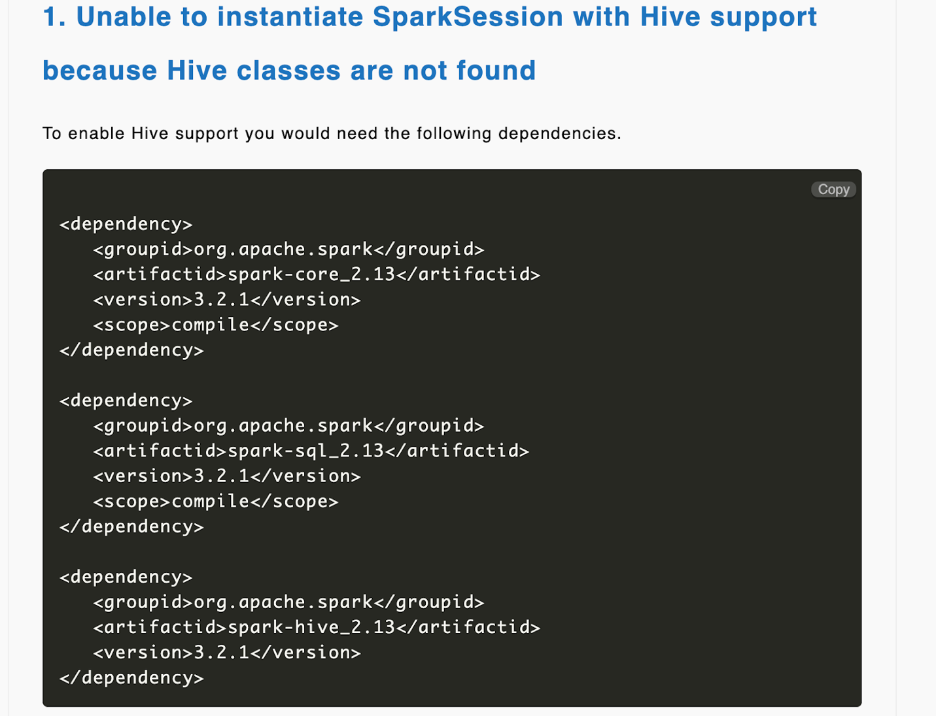

**Spark Scala Version**

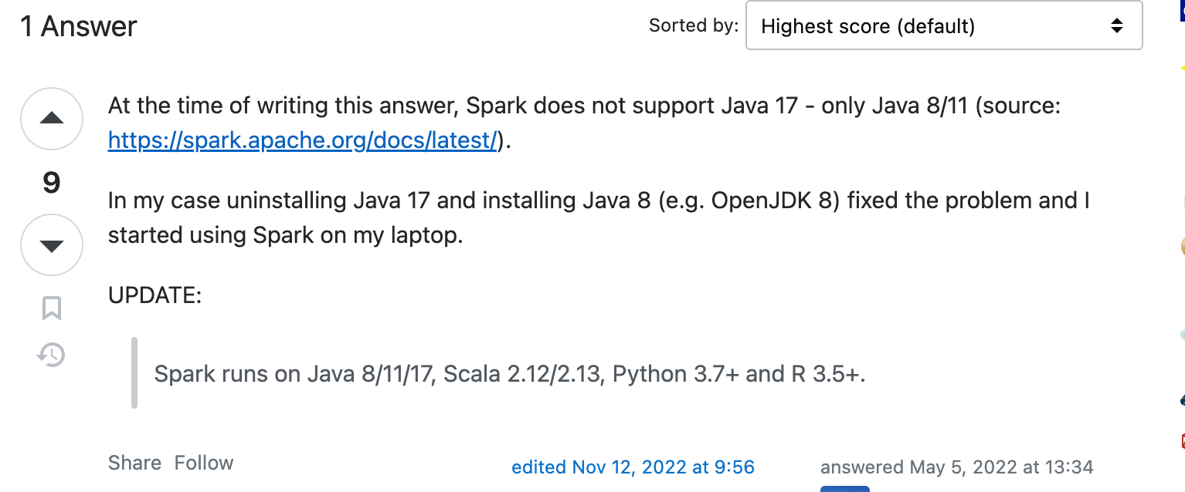

**SBT Options for Java Heap**

<https://stackoverflow.com/questions/35197120/java-outofmemoryerror-on-sbt-assembly>

