**Kick starting with Excel**

Student Name

Institutional Affiliation

Course Name

Instructor Name

Date

**Kick starting with Excel**

**Overview of Project**

The purpose of deliverable 1 was to use the pivot table knowledge and Microsoft Excel graphing to visualize campaign outcomes based on launch date. Specifically, to visualize the outcomes "successful," "failed," and "canceled" with the launch date. Similarly, deliverable 2 aimed at using Excel to visualize the percentage of the outcomes "successful," "failed," and "canceled" plays based on the funding goal amount.

**Analysis and Challenges**

**Analysis of Outcomes Based on Launch Date**

The analysis was performed using the “YEAR()” to create a Years column followed by making a pivot table to display the required data. After that, a chart a line graph was plotted to display the relationship between outcomes and launch date as shown in figure 1.

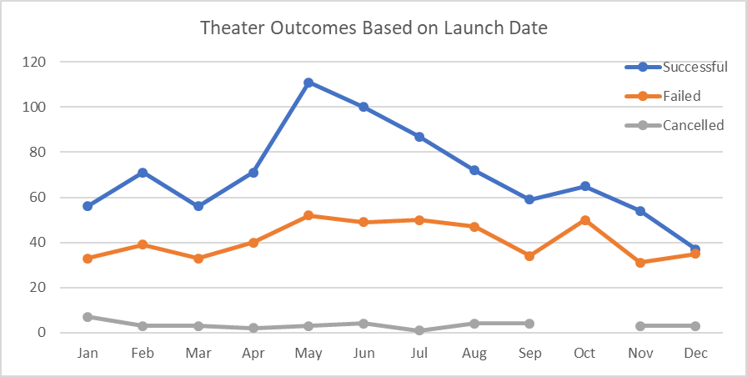

Figure 1: Theater Outcomes Based on Launch Date

From the graph, we can see that Successful outcomes had the largest frequency as followed by failed outcomes. Cancelled outcomes comprised the lowest frequency. Also, the highest number of the outcomes was observed between April and July as shown in figure 1.

**Analysis of Outcomes Based on Goals**

The analysis was mainly done using the Excel function “COUNTIFS()” to collect the outcome and goal data for the “plays” subcategory. The sums were then calculated using the SUM() function. The corresponding percentages of outcomes were calculated and a line graph plotted to compare different outcomes based on goal amount as shown in figure 2.

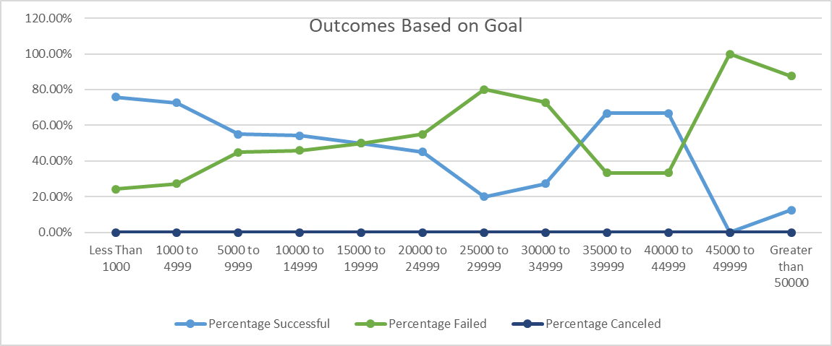

Figure 2: Outcomes Based on Goal

From figure 2, we can see that no plays were cancelled. Also, a higher percentage of the plays failed as opposed to the ones that succeeded.

**Challenges and Difficulties Encountered**

The main challenge encounteredusing the Excel function “COUNTIFS()” to collect the outcome and goal data for the “plays” subcategory. Initially, the function returned errors but upon research, it worked perfectly to give the desired results.

**Results**

The project was successfully completed and the outcomes conformed to the expected results.