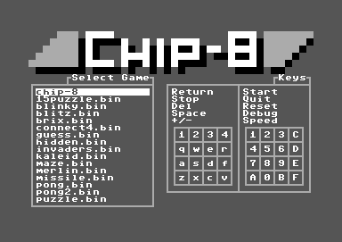

**CHIP-8**

**Background on the system:**

CHIP-8 is an interpreted programming language developed by Joseph Weisbecker in the mid 1970s. Its initial use was for the making of video games easier on the COSMAC VIP and Telmac 1800 8-bit computer systems.

**Why do this project?**

I did this project in specific because creating an emulator requires knowledge and understanding of the hardware that is going to be reconstructed via pure software. Along the way, in completing this project lays the groundwork for being able to make more emulators of more complex systems, such as the Gameboy or the NES.

**Technical challenges that came with this project:**

This project required me to recreate a computing system in software. In order to do this, I needed to learn how to read the operation codes (opcodes), parse them, then enact the same action that the actual machine would have done based on the op code read. I also needed to learn how a basic computer system works, for example, learning how to efficiently create and use a stack for the system, create its system registers, as well as manipulation of opcodes using bitwise operators such as AND, OR, and XOR.

**The skills and knowledge gained from this project:**

I gained an immense knowledge of how a basic computing system works from the inside. For instance, I learned how the stack worked, on a basic level when it came to saving memory addresses from subroutines once a subroutine had jumped to another routine, as well as how a processor advances in the instructions it is given.

**How this project was made:**

This project was made using C++, SFML library for making a window, drawing, and receiving user input. Among this, the resources used were this tutorial(http://www.multigesture.net/articles/how-to-write-an-emulator-chip-8-interpreter/) to get an understanding of how emulators in general work, as well as how to start with the chip-8 emulator. Special credits to this user on github(https://github.com/aaruel/CHIP8-SFML) for showing how to implement the user input and the drawing. Also, this project utilized wikipedia as a reference for the opcodes that the chip-8 system has.

**Screenshots:**

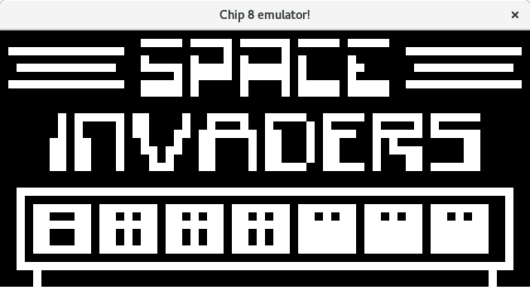

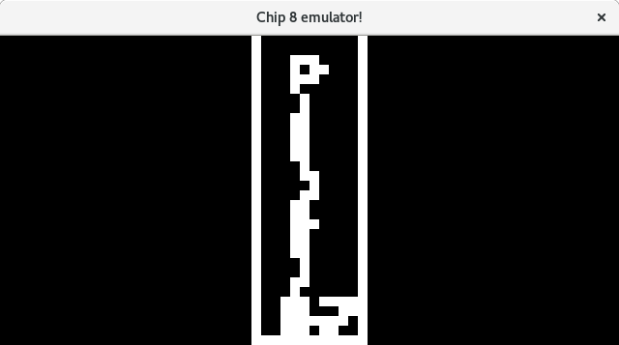

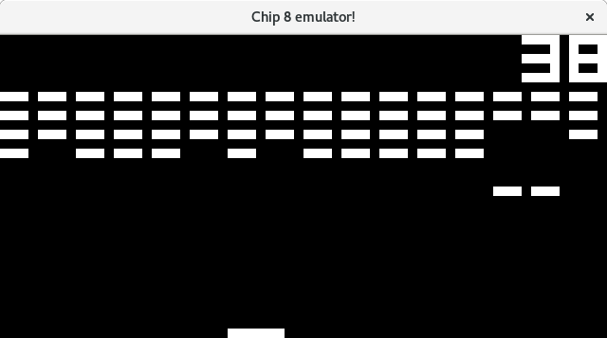

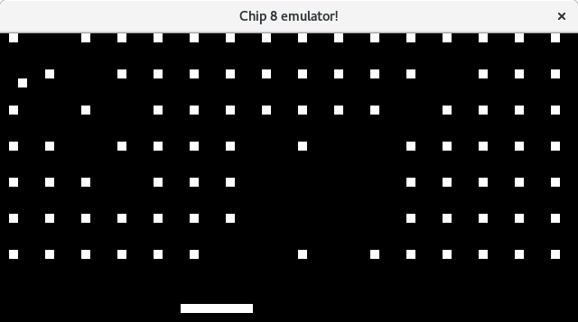?  
 )+{fgvb