Community IntuneHRFlow - Quick Setup Guide

**This guide assumes you have knowledge of Microsoft Azure, Power Automate, Power Apps and Sharepoint online before proceeding.**

Please ensure you set this all up using an account that is an Intune Global admin with a M365 and Power Automate Premium License. Please also note, depending on the import experience, the solution may require you confirm data and setup for SharePoint lists and Power Automate flows as the Microsoft import process is not particularly great.

1. Set an azure App registration with the included permissions and create a client secret. When you create the client secret copy the details for the Value **IMMEDIATELY** as it will disappear after creation and navigating away.

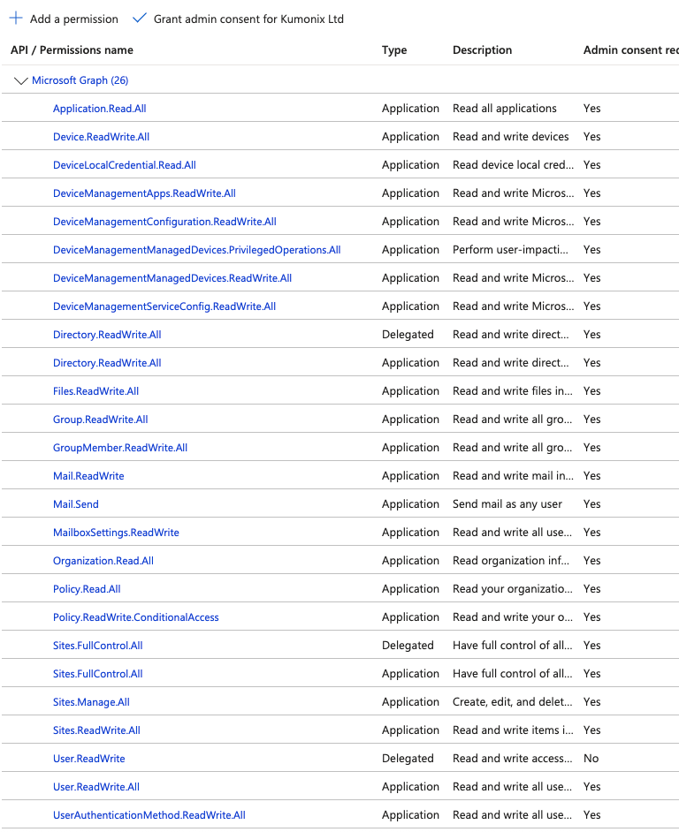

1. Setup a new SharePoint site called ‘New Starters’ - This is the site the automation flow uses to assign the new starter to. This can also be your own existing site. Used for providing information, data and collaboration when the new user joins the company. You need to change the ‘NewStarterSite’ field within the AutomateSettings Sharepoint list to reflect this.
2. Setup a Employee onboarding SharePoint template site (Call it what you want) and one for ‘IntuneHRFlow’ using a Collaboration blank site (as it includes documents)
3. Import Sharepoint lists (individually) – into the IntuneHRFlow Sharepoint site just created - keep the default option as private to maintain security access to data
   1. Change the data in the following Lists to reflect the environment you are importing into – ‘AutomateSettings’.
   2. AutomateSettings is important as it contains all your Application registration information and SharePoint List Names used within the Automate flows.
4. Create New Groups within Intune and save the object ID of these:
   1. ‘standard persona’
   2. ‘Windows365Users’
   3. ‘Intune License User Group’
5. Assign M365 E3/E5 licenses automatically to your new ‘Intune License User Group’ just created. This allows you automatically assign licenses to youe new onboarding users.
6. Import Power Automate (solution - 'CommunityHRAutomation’) with all the automate flows (Login to make.powerautomate.com)
7. When Importing the solution please ensure you configure to setup the flows as new (NOT UPDATE)
8. Go into the solution and access the 4 Environment variables
   1. VarAutomateList – This is the address of the IntuneHRFlow site you create for example mine is ‘https://Domain.sharepoint.com/sites/IntuneHRFlow’. Change this to your site address.
   2. The other three you can leave as is assuming you haven’t customised the names and locations of the SharePoint imports. These are important as they are variables used within the Power App flows so you do not have to access them all and update them (which is very very time consuming)

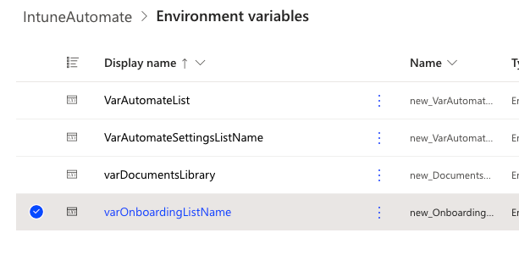

**Variable** - ‘Initialize variable - Intune License group’

**Variable** - ‘Initialize persona standard’

1. Alter Automate flow ‘Community - Onboarding - Setup onboarding user’ – Update with the Object ID’s of your new Entra groups created above:
   1. Initialize variable - Intune License group - To your own group object ID for the Intune license group
   2. Initialize domain – Change to your own domain like Kumonix.com
   3. Initialize persona standard – Change to your own Entra group called ‘standard persona’
   4. Change ‘Post message in HR Approvals chat’ within the flow to point to your own dedicated Teams channel you want to use for the Onboarding. This is optional and can be switched off in the ‘AutomateSettings’ SharePoint List.
   5. If you would like to use Microsoft Planner, create a new Plan with a Plan Id of ‘Employee Onboarding’ and adjust the flow to point to it. This is optional and can be switched off in the ‘AutomateSettings’ SharePoint List.

Flow 2 must also have a valid newstarters sharepoint site to add the new user to – This setting is in the Automatesettings SharePoint List as previously mentioned

1. Alter the AutomateSettings sharepoint list to reflect your tenant details (Site/Tenantid/clientid/appsecret/ReportGroup/Win365/NewStarterSiity/streatAddress//ITAdminEmail/CompanyName/Domain/CompanyName/NewStarterSite)
2. Ensure you Switch on Power Automate flows as they are set to off by default.

**Before creating data**

Within SharePoint click the > ‘Onboarding’ List then > Forms. Alter your form to include the following fields, not all fields are required to create an onboarding record (Some are included to cover included functionality).

**Onboarding**

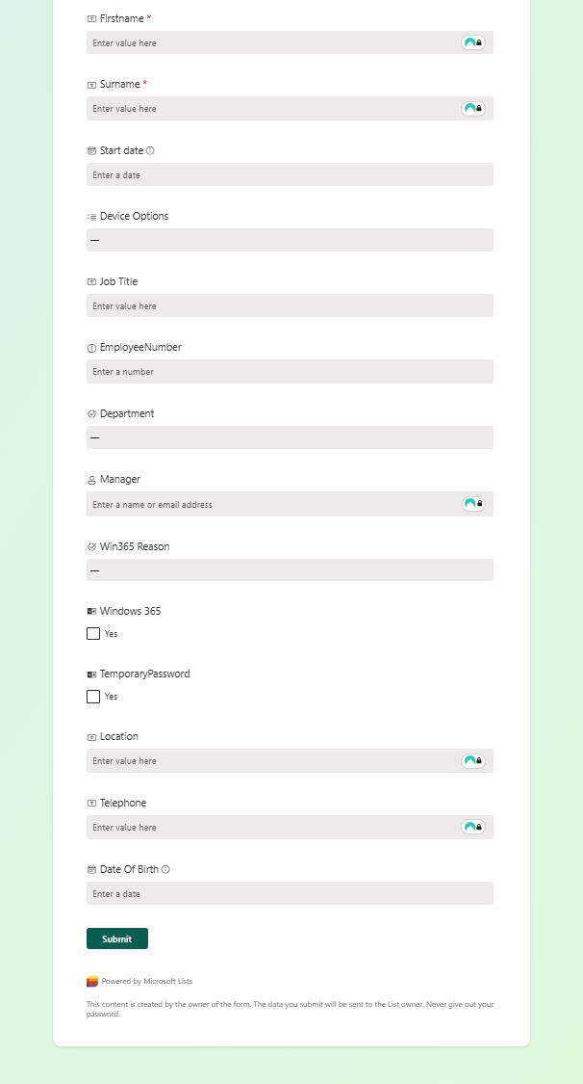

**Offboarding**

