CruDoc on Firebase
Storage tiering design, and status against the AWS Medical Platform plan
Item | Value
Version | 1.0
Date | 30 September 2026
Firebase project | svayatta-crudoc-dev
Primary region | asia-south1 (Mumbai)
Compared against | AWS Medical Platform – Production Architecture & Implementation Design, v1.0 (September 2026)
Evidence | CruDoc code on branch main, including the uncommitted Firebase Storage work; storage rules tests run in the Firebase emulator; Firebase CLI checks of the live project on 30 September 2026

Prices are not quoted in this document. Check the Cloud Storage pricing page for asia-south1 before budgeting; storage is one part of the bill, alongside reads, network egress and backups.

1. Summary
The AWS plan breaks down into 50 separate deliverables. One of them, building a private network (VPC, subnets, NAT), is not needed on Firebase because every service CruDoc uses today is fully managed. That leaves 49 items to compare.
Status | Items | Share of the plan
Live | 7 | 14%
Built, not deployed | 4 | 8%
Partly done | 15 | 31%
Not started | 23 | 47%
Total compared | 49 | 100%

In short: 11 of 49 items (22%) are live or built. Counting each partly-done item as half, the plan is about 38% complete on Firebase.
- Solid today: sign-in, the database, cloud functions and secrets are live, and the database is in Mumbai. Per-doctor file storage is built and its access rules pass 23 automated tests; it goes live once Storage is enabled and the rules are deployed.
- Biggest gaps: the medical imaging layer (Orthanc, DICOMweb, frame streaming) has not been started, and neither have scheduled backups, disaster recovery, separate production environments or the security monitoring services.
- Storage tiering: the recommended design is Google Cloud Storage Autoclass on the Firebase bucket plus a few delete rules. It needs no app code changes and about half a day of setup after Storage is enabled (Part B).

Part A – How much of the AWS plan is set up on Firebase

2. How this was measured
Each section of the AWS plan (regions, accounts, identity, storage, imaging, application services, audit, backup and delivery) was broken into individual deliverables. Each one was then matched to its Firebase or Google Cloud equivalent and checked against the code and the live project.
Status | Meaning
Live | Working in the Firebase project today.
Built, not deployed | Code and configuration are written and tested, but not yet switched on in the project.
Partly done | Some of it exists, or a simpler version exists; the notes say what is missing.
Not started | Nothing in place yet.
Not needed | A Firebase managed service makes this unnecessary.

Checked directly against the live project:
- Firestore database location: asia-south1 (Mumbai).
- Firestore point-in-time recovery: enabled, 7-day window. Delete protection: disabled. Scheduled backups: none.
- Cloud Functions: pinned to asia-south1; API keys held in Google Secret Manager.
- Storage rules: 23 of 23 tests pass in the Firebase emulator (own files, other doctors, signed-out users, size and file-type limits, voice folder).
Not verified here: whether the Storage bucket has been created and its location, Cloud Audit Logs settings, and IAM role assignments. These need the Google Cloud console or the gcloud CLI, which is not installed on this machine.

3. Status at a glance
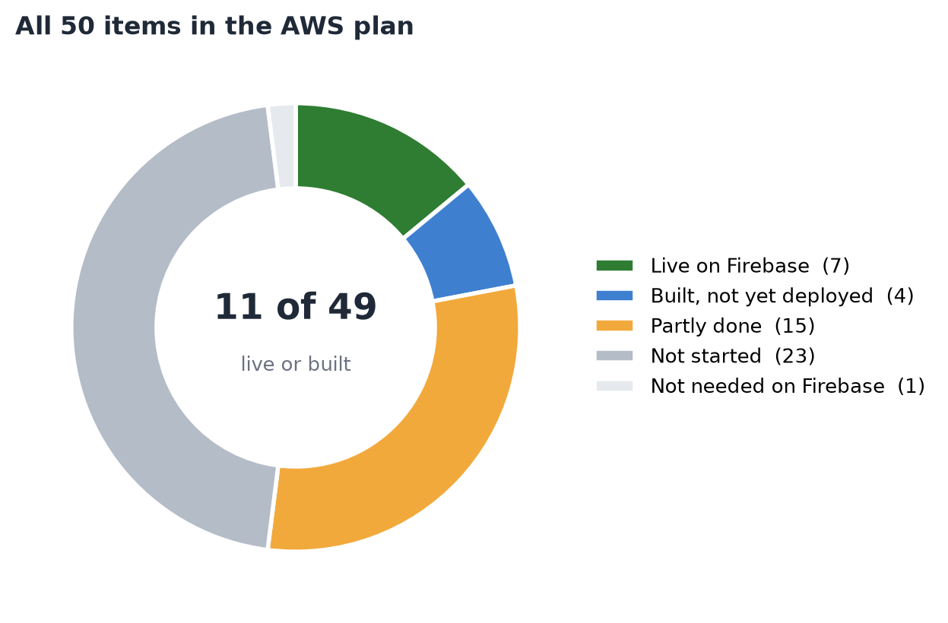
Figure 1. All 50 items in the AWS plan by status.
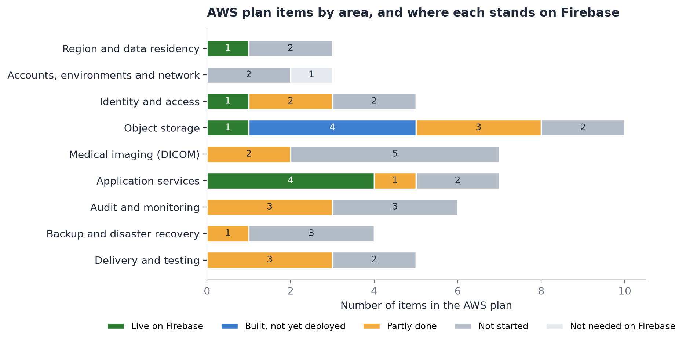
Figure 2. The same items by area of the plan.

4. Item-by-item status
Region and data residency
# | AWS plan item | Firebase / Google Cloud equivalent | Status | Notes
1 | Primary region: Mumbai (ap-south-1) | asia-south1 (Mumbai) | Live | Firestore database confirmed in asia-south1; Cloud Functions pinned to asia-south1. Pick asia-south1 when Storage is enabled.
2 | DR region: Hyderabad (ap-south-2) | asia-south2 (Delhi), Google's second India region | Not started | No second-region copy of any data.
3 | Restrict resources to India regions | Organization Policy: resource locations = India | Not started | No organization policy set.

Accounts, environments and network
# | AWS plan item | Firebase / Google Cloud equivalent | Status | Notes
4 | Separate accounts: security, logs, dev, staging, prod, DR | Separate Firebase projects under a Google Cloud organization | Not started | Only svayatta-crudoc-dev exists.
5 | VPC, 3-AZ subnets, NAT, security groups, VPC endpoints | Not needed: Firestore, Storage, Auth and Functions are managed services | Not needed | No servers or network to run while there is no Orthanc.
6 | Hospital PACS link over VPN / Direct Connect | Cloud VPN / Interconnect to an Orthanc service | Not started | Only needed once PACS ingest is built.

Identity and access
# | AWS plan item | Firebase / Google Cloud equivalent | Status | Notes
7 | Amazon Cognito sign-in | Firebase Authentication (Google sign-in, phone OTP) | Live | In production use by the app.
8 | MFA for privileged users | Firebase Auth multi-factor (Identity Platform) | Not started | No multi-factor sign-in in the code.
9 | Roles: Doctor, Radiologist, Hospital Admin, Patient, Support, Platform Admin | Custom claims + security rules | Partly done | Doctor and Super Admin exist; clinic roles are not built.
10 | Tenant / doctor / patient object authorization | Firestore rules + Storage rules scoped to the doctor's uid | Partly done | Per-doctor isolation live in Firestore, built for Storage (23 rules tests pass). No clinic-level tenant yet.
11 | Least-privilege IAM for services | Reviewed service-account roles | Not started | Default service accounts, not reviewed.

Object storage
# | AWS plan item | Firebase / Google Cloud equivalent | Status | Notes
12 | Amazon S3 as the durable object store | Cloud Storage for Firebase (svayatta-crudoc-dev.firebasestorage.app) | Built, not deployed | Service, upload queue and rules written; Storage not yet enabled, rules not deployed.
13 | Separate buckets: DICOM, documents, derived, audit, backup | One bucket, folders per doctor / patient / category | Partly done | Enough for today; imaging and backups should get their own buckets later.
14 | Block public access, no public object URLs | Default-deny storage.rules; app saves paths, not URLs | Built, not deployed | Takes effect when rules are deployed.
15 | Document upload with validation (multipart / presigned) | Firebase SDK upload via the offline StorageSyncQueue; 15 MB and file-type checks in app and rules | Built, not deployed | Covers X-rays, clinical photos, invoice and prescription PDFs, inventory receipts.
16 | Metadata record for every object | Storage path saved on the owning record | Built, not deployed | The PDF register is local to the device for now.
17 | Versioning and controlled deletion | Soft delete / object versioning | Not started | Confirm soft delete when the bucket is created.
18 | Lifecycle rules and Intelligent-Tiering | Autoclass + lifecycle rules (Part B of this document) | Not started | Designed in Part B; nothing configured.
19 | Large files (500 MB - 1 GB) through async ingest | Files over 15 MB stay on the device, marked local-only | Partly done | Avoided rather than solved.
20 | Encryption at rest (SSE-KMS) | Google default encryption; customer-managed keys optional | Partly done | Default encryption is always on; no CMEK. PHI fields also encrypted in-app. The Windows local database is not encrypted.
21 | Encryption in transit (TLS) | Firebase SDKs use HTTPS only | Live | Always on.

Medical imaging (DICOM)
# | AWS plan item | Firebase / Google Cloud equivalent | Status | Notes
22 | Orthanc DICOM / PACS gateway | Orthanc on Cloud Run or GKE with the GCS plugin, or Cloud Healthcare API DICOM store | Not started | The app's C-STORE receiver is a placeholder.
23 | DICOMweb: QIDO-RS, WADO-RS, STOW-RS | Provided by the imaging service above | Not started | Not started.
24 | Partial retrieval of slices / frames | WADO-RS frame retrieval | Not started | Not started.
25 | OHIF or equivalent DICOMweb viewer | CruDoc's own radiology viewer (desktop) | Partly done | Works on files stored on the computer; cannot stream from the cloud.
26 | PostgreSQL index of studies / series / instances | Study records in radiology_docs (Firestore, encrypted) | Partly done | Study level only; no per-instance index.
27 | DICOM objects in object storage | Imaging bucket | Not started | storage.rules refuse DICOM and TIFF; those files stay local.
28 | Derived images (thumbnails, previews) | Separate bucket or folder | Not started | Not started.

Application services
# | AWS plan item | Firebase / Google Cloud equivalent | Status | Notes
29 | Web frontend (React / Next.js) | Flutter web, desktop and mobile apps | Live | Different technology, same role.
30 | API on ECS / Fargate or Lambda | Cloud Functions v2 in asia-south1 | Live | In use.
31 | Aurora / RDS PostgreSQL | Cloud Firestore + encrypted local SQLite cache | Live | Different data model, same role.
32 | SQS / EventBridge background jobs | Client upload queue today; Pub/Sub, Cloud Tasks, Storage triggers later | Partly done | Uploads retry in the app; no server-side job queue.
33 | Secrets Manager | Google Secret Manager (defineSecret) | Live | Gemini, voice-bot and WhatsApp keys.
34 | CloudFront CDN | Firebase Hosting CDN | Not started | No hosting set up in firebase.json.
35 | AWS WAF | Firebase App Check (+ Cloud Armor for HTTP endpoints) | Not started | App Check is not enabled.

Audit and monitoring
# | AWS plan item | Firebase / Google Cloud equivalent | Status | Notes
36 | CloudTrail (platform audit) | Cloud Audit Logs | Partly done | Admin Activity logs are on by default; Data Access logs for Storage and Firestore are off.
37 | Clinical access audit (view, download, share) | App audit trail | Partly done | Radiology and super-admin actions are logged; patient views and downloads are not.
38 | CloudWatch metrics and alarms | Cloud Monitoring + billing budget alerts | Not started | Nothing configured.
39 | GuardDuty, Security Hub, AWS Config | Security Command Center | Not started | Not enabled.
40 | Inspector / dependency and image scanning | GitHub secret scanning + dependency scanning | Partly done | Gitleaks secret scan runs; no dependency scanning.
41 | Macie sensitive-data discovery | Sensitive Data Protection (DLP) | Not started | Optional.

Backup and disaster recovery
# | AWS plan item | Firebase / Google Cloud equivalent | Status | Notes
42 | Database backup with point-in-time recovery | Firestore PITR | Partly done | PITR is on (7 days). Delete protection is off.
43 | Scheduled backups (AWS Backup) | Firestore scheduled backups + bucket copies | Not started | No backup schedule found.
44 | Cross-region replication of objects | Copy to asia-south2 (Storage Transfer Service) or a dual-region bucket | Not started | Not started.
45 | RPO < 15 min, RTO < 1 h, tested DR | Runbook + regular recovery test | Not started | Not started.

Delivery and testing
# | AWS plan item | Firebase / Google Cloud equivalent | Status | Notes
46 | Infrastructure as Code (Terraform / CloudFormation) | Terraform for Google Cloud + rules files in git | Partly done | Rules files are in git, but firebase.json is git-ignored and there is no Terraform.
47 | CI/CD with scanning | GitHub Actions | Partly done | Secret scan runs; release.yml is empty.
48 | Tenant isolation and broken-object authorization tests | Rules unit tests in the emulator | Partly done | Storage: 23 automated tests pass. Firestore: a written test matrix only.
49 | Imaging performance benchmark (POC) | Same benchmark against the chosen imaging service | Not started | Not started.
50 | Penetration test, DR test, compliance sign-off | Same | Not started | Not started.

5. What to do first to close the gap
Ordered by risk to patient data and effort, not by the order in the AWS plan.
# | Action | Closes | Effort
1 | Upgrade to the Blaze plan, enable Cloud Storage in asia-south1, deploy storage.rules | 4 'built' items become live | Under 1 hour
2 | Turn on Firestore scheduled backups (daily, 14 days kept) and delete protection | Backup gap | Under 1 hour
3 | Enable App Check for the app, and multi-factor sign-in for super-admin accounts | WAF and MFA items | 1–2 days
4 | Create a separate production Firebase project; keep svayatta-crudoc-dev for development | Environment separation | 1–2 days
5 | Turn on Data Access audit logs for Storage and Firestore; log patient views and downloads in the app | Audit items | 2–3 days
6 | Storage tiering (Part B) | Lifecycle and tiering item | Half a day
7 | Copy the bucket and backups to asia-south2 (Delhi); write and test a recovery runbook | DR items | 3–5 days
8 | Decide the imaging platform (Orthanc on Cloud Run, or the Cloud Healthcare API DICOM store) and run the POC from section 23 of the AWS plan | Imaging items | 2–4 weeks
9 | Encrypt the Windows local database (it is unencrypted today; mobile uses SQLCipher) | Encryption at rest | 2–3 days
10 | Stop git-ignoring firebase.json; add Terraform for buckets, backups and IAM | Infrastructure as code | 2–3 days

Part B – Storage tiering with Firebase

6. How tiering works on Google Cloud
A Firebase Storage bucket is an ordinary Google Cloud Storage bucket, so every Cloud Storage feature applies to it: storage classes, Autoclass and lifecycle rules. None of them change how the app uploads or reads files, and storage.rules keeps working the same in every class.
Four differences from AWS matter for the design:
- Every class is instant. Even the Archive class returns a file in milliseconds. There is no Glacier-style restore to wait for. The cheaper classes trade a lower storage price for a charge on each read and a minimum storage period.
- Autoclass is Google's Intelligent-Tiering. It moves each file down a class after a set time without being opened, and straight back to Standard when it is opened. It charges no retrieval or early-deletion fees, only a small monthly management fee per file.
- The 128 KB rule is built in. Under Autoclass, files smaller than 128 KiB always stay in Standard and carry no management fee. This matches the old AWS decision to tier only files over 128 KB.
- Lifecycle rules can't use wildcards or file size. They match on age, creation date, a custom time, storage class, the start of the file path (prefix) or its ending (suffix). So a rule can target 'voice-scratch/' or '.csv', but not 'doctors/*/patients/*/clinical/'.

7. AWS tiers and their Google Cloud equivalents
AWS (from the plan) | Google Cloud | Difference to note
S3 Standard | Standard | Same role.
S3 Intelligent-Tiering | Autoclass (set per bucket) | Fixed timings: 30, 90 and 365 days without access. No retrieval fees.
S3 Standard-IA | Nearline | 30-day minimum storage period.
Glacier Instant Retrieval | Coldline | 90-day minimum storage period.
Glacier Flexible Retrieval | Archive | 365-day minimum, but reads are instant: no restore step.
Glacier Deep Archive | Archive | Google has no slower, cheaper tier below Archive.

8. Storage classes
Class | Minimum storage period | Charge to read | Read speed | Suits files opened
Standard | None | None | Milliseconds | Often, or recently created
Nearline | 30 days | Yes | Milliseconds | About once a month or less
Coldline | 90 days | Yes, higher | Milliseconds | About once a quarter or less
Archive | 365 days | Yes, highest | Milliseconds | About once a year or less; kept for records

Storage price falls down the table and the charge to read rises. Deleting a file before its minimum period is billed as if it had stayed the full period, except under Autoclass.

9. Options compared
Option | How it works | For | Against
A. Autoclass on the Firebase bucket (recommended) | Turn on Autoclass with Archive as the final class. Each file moves by its own last-opened date. | No code changes. No retrieval or early-deletion fees. Handles the rare follow-up visit years later. Small files are left alone. | Timings are fixed (30/90/365 days). Small monthly fee per file of 128 KiB or more.
B. Age-based lifecycle rules | For example: move to Nearline at 60 days and Coldline at 180 days, matching the original AWS rule. | Timings are yours to choose. No management fee. | Moves files by age even if they are still being opened. Read and early-deletion charges apply. No size condition, so small files move too.
C. Separate buckets per data type | For example: clinical, imaging, backups and exports buckets, each with its own policy. | Cleanest control, as in the AWS plan (section 8). | Needs app changes, extra rules files and deploy targets. Worth it once imaging arrives, not before.
D. App-driven 'custom time' | A Cloud Function stamps each file's custom time when a patient becomes inactive; lifecycle rules act on days since that time. | Tiering follows clinical activity rather than file access. | Most work. Can't be combined with Autoclass on the same bucket. Only if A proves unsuitable.

Recommendation: Option A now, with a few lifecycle delete rules for files that should not be kept forever. Move to Option C when the imaging platform is built, giving DICOM its own bucket.

10. Recommended design
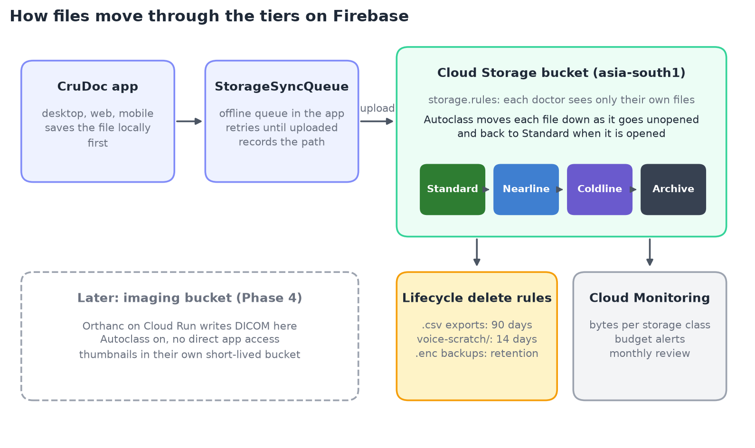
Figure 3. Files are saved on the device first, uploaded by the app's queue, then tiered by Autoclass inside the bucket.
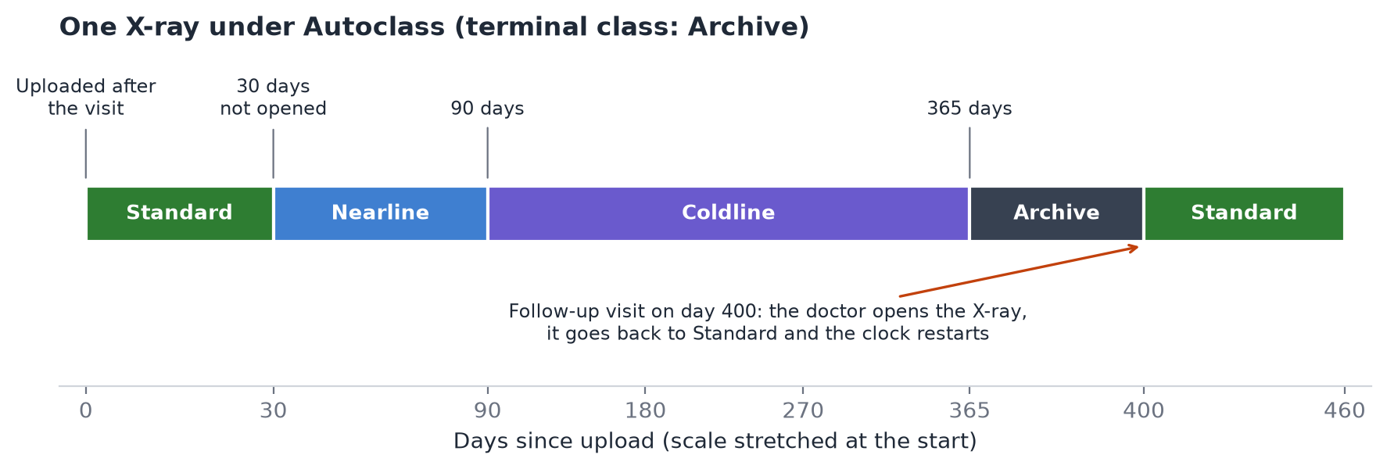
Figure 4. What happens to one X-ray that is not opened until a follow-up visit on day 400.
What each kind of file gets
Files | Where they are stored | Tiering | Deleted automatically
Prescriptions, invoices, treatment plans (PDF) | doctors/{doctor}/patients/{patient}/prescriptions, invoices, treatment-plans/ | Autoclass | No. Kept for the legal retention period; deleted only on purpose.
X-rays, clinical photos, lab reports | doctors/{doctor}/patients/{patient}/clinical/xrays, photos, labs/ | Autoclass | No. As above.
Patient photo | doctors/{doctor}/patients/{patient}/avatar/ | Autoclass (most stay Standard, being small) | When the patient record is erased.
Clinic logo and signature | doctors/{doctor}/clinic/branding/ | Stays Standard (small, used on every print) | No.
Inventory receipts, sterilization strip photos | doctors/{doctor}/inventory-receipts/, sterilization-strips/ | Autoclass | Optional: after the record-keeping period you choose.
Encrypted database backups (.enc) | doctors/{doctor}/backups/ | Autoclass | Yes: files ending .enc after the backup retention period (365 days proposed).
Revenue CSV exports | doctors/{doctor}/exports/revenue/ | Autoclass | Yes: files ending .csv after 90 days (proposed).
Voice recordings | voice-scratch/ | Uploads are switched off | Yes: 14 days, kept as a safety net.

Each kind of file already has its own folder and file ending, set by MedicalStorageService. That is what lets delete rules target backups and exports without wildcards. Keep it that way when adding new file types.

11. Implementation steps
# | Step | Who | Effort | Done when
Phase 0 – prerequisites (already on the Firebase plan)
1 | Upgrade the project to the Blaze plan (needed for Storage on new projects) | Owner | 10 min | Billing shows Blaze
2 | Enable Cloud Storage and choose asia-south1. The location can't be changed later. | Owner | 10 min | Bucket shows asia-south1
3 | Deploy the rules: firebase deploy --only storage | Developer | 5 min | Rules visible in the console
4 | Confirm soft delete is on (7 days is the default for new buckets) | Developer | 5 min | Bucket settings show soft delete
Phase 1 – tiering (about half a day)
5 | Install the Google Cloud CLI, or use the Cloud Console for steps 6–7 | Developer | 20 min | gcloud storage buckets list works
6 | Turn on Autoclass with Archive as the final class (section 12) | Developer | 10 min | Describe shows Autoclass enabled
7 | Add lifecycle.json to the repo and apply it (section 12) | Developer | 30 min | Lifecycle tab lists the rules
8 | Add a billing budget alert and a storage-by-class chart in Cloud Monitoring | Developer | 1 hour | Alert email received on test
Phase 2 – retention and erasure (1–2 days)
9 | Record the retention decisions (section 15) in the repo next to lifecycle.json | Owner + legal | – | Decisions signed off
10 | Cloud Function that deletes a patient's folder when the patient is erased (DPDP request), and uses object holds for any legal hold | Developer | 1–2 days | Tested in the emulator
Phase 3 – later
11 | Copy the bucket and backups to asia-south2 (Delhi) for disaster recovery | Developer | 2–3 days | Restore test passes
12 | Imaging bucket for DICOM, written by Orthanc, with Autoclass on and no direct app access (Option C) | Developer | With the imaging project | Imaging POC passes

12. Configuration
Turn on Autoclass (step 6):
gcloud storage buckets update gs://svayatta-crudoc-dev.firebasestorage.app \
--enable-autoclass --autoclass-terminal-storage-class=ARCHIVE

Delete rules, saved in the repo as lifecycle.json (step 7). There are no rules that change storage class: Autoclass does that, and the two can't be combined on one bucket.
{
"lifecycle": {
"rule": [
{ "action": { "type": "Delete" },
"condition": { "age": 14, "matchesPrefix": ["voice-scratch/"] } },
{ "action": { "type": "Delete" },
"condition": { "age": 90, "matchesSuffix": [".csv"] } },
{ "action": { "type": "Delete" },
"condition": { "age": 365, "matchesSuffix": [".enc"] } }
]
}
}

Apply it and check the result:
gcloud storage buckets update gs://svayatta-crudoc-dev.firebasestorage.app \
--lifecycle-file=lifecycle.json
gcloud storage buckets describe gs://svayatta-crudoc-dev.firebasestorage.app

Without the CLI: Cloud Console → Cloud Storage → Buckets → the bucket → Configuration → Autoclass → Edit; then the Lifecycle tab → Add a rule.
Later, when the imaging bucket exists (step 12), Firebase deploys a rules file to each bucket through deploy targets:
firebase target:apply storage main svayatta-crudoc-dev.firebasestorage.app
firebase target:apply storage imaging <imaging-bucket-name>

"storage": [
{ "target": "main", "rules": "storage.rules" },
{ "target": "imaging", "rules": "storage-imaging.rules" }
]

13. Working out the cost
Monthly storage cost = for each class, the GB held in that class × that class's price for asia-south1, plus read charges and the Autoclass management fee. Reads under Autoclass carry no retrieval fee.
To put numbers on it, the same inputs the AWS plan asks for (its section 22) are needed:
- Number of doctors and active patients.
- Files per visit, and average size by type (PDF, photo, X-ray).
- How often files older than a month, a quarter and a year are opened again.
- Retention period for each kind of file (section 15).
- How much data leaves Google Cloud (downloads to devices), which is billed as network egress.
Cost driver | Why it matters | How the design controls it
Storage | Grows every month with clinical files | Autoclass moves unopened files to cheaper classes
Reads | Every file download is an operation | The app keeps a local copy and reads the cloud only when needed
Autoclass fee | Per file of 128 KiB or more, per month | Small files are exempt; X-ray and PDF counts stay moderate
Network egress | Downloads to devices are billed | Local-first app; files are uploaded once and rarely downloaded
Soft delete | Deleted files are kept 7 days | Keep the default; it guards against mistakes

14. Risks and how the design handles them
Risk | Effect | Handling
Old files opened often after all | Reads from cheaper classes cost more | Autoclass charges no retrieval fee and moves the file back to Standard
A delete rule removes clinical files | Permanent loss after the 7-day soft delete | Delete rules only target voice-scratch/, .csv and .enc. No rule touches patient clinical folders. Review every rule change.
Wrong bucket location at creation | Can't be changed; data outside Mumbai | Choose asia-south1 in step 2; check before uploading anything
Rules and settings drift from the repo | Nobody knows what is live | Keep lifecycle.json in git; stop git-ignoring firebase.json
Retention periods not decided | Files kept too long (DPDP) or too short (medical records rules) | Decide in section 15 before enabling any delete rule on clinical data
Large imaging files | Over the 15 MB limit, so kept on the device only | Imaging bucket and Orthanc (step 12)

15. Decisions needed
Decision | Proposed starting point | Who decides
How long clinical files (PDFs, X-rays, photos) are kept | Keep until erased on request; confirm the minimum with legal (medical-records rules and the DPDP Act) | Owner + legal
How long encrypted backups are kept | 365 days | Owner
How long revenue CSV exports are kept | 90 days | Owner
Autoclass final class: Nearline or Archive | Archive (cheapest for files kept for years) | Owner
Disaster-recovery copy in asia-south2 (Delhi) | Yes, for the bucket and Firestore backups | Owner
Imaging platform | Orthanc on Cloud Run, or the Cloud Healthcare API DICOM store (check it is offered in asia-south1) | Owner + developer

Appendix – Sources
- Cloud Storage classes: https://cloud.google.com/storage/docs/storage-classes
- Autoclass: https://cloud.google.com/storage/docs/autoclass
- Object Lifecycle Management: https://cloud.google.com/storage/docs/lifecycle
- Soft delete: https://cloud.google.com/storage/docs/soft-delete
- Bucket locations: https://cloud.google.com/storage/docs/locations
- Cloud Storage pricing: https://cloud.google.com/storage/pricing
- Firebase deploy targets: https://firebase.google.com/docs/cli/targets
- Original plan: AWS_Medical_Platform_Implementation_Architecture.docx, v1.0, September 2026

