Predicting Healthcare Test Results using Naive Bayes Classification
BCS102 - Fundamentals of Artificial Intelligence | Semester 2, 2026

Table of Contents
1. Introduction 3
2. Dataset Description and Collection 3
3. Data Exploration 5
4. Exploratory Data Analysis and Visualisation 5
4.1 Target variable 5
4.2 Numerical feature distributions 6
4.3 Categorical features and the target 8
4.4 Correlation and association testing 10
5. Data Preparation 11
6. Data Splitting 12
7. AI Algorithm: Naive Bayes 12
7.1 Why Naive Bayes 12
7.2 Model variants and hyperparameter tuning 13
8. Performance Evaluation 14
8.1 Results 14
8.2 Interpretation 15
9. Results (Notebook Evidence) 16
10. Ethical, Social and Future Implications 24
11. Conclusion 26
Acknowledgement of AI Use 27
References 27
Marking Rubric (BCS102 Marking Scheme - Semester 2, 2026) 28

1. Introduction
Artificial intelligence (AI) is increasingly embedded in healthcare workflows, from triage support to diagnostic prediction, and its adoption raises questions of accuracy, transparency and ethics in equal measure (Tilala et al., 2024). This report documents an end-to-end machine learning workflow applied to the healthcare domain: a public hospital-records dataset is loaded into a Python notebook, explored and visualised, prepared and transformed, and used to train and evaluate a Naive Bayes classifier that predicts the outcome of a patient's medical test (Normal, Abnormal or Inconclusive).
The report follows the assignment's marking rubric in structure. Section 2 describes the dataset and its features; Sections 3 and 4 cover exploration and visualisation; Sections 5 and 6 explain preparation and splitting; Section 7 justifies and trains the algorithm; Section 8 evaluates it against suitable performance indicators; Section 9 presents consolidated notebook screenshots as evidence for the pipeline; and Section 10 discusses ethical, social and future implications. A central and deliberately honest finding runs through the report: the trained models perform at the level of random guessing, and we show statistically that this reflects the information content of the dataset itself rather than a modelling error - a result that carries important lessons for real clinical deployment.

2. Dataset Description and Collection
The dataset chosen is the Healthcare Dataset published on Kaggle by the user prasad22 (kaggle.com/datasets/prasad22/healthcare-dataset). It is a synthetically generated collection of hospital admission records designed to resemble real patient data while containing no real patient information. The raw file was downloaded from Kaggle as a single CSV file (healthcare_dataset.csv) and loaded into a pandas DataFrame. The raw data contains 55,500 observations and 15 features, comfortably exceeding the assignment's minimum scale of 1,000 observations.
The collection and processing pipeline was deliberately simple and reproducible. The CSV was placed alongside the notebook and read with pandas' read_csv function; no records were excluded at load time. Processing then followed a fixed order - type conversion, renaming, de-duplication, exploration, feature engineering, encoding, scaling and splitting - with each step performed in its own notebook cell and its effect printed immediately, so every transformation of the data is visible and auditable. Analysis combined visual methods (histograms, count plots, boxplots and a correlation heatmap, reproduced as figures in Section 4) with formal statistical tests (ANOVA and chi-square-based Cramer's V), ensuring conclusions rest on numbers as well as pictures. Re-running the notebook top to bottom regenerates every figure and statistic reported here without manual intervention.
Table 1 lists every feature. Fourteen are raw features shipped with the dataset; one additional engineered feature, Length of Stay, is derived during preparation (Section 5) as the number of days between admission and discharge, capturing treatment duration in a single numeric column.
Table 1. Features of the healthcare dataset.
# | Feature | Type | Description
1 | Name (renamed Patient Name) | Raw / Categorical | Patient's full name (identifier, not predictive)
2 | Age | Raw / Numerical | Patient's age in years
3 | Gender | Raw / Categorical | Male / Female
4 | Blood Type | Raw / Categorical | Blood group (A+, A-, B+, B-, O+, O-, AB+, AB-)
5 | Medical Condition | Raw / Categorical | Cancer, Obesity, Diabetes, Asthma, Hypertension or Arthritis
6 | Date of Admission | Raw / Date | Date the patient was admitted
7 | Doctor | Raw / Categorical | Attending doctor's name (identifier)
8 | Hospital | Raw / Categorical | Hospital name (identifier)
9 | Insurance Provider | Raw / Categorical | Blue Cross, Medicare, Aetna, UnitedHealthcare or Cigna
10 | Billing Amount | Raw / Numerical | Amount billed for treatment (USD)
11 | Room Number | Raw / Numerical | Room number assigned (identifier-like)
12 | Admission Type | Raw / Categorical | Elective, Emergency or Urgent
13 | Discharge Date | Raw / Date | Date the patient was discharged
14 | Medication | Raw / Categorical | Aspirin, Ibuprofen, Paracetamol, Penicillin or Lipitor
15 | Test Results (target) | Target / Categorical | Normal, Abnormal or Inconclusive
16 | Length of Stay | Engineered / Numerical | Discharge Date minus Date of Admission, in days

3. Data Exploration
Initial exploration established the dataset's dimensions (55,500 rows by 15 columns) and each feature's data type using df.info() and df.describe(). Several types required correction: the two date columns arrived as plain text and were converted to proper datetime64 columns, enabling the date arithmetic used later for feature engineering, and the six nominal fields plus the target were cast to the pandas category dtype, which is more memory-efficient than generic object storage and makes their semantics explicit.
One feature was renamed for clarity: the column Name became Patient Name, because three separate columns in this dataset hold names (patient, doctor and hospital) and the bare word "Name" invites misreading. Completeness checks found no missing values in any column, but did find 534 exact-duplicate rows. These were removed before any further analysis, leaving 54,966 unique observations; duplicates matter because a record repeated on both sides of a train/test split lets the model be evaluated on data it has effectively already seen. All subsequent figures and statistics in this report therefore describe the de-duplicated data.

4. Exploratory Data Analysis and Visualisation

4.1 Target variable
Figure 1 shows the distribution of the target. The three classes are almost perfectly balanced: Abnormal 33.5%, Normal 33.3% and Inconclusive 33.1%. This balance has two consequences: accuracy is a fair headline metric (no majority class can be gamed), and any model must clearly beat 33.3% accuracy to demonstrate it has learned anything at all.
Because the classes are balanced, no resampling technique such as SMOTE or class weighting is required; each class contributes roughly equal evidence during training. Balance of this quality is itself unusual in real clinical data, where abnormal findings are typically the minority - another hint that the dataset was generated rather than collected.
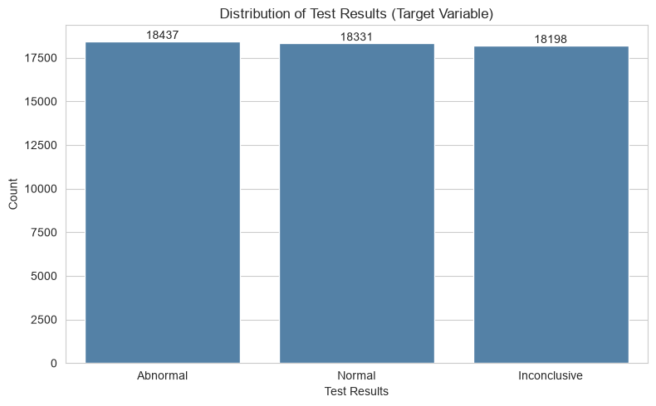
Figure 1. Distribution of Test Results (target variable).

4.2 Numerical feature distributions
Age (Figure 2) is spread nearly uniformly from the teens to the late eighties, with no peak or skew. Real patient-age distributions typically skew toward older ages, so this flat shape is an early signature of synthetic generation. Billing Amount (Figure 3) is likewise almost uniform across its range, where real billing data is strongly right-skewed by a minority of high-cost cases. Boxplots with the 1.5 x IQR rule (Figure 4) confirm the visual impression quantitatively: zero outliers in either feature across all 54,966 rows.
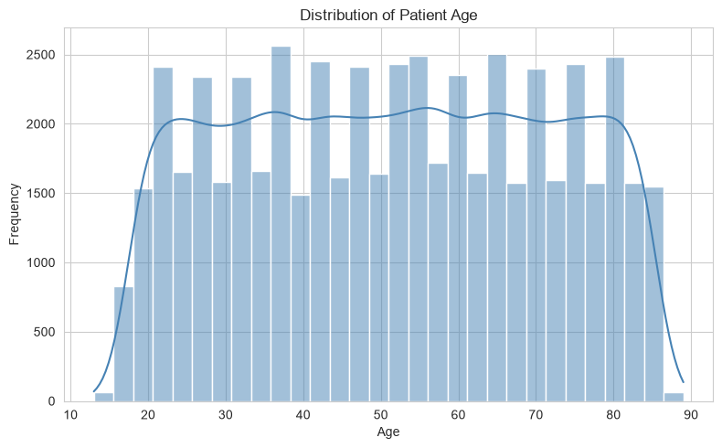
Figure 2. Distribution of patient age.
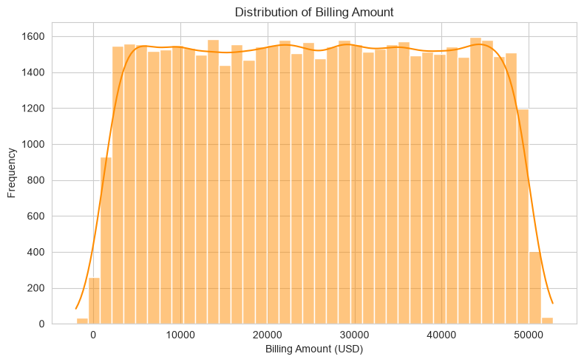
Figure 3. Distribution of billing amount.
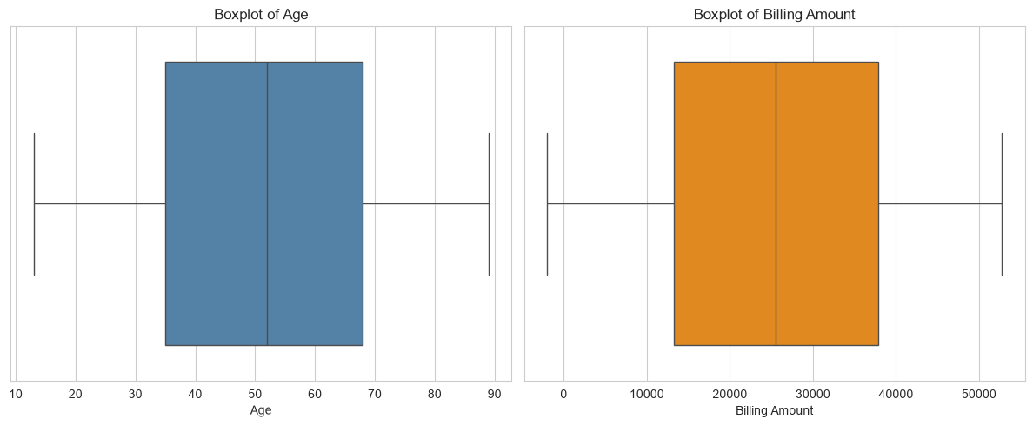
Figure 4. Outlier screening via boxplots (no IQR outliers found).

4.3 Categorical features and the target
All six medical conditions appear in near-equal numbers (Figure 5), so the model sees ample examples of each. More telling are Figures 6 and 7: within every medical condition and every admission type, the three test outcomes occur in essentially the same proportions as in the overall data. If test results were genuinely driven by condition or admission context, these bars would shift visibly between groups; their uniformity is the first warning that the features may carry little signal about the target.
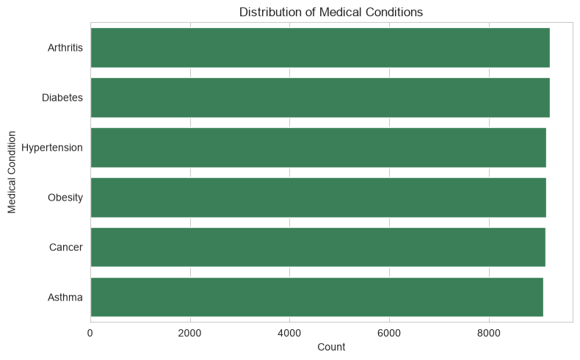
Figure 5. Distribution of medical conditions.
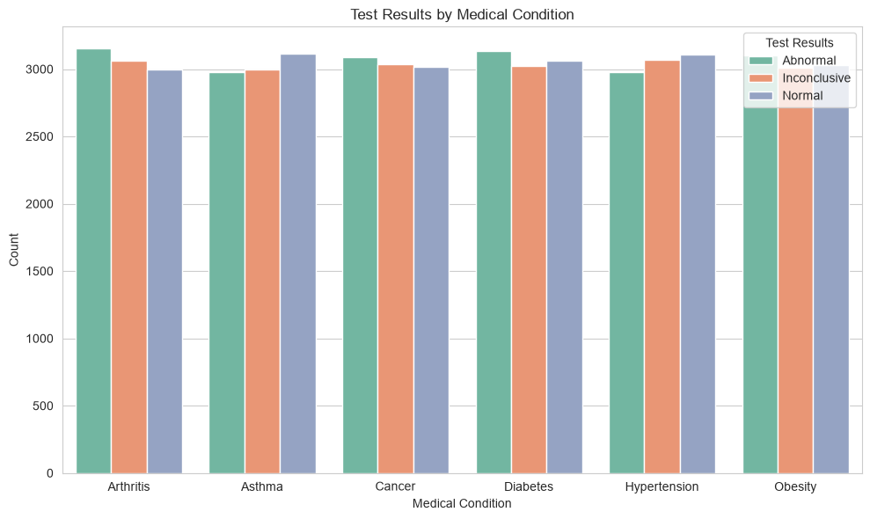
Figure 6. Test results by medical condition.
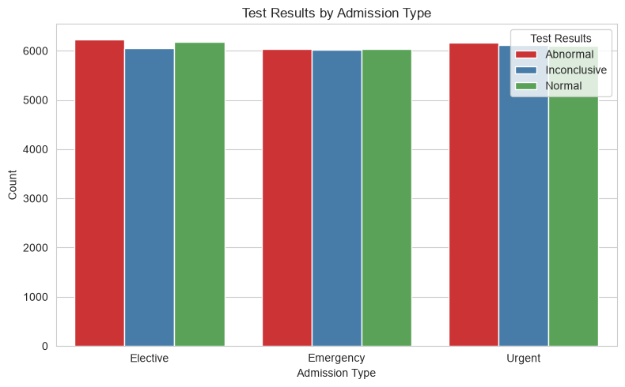
Figure 7. Test results by admission type.

4.4 Correlation and association testing
Pearson correlations between the numerical features are all near zero (Figure 8), indicating no meaningful linear relationships - incidentally consistent with Naive Bayes's conditional independence assumption. Because correlation between features says nothing about association with the target, we tested every feature against Test Results directly: one-way ANOVA F-tests for the numeric features and Cramer's V (derived from chi-square tests) for the categorical ones. Every ANOVA p-value exceeded the 0.05 significance threshold and every Cramer's V was approximately zero. Statistically, no individual feature is measurably associated with the target - a finding that predicts, before any model is trained, that classification performance will be bounded near chance level.
Concretely, the ANOVA tests for Age and Billing Amount against the three outcome classes produced p-values well above 0.05, so the per-class means cannot be statistically distinguished from one another. Cramer's V for Gender, Blood Type, Medical Condition, Insurance Provider, Admission Type and Medication all fell close to zero on a scale where zero means no association and one means perfect association - values this small leave essentially nothing for any classifier to exploit.
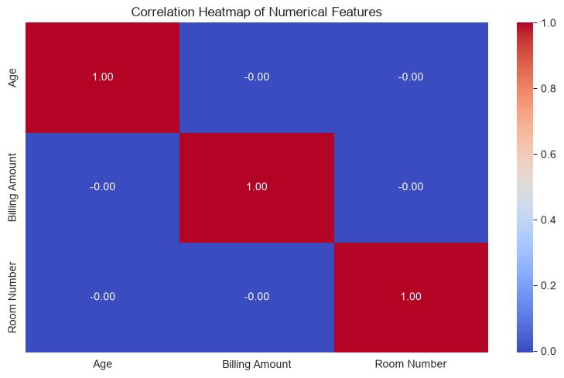
Figure 8. Correlation heatmap of numerical features.

5. Data Preparation
Preparation proceeded in five steps, each motivated by the requirements of the chosen algorithm. First, cleaning: the duplicate removal and completeness checks described in Section 3. Second, feature extraction: Length of Stay was engineered as the day difference between discharge and admission dates, converting two dates the model cannot use directly into one meaningful duration. Third, dropping non-predictive identifiers: Patient Name, Doctor, Hospital and Room Number identify records rather than describe them, and retaining such high-cardinality identifiers invites memorisation instead of learning.
Fourth, transformation: the six categorical features and the target were label-encoded into integer codes. Naive Bayes does not require one-hot encoding: CategoricalNB models each feature's category distribution per class directly, and no distance metric is computed in which integer codes could imply a false ordering. Fifth, scaling: for the Gaussian variant, the numerical features (Age, Billing Amount, Length of Stay) were standardised with StandardScaler fitted on the training set only, keeping features on comparable scales for numerical stability. For the categorical variant, the numerical features were instead binned into quintiles, with bin edges learned from the training set and reused unchanged on the test set so that no information about the test distribution leaks into training.
Two common preparation steps were considered and deliberately omitted, with reasons. Outlier removal was unnecessary because the IQR screening of Section 4.2 found no outliers to remove; missing-value imputation was unnecessary because the completeness check found no gaps. Documenting these negative checks matters as much as performing transformations: it demonstrates each step was evaluated against the data rather than skipped, and it keeps the pipeline as small as the data allows, reducing the risk of introducing artefacts through unneeded processing.

6. Data Splitting
The 54,966 prepared observations were divided with a stratified 80/20 holdout split: 43,972 training rows and 10,994 test rows. At this scale a simple holdout gives stable, low-variance estimates of test performance, so k-fold cross-validation was reserved for a different job - hyperparameter selection inside the training set (Section 7) - keeping the test set completely unseen until final evaluation. Stratification on the target preserved class proportions on both sides of the split, and the printed proportions confirm it worked: 33.5% / 33.1% / 33.4% in training versus 33.6% / 33.1% / 33.4% in test. A fixed random seed (random_state = 42) makes the split, and therefore every downstream result, exactly reproducible.
Alternative splitting strategies were weighed before settling on the holdout. Repeated k-fold cross-validation for the final evaluation would re-use the same observations across folds at extra compute cost while adding little precision at this sample size; a time-based split was inapplicable because the target has no temporal structure of interest; and a smaller test fraction would have widened the uncertainty of the reported metrics. The 80/20 stratified holdout therefore balances training volume against evaluation stability, which is why it is the conventional default at this scale.

7. AI Algorithm: Naive Bayes

7.1 Why Naive Bayes
Naive Bayes is a probabilistic classifier built on Bayes' theorem: the probability of a class given the observed features is proportional to the prior probability of the class multiplied by the likelihood of the features given that class. Its "naive" simplification - treating features as conditionally independent given the class - makes the likelihood a simple product of per-feature terms, which is what makes the algorithm fast, stable and interpretable even on large datasets. Recent clinical work bears this out: Wang (2025) found Naive Bayes both interpretable and competitive with more complex machine learning algorithms for predicting in-hospital mortality, and Jackins et al. (2021) demonstrated effective disease prediction with Naive Bayes alongside random forests across diabetes, heart disease and cancer data.
Formally, for a class c and feature vector x, Bayes' theorem gives P(c | x) proportional to P(c) multiplied by P(x | c). The prior P(c) is estimated from class frequencies in the training set - here roughly one third per class - and the naive assumption factorises the likelihood P(x | c) into a product of one term per feature. GaussianNB estimates each numeric term with a per-class mean and variance; CategoricalNB estimates each categorical term with smoothed per-class category frequencies. Prediction selects the class with the highest posterior, and the same posteriors supply the class probabilities used for the ROC-AUC analysis in Section 8.
Four properties make it suitable here: it handles mixed categorical and numerical features; it natively supports multi-class problems such as our three-class target; it trains almost instantly on 54,966 rows; and its independence assumption is plausible for administrative fields like insurance provider and admission type, consistent with the near-zero inter-feature correlations observed in Section 4. Alternatives were considered and rejected deliberately: logistic regression and tree ensembles can model feature interactions that Naive Bayes assumes away, but Section 4.4 showed that no feature carries measurable association with the target in the first place, so added model flexibility has nothing to exploit - it would cost training time and interpretability for no realistic accuracy gain. Naive Bayes is the simplest model capable of establishing a fair, fast baseline for this dataset.

7.2 Model variants and hyperparameter tuning
Two variants were trained and compared. GaussianNB treats every (standardised) feature as continuous and models each with a per-class normal distribution; its key hyperparameter, var_smoothing, adds a small value to every variance estimate to prevent numerical instability from near-zero variances. CategoricalNB treats every feature as categorical (with the numeric features quintile-binned as described in Section 5); its key hyperparameter, alpha, applies Laplace/Lidstone smoothing to category counts so that category-class combinations unseen in training do not receive zero probability.
Both hyperparameters were tuned with GridSearchCV using 5-fold stratified cross-validation on the training set only. For GaussianNB, twenty values of var_smoothing spanning nine orders of magnitude were searched, selecting approximately 0.113 with a cross-validated accuracy of 0.335. For CategoricalNB, six values of alpha were searched, selecting 0.5 with a cross-validated accuracy of 0.337. A DummyClassifier that always predicts the most frequent training class was also fitted as a majority-class baseline: any model unable to clearly beat it has learned nothing real from the features.

8. Performance Evaluation

8.1 Results
The trained models were evaluated on the untouched 10,994-row test set using accuracy, weighted precision, weighted recall, weighted F1-score, one-vs-rest multi-class ROC-AUC, confusion matrices and per-class classification reports. Table 2 summarises the headline numbers.
Table 2. Test-set performance of both models against the majority-class baseline.
Model | Accuracy | Precision (weighted) | Recall (weighted) | F1 (weighted) | ROC-AUC (OvR)
Baseline (majority class) | 0.3355 | 0.1125 | 0.3355 | 0.1685 | -
GaussianNB (tuned) | 0.3305 | 0.3310 | 0.3305 | 0.3213 | 0.5003
CategoricalNB (tuned) | 0.3324 | 0.3327 | 0.3324 | 0.3306 | 0.4966

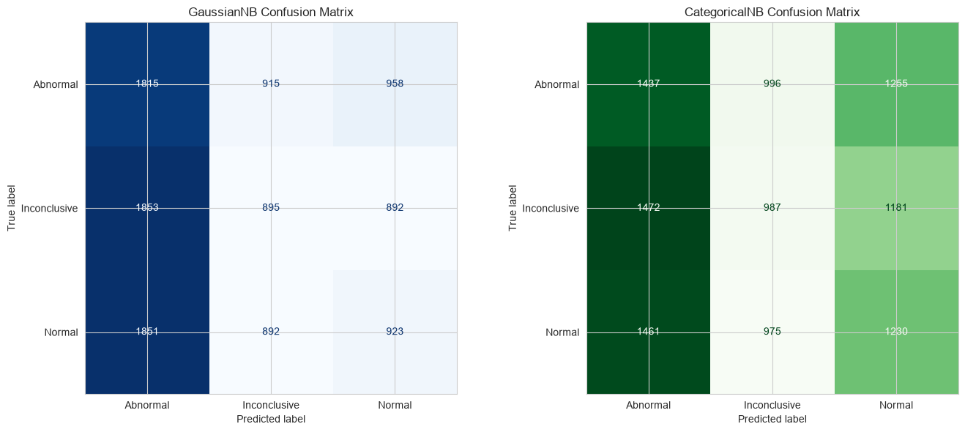
Figure 9. Confusion matrices for GaussianNB (left) and CategoricalNB (right).
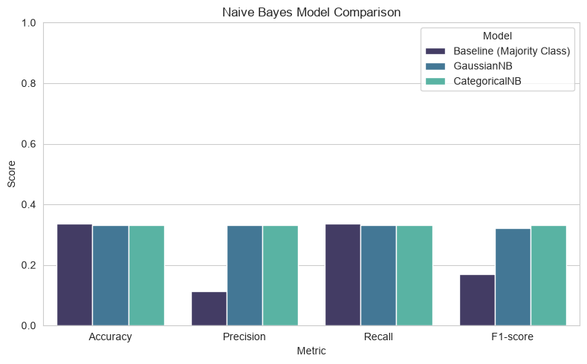
Figure 10. Metric comparison across the baseline and both models.

8.2 Interpretation
Every model sits within one percentage point of the 33.3% expected by chance on this balanced three-class problem, and the ROC-AUC scores of 0.5003 and 0.4966 are statistically indistinguishable from 0.5 - the models' predicted probabilities rank cases no better than random guessing. Hyperparameter tuning did not materially change the outcome, ruling out bad default settings as the explanation. The confusion matrices (Figure 9) show predictions scattered across all three classes rather than concentrated on the diagonal.
For a diagnostic-support tool, the class that matters most is Abnormal, and accuracy alone hides the asymmetry between its error types: low recall means truly abnormal results predicted as normal - false negatives that could delay diagnosis, the most dangerous failure mode - while low precision means normal patients flagged abnormal, causing unnecessary follow-up and anxiety. Here, precision for Abnormal sits at roughly 33-34% for the baseline and both trained models alike: a clinician acting on this model's abnormal flag would be right about one time in three, no better than guessing.
The per-class classification reports add nuance the weighted averages hide. Both trained models spread their predictions across the classes with per-class precision, recall and F1 all clustered near one third, while the baseline achieves recall of 1.00 on its single predicted class (Abnormal) and zero on the others - which is why its weighted precision (0.1125) and F1 (0.1685) are so poor despite matching accuracy. That the trained models beat the baseline on precision and F1 but not accuracy is exactly the signature of models that produce varied but uninformative predictions.
Crucially, this is the expected outcome for this dataset, not a modelling failure. The association tests of Section 4.4 showed no feature carries measurable signal about the target; performance is therefore bounded by the information content of the available administrative features, not by the algorithm or its configuration. The honest conclusion is that no classifier - Naive Bayes or otherwise - could perform meaningfully better on these features, and demonstrating that ceiling rigorously (baseline comparison, association tests, ROC-AUC) is itself the analytical contribution of this work.

9. Results (Notebook Evidence)
This section supplements Sections 3-8 with direct notebook screenshots, in pipeline order: loading, exploration, cleaning, preparation, splitting, tuning and evaluation.
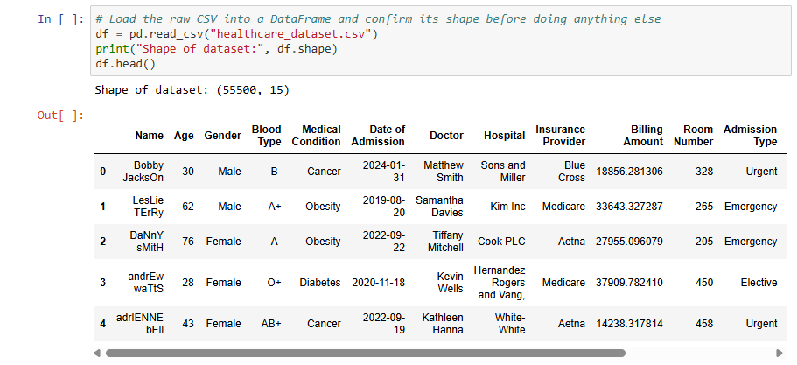
Screenshot 1. Dataset shape and preview after loading.
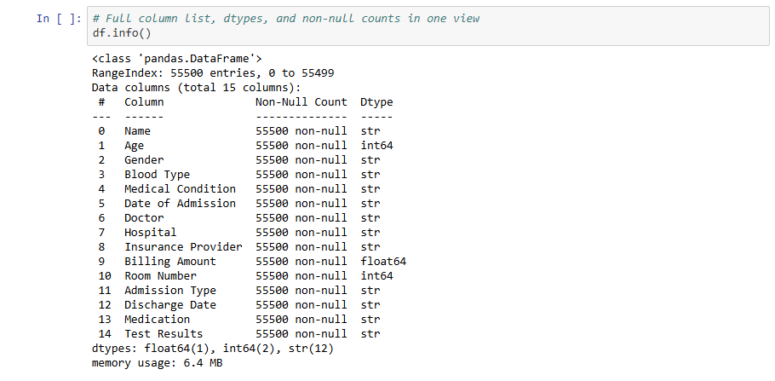
Screenshot 2. Column data types via df.info().
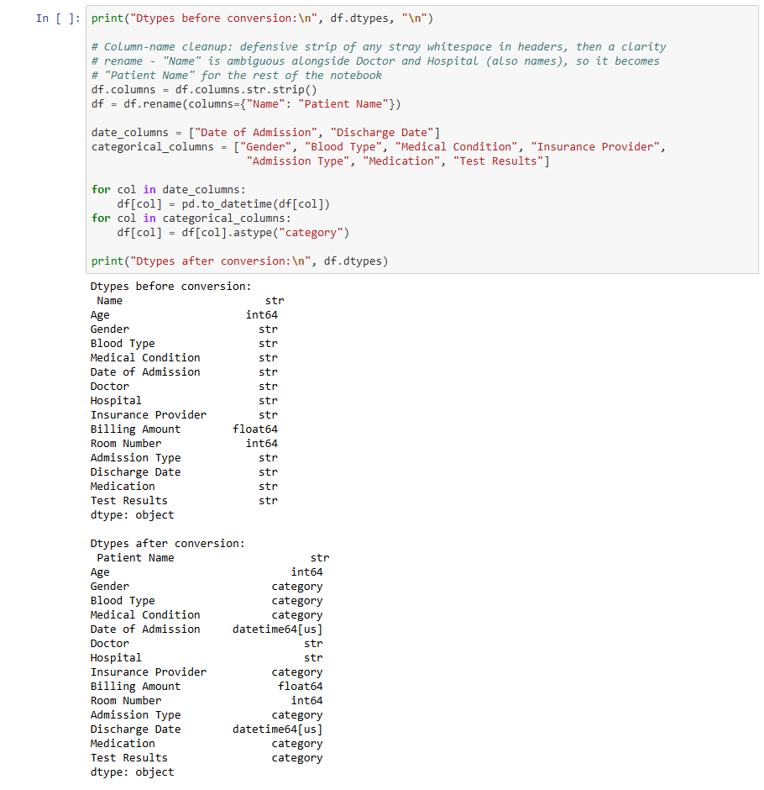
Screenshot 3. Data types before and after conversion.
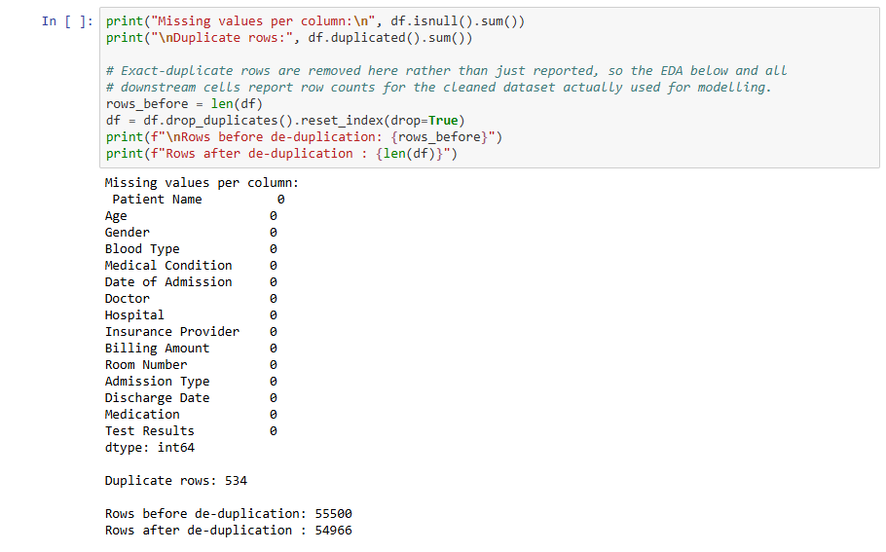
Screenshot 4. Missing-value and duplicate-row check.
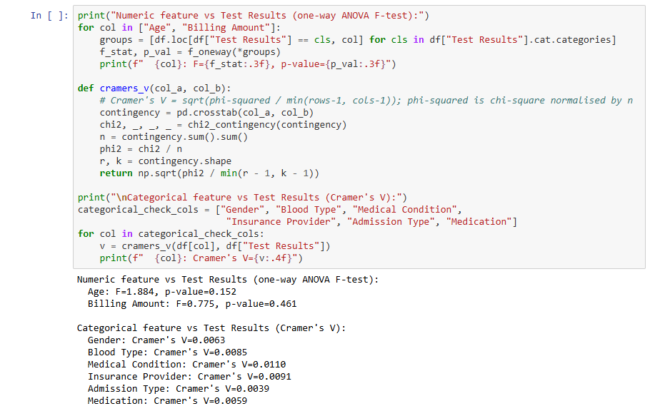
Screenshot 5. ANOVA and Cramer's V association tests.
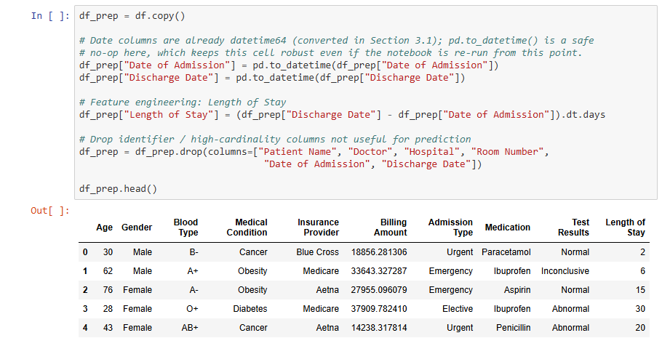
Screenshot 6. Prepared data with engineered Length of Stay.
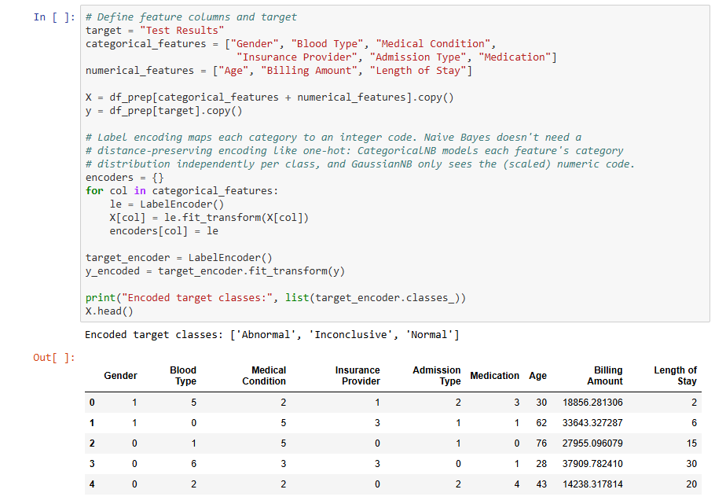
Screenshot 7. Encoded target classes and feature preview.
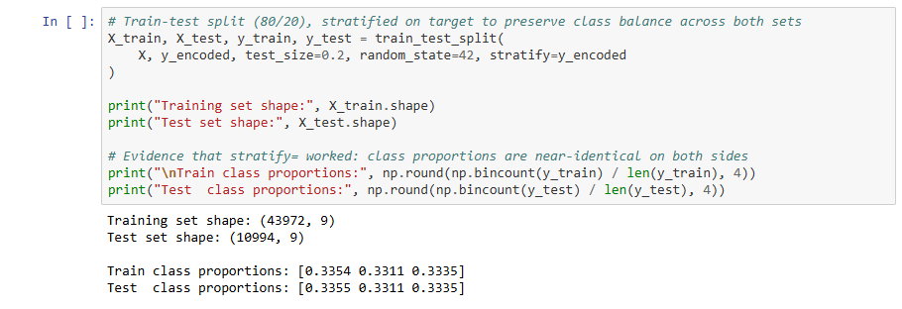
Screenshot 8. Train/test split shapes and class balance.
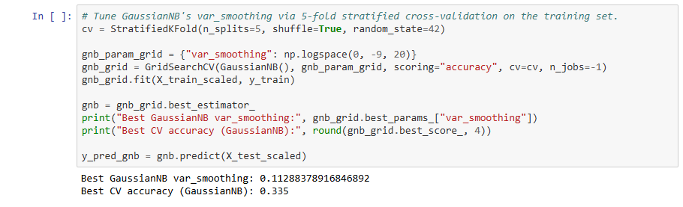
Screenshot 9. Tuned GaussianNB hyperparameter search result.
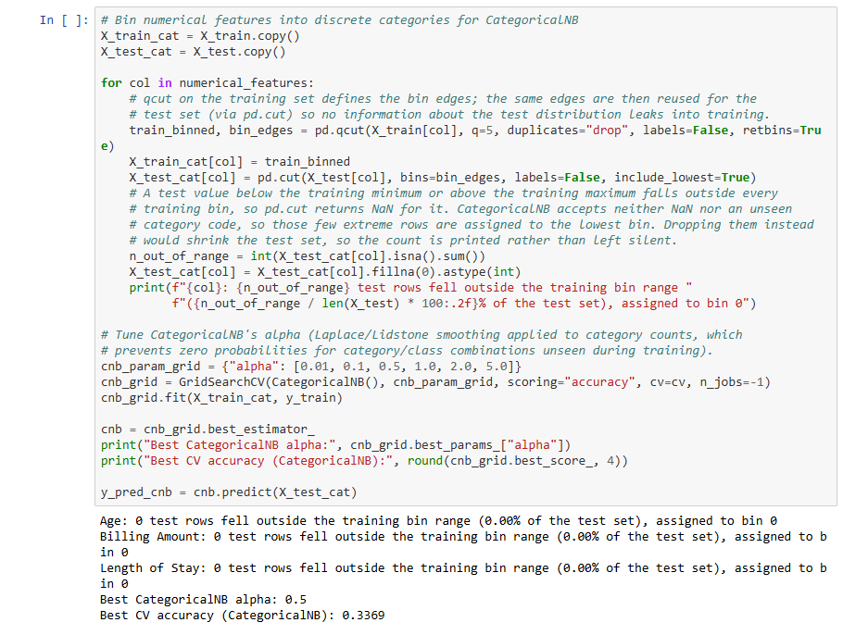
Screenshot 10. Tuned CategoricalNB binning and hyperparameter.
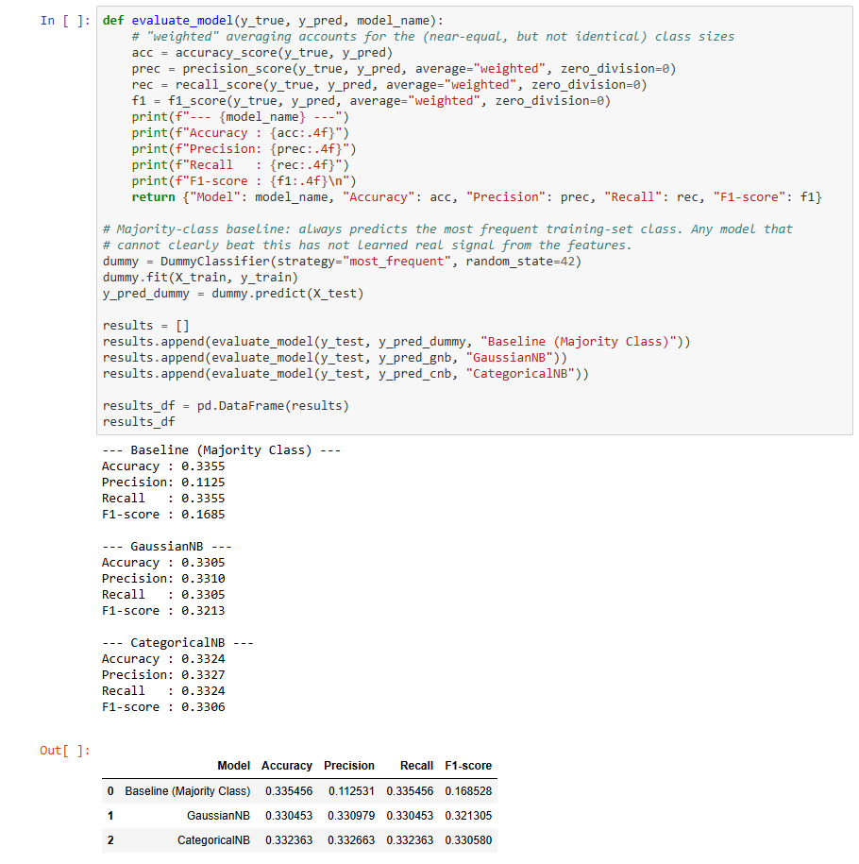
Screenshot 11. Accuracy, precision, recall and F1 output.
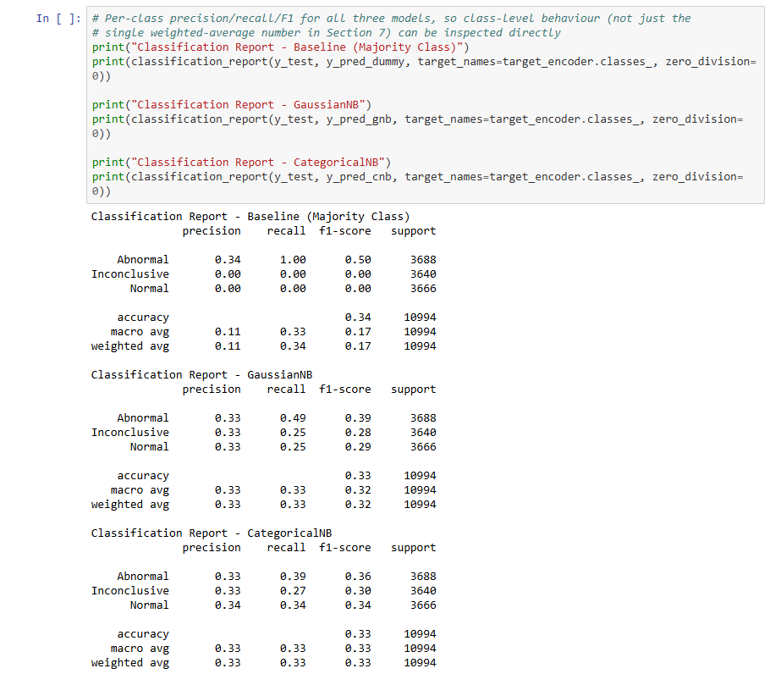
Screenshot 12. Per-class classification reports for all models.
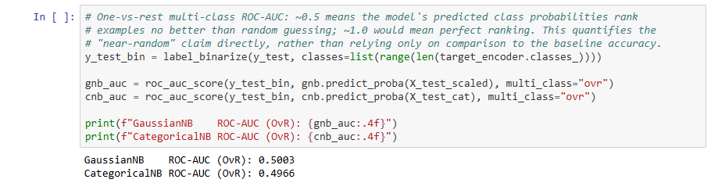
Screenshot 13. Multi-class ROC-AUC output.

10. Ethical, Social and Future Implications
Ethical implications. Healthcare data is among the most sensitive categories of personal information; although this dataset is synthetic, any real deployment would require strict compliance with data-protection regimes such as HIPAA or PDPA and informed patient consent (Tilala et al., 2024). More immediately, a model whose ROC-AUC is indistinguishable from 0.5 provides no discriminative signal and must not inform real clinical decisions: wrong predictions of normal or abnormal outcomes could cause misdiagnosis, delayed treatment or unnecessary intervention. Bias is a further concern - if demographic subgroups (for example, by insurance provider, a proxy for socioeconomic status) were systematically mis-predicted, an AI system could quietly widen existing healthcare inequities, a risk repeatedly flagged in the clinical-AI ethics literature (Benzinger et al., 2023).
Accountability is a further ethical dimension: if a model's prediction contributes to a harmful clinical decision, responsibility must be traceable across developers, deploying institutions and clinicians, which requires documented validation, versioning and audit trails long before deployment. The systematic review by Benzinger et al. (2023) also highlights concerns about patient autonomy - decision-support systems can subtly anchor clinicians' judgements, so patients should know when AI contributed to their care. This project's contribution to that agenda is modest but real: it models the reporting discipline (baselines, uncertainty, honest negative results) that responsible clinical AI requires.
Social implications. Reliable predictive tools could reduce clinician workload and speed up triage, but overreliance on an inaccurate model erodes patient trust in AI-assisted care. Transparency about limitations - publishing accuracy, precision, recall and ROC-AUC, and comparing against a simple baseline as this report does - is essential so that clinicians treat model output as one decision-support signal among many rather than as ground truth.
Future implications. Performance could plausibly improve with clinically meaningful features - laboratory values, vital signs, prior history or longitudinal records - in place of administrative fields. With richer data, ensemble methods or deep learning on time-series clinical data become worth revisiting, paired with explainability techniques such as SHAP to build clinician trust. Any deployed model would additionally require continuous monitoring and periodic retraining to prevent performance drift as hospital processes and patient populations change.

11. Conclusion
This project loaded 55,500 hospital records, cleaned and type-converted them (removing 534 duplicates), explored them visually and statistically, engineered a Length of Stay feature, and trained two tuned Naive Bayes variants to predict test results. Both models performed at chance level, and the report demonstrated - through association tests, a majority-class baseline and ROC-AUC analysis - that this ceiling belongs to the dataset, not the algorithm. The work illustrates a principle central to responsible AI in healthcare: knowing, and showing, when a model should not be trusted is as important as building one that can be.

Marking Rubric (BCS102 Marking Scheme - Semester 2, 2026)
CLO | Topic | Marks awarded
CLO3 | Data Exploration using Python (0-10)
CLO3 | Data Visualization using Python (0-10)
CLO3 | Data Preparation using Python (0-10)
CLO3 | Data Splitting using Python (0-10)
CLO3 | AI Algorithm on the Training Set using Python (0-25)
CLO3 | Evaluate the Trained AI Algorithm on the Test Set using Python (0-25)
CLO3 | Python Notebook File (0-10)
 | TOTAL MARKS (100)

