Code Challenge

Instructions
Welcome to the Telstra Front-end Developer code challenge.
You will be assessed on the following criteria;
- Testing and documentation
- Design and architecture approach
- Knowledge of chosen libraries and languages
You have been given the below JSON data file that presents an array of product objects.
Read and review the follow user stories and UX to develop a working prototype.

User story
As a customer
I want to see a range of mobile phones
So I can click one to add to my cart
As a customer
I want to remove items from my shopping cart
So I can update my shopping cart

Acceptance criteria
- Only display products that are published
- Adding to my cart removes item from product list
- Removing item from cart, adds item back into product list
- Responsive view that works across mobile and desktop devices
- WCAG 2.1 AA compliant
- Semantic markup

UX
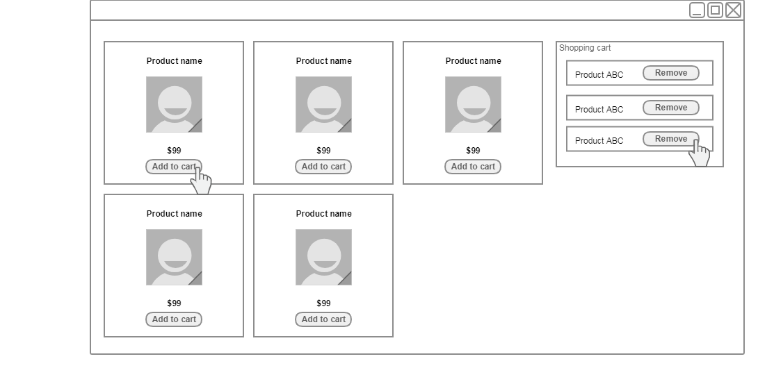

Product data JSON
Product data
[
{
"isPublished":"true",
"productName":"Apple iPhone X",
"productImage":"https://www.telstra.com.au/content/dam/tcom/personal/mobile-phones/product-catalogue/iphone-x/iphone-x-silver-grid.png",
"price":"299"
},
{
"isPublished":"true",
"productName":"Apple iPhone 8",
"productImage":"https://www.telstra.com.au/content/dam/tcom/personal/mobile-phones/product-catalogue/iphone-8/iphone-8-silver-grid.png",
"price":"100"
},
{
"isPublished":"false",
"productName":"Apple iPhone 8 Plus",
"productImage":"https://www.telstra.com.au/content/dam/tcom/personal/mobile-phones/product-catalogue/iphone-8/iphone-8plus-space-grey-grid.png",
"price":"99"
},
{
"isPublished":"true",
"productName":"Samsung Galaxy S9",
"productImage":"https://www.telstra.com.au/content/dam/tcom/personal/mobile-phones/product-catalogue/samsung-galaxy-s9/samsung-galaxy-s9-purple-front.png",
"price":"149"
},
{
"isPublished":"true",
"productName":"OPPO R15 Pro",
"productImage":"https://www.telstra.com.au/content/dam/tcom/personal/mobile-phones/product-catalogue/oppo-r15-pro/oppo-r15-device-front.png",
"price":"199"
},
{
"isPublished":"true",
"productName":"Sony Xperia XA2",
"productImage":"https://www.telstra.com.au/content/dam/tcom/personal/mobile-phones/product-catalogue/sony-xperia-xa2/sony_xperia_xa2_front_v1.png",
"price":"19"
}
]

