**Linux Commands**

**Name: Lapitan, Hanz Jared C. Date: 2024/03/30**

**Course/Section: DS163/B1**

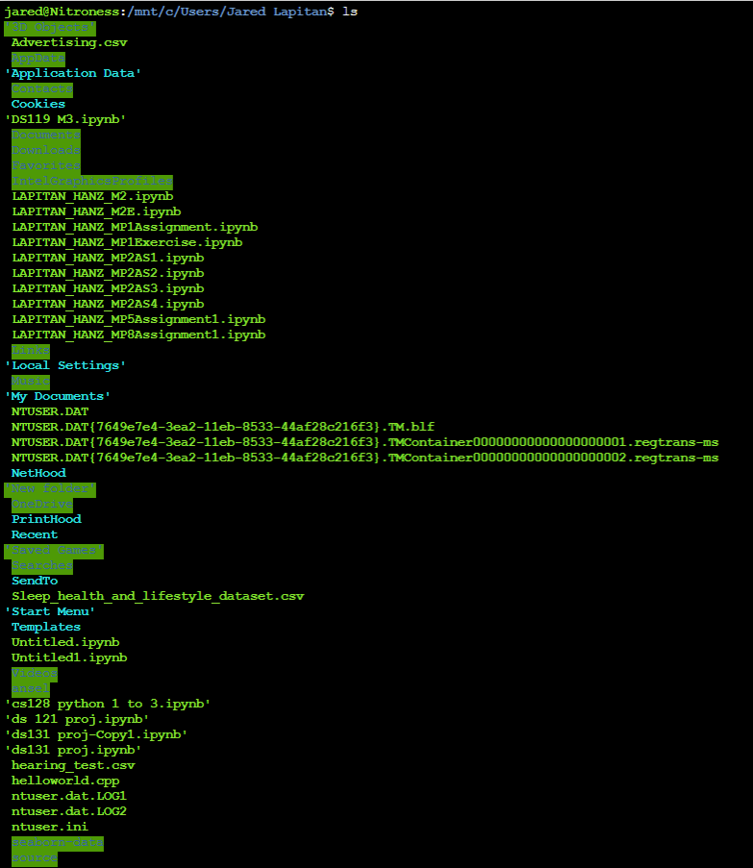

1. **ls** – Lists the files and directories in the current directory.

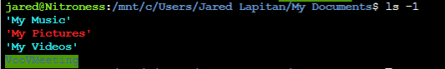

1. **ls -l** – Lists the files and directories in long format showing



1. **pwd** – Prints the working directory, showing the full path to the current directory.



1. **ls -r** – list the files and directories in reverse order.

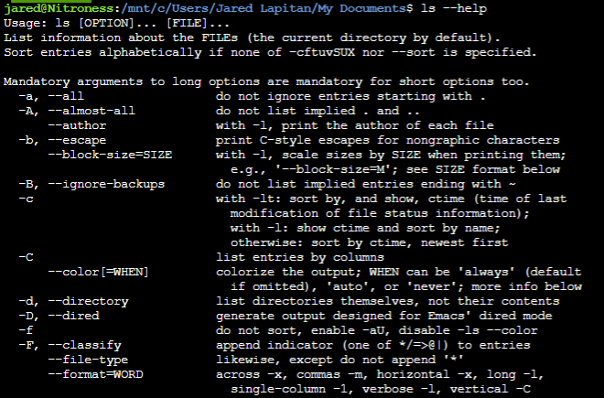

1. **ls –help** – list all the commands and as act a guide for the users.

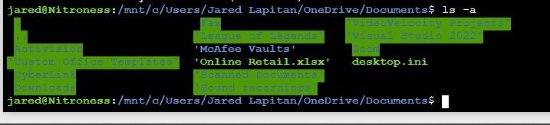

1. **ls -a** -Lists all entries in the directory, including hidden files starting with a dot(.).



1. **~** - Represents the home directory.

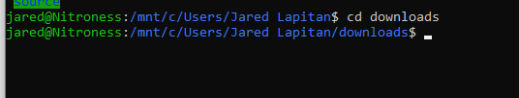

1. **cd directory_name** – Changes the current directory to the specified directory, which in this case “downloads”

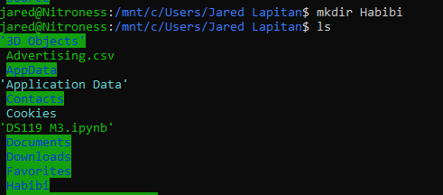

1. **Mkdir directory_name** – Creates a new directory with the specified name, which in this case Habibi

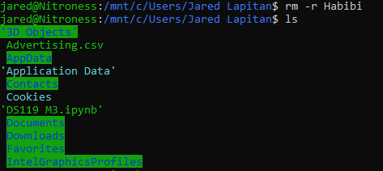

1. **rm -r directory_name** – Recursively removes a directory and all its contents.



1. **mv** – Moves or renames files and directories. It can also be used to move files to a different directory.