Technics SL-1350 SFDP130-01
Real Board:
- 5.12 in
- 3.93 tall

motor connector
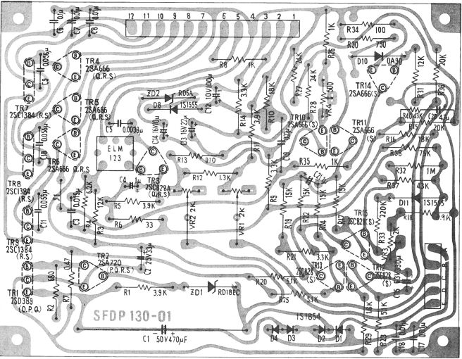

Row A

-----------------

heatsink side

Row B

-----------------

connector
Row C

column 1 | column 2 | column 3

