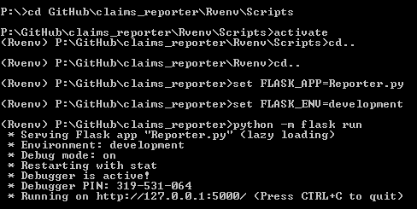

* Python –m flask run –host-0.0.0.0
* In a new terminal, ipconfig
* Look for ipv4

Stopped at part V User Registration

Removed ‘user=boss’ and ‘user=user’ from routes.

Instead, using ‘current_user.user’ in base template. Check to see if these work after registering.

When @roles_required is added, error in page :

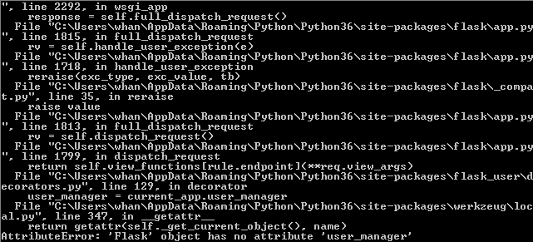

Also, when logged in, should have ‘logout button’ and ‘Hello, current_user.username’

How to query the Role table:

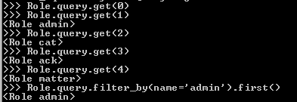

Users:

Username: cattest

Email: [cattest@example.com](mailto:cattest@example.com)

Role: cat

Pw: password

Username: acktest

Email: [acktest@example.com](mailto:acktest@example.com)

Role: ack

Pw: password

Username:mattertest

Email: [mattertest@example.com](mailto:mattertest@example.com)

Role: matter

Pw: password

**From Cyle:**

https://ampersandacademy.com/tutorials/flask-framework/flask-framework-form-values  
The part you want is at the very bottom, they cover the POST data there.  One thing I saw is that the url functions don't take a request argument, you just import it at the very top and access it from within the url function

from flask import Flask,request

That should be at the top of your urls file, you might already be importing Flask itself so just add 'request' to the end of it if so

**Pushd and popd**

>>pushd Z:

>>popd “to stop”