Lab 1 — Exploiting LLM APIs with excessive agency
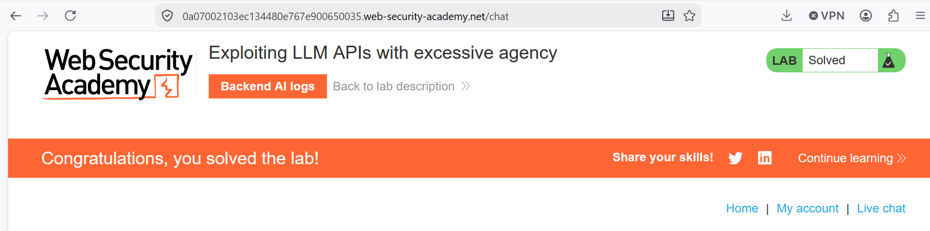
The chatbot could run raw SQL through a Debug SQL API, so I just asked it to delete the user carlos and it did. The problem is the LLM had way more power than it needed for a support bot. The fix is to only give it the functions it actually needs and keep it away from the database.
Lab 2 — Exploiting vulnerabilities in LLM APIs
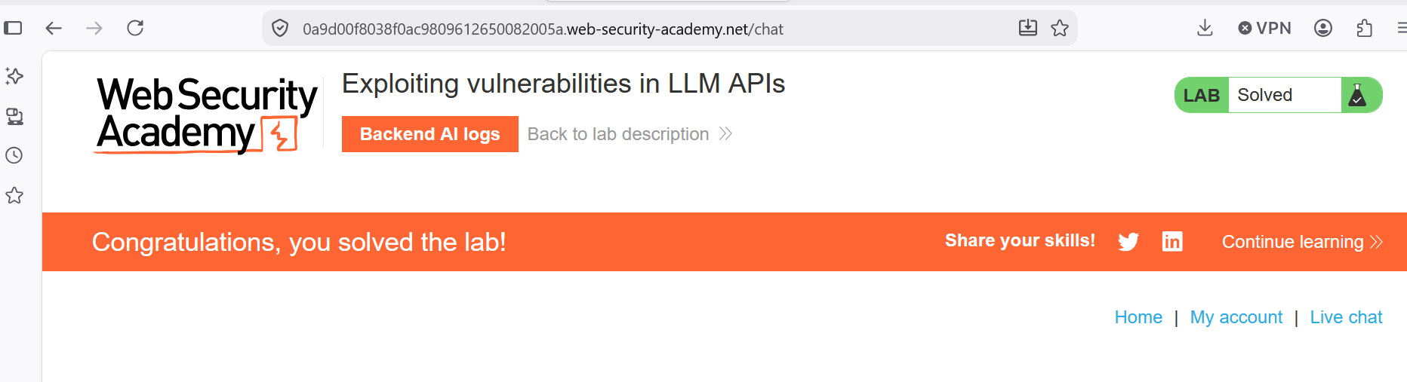
The newsletter signup API stuck the email you gave it straight into a system command. So I put $(whoami) inside the email and the server ran it, which let me delete carlos' morale.txt file. This is OS command injection. The fix is to check the email input and never feed user text into shell commands.
Lab 3 — Indirect prompt injection
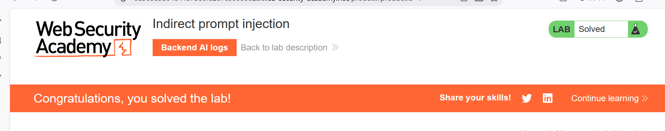
The chatbot read product reviews and trusted them like real instructions. I left a review that faked a new user message telling it to delete the account, and when carlos asked about the jacket it deleted him. The fix is to keep review text separate from actual user commands and confirm with the real user before deleting anything.
Lab 4 — Exploiting insecure output handling in LLMs
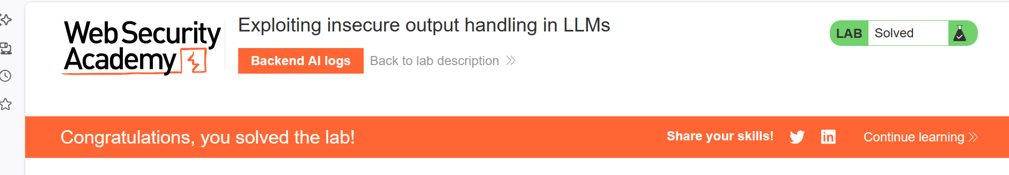
The chat showed the LLM's reply as raw HTML, so whatever it repeated would run in your browser. I hid an iframe in a review, and when the bot repeated it back the page auto-submitted the delete account form. The fix is to encode the output so tags show up as plain text instead of running.

