**Lab 1 – Product Description**

Byron Aquilino

Old Dominion University

CS410

Janet Brunelle

13 December 2020

Version 1

Table of Contents

1 Introduction 4

2 Product Description 5

2.1 Key Product Features and Capabilities 6

2.1.1 Load Plan 6

2.1.2 Move Inventory 7

2.1.3 Rental Estimations and Logistics Planning 7

2.1.4 Expert Packing Tips, Chat Bot and Move Experts 8

2.1.5 Vendor Synchronization 9

2.1.6 Move Analytics 9

2.2 Major Components (Hardware/Software) 10

2.2.1 Database 11

2.2.2 Smartphone Client 11

2.2.3 Website Client 13

2.2.4 Web API 13

2.2.5 Web Application 13

2.2.6 Vendor Synchronization Service 14

3 Identification of Case Study 14

4 Glossary 16

5 References 17

**List of Figures**

Figure 1 10

# Introduction

When it comes to moving, not every American can afford to pay for professionals (Wood, 2020). This is because in addition to typical moving expenses, such as the moving truck, the packing materials, the gas and the insurance, professional moves incur labor costs (Wood, 2020). The avoidance of incurring these costs is not without its downside. Professional movers bring additional benefits to the consumer such as, depending on how expensive one wants to go, packing assistance, which is the most expensive feature and can include someone packing a house for someone, and expert loading of items into the truck. This expertise is something that an inexperienced “do it yourself” mover lacks inherently. This lack of expertise can cause significant issues such as damage to property or accidents.

Moving is inherently a complicated problem. Because of the complexity, “do it yourself” movers face many obstacles, which although less severe than property damage or accidents, cause anxiety or annoyance and impact the project success (Knoblauch, 2019). Examples of these challenges include figuring out truck rental estimation, packing one’s belongings in a safe and effective way to insure that items are not damaged along the way, estimating the number of trips required for the move so as to avoid surprise bills, knowing where all one’s items are at any given time so that important or critical items are not lost and staying organized so that things run smoothly. If the move is time sensitive, such as it must be conducted within a specific timeframe due to the selling of a house for example, this can further impact the planning process and cause significant stress on the part of the mover who may not be experienced in managing that large of a project.

With all of the negative aspects of “do it yourself” moving, one would think professional moving would be the way to go. However, the evidence of the desire for individuals to move themselves versus paying for professionals (despite all the drawbacks) comes from the numbers. Out of the nearly 31 million moves that occur every year, a staggering 78.3% of all moves are done by individuals moving themselves (Wood, 2020). Compared to the cost of “do it yourself” moving, professional moving overall gets exponentially more expensive as the number of rooms involved in the move increases (Wood, 2020).

# Product Description

Businesses in the current market of logistics for moving focus on either the aspect of all-encompassing services or the “do it yourself market” with no in-between. That means that if an individual intends to move themselves, they do not have very good options for support for their move that fills the gap for the expert knowledge portion that is missing when compared with professional moving. This is where Load.In comes in. With key features such as Load Plan generation, Move Inventory, access to Expert Packing Tips (help in the form of articles and chat) as well as Rental Estimation and Logistics Planning, Load.In intends to augment the process of “do it yourself” moving by decreasing key pain points and minimizing the hardships of figuring out a move when compared with flying solo as well as increase efficiency resulting in cost savings and peace of mind to the “do it yourself mover”. In addition to providing benefits to the “do it yourself mover” Load.In also intends to introduce several key benefits to the rental company industry as well to make it easier for customers to get rentals (through the Vendor Synchronization feature) within proximity of the move and also help guide customers to the right choice of rental vehicle while providing valuable analytics for consumption by the rental companies so that they can better forecast moving demands and trends as well as get feedback on how rentals actually went directly from the customers.

## Key Product Features and Capabilities

### Load Plan

One of Load.In’s flagship innovations is the Load Plan feature. This feature will take all of the inventory that the “do it yourself”, or DIY, mover enters into the “Load.In Move Plan” and figure out a way to load everything into a selected truck such that it accomplishes several main goals. The first goal that it intends to accomplish is packing everything safely. This means that when Load.In generates a move plan, it will distribute the weight in a manner that is consistent with proper loading practices so that it avoids an unsafe condition which might result in a higher center of gravity and the unsafe operation of the rental truck. This feature benefits the customer who may be unaware that distribution of weight can be a safety consideration and benefits the rental company because the Load Plan helps reduce the risk of poor weight distribution and possible truck tipping. The second goal of the Load Plan is to accomplish maximum efficiency of space. This benefits the DIY mover by reducing wasted space in the truck so that one can avoid making unnecessary round trips, something that costs both time and money to the DIY mover. The third goal is to make life easier on the DIY mover by providing detailed instructions on where everything should go on the truck and how to load everything in the correct order. This benefits the DIY mover by reducing the time it takes to figure out how to load the truck themselves, which can be time consuming and difficult for people to solve, especially for someone who has never experienced trying to load a truck before.

### Move Inventory

The Load Plan gets its power from the “Move Inventory”, which is another feature of Load.In. This feature aims to keep an accounting of all boxes, what’s in each box and the furniture of the DIY mover. By cataloging everything, and uniquely identifying each box, this allows the DIY mover to keep an accurate accounting of all their possessions and let’s them know where everything is. This can be especially helpful if the DIY mover needs access to certain items that may be important, such as important documents, and may need to prioritize certain boxes being accessible first or need those items to come off the truck first for whatever reason. Once the DIY mover establishes the Move Inventory, it can be searched at any time so that when the DIY mover is looking for something in particular, they will know exactly what box that item is in and where that box is at any given time. This may also provide future capabilities such as integrating rental insurance with the move since it will be a detailed accounting of all possessions that are moving, something that a property insurance company might require.

### Rental Estimations and Logistics Planning

Because Load.In will have both the Move Inventory and the Load Plan, the Load.In solution will also be able to accurately establish several estimations for moving including the number or projected round trips and the time it will take to move everything. Load.In derives the estimate of time it will take to move everything from the combined move experiences of countless other DIY movers in the form of analytics based off of their moves. Presented with several different rental options (available from the rental companies as described later) the DIY mover will be able to determine whether the price estimates and the number of trips provided fits what they need. For example, let’s say a mover wanted to compare a box truck to a cargo van. The cargo van might require more trips, but due to the projected cost of the rental, may be a less expensive option than the box truck. However, due to the extra trips, which might require twice the time to move and as a result, the DIY mover might decide to either optimize their time or their cost savings depending on what they want. The estimation function provides a way for the DIY mover to see all options and carefully consider what they want to make a priority for their move helping them rent with confidence and plan, accordingly, avoiding nasty surprises along the way.

### Expert Packing Tips, Chat Bot and Move Experts

In order to get to the move inventory, one has to be able to pack items up with confidence. This is where the next feature of Load.In comes in, the “Expert Tips” feature. Many items around the house may be a challenge to the unexperienced mover in such a way that when presented with the task of packing that item, the inexperienced mover may be stuck and unsure of how to proceed. With the Expert Tips feature, the DIY mover can search for articles written by moving experts on how to pack certain items. These articles may also contain videos as well as images and text.

If there are no articles to find on a particular subject or if the mover is unable to search for the article, a chat bot feature is also available that allows for the mover to post a question to the chat bot and the bot will automatically search for the best article covering the subject. If the mover is unable to still resolve their issue, Load.In will connect them to a live move expert who can help them with their packing needs. This brings the expert knowledge of packing within reach of the DIY mover.

### Vendor Synchronization

As mentioned above in the section 2.1.3, the DIY mover needs to be able to see a list of available options for a move so that the DIY mover can make a decision on what to rent with confidence allowing them to prioritize what’s important to them. The Vendor Synchronization feature keeps Load.In up to date with the latest information about rental vehicle options and rental inventory, including what truck sizes are available, their exact dimensions and where are the trucks available to rent and from whom. The synchronization service will connect with third party rental APIs or third-party web sites and periodically pull in information into Load.In from those vendors to power the cost estimation feature. This is of benefit to both the DIY mover as well as the rental companies as this will ensure accurate, dependable information is flowing freely between the rental companies and the Load.In system for consumption and does not require manual effort on the part of some operator to enter the data into the system.

### Move Analytics

The power behind all of the move estimates comes from the analytics feature of Load.In. Load in will keep track of certain data in an anonymous fashion including the locations of where people moved, what routes they took and the number of trips they made, the total distance traveled, the gas costs, the rental costs, and the supply costs of the move. Other data that Load.In will capture is the aggregate weight of the items moved, the percentages of items that were fragile, and the average dimensions of the items. Load.In will also track standard box sizes and the quantities of boxes per move. Load.In will keep track of the length in time of the entire move process such that it can determine how long was spent on the road versus actual move time and how long it took for each move to load and unload the truck per item. All of these analytics will help drive better move estimations as well as improve rental companies’ insights into new potential solutions and services to better equip the DIY mover to do what they do even easier.

In addition to raw numbers, Load.In will collect more qualitative information in the form of user feedback and ratings. This will allow not only Load.In to improve, but the partner rental companies as well will be able to search and view user feedback of their rentals so that they can better serve the needs of the customers too.

## Major Components (Hardware/Software)

Load.In’s main solution consists of a centralized database, a smartphone client, a website client, a central web API (Application Programming Interface), and a website.

Figure 1

Major Functional Component Diagram

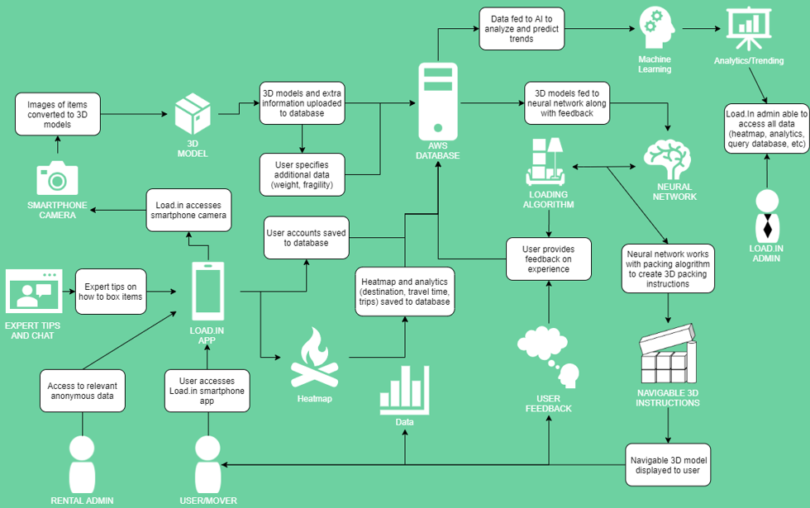

### Database

In order to store data in a centralized way such that all clients using Load.In, whether it is the website client or the smartphone client, can see and manipulate the same data, Load.In will store it’s data in the relational database known as RDS, or Relational Data Service, in the cloud provider Amazon Web Services. The platform of SQL that the database will be based off of will by MySQL with the possibility of eventually utilizing Oracle.

### Smartphone Client

Because Load.In needs to interact alongside of the moving process, the Load.In solution needs to be portable and available to the user at all times. This makes the use of a Smartphone client the ideal choice when considering the platform and will be the primary choice for the DIY mover. In addition to the portable benefit of the smartphone platform, the Load.In application by necessity, needs access to a camera for the move inventory and also for generation of the 3D models used to power the Load Plan.

Central to the Smartphone client is several things, one, the speed of the internet connection, two, the quality of the images taken, three, the raw processing power of the device and four, the storage available on the device. Ideally, for best user experience, if the processor on the device is sufficient, meaning there should be at least 8 cores at around 1.8 GHZ each ideally, then the rendering of the 3D models should take place locally with minimal transmission to the cloud. Consequently, the device would also need to support additional storage in order to facilitate Load.In storing the pictures temporarily on the device. With about 100 pictures on the device of around 12 megapixels in quality, then the device might need around 1-2 GB of storage for pictures and the generated 3D models. If either of those two items are unavailable, then Load.In will fall back to using cloud storage and cloud processing resources to produce the 3D models. Therefore, internet connectivity must be at least 15 Mbps or at least 4G for cellular network.

Currently, the plan for implementation of the Smartphone app will be Android with a minimum version of the OS being 4.4 so as to give older devices support. Load.In will need to utilize Photo compression in order to cut down on transmission and the storage requirements of the photos. The PNG file format should provide a fair degree of compression while supporting an open standard.

### Website Client

In addition to the DIY movers, users such as Rental Administrators, Administrators, and Guests will need to use the Load.In system. The website client is the way that these other users will interact with the Load.In system. Their interaction requirements will vary, but the core emphasis of the Website Client will be to serve up data and the analytics. The Website Client does not need to be particularly powerful. In fact, a typical thin client capable of rendering a website from HTML5, JavaScript and CSS should do nicely. For sake of keeping performance at a recommended level, Load.In will recommend that the website client have at least 4 cores for its CPU and have at least 2GB free of memory when loading the website.

The Website Client will be accessible from any major browser supporting ECMA script 6 and HTML 5, which should include, but not limited to, Firefox, Edge, Safari and Opera.

### Web API

Load.In’s Web API provides data access and manipulation from the Website Client and the Smartphone Client. It will be writing in Java and utilize the Apache CFX web API frameworks. It will be hosted on Tomcat and run in an instance of AWS Elastic Beanstalk. It will interact with the database, hosted in MySQL and utilize Amazon’s Elastic File Storage option for storage of photographs associated with the move inventory.

### Web Application

Load.In’s web application will serve information to the Website Clients. Developers will write it in a combination of Java, Spring MVC, HTML5, CSS, and JavaScript. It will communicate primarily with the Web API for uniformity of access. AWS using Elastic Bean Stalk and Apache Tomcat will serve as the platform for the web application.

### Vendor Synchronization Service

Load.In’s synchronization functionality will reside on AWS using AWS Lambda, which allows for execution of Java code to run on triggers and can scale up into multiple distinct instances. The synchronization process will execute on a regular schedule and will communicate with the MySQL database to bring in vendor related information into the Load.In system. One such process will run for each vendor that Load.In interacts with.

# Identification of Case Study

For the purposes of the case study, Load.In will focus its main attention on a typical or otherwise average moving family. According to the Census Bureau, the average family size in the U.S. as of 2019 is 2.52 which for the purposes of the case study, the family size will be 3 and will have one dog (2020). The average house size in the US is approx. 2,200 sq. ft (Andrew P., 2020). Therefore, with this house size in consideration and the consideration of well-established furniture and other household furnishings, a move via a family vehicle such as a pickup truck, would be too much effort for this family in terms of trips and thus require the rental of a moving truck. This average family is also concerned with budget and would want an accurate estimation of the cost involved as by virtue of trying to minimize cost at the expense of time.

For the family, there would be a mother, a father and a child. The mother and the father would be “movers” and they would like to collaborate on the move by sharing a move plan. For the purposes of this exercise, they will need to be able to create a move plan, catalog their inventory, generate a Load Plan and be able to get rental estimates.

In the future, the Load.In application could easily be scaled up to include families of all sizes and accommodate larger houses and possibly be used on business moves or even logistics planning for larger moves involving multiple parties and multiple houses. There is also an international component as well, which Load.In could expand out and be a global solution as well.

# Glossary

**Algorithm:** A finite sequence of well-defined, computer-implementable instructions, typically to solve a class of problems or to perform a computation.

**Analytics**: The analysis of data, typically large sets of business data through mathematics, statistics and computer software.

**Chat-bot:** An automated software designed to imitate human interactions and provide information to the user.

**Heat map:** A representation of data in the form of a map or diagram in which data values are represented as colors.

**Professional Movers:** Professionals who move all your belongings for you from one place to another.

**Do It Yourself Movers (DIY)**: Individuals who choose to move themselves instead of hiring professional movers.

# References

Andrew, P. (2020, January 26). *Is Your House the “Typical American Home”?*  Hsh. <https://www.hsh.com/homeowner/average-american-home.html>

CADCode Systems. (n.d.). *Optimizing & Machining | CADCode Systems*. CADCode. Retrieved September 20, 2020, from <https://www.cadcode.com/category/categories/optimizing-machining>

Collins, T. (2018, April 20). *A Look into Photogrammetry and Video Games*. Medium. <https://medium.com/@homicidalnacho/a-look-into-photogrammetry-and-video-games-71d602f51c31>

Dube, E. (2020, September 20). *Optimizing Three-dimensional Bin Packing through Simulation*. Semantics Scholar. <https://www.semanticscholar.org/paper/OPTIMIZING-THREE-DIMENSIONAL-BIN-PACKING-THROUGH-Dube/bb9986af2f26f7726fcef1bc684eac8239c9b853#references>

Economy Moving & Storage, LLC. (2015, January 4). *How to properly pack and load a moving truck- Movers Cincinnati*. YouTube. <https://www.youtube.com/watch?v=rjmofUZOdwo&feature=youtu.be>

Knoblauch, M. (2019, May 8). *One in ten Americans would prefer a week in jail over moving*. New York Post. <https://nypost.com/2019/05/08/one-in-ten-americans-would-prefer-a-week-in-jail-over-moving/>

Nat and Friends. (2017, April 18). *Google Earth’s Incredible 3D Imagery, Explained*. YouTube. <https://www.youtube.com/watch?v=suo_aUTUpps&feature=youtu.be>

The American Institute of Stress. (n.d.). *The Holmes-Rahe Stress Inventory* PDF. Retrieved September 20, 2020, from <https://www.stress.org/wp-content/uploads/2019/04/stress-inventory-1.pdf>

*The Top 5 Moving Mistakes Across America*. (2019, August 13). Article. https://www.article.com/blog/top-5-moving-mistakes/

US Census Bureau. (2019, October 10). *Historical Households Tables*. The United States Census Bureau. <https://www.census.gov/data/tables/time-series/demo/families/households.html>

Wood, T. (2020, January 6). *Moving Industry Statistics*. MoveBuddha. <https://www.movebuddha.com/blog/moving-industry-statistics/>