Lab 1 - Load.In Description

Paul Rodriguez

Old Dominion University

CS 410

Professor Janet Brunelle

12 December 2020

Version 1 - Draft

Table of Contents

1. Introduction.........................................................................................................................3
2. Product Description.............................................................................................................4
   1. Key Product Features and Capabilities....................................................................4
   2. Major Components (Hardware/Software)................................................................7
3. Identification of Case Study.................................................................................................9
4. Glossary.............................................................................................................................10
5. References..........................................................................................................................12

Tables and Figures

Figure 1 - Load.In Major Functional Components Diagram

1. **Introduction**

In today’s society there is a level of technology that allows people to move across the globe in a matter of hours or days. Everyone has most likely moved at least once in their life, and knows the process can often be tedious and time consuming. However many people are unable to afford a professional mover who can make the moving process easier for them. The do it yourself mover is often inexperienced with the logistical aspects of moving including, cost estimation, proper packing and loading of boxes, and keeping track of their items while keeping track of important items. This is where Load.In comes into the equation. Load.In will help the do it yourself mover during their entire moving process.

Load.In is a product that will not only help the do it yourself mover. Through its ability to gather data from third party rental companies Load.In is able to help connect these two groups in a mutually beneficial relationship. With the increased predictability that is provided by Load.In’s analytical data and their algorithms that help the user estimate their needed vehicle and trips, rental companies have the increased predictability of revenue.

Load.In will provide the user with an easy to use experience that will allow them to produce an inventory of all of their household items through the use of photogrammetry to create 3D models. Once the user has inventoried their household Load.In will provide them with the most space and cost efficient plan to make their move as seamless as possible. If the user runs into any unusual scenario during their moving process Load.In has the built in capabilities to provide them with a database of useful articles, and if needed live support to get them through those tricky situations.

1. **Load.In Product Description**

Load.In is a mobile and web application that is the solution for many issues that arise during the moving process. The goal of the application is to help the do it yourself mover save time and money while increasing the speed and efficiency of their entire move. Users may create an account that will allow them to begin inputting information relevant to their move such as the start and end location of their move and an estimation of items that will need to be moved. Once this initial information has been entered the user will be provided with an estimation of needed trips, move time, and the size of truck needed. The user will then be able to begin generating 3D models of their furniture and items within their home and all of these generated models will be stored within the applications database. After the user has entered the items that they have in their home into the application, Load.In will generate a load plan that will show the user how to properly pack their boxes and how to load them into their vehicle. Once the user has loaded all of their possessions into their vehicle they will be able to view where certain items are located within their vehicle. If the user encounters an issue during the moving process such as a unique item, they will be able to access a chat-bot system that can provide them with expert tips that pertain to their situation and if needed they can get live support to help them. After the user has completed their move they will be able to leave reviews of the application, their move plan, and any help they received from the chat-bot or live move experts. On the back end of the Load.In system, anonymous analytical data will be gathered from the moves and this will help increase the efficiency of the product and increase user satisfaction.

**2.1 Key Product Features and Capabilities**

The main feature of Load.In is the ability to generate a customized load plan that is created from the information entered by the user. Load.In achieves this by having the user generate 3D models of all of the items in their home and providing measurements for large or abnormal furniture. After the user has entered all relevant information the application will create the load plan which will provide detailed instructions on how to properly pack their boxes and load their vehicle.

All of the items that are entered by the user will be stored into an move inventory database. This feature will allow the user to generate a new load plan if they encounter an error or feel that the plan being given is not correct. Once the user indicates that they have completed their move, the application will delete this database as to not store any user information.

Load.In will provide rental estimations to the user including, estimated number of trips, estimated time needed to complete their move, and estimated cost of rental trucks based upon their size. This information will be generated through the use of 3rd party vendor information, and past anonymous analytical information that has been gathered through the use of Load.In.

During the moving process if the user encounters a situation that is unusual, or the load plan has an error, they can search through a database of expert tips based on keywords. These tips will contain suggestions for packing and loading items that may not be found in every household such as large and/or oddly shaped furniture. These tips will be gathered from move experts that create articles for the application for situations they have encountered in their professional experience. If the user finds an article that pertains to their situation they will be able to leave a review based on how the article was able to help them.

Alongside a database of articles, the application will include a chat-bot feature that will allow the user to interact with an artificial intelligence that can help them search through the database more efficiently to find a useful article faster. If the chat-bot feature fails in helping the user then the user can be connected to a live support agent who can help them with their situation or error.

In the back-end system of the application, Load.In will utilize third party vendor synchronization that will pull data from vendor systems and databases and allow Load.In to properly estimate truck prices, and availability based on user location. Alongside these third party applications, a web scraper will also be able to scrape relevant data from the internet to help increase the accuracy of these estimations.

Throughout the entire moving process, Load.In will be able to gather analytical data that will lead to increased accuracy as the amount of users increases. Some of the types of data that may be gathered include, location data, move cost data, feedback data, and anonymous user inventory. The location data may include the start and end locations of a move, and the amount of trips needed along with the total distance traveled. Move cost data may include all costs associated with the move including gas, cost of rental vehicle, cost of supplies used during move, and time needed to load and unload the vehicle. Feedback data will include all of the ratings provided by the user for the entire application experience and any individual expert tips they received during their move. Lastly, anonymous user inventory may include number of items, average size weight, and any abnormal furniture that was encountered. All data will be anonymous and only used for the analysis and improvement of any estimation algorithms being used within the application to improve the user experience.

The heat map feature of the application will be used for developers to analyze the utilization of smartphones. The heat map will track what the users are accessing the most on the application and how often features are being used to help developers decide what needs to be improved upon. Some issues that the heat map may help solve are difficult to navigate user interfaces that may reduce the user experience.

**2.2 Major Components (Hardware/Software)**

Load.In will consist of a web application and a smartphone application. Shown in figure one is the major functional component diagram (MFCD) for Load.In. The figure provides insight into how Load.In will function, with the user using their personal smart device to use the mobile application to perform all of their 3D scans and move inventory input. All of this information will be passed into a database and run through the algorithms in place to provide the user with their load plan.

For the hardware the most critical component for the success of Load.In is the database which will be based in the cloud to reduce resource demand on the user’s devices. The database will use Amazon RDS which is compatible with MySQL and Amazon’s Lambda. The database will need to be able to store large amounts of information so that it may all be processed to provide usable output to the user. Along with this, some of the information that is stored in the cloud will be used by developers and administrators for analytics to provide a better user experience and service in the future. The core of the work will fall upon the smartphone of the user which will need to meet a few standard requirements. Some of these requirements include, wifi connectivity, a 12 megapixel camera, 4Gb of RAM, and a 8 core processor. For the web application, it will be capable of running on a computer which uses Linux, Windows, and Mac OS. The android application will be programmed in Java and will be able to be run on modern android operating systems found on smartphones. The web API will use AWS elastic beanstalk and Apache CFX with Tomcat. The vendor synchronization portal will make use of AWS lambda to be triggered on a schedule to draw data from various vendor websites.

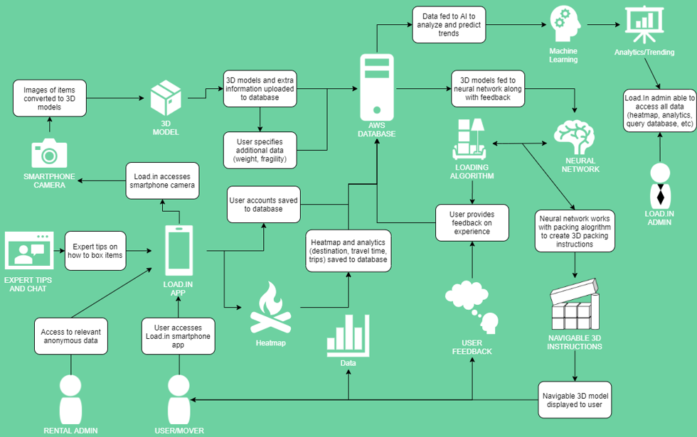

1. **Identification of Case Study**

As Load.In is being developed to help the average do it yourself mover, the case study will be focused on averaged information collected from the analysis of move statistics across the country. The reason for a case study to contain average information found from moving statistics is that it will be able to provide the most accurate data and results that will be faced in real world use. This leads to a scenario where the move is within the same city and within a twenty mile radius of the original location. The house size will be around 2,200 square feet and will contain the items of a three person family that has one dog. The family will need to rent a vehicle for their boxes which will allow the utilization of Load.In’s estimation features. For items in the home the family will have common furniture found in many households. To take advantage of Load.In’s ability to share load plans among smart devices, the case study will include friends or family of the user helping them during their move. Since the case study is targeting the average scenario that the product will face, oddly shaped items will be excluded since they are only one factor in the problem that Load.In will help solve. The goal of conducting such a case study on an average home, is that Load.In will then be able to be scaled upward or downwards depending on how the specific situation pertains to the average moving situation.

**4. Glossary**

**Algorithm** - A finite sequence of well-defined, computer-implementable instructions, typically to solve a class of problems or to perform a computation.

**Analytics** - The analysis of data, typically large sets of business data through mathematics, statistics and computer software.

**Artificial intelligence** - The capacity of a computer, robot, or other programmed mechanical device to perform operations and tasks analogous to learning and decision making in humans, as speech recognition or question answering.

**Chat-bot** - An automated software designed to imitate human interactions and provide information to the user.

**Equilibrium** - A state of balance due to the equal action of opposing forces, in this case weight within a moving truck.

**Heat map** - A representation of data in the form of a map or diagram in which data values are represented as colors.

**Machine learning** - A field of computer science that aims to teach computers how to learn and act without being explicitly programmed. More specifically, machine learning is an approach to data analysis that involves building and adapting models, which allow programs to "learn" through experience. Machine learning involves the construction of algorithms that adapt their models to improve their ability to make predictions.

**Packing problems** - Are a class of optimization problems in mathematics that involve attempting to pack objects together into containers. The goal is to either pack a single container as densely as possible or pack all objects using as few containers as possible.

**Photogrammetry** - Photogrammetry is the science and technology of obtaining reliable information about physical objects and the environment through the process of recording, measuring and interpreting photographic images and patterns of electromagnetic radiant imagery and other phenomena.

**Professional movers** - Professionals who move all your belongings for you from one place to another.

**5. References**

Andrew, P. (2020, January 26). *Is Your House the “Typical American Home”?*  Hsh. <https://www.hsh.com/homeowner/average-american-home.html>

CADCode Systems. (n.d.). *Optimizing & Machining | CADCode Systems*. CADCode. Retrieved September 20, 2020, from <https://www.cadcode.com/category/categories/optimizing-machining>

Collins, T. (2018, April 20). *A Look into Photogrammetry and Video Games*. Medium. <https://medium.com/@homicidalnacho/a-look-into-photogrammetry-and-video-games-71d602f51c31>

Dube, E. (2020, September 20). *Optimizing Three-dimensional Bin Packing through Simulation*. Semantics Scholar. [https://www.semanticscholar.org/paper/OPTIMIZING-THREE-DIMENSIONAL-BIN-PACKING-THROUGH-Dube/bb9986af2f26f7726fcef1bc684eac8239c9b853#references](https://www.semanticscholar.org/paper/OPTIMIZING-THREE-DIMENSIONAL-BIN-PACKING-THROUGH-Dube/bb9986af2f26f7726fcef1bc684eac8239c9b853" \l "references)

Economy Moving & Storage, LLC. (2015, January 4). *How to properly pack and load a moving truck- Movers Cincinnati*. YouTube. <https://www.youtube.com/watch?v=rjmofUZOdwo&feature=youtu.be>

Knoblauch, M. (2019, May 8). *One in ten Americans would prefer a week in jail over moving*. New York Post. <https://nypost.com/2019/05/08/one-in-ten-americans-would-prefer-a-week-in-jail-over-moving/>

Nat and Friends. (2017, April 18). *Google Earth’s Incredible 3D Imagery, Explained*. YouTube. <https://www.youtube.com/watch?v=suo_aUTUpps&feature=youtu.be>

The American Institute of Stress. (n.d.). *The Holmes-Rahe Stress Inventory* PDF. Retrieved September 20, 2020, from <https://www.stress.org/wp-content/uploads/2019/04/stress-inventory-1.pdf>

*The Top 5 Moving Mistakes Across America*. (2019, August 13). Article. https://www.article.com/blog/top-5-moving-mistakes/

US Census Bureau. (2019, October 10). *Historical Households Tables*. The United States Census Bureau. <https://www.census.gov/data/tables/time-series/demo/families/households.html>

Wood, T. (2020, January 6). *Moving Industry Statistics*. MoveBuddha. <https://www.movebuddha.com/blog/moving-industry-statistics/>