**Team Yellow: Load.In**

**Weekly Development Report # 7**

**Performance Period:** 3/1/2021 – 3/7/2021

1. **Group Accomplishments:** 
   1. **Meetings**
      1. **3/4/2021**
         1. **Regular group meeting**
         2. **Discussed progress made**
         3. **Discussed plan for work over weekend**
      2. **3/6/2021**
         1. **Group meeting to go over progress and troubleshoot issues**
      3. **3/7/2021**
         1. **Group meeting to go over progress and troubleshoot issues**
2. **Individual Contributions/Accomplishments:** 
   1. **Byron**
      1. Worked on process of displaying steps in a load plan
      2. Setup camera to display next to boxes
      3. Created animations to be able to render changes over time
      4. Created cube mapping solution to map box textures to box
      5. Integrated with Jason test load plan generation
      6. Added additional support for textures
      7. Refactored code for stability
      8. Created 2d Hud rendering capabilities for overlaying elements on screen
      9. Created static HUD elements for information such as box dimensions as well as forward and backward buttons
      10. Fixed issues with load plan forward button
   2. **Jason**
      1. “Simple” Load Plan Development
         1. Set up very basic 3D load plan generation
         2. Built up objects to connect with Byron’s stuff
      2. Lab 2 requirements
   3. **Lance** 
      1. Edited database to meet everyone needs when changes were needed.
      2. Worked on implementing remote video sharing inside of the app.
      3. Connected the backend for the expert tips.
      4. Tried to remember how to log into AWS that was offered early in the semester but gave up prematurely.
   4. **Greg**
      1. Worked with Chris to resolve issues with login connection to WebAPI
      2. Worked on Inventory Service for WebAPI to reflect new updates made to the database
      3. Fixed connection issues between WebAPI and Android app for Inventory/User services with the help of **Chris** and **Byron.** Now only a User’s personal items will be displayed in their move inventory.
      4. Worked on adding edit feature to Inventory service
   5. **Chris**
      1. Worked with Lance Saturday to figure out some database stuff and brainstorm inventory thoughts
      2. Worked with Greg on Sunday on move inventory, which is now nearly fully implemented, also fixed some bugs with the help of Byron
      3. Fully connected the front-end Inventory edit feature to the backend
      4. Created fully functional login that sets each activity to that specific user, and if the user is logged out, they are returned to the login screen
      5. Created an account management UI that displays a user’s account information
   6. **Paul**
      1. Continued working to attempt to implement videos into expert tips.
      2. Worked with Lance on connecting application to web API to database for passing expert tips including an indexer inside of the webAPI.
      3. Lab 2 Requirements
      4. Appreciated Jason’s excellent Byron memes.
3. **Issues/Concerns:**
   1. 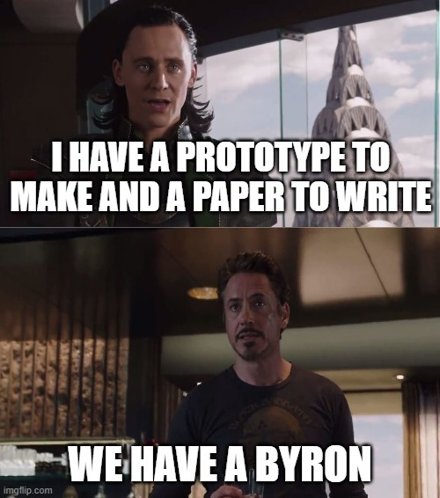
   2. Why does youTube make you register your application in order to easily stream their videos into your application?