Algorithms_Data Structures

Exercise 2: E-commerce Platform Search Function

import java.util.Arrays;
import java.util.Comparator;

public class Product {

int productId;
String productName;
String category;

Product(int productId, String productName, String category) {
this.productId = productId;
this.productName = productName;
this.category = category;
}

void display() {
System.out.println(
"ID: " + productId +
", Name: " + productName +
", Category: " + category);
}

// Linear Search
public static Product linearSearch(Product[] products, int id) {
for (Product product : products) {
if (product.productId == id) {
return product;
}
}
return null;
}

// Binary Search
public static Product binarySearch(Product[] products, int id) {
int low = 0;
int high = products.length - 1;

while (low <= high) {
int mid = low + (high - low) / 2;

if (products[mid].productId == id) {
return products[mid];
}

if (products[mid].productId < id) {
low = mid + 1;
} else {
high = mid - 1;
}
}

return null;
}

public static void main(String[] args) {

Product[] products = {
new Product(105, "Laptop", "Electronics"),
new Product(102, "Shoes", "Fashion"),
new Product(108, "Phone", "Electronics"),
new Product(101, "Watch", "Accessories"),
new Product(110, "Headphones", "Electronics")
};

int searchId = 108;

System.out.println("Linear Search:");
Product result1 = linearSearch(products, searchId);

if (result1 != null)
result1.display();
else
System.out.println("Product not found.");

Arrays.sort(products,
Comparator.comparingInt(p -> p.productId));

System.out.println("\nBinary Search:");

Product result2 = binarySearch(products, searchId);

if (result2 != null)
result2.display();
else
System.out.println("Product not found.");
}
}
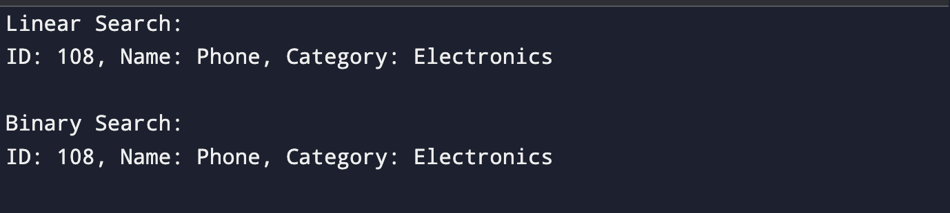

Exercise 7: Financial Forecasting

public class FinancialForecast {

public static double forecast(double value,
double[] rates,
int year) {

// Base case
if (year == rates.length) {
return value;
}

value = value * (1 + rates[year]);

return forecast(value, rates, year + 1);
}

public static void main(String[] args) {

double initialValue = 10000;

double[] growthRates = {
0.10, 0.08, 0.12, 0.09, 0.11
};

double result = forecast(initialValue, growthRates, 0);
System.out.printf(
"Predicted Future Value = $%.2f",
result
);
}



