**Module 7: Final Project Submission**

Nolan Moss

Project Introduction:

This project aims to visualize and analyze the price behavior of Bitcoin (BTC) and Dogecoin over the past 12 months, with a primary focus on Bitcoin. BTC was chosen due to its prominence in the cryptocurrency market, making it a strong indicator of overall crypto trends and potential future returns. A variety of data manipulation techniques and analytical methods were applied to meet the project’s objectives.

One of the key goals was to explore the volatility of these cryptocurrencies and assess Bitcoin’s performance as an investment. Based on the analysis, Bitcoin proved to be a strong investment over the last year. However, cryptocurrency markets are highly volatile and influenced by numerous external factors, meaning that a 12-month window may not be sufficient to predict long-term performance.

Ultimately, this project provides investors with valuable insight into both the risks and rewards associated with Bitcoin, helping them make more informed decisions when considering cryptocurrency investments.

Domain of the data set: Cryptocurrency Market Data

Data Source: <https://www.marketwatch.com/investing/cryptocurrency/btcusd/download-data?mod=mw_quote_tab>

<https://www.marketwatch.com/investing/cryptocurrency/dogeusd/download-data?mod=mw_quote_tab>

Number of records and columns: 17 Columns and 367 rows

Visualization tools selected: Excel

Data cleaning strategies: I manipulated the data in a variety of ways to gain better insight into what was going on within the cryptocurrency market. The data itself was clean and there were no missing values, but I used a few simple formulas to add some extra columns to meet the goals I have laid out for my project.

Cleaned dataset:



Goal 1:

**Goal:** Showcase the ongoing fluctuations in Bitcoin’s value.

**Story:** The visualization highlights Bitcoin’s volatility over the past year, with noticeable swings between daily high and low prices. Despite these constant fluctuations, the chart also reveals a clear upward trend in Bitcoin’s overall value over the last 12 months.

Goal 2:

**Goal:** Compare the opening and closing prices to identify bullish and bearish days in Bitcoin’s valuation.

**Story:** The chart illustrates the distribution of bullish (positive) and bearish (negative) days based on Bitcoin’s daily opening and closing prices. The visualization reveals that bullish and bearish days occur in roughly equal proportion. It also highlights the significant gains and losses on certain days, emphasizing the volatility inherent in Bitcoin’s valuation.

Goal 3:

**Goal:** Compare the 12 month average price of Bitcoin to the daily closing price using a line chart.

**Story:** The average closing price of Bitcoin over the last 12 months has been heavily influenced by the sharp increase during the final quarter of 2024. Between October 20, 2024, and December 12, 2024, Bitcoin experienced a significant surge in value, substantially lifting the overall average. Without this period of growth, the 12-month performance would have been much weaker. Although there was a noticeable dip in early 2025, the price recovered quickly, maintaining the upward trend.

Goal 4:

**Goal:** Highlight the outliers in the percentage of Bitcoin’s daily price changes.

**Story:** Most daily price changes fall between -6% and +6%. Any day with a percentage change outside of this range is considered an outlier. The data shows that there are nearly twice as many positive outliers as negative ones. This trend suggests that investors have historically seen more large positive swings than negative, offering some confidence in Bitcoin’s potential for significant gains.

Goal 5:

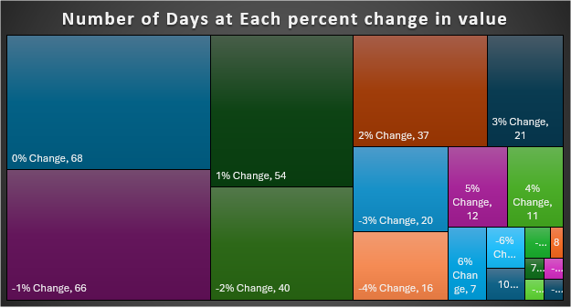

**Goal:** Visualize the number of days corresponding to each percentage change to highlight the proportion of different price movements.

**Story:** The treemap shows that 0% is the most common daily percentage change, followed closely by -1%. The high number of small or negative daily changes suggests that it takes many positive days to sustain an overall upward trend in Bitcoin’s value. By visualizing the data this way, it becomes clear that Bitcoin has a large number of negative-return days, making it psychologically challenging for investors to hold their positions long-term, even though the overall trend remains positive.

Goal 6:

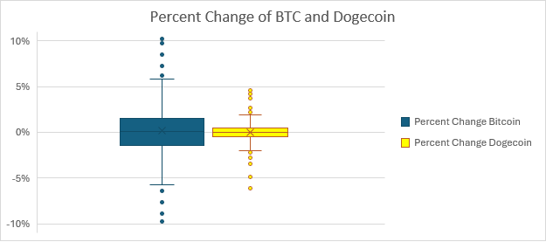

**Goal:** Use a box-and-whisker plot to visualize the statistical spread of the percentage changes for Bitcoin and Dogecoin.

**Story:** The mean percentage change for both Bitcoin and Dogecoin is around zero. However, the plot reveals a significant difference in the range and number of outliers between the two. This contrast is likely due to the difference in overall interest and market maturity. Bitcoin has been established much longer and enjoys broader adoption. As a result, Bitcoin tends to exhibit greater price swings compared to Dogecoin.

Conclusion of Analysis:

The charts analyzed the performance of Bitcoin (BTC) and Dogecoin over the past 12 months, focusing on their market trends and investment potential. Based on the data provided, BTC demonstrated a positive overall trend with a significant return on investment. While there were several days with negative returns, the number of positive return days outweighed the losses, making BTC a strong investment for long-term holders during this period.

The analysis of BTC’s daily highs and lows highlights consistent trading activity and strong market interest and when compared to Dogecoin, BTC not only maintained a substantially higher market value but also exhibited greater daily market swings and stronger long-term performance.

From this analysis, it’s clear that Bitcoin has been a rewarding investment for current holders, and the positive trend suggests that it may continue to offer strong potential in the future.