Prudential data

#### ***Lee-sohyun, Kwon-Yunhwan, Kim-jaehoon, Lee-jaehoo,***

#### ***2017-04-22***

prudential insurance

Prudential회사의 보험 데이터이다. 고객들의 **Response**를 예측하는 것이 이 데이터 분류의 목적이며, Response가 큰게 좋은 것인지, 나쁜 것인지는 알수 없다. 이 데이터의 특징은 몇몇 데이터가 정규화로 되어 있음

데이터 변수 설명

|  |  |
| --- | --- |
| 변수 | 설명 |
| **Id** | 회원들의 고유한 id |
| **Product_Info_1-7** | 보험 상품과 관련된 변수 |
| **Ins_Age** | 회원들의 나이를 정규화해 놓은 변수 |
| **Ht** | 회원들의 키를 정규화한 변수 |
| **Wt** | 회원들의 몸무게를 정규화한 변수 |
| **BMI** | 회원들의 BMI를 정규화한 변수 |
| **Employment_Info_1-6** | 회원들의 과거 일자리와 관련된 변수 |
| **InsuredInfo_1-6** | 회원들에 대하 제공된 정보 변수를 정규화 시켜놓은 것 |
| **Insurance_History_1-9** | 회원들이 보험 이력에 대한 변수 |
| **Family_Hist_1-5** | 회원들 가족들의 이력과 관련된 정규화 변수 |
| **Medical_History_1-41** | 회원들의 의료 이력을 정규화한 변수 |
| **Medical_Keyword_1-48** | 회원들과 관련된 의료 키워드의 존재/부재와 관련된 더미 변수 |
| **Response** | 회원들과 관련된 마지막 결정 변수, ordinal 변수 |

데이터 변수 요약

train <- fread("train.csv")  
test <- fread("test.csv")  
head(train)

## Id Product_Info_1 Product_Info_2 Product_Info_3 Product_Info_4  
## 1: 2 1 D3 10 0.07692308  
## 2: 5 1 A1 26 0.07692308  
## 3: 6 1 E1 26 0.07692308  
## 4: 7 1 D4 10 0.48717949  
## 5: 8 1 D2 26 0.23076923  
## 6: 10 1 D2 26 0.23076923  
## Product_Info_5 Product_Info_6 Product_Info_7 Ins_Age Ht  
## 1: 2 1 1 0.64179104 0.5818182  
## 2: 2 3 1 0.05970149 0.6000000  
## 3: 2 3 1 0.02985075 0.7454545  
## 4: 2 3 1 0.16417910 0.6727273  
## 5: 2 3 1 0.41791045 0.6545455  
## 6: 3 1 1 0.50746269 0.8363636  
## Wt BMI Employment_Info_1 Employment_Info_2  
## 1: 0.1485356 0.3230080 0.028 12  
## 2: 0.1317992 0.2722877 0.000 1  
## 3: 0.2887029 0.4287804 0.030 9  
## 4: 0.2050209 0.3524377 0.042 9  
## 5: 0.2343096 0.4240456 0.027 9  
## 6: 0.2991632 0.3648867 0.325 15  
## Employment_Info_3 Employment_Info_4 Employment_Info_5 Employment_Info_6  
## 1: 1 0 3 NA  
## 2: 3 0 2 0.0018  
## 3: 1 0 2 0.0300  
## 4: 1 0 3 0.2000  
## 5: 1 0 2 0.0500  
## 6: 1 0 2 1.0000  
## InsuredInfo_1 InsuredInfo_2 InsuredInfo_3 InsuredInfo_4 InsuredInfo_5  
## 1: 1 2 6 3 1  
## 2: 1 2 6 3 1  
## 3: 1 2 8 3 1  
## 4: 2 2 8 3 1  
## 5: 1 2 6 3 1  
## 6: 1 2 8 3 1  
## InsuredInfo_6 InsuredInfo_7 Insurance_History_1 Insurance_History_2  
## 1: 2 1 1 1  
## 2: 2 1 2 1  
## 3: 1 1 2 1  
## 4: 2 1 2 1  
## 5: 2 1 2 1  
## 6: 1 1 2 1  
## Insurance_History_3 Insurance_History_4 Insurance_History_5  
## 1: 3 1 0.000666667  
## 2: 3 1 0.000133333  
## 3: 1 3 NA  
## 4: 1 3 NA  
## 5: 1 3 NA  
## 6: 3 2 0.005000000  
## Insurance_History_7 Insurance_History_8 Insurance_History_9  
## 1: 1 1 2  
## 2: 1 3 2  
## 3: 3 2 3  
## 4: 3 2 3  
## 5: 3 2 3  
## 6: 1 3 2  
## Family_Hist_1 Family_Hist_2 Family_Hist_3 Family_Hist_4 Family_Hist_5  
## 1: 2 NA 0.5980392 NA 0.5267857  
## 2: 2 0.1884058 NA 0.08450704 NA  
## 3: 3 0.3043478 NA 0.22535211 NA  
## 4: 3 0.4202899 NA 0.35211268 NA  
## 5: 2 0.4637681 NA 0.40845070 NA  
## 6: 2 NA 0.2941176 0.50704225 NA  
## Medical_History_1 Medical_History_2 Medical_History_3 Medical_History_4  
## 1: 4 112 2 1  
## 2: 5 412 2 1  
## 3: 10 3 2 2  
## 4: 0 350 2 2  
## 5: NA 162 2 2  
## 6: 6 491 2 2  
## Medical_History_5 Medical_History_6 Medical_History_7 Medical_History_8  
## 1: 1 3 2 2  
## 2: 1 3 2 2  
## 3: 1 3 2 2  
## 4: 1 3 2 2  
## 5: 1 3 2 2  
## 6: 1 3 2 2  
## Medical_History_9 Medical_History_10 Medical_History_11  
## 1: 1 NA 3  
## 2: 1 NA 3  
## 3: 2 NA 3  
## 4: 2 NA 3  
## 5: 2 NA 3  
## 6: 2 NA 3  
## Medical_History_12 Medical_History_13 Medical_History_14  
## 1: 2 3 3  
## 2: 2 3 3  
## 3: 2 3 3  
## 4: 2 3 3  
## 5: 2 3 3  
## 6: 2 3 3  
## Medical_History_15 Medical_History_16 Medical_History_17  
## 1: 240 3 3  
## 2: 0 1 3  
## 3: NA 1 3  
## 4: NA 1 3  
## 5: NA 1 3  
## 6: NA 1 3  
## Medical_History_18 Medical_History_19 Medical_History_20  
## 1: 1 1 2  
## 2: 1 1 2  
## 3: 1 1 2  
## 4: 1 1 2  
## 5: 1 1 2  
## 6: 2 1 2  
## Medical_History_21 Medical_History_22 Medical_History_23  
## 1: 1 2 3  
## 2: 1 2 3  
## 3: 1 2 3  
## 4: 2 2 3  
## 5: 1 2 3  
## 6: 2 2 3  
## Medical_History_24 Medical_History_25 Medical_History_26  
## 1: NA 1 3  
## 2: NA 1 3  
## 3: NA 2 2  
## 4: NA 1 3  
## 5: NA 2 2  
## 6: NA 1 3  
## Medical_History_27 Medical_History_28 Medical_History_29  
## 1: 3 1 3  
## 2: 3 1 3  
## 3: 3 1 3  
## 4: 3 1 3  
## 5: 3 1 3  
## 6: 3 1 3  
## Medical_History_30 Medical_History_31 Medical_History_32  
## 1: 2 3 NA  
## 2: 2 3 NA  
## 3: 2 3 NA  
## 4: 2 3 NA  
## 5: 2 3 NA  
## 6: 2 3 NA  
## Medical_History_33 Medical_History_34 Medical_History_35  
## 1: 1 3 1  
## 2: 3 1 1  
## 3: 3 3 1  
## 4: 3 3 1  
## 5: 3 3 1  
## 6: 3 1 1  
## Medical_History_36 Medical_History_37 Medical_History_38  
## 1: 2 2 1  
## 2: 2 2 1  
## 3: 3 2 1  
## 4: 2 2 1  
## 5: 3 2 1  
## 6: 2 2 1  
## Medical_History_39 Medical_History_40 Medical_History_41  
## 1: 3 3 3  
## 2: 3 3 1  
## 3: 3 3 1  
## 4: 3 3 1  
## 5: 3 3 1  
## 6: 3 3 3  
## Medical_Keyword_1 Medical_Keyword_2 Medical_Keyword_3 Medical_Keyword_4  
## 1: 0 0 0 0  
## 2: 0 0 0 0  
## 3: 0 0 0 0  
## 4: 0 0 0 0  
## 5: 0 0 0 0  
## 6: 0 0 0 0  
## Medical_Keyword_5 Medical_Keyword_6 Medical_Keyword_7 Medical_Keyword_8  
## 1: 0 0 0 0  
## 2: 0 0 0 0  
## 3: 0 0 0 0  
## 4: 0 0 0 0  
## 5: 0 0 0 0  
## 6: 0 0 0 0  
## Medical_Keyword_9 Medical_Keyword_10 Medical_Keyword_11  
## 1: 0 0 0  
## 2: 0 0 0  
## 3: 0 0 0  
## 4: 0 0 0  
## 5: 0 0 0  
## 6: 0 0 0  
## Medical_Keyword_12 Medical_Keyword_13 Medical_Keyword_14  
## 1: 0 0 0  
## 2: 0 0 0  
## 3: 0 0 0  
## 4: 0 0 0  
## 5: 0 0 0  
## 6: 0 0 0  
## Medical_Keyword_15 Medical_Keyword_16 Medical_Keyword_17  
## 1: 0 0 0  
## 2: 0 0 0  
## 3: 0 0 0  
## 4: 0 0 0  
## 5: 0 0 0  
## 6: 0 0 0  
## Medical_Keyword_18 Medical_Keyword_19 Medical_Keyword_20  
## 1: 0 0 0  
## 2: 0 0 0  
## 3: 0 0 0  
## 4: 0 0 0  
## 5: 0 0 0  
## 6: 0 0 0  
## Medical_Keyword_21 Medical_Keyword_22 Medical_Keyword_23  
## 1: 0 0 0  
## 2: 0 0 0  
## 3: 0 0 0  
## 4: 0 0 0  
## 5: 0 0 0  
## 6: 0 1 0  
## Medical_Keyword_24 Medical_Keyword_25 Medical_Keyword_26  
## 1: 0 0 0  
## 2: 0 0 0  
## 3: 0 0 0  
## 4: 0 0 0  
## 5: 0 0 0  
## 6: 0 0 0  
## Medical_Keyword_27 Medical_Keyword_28 Medical_Keyword_29  
## 1: 0 0 0  
## 2: 0 0 0  
## 3: 0 0 0  
## 4: 0 0 0  
## 5: 0 0 0  
## 6: 0 0 0  
## Medical_Keyword_30 Medical_Keyword_31 Medical_Keyword_32  
## 1: 0 0 0  
## 2: 0 0 0  
## 3: 0 0 0  
## 4: 0 0 1  
## 5: 0 0 0  
## 6: 0 0 0  
## Medical_Keyword_33 Medical_Keyword_34 Medical_Keyword_35  
## 1: 0 0 0  
## 2: 0 0 0  
## 3: 0 0 0  
## 4: 0 0 0  
## 5: 0 0 0  
## 6: 0 1 0  
## Medical_Keyword_36 Medical_Keyword_37 Medical_Keyword_38  
## 1: 0 0 0  
## 2: 0 0 0  
## 3: 0 0 0  
## 4: 0 0 0  
## 5: 0 0 0  
## 6: 0 0 0  
## Medical_Keyword_39 Medical_Keyword_40 Medical_Keyword_41  
## 1: 0 0 0  
## 2: 0 0 0  
## 3: 0 0 0  
## 4: 0 0 0  
## 5: 0 0 0  
## 6: 0 0 0  
## Medical_Keyword_42 Medical_Keyword_43 Medical_Keyword_44  
## 1: 0 0 0  
## 2: 0 0 0  
## 3: 0 0 0  
## 4: 0 0 0  
## 5: 0 0 0  
## 6: 0 0 0  
## Medical_Keyword_45 Medical_Keyword_46 Medical_Keyword_47  
## 1: 0 0 0  
## 2: 0 0 0  
## 3: 0 0 0  
## 4: 0 0 0  
## 5: 0 0 0  
## 6: 0 0 0  
## Medical_Keyword_48 Response  
## 1: 0 8  
## 2: 0 4  
## 3: 0 8  
## 4: 0 8  
## 5: 0 8  
## 6: 0 8

summary(train)

## Id Product_Info_1 Product_Info_2 Product_Info_3   
## Min. : 2 Min. :1.000 Length:59381 Min. : 1.00   
## 1st Qu.:19780 1st Qu.:1.000 Class :character 1st Qu.:26.00   
## Median :39487 Median :1.000 Mode :character Median :26.00   
## Mean :39507 Mean :1.026 Mean :24.42   
## 3rd Qu.:59211 3rd Qu.:1.000 3rd Qu.:26.00   
## Max. :79146 Max. :2.000 Max. :38.00   
##   
## Product_Info_4 Product_Info_5 Product_Info_6 Product_Info_7   
## Min. :0.00000 Min. :2.000 Min. :1.000 Min. :1.000   
## 1st Qu.:0.07692 1st Qu.:2.000 1st Qu.:3.000 1st Qu.:1.000   
## Median :0.23077 Median :2.000 Median :3.000 Median :1.000   
## Mean :0.32895 Mean :2.007 Mean :2.674 Mean :1.044   
## 3rd Qu.:0.48718 3rd Qu.:2.000 3rd Qu.:3.000 3rd Qu.:1.000   
## Max. :1.00000 Max. :3.000 Max. :3.000 Max. :3.000   
##   
## Ins_Age Ht Wt BMI   
## Min. :0.0000 Min. :0.0000 Min. :0.0000 Min. :0.0000   
## 1st Qu.:0.2388 1st Qu.:0.6545 1st Qu.:0.2259 1st Qu.:0.3855   
## Median :0.4030 Median :0.7091 Median :0.2887 Median :0.4513   
## Mean :0.4056 Mean :0.7073 Mean :0.2926 Mean :0.4695   
## 3rd Qu.:0.5672 3rd Qu.:0.7636 3rd Qu.:0.3452 3rd Qu.:0.5329   
## Max. :1.0000 Max. :1.0000 Max. :1.0000 Max. :1.0000   
##   
## Employment_Info_1 Employment_Info_2 Employment_Info_3 Employment_Info_4  
## Min. :0.00000 Min. : 1.000 Min. :1.000 Min. :0.000   
## 1st Qu.:0.03500 1st Qu.: 9.000 1st Qu.:1.000 1st Qu.:0.000   
## Median :0.06000 Median : 9.000 Median :1.000 Median :0.000   
## Mean :0.07758 Mean : 8.642 Mean :1.301 Mean :0.006   
## 3rd Qu.:0.10000 3rd Qu.: 9.000 3rd Qu.:1.000 3rd Qu.:0.000   
## Max. :1.00000 Max. :38.000 Max. :3.000 Max. :1.000   
## NA's :19 NA's :6779   
## Employment_Info_5 Employment_Info_6 InsuredInfo_1 InsuredInfo_2   
## Min. :2.000 Min. :0.000 Min. :1.000 Min. :2.000   
## 1st Qu.:2.000 1st Qu.:0.060 1st Qu.:1.000 1st Qu.:2.000   
## Median :2.000 Median :0.250 Median :1.000 Median :2.000   
## Mean :2.143 Mean :0.361 Mean :1.209 Mean :2.007   
## 3rd Qu.:2.000 3rd Qu.:0.550 3rd Qu.:1.000 3rd Qu.:2.000   
## Max. :3.000 Max. :1.000 Max. :3.000 Max. :3.000   
## NA's :10854   
## InsuredInfo_3 InsuredInfo_4 InsuredInfo_5 InsuredInfo_6   
## Min. : 1.000 Min. :2.000 Min. :1.000 Min. :1.000   
## 1st Qu.: 3.000 1st Qu.:3.000 1st Qu.:1.000 1st Qu.:1.000   
## Median : 6.000 Median :3.000 Median :1.000 Median :1.000   
## Mean : 5.836 Mean :2.884 Mean :1.027 Mean :1.409   
## 3rd Qu.: 8.000 3rd Qu.:3.000 3rd Qu.:1.000 3rd Qu.:2.000   
## Max. :11.000 Max. :3.000 Max. :3.000 Max. :2.000   
##   
## InsuredInfo_7 Insurance_History_1 Insurance_History_2  
## Min. :1.000 Min. :1.000 Min. :1.000   
## 1st Qu.:1.000 1st Qu.:1.000 1st Qu.:1.000   
## Median :1.000 Median :2.000 Median :1.000   
## Mean :1.039 Mean :1.728 Mean :1.056   
## 3rd Qu.:1.000 3rd Qu.:2.000 3rd Qu.:1.000   
## Max. :3.000 Max. :2.000 Max. :3.000   
##   
## Insurance_History_3 Insurance_History_4 Insurance_History_5  
## Min. :1.000 Min. :1.000 Min. :0.000   
## 1st Qu.:1.000 1st Qu.:1.000 1st Qu.:0.000   
## Median :3.000 Median :2.000 Median :0.001   
## Mean :2.147 Mean :1.959 Mean :0.002   
## 3rd Qu.:3.000 3rd Qu.:3.000 3rd Qu.:0.002   
## Max. :3.000 Max. :3.000 Max. :1.000   
## NA's :25396   
## Insurance_History_7 Insurance_History_8 Insurance_History_9  
## Min. :1.000 Min. :1.000 Min. :1.000   
## 1st Qu.:1.000 1st Qu.:1.000 1st Qu.:2.000   
## Median :1.000 Median :2.000 Median :2.000   
## Mean :1.902 Mean :2.048 Mean :2.419   
## 3rd Qu.:3.000 3rd Qu.:3.000 3rd Qu.:3.000   
## Max. :3.000 Max. :3.000 Max. :3.000   
##   
## Family_Hist_1 Family_Hist_2 Family_Hist_3 Family_Hist_4   
## Min. :1.000 Min. :0.000 Min. :0.00 Min. :0.000   
## 1st Qu.:2.000 1st Qu.:0.362 1st Qu.:0.40 1st Qu.:0.324   
## Median :3.000 Median :0.464 Median :0.52 Median :0.423   
## Mean :2.686 Mean :0.475 Mean :0.50 Mean :0.445   
## 3rd Qu.:3.000 3rd Qu.:0.580 3rd Qu.:0.60 3rd Qu.:0.563   
## Max. :3.000 Max. :1.000 Max. :1.00 Max. :0.944   
## NA's :28656 NA's :34241 NA's :19184   
## Family_Hist_5 Medical_History_1 Medical_History_2 Medical_History_3  
## Min. :0.00 Min. : 0.000 Min. : 1 Min. :1.000   
## 1st Qu.:0.40 1st Qu.: 2.000 1st Qu.:112 1st Qu.:2.000   
## Median :0.51 Median : 4.000 Median :162 Median :2.000   
## Mean :0.48 Mean : 7.962 Mean :254 Mean :2.102   
## 3rd Qu.:0.58 3rd Qu.: 9.000 3rd Qu.:418 3rd Qu.:2.000   
## Max. :1.00 Max. :240.000 Max. :648 Max. :3.000   
## NA's :41811 NA's :8889   
## Medical_History_4 Medical_History_5 Medical_History_6 Medical_History_7  
## Min. :1.000 Min. :1.000 Min. :1.00 Min. :1.000   
## 1st Qu.:1.000 1st Qu.:1.000 1st Qu.:3.00 1st Qu.:2.000   
## Median :2.000 Median :1.000 Median :3.00 Median :2.000   
## Mean :1.655 Mean :1.007 Mean :2.89 Mean :2.012   
## 3rd Qu.:2.000 3rd Qu.:1.000 3rd Qu.:3.00 3rd Qu.:2.000   
## Max. :2.000 Max. :3.000 Max. :3.00 Max. :3.000   
##   
## Medical_History_8 Medical_History_9 Medical_History_10 Medical_History_11  
## Min. :1.000 Min. :1.00 Min. : 0.0 Min. :1.000   
## 1st Qu.:2.000 1st Qu.:2.00 1st Qu.: 8.0 1st Qu.:3.000   
## Median :2.000 Median :2.00 Median :229.0 Median :3.000   
## Mean :2.044 Mean :1.77 Mean :141.1 Mean :2.994   
## 3rd Qu.:2.000 3rd Qu.:2.00 3rd Qu.:240.0 3rd Qu.:3.000   
## Max. :3.000 Max. :3.00 Max. :240.0 Max. :3.000   
## NA's :58824   
## Medical_History_12 Medical_History_13 Medical_History_14  
## Min. :1.000 Min. :1.000 Min. :1.000   
## 1st Qu.:2.000 1st Qu.:3.000 1st Qu.:3.000   
## Median :2.000 Median :3.000 Median :3.000   
## Mean :2.057 Mean :2.768 Mean :2.969   
## 3rd Qu.:2.000 3rd Qu.:3.000 3rd Qu.:3.000   
## Max. :3.000 Max. :3.000 Max. :3.000   
##   
## Medical_History_15 Medical_History_16 Medical_History_17  
## Min. : 0.0 Min. :1.000 Min. :1.000   
## 1st Qu.: 17.0 1st Qu.:1.000 1st Qu.:3.000   
## Median :117.0 Median :1.000 Median :3.000   
## Mean :123.8 Mean :1.328 Mean :2.978   
## 3rd Qu.:240.0 3rd Qu.:1.000 3rd Qu.:3.000   
## Max. :240.0 Max. :3.000 Max. :3.000   
## NA's :44596   
## Medical_History_18 Medical_History_19 Medical_History_20  
## Min. :1.000 Min. :1.000 Min. :1.000   
## 1st Qu.:1.000 1st Qu.:1.000 1st Qu.:2.000   
## Median :1.000 Median :1.000 Median :2.000   
## Mean :1.054 Mean :1.034 Mean :1.985   
## 3rd Qu.:1.000 3rd Qu.:1.000 3rd Qu.:2.000   
## Max. :3.000 Max. :3.000 Max. :3.000   
##   
## Medical_History_21 Medical_History_22 Medical_History_23  
## Min. :1.000 Min. :1.000 Min. :1.000   
## 1st Qu.:1.000 1st Qu.:2.000 1st Qu.:3.000   
## Median :1.000 Median :2.000 Median :3.000   
## Mean :1.109 Mean :1.982 Mean :2.528   
## 3rd Qu.:1.000 3rd Qu.:2.000 3rd Qu.:3.000   
## Max. :3.000 Max. :2.000 Max. :3.000   
##   
## Medical_History_24 Medical_History_25 Medical_History_26  
## Min. : 0.00 Min. :1.000 Min. :1.000   
## 1st Qu.: 1.00 1st Qu.:1.000 1st Qu.:3.000   
## Median : 8.00 Median :1.000 Median :3.000   
## Mean : 50.64 Mean :1.195 Mean :2.809   
## 3rd Qu.: 64.00 3rd Qu.:1.000 3rd Qu.:3.000   
## Max. :240.00 Max. :3.000 Max. :3.000   
## NA's :55580   
## Medical_History_27 Medical_History_28 Medical_History_29  
## Min. :1.00 Min. :1.000 Min. :1.000   
## 1st Qu.:3.00 1st Qu.:1.000 1st Qu.:3.000   
## Median :3.00 Median :1.000 Median :3.000   
## Mean :2.98 Mean :1.067 Mean :2.543   
## 3rd Qu.:3.00 3rd Qu.:1.000 3rd Qu.:3.000   
## Max. :3.00 Max. :3.000 Max. :3.000   
##   
## Medical_History_30 Medical_History_31 Medical_History_32  
## Min. :1.000 Min. :1.000 Min. : 0.00   
## 1st Qu.:2.000 1st Qu.:3.000 1st Qu.: 0.00   
## Median :2.000 Median :3.000 Median : 0.00   
## Mean :2.041 Mean :2.985 Mean : 11.97   
## 3rd Qu.:2.000 3rd Qu.:3.000 3rd Qu.: 2.00   
## Max. :3.000 Max. :3.000 Max. :240.00   
## NA's :58274   
## Medical_History_33 Medical_History_34 Medical_History_35  
## Min. :1.000 Min. :1.000 Min. :1.000   
## 1st Qu.:3.000 1st Qu.:3.000 1st Qu.:1.000   
## Median :3.000 Median :3.000 Median :1.000   
## Mean :2.805 Mean :2.689 Mean :1.002   
## 3rd Qu.:3.000 3rd Qu.:3.000 3rd Qu.:1.000   
## Max. :3.000 Max. :3.000 Max. :3.000   
##   
## Medical_History_36 Medical_History_37 Medical_History_38  
## Min. :1.000 Min. :1.000 Min. :1.000   
## 1st Qu.:2.000 1st Qu.:2.000 1st Qu.:1.000   
## Median :2.000 Median :2.000 Median :1.000   
## Mean :2.179 Mean :1.938 Mean :1.005   
## 3rd Qu.:2.000 3rd Qu.:2.000 3rd Qu.:1.000   
## Max. :3.000 Max. :3.000 Max. :2.000   
##   
## Medical_History_39 Medical_History_40 Medical_History_41  
## Min. :1.000 Min. :1.000 Min. :1.000   
## 1st Qu.:3.000 1st Qu.:3.000 1st Qu.:1.000   
## Median :3.000 Median :3.000 Median :1.000   
## Mean :2.831 Mean :2.968 Mean :1.641   
## 3rd Qu.:3.000 3rd Qu.:3.000 3rd Qu.:3.000   
## Max. :3.000 Max. :3.000 Max. :3.000   
##   
## Medical_Keyword_1 Medical_Keyword_2 Medical_Keyword_3 Medical_Keyword_4  
## Min. :0.000 Min. :0.000000 Min. :0.00000 Min. :0.00000   
## 1st Qu.:0.000 1st Qu.:0.000000 1st Qu.:0.00000 1st Qu.:0.00000   
## Median :0.000 Median :0.000000 Median :0.00000 Median :0.00000   
## Mean :0.042 Mean :0.008942 Mean :0.04927 Mean :0.01455   
## 3rd Qu.:0.000 3rd Qu.:0.000000 3rd Qu.:0.00000 3rd Qu.:0.00000   
## Max. :1.000 Max. :1.000000 Max. :1.00000 Max. :1.00000   
##   
## Medical_Keyword_5 Medical_Keyword_6 Medical_Keyword_7 Medical_Keyword_8  
## Min. :0.000000 Min. :0.0000 Min. :0.00000 Min. :0.00000   
## 1st Qu.:0.000000 1st Qu.:0.0000 1st Qu.:0.00000 1st Qu.:0.00000   
## Median :0.000000 Median :0.0000 Median :0.00000 Median :0.00000   
## Mean :0.008622 Mean :0.0126 Mean :0.01391 Mean :0.01041   
## 3rd Qu.:0.000000 3rd Qu.:0.0000 3rd Qu.:0.00000 3rd Qu.:0.00000   
## Max. :1.000000 Max. :1.0000 Max. :1.00000 Max. :1.00000   
##   
## Medical_Keyword_9 Medical_Keyword_10 Medical_Keyword_11  
## Min. :0.000000 Min. :0.00000 Min. :0.00000   
## 1st Qu.:0.000000 1st Qu.:0.00000 1st Qu.:0.00000   
## Median :0.000000 Median :0.00000 Median :0.00000   
## Mean :0.006652 Mean :0.03646 Mean :0.05802   
## 3rd Qu.:0.000000 3rd Qu.:0.00000 3rd Qu.:0.00000   
## Max. :1.000000 Max. :1.00000 Max. :1.00000   
##   
## Medical_Keyword_12 Medical_Keyword_13 Medical_Keyword_14  
## Min. :0.00 Min. :0.000000 Min. :0.000000   
## 1st Qu.:0.00 1st Qu.:0.000000 1st Qu.:0.000000   
## Median :0.00 Median :0.000000 Median :0.000000   
## Mean :0.01 Mean :0.005961 Mean :0.007848   
## 3rd Qu.:0.00 3rd Qu.:0.000000 3rd Qu.:0.000000   
## Max. :1.00 Max. :1.000000 Max. :1.000000   
##   
## Medical_Keyword_15 Medical_Keyword_16 Medical_Keyword_17  
## Min. :0.0000 Min. :0.00000 Min. :0.000000   
## 1st Qu.:0.0000 1st Qu.:0.00000 1st Qu.:0.000000   
## Median :0.0000 Median :0.00000 Median :0.000000   
## Mean :0.1905 Mean :0.01271 Mean :0.009161   
## 3rd Qu.:0.0000 3rd Qu.:0.00000 3rd Qu.:0.000000   
## Max. :1.0000 Max. :1.00000 Max. :1.000000   
##   
## Medical_Keyword_18 Medical_Keyword_19 Medical_Keyword_20  
## Min. :0.000000 Min. :0.000000 Min. :0.000000   
## 1st Qu.:0.000000 1st Qu.:0.000000 1st Qu.:0.000000   
## Median :0.000000 Median :0.000000 Median :0.000000   
## Mean :0.007494 Mean :0.009296 Mean :0.008134   
## 3rd Qu.:0.000000 3rd Qu.:0.000000 3rd Qu.:0.000000   
## Max. :1.000000 Max. :1.000000 Max. :1.000000   
##   
## Medical_Keyword_21 Medical_Keyword_22 Medical_Keyword_23  
## Min. :0.0000 Min. :0.00000 Min. :0.00000   
## 1st Qu.:0.0000 1st Qu.:0.00000 1st Qu.:0.00000   
## Median :0.0000 Median :0.00000 Median :0.00000   
## Mean :0.0146 Mean :0.03717 Mean :0.09778   
## 3rd Qu.:0.0000 3rd Qu.:0.00000 3rd Qu.:0.00000   
## Max. :1.0000 Max. :1.00000 Max. :1.00000   
##   
## Medical_Keyword_24 Medical_Keyword_25 Medical_Keyword_26  
## Min. :0.00000 Min. :0.00000 Min. :0.00000   
## 1st Qu.:0.00000 1st Qu.:0.00000 1st Qu.:0.00000   
## Median :0.00000 Median :0.00000 Median :0.00000   
## Mean :0.01889 Mean :0.08946 Mean :0.01344   
## 3rd Qu.:0.00000 3rd Qu.:0.00000 3rd Qu.:0.00000   
## Max. :1.00000 Max. :1.00000 Max. :1.00000   
##   
## Medical_Keyword_27 Medical_Keyword_28 Medical_Keyword_29  
## Min. :0.00000 Min. :0.00000 Min. :0.00000   
## 1st Qu.:0.00000 1st Qu.:0.00000 1st Qu.:0.00000   
## Median :0.00000 Median :0.00000 Median :0.00000   
## Mean :0.01186 Mean :0.01494 Mean :0.01175   
## 3rd Qu.:0.00000 3rd Qu.:0.00000 3rd Qu.:0.00000   
## Max. :1.00000 Max. :1.00000 Max. :1.00000   
##   
## Medical_Keyword_30 Medical_Keyword_31 Medical_Keyword_32  
## Min. :0.00000 Min. :0.0000 Min. :0.00000   
## 1st Qu.:0.00000 1st Qu.:0.0000 1st Qu.:0.00000   
## Median :0.00000 Median :0.0000 Median :0.00000   
## Mean :0.02504 Mean :0.0109 Mean :0.02117   
## 3rd Qu.:0.00000 3rd Qu.:0.0000 3rd Qu.:0.00000   
## Max. :1.00000 Max. :1.0000 Max. :1.00000   
##   
## Medical_Keyword_33 Medical_Keyword_34 Medical_Keyword_35  
## Min. :0.00000 Min. :0.00000 Min. :0.000000   
## 1st Qu.:0.00000 1st Qu.:0.00000 1st Qu.:0.000000   
## Median :0.00000 Median :0.00000 Median :0.000000   
## Mean :0.02284 Mean :0.02065 Mean :0.006938   
## 3rd Qu.:0.00000 3rd Qu.:0.00000 3rd Qu.:0.000000   
## Max. :1.00000 Max. :1.00000 Max. :1.000000   
##   
## Medical_Keyword_36 Medical_Keyword_37 Medical_Keyword_38  
## Min. :0.00000 Min. :0.00000 Min. :0.000000   
## 1st Qu.:0.00000 1st Qu.:0.00000 1st Qu.:0.000000   
## Median :0.00000 Median :0.00000 Median :0.000000   
## Mean :0.01041 Mean :0.06659 Mean :0.006837   
## 3rd Qu.:0.00000 3rd Qu.:0.00000 3rd Qu.:0.000000   
## Max. :1.00000 Max. :1.00000 Max. :1.000000   
##   
## Medical_Keyword_39 Medical_Keyword_40 Medical_Keyword_41  
## Min. :0.00000 Min. :0.00000 Min. :0.00000   
## 1st Qu.:0.00000 1st Qu.:0.00000 1st Qu.:0.00000   
## Median :0.00000 Median :0.00000 Median :0.00000   
## Mean :0.01366 Mean :0.05695 Mean :0.01005   
## 3rd Qu.:0.00000 3rd Qu.:0.00000 3rd Qu.:0.00000   
## Max. :1.00000 Max. :1.00000 Max. :1.00000   
##   
## Medical_Keyword_42 Medical_Keyword_43 Medical_Keyword_44  
## Min. :0.00000 Min. :0.00000 Min. :0.000000   
## 1st Qu.:0.00000 1st Qu.:0.00000 1st Qu.:0.000000   
## Median :0.00000 Median :0.00000 Median :0.000000   
## Mean :0.04554 Mean :0.01071 Mean :0.007528   
## 3rd Qu.:0.00000 3rd Qu.:0.00000 3rd Qu.:0.000000   
## Max. :1.00000 Max. :1.00000 Max. :1.000000   
##   
## Medical_Keyword_45 Medical_Keyword_46 Medical_Keyword_47  
## Min. :0.00000 Min. :0.000000 Min. :0.00000   
## 1st Qu.:0.00000 1st Qu.:0.000000 1st Qu.:0.00000   
## Median :0.00000 Median :0.000000 Median :0.00000   
## Mean :0.01369 Mean :0.008488 Mean :0.01991   
## 3rd Qu.:0.00000 3rd Qu.:0.000000 3rd Qu.:0.00000   
## Max. :1.00000 Max. :1.000000 Max. :1.00000   
##   
## Medical_Keyword_48 Response   
## Min. :0.0000 Min. :1.000   
## 1st Qu.:0.0000 1st Qu.:4.000   
## Median :0.0000 Median :6.000   
## Mean :0.0545 Mean :5.637   
## 3rd Qu.:0.0000 3rd Qu.:8.000   
## Max. :1.0000 Max. :8.000   
##

Response : 8이 가장 많으며 3, 4, 5 중간 번호가 적게 나타남

train %>% ggplot(aes(factor(Response))) + geom_bar()

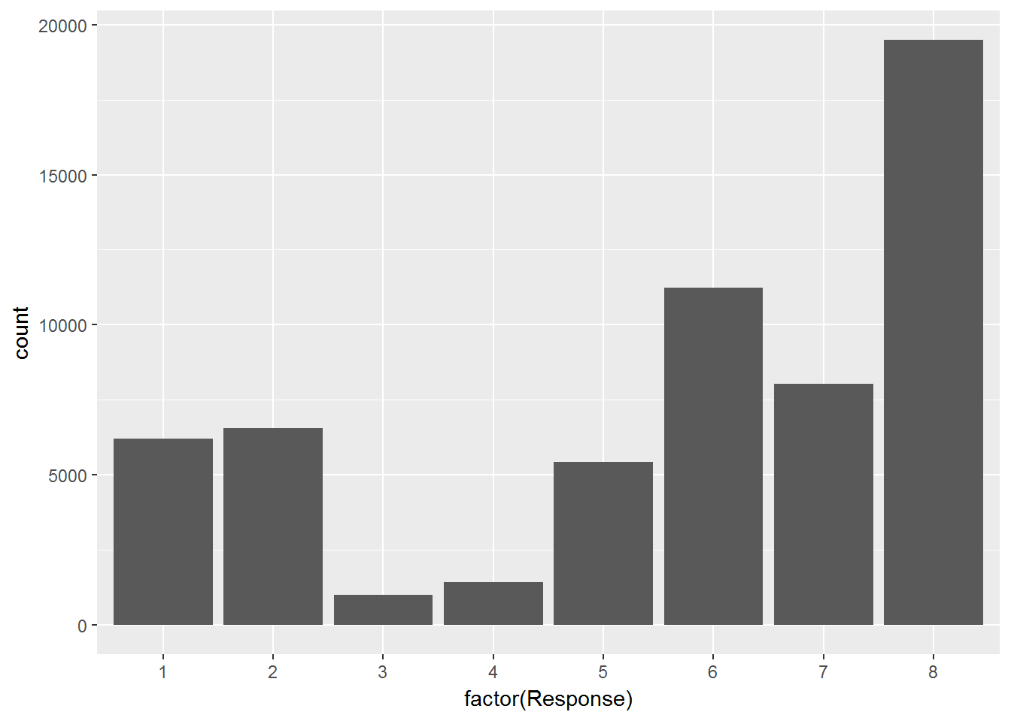

Product_Info_1 : Response가 8인 값이 1 빈도가 가장 많으며 2는 대체로 다 빈도수가 낮음

ggplot(train, aes(x=factor(Response),fill =factor(Product_Info_1))) +   
geom_bar(position = "dodge")

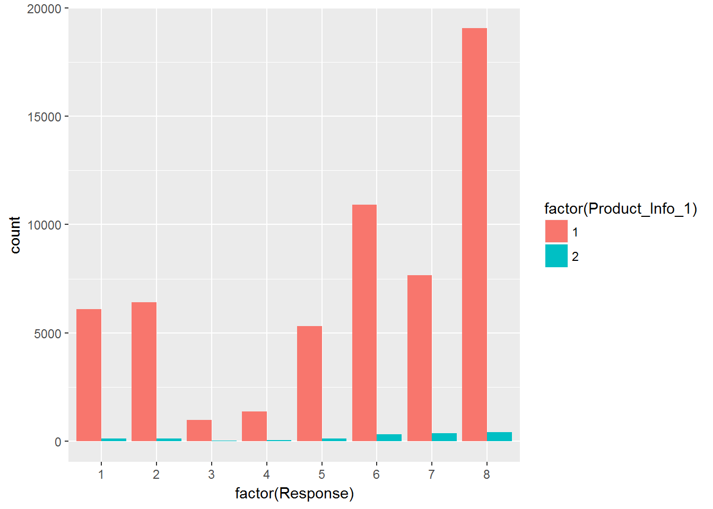

Product_Info_1 : 2만 보았을 때 Response 4, 7이 많게 나타남

train %>%  
 select(Response, Product_Info_1) %>%  
 group_by(Response) %>%  
 summarise(is2 = sum(Product_Info_1 == 2)/n()) %>%  
 reshape2::melt(id.vars="Response",variable.names="is1+is2") %>%   
 ggplot(aes(x = factor(Response), y = value, fill = variable)) +   
 geom_col(position = "dodge")

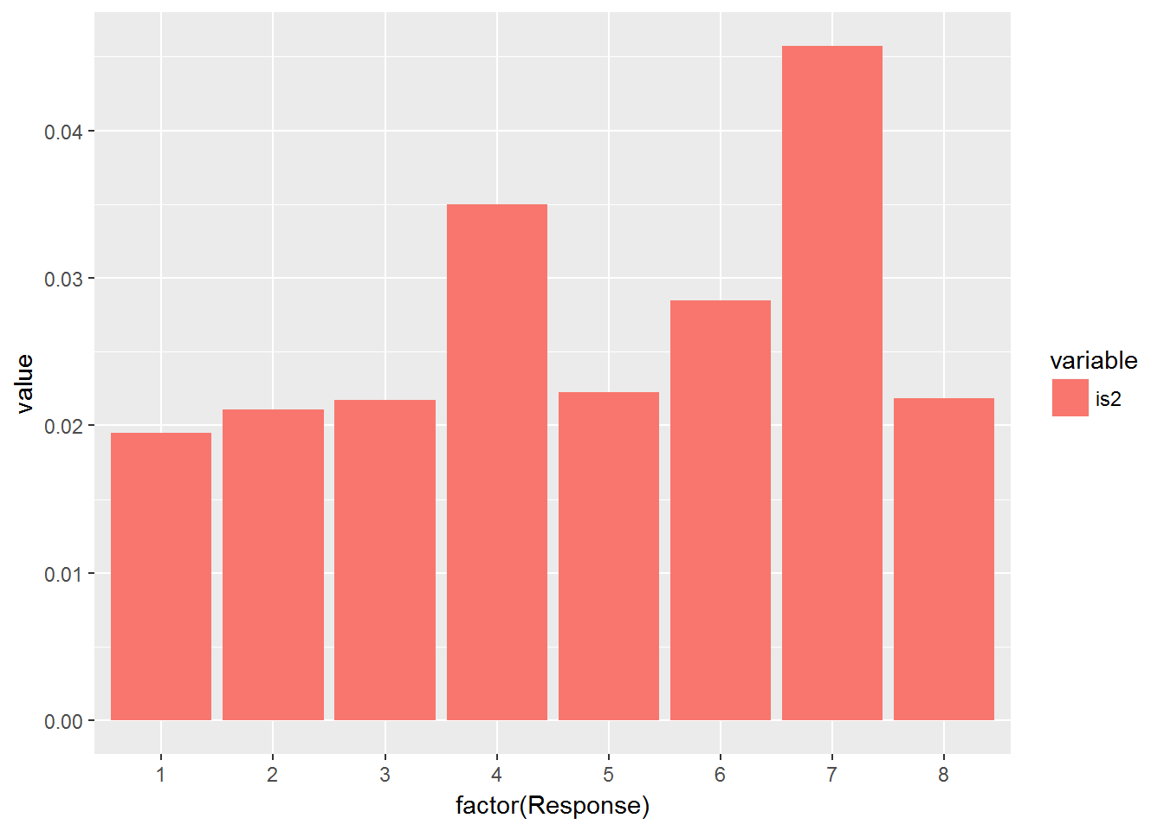

Product_Info_1 : 2만 보았을 때 Response 4, 7이 많게 나타남

train %>%  
 select(Response, Product_Info_1) %>%  
 group_by(Response) %>%  
 summarise(is2 = sum(Product_Info_1 == 2)/n()) %>%  
 reshape2::melt(id.vars="Response",variable.names="is1+is2") %>%   
 ggplot(aes(x = factor(Response), y = value, fill = variable)) +   
 geom_col(position = "dodge")



Product_Info_2 : Response 의 카운트에 따라 상품 갯수가 많이 나오며, 특히나 D3, D4 등의 상품이 많음

ggplot(train, aes(x=factor(Response), fill=factor(as.character(Product_Info_2))))+  
 geom_bar(position = "dodge")

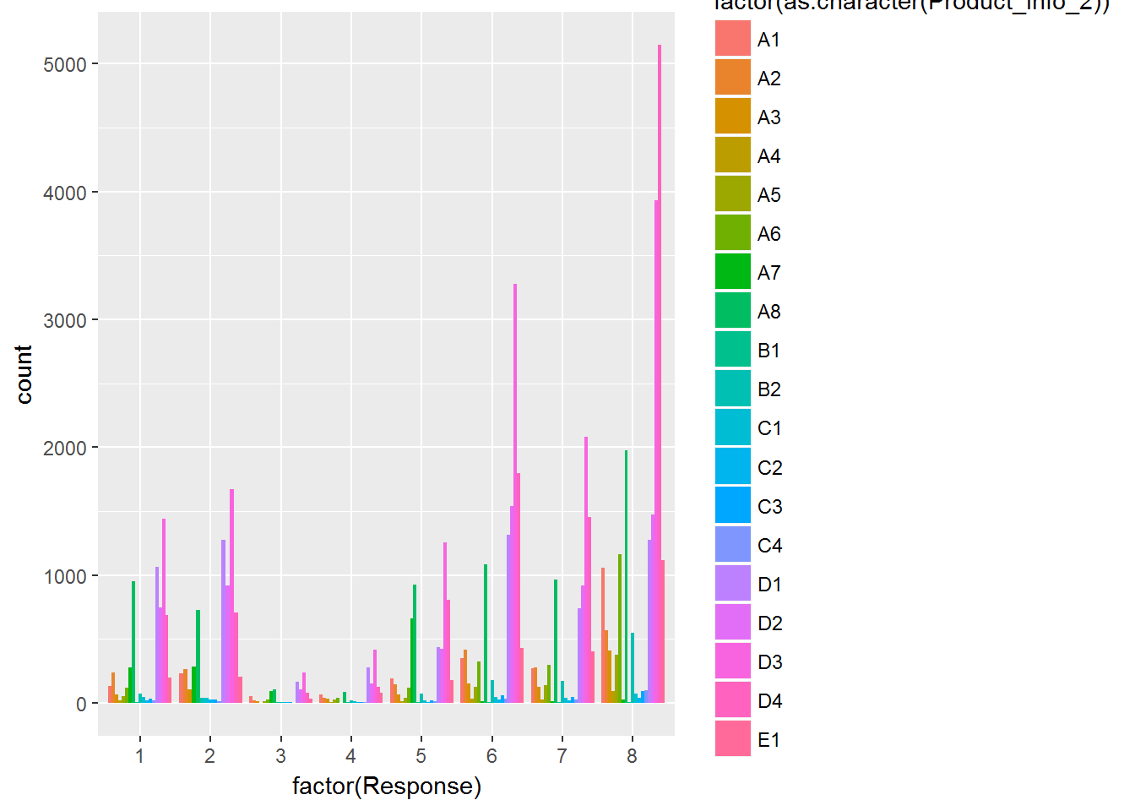

Product_Info_4 : 8의 평균값이 가장 높고 1에 가까울 수록 낮은 성향이 있음 / 변수로 활용하기 용이하다고 판단됨

ggplot(train[,list(mean_Product_Info_5=mean(Product_Info_4)),by="Response"],  
 aes(x=Response, y=mean_Product_Info_5)) + geom_bar(stat="identity")

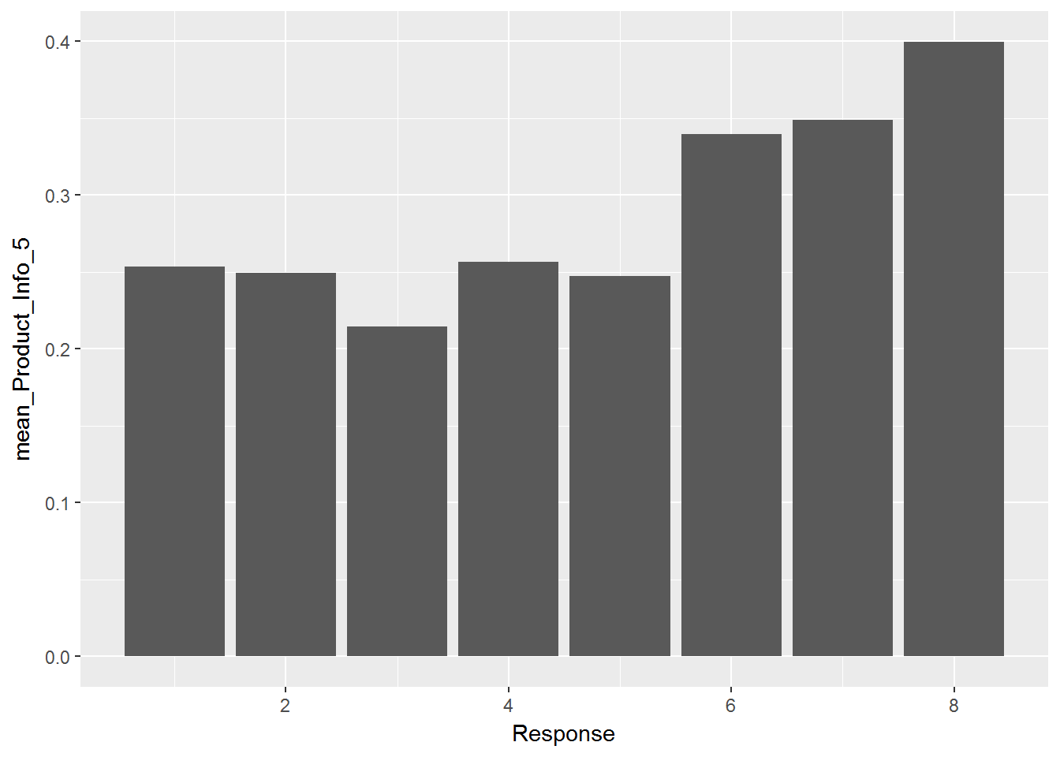

Product_Info_5 : 반면, Product_Info_5의 평균값이 대부분 2를 나타냄

ggplot(train[,list(mean_Product_Info_5=mean(Product_Info_5)),by="Response"], aes(x=Response, y=mean_Product_Info_5), fill=Response) + geom_bar(stat="identity")

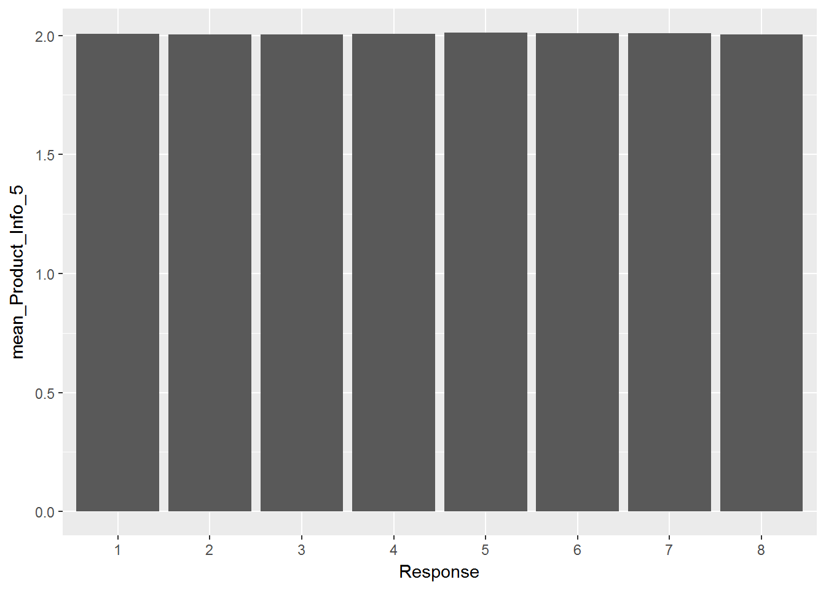

summary(aov(Product_Info_4 ~ Response, data= train)) # ANOVA 테스트

## Df Sum Sq Mean Sq F value Pr(>F)   
## Response 7 236 33.69 443.9 <2e-16 ***  
## Residuals 59373 4505 0.08   
## ---  
## Signif. codes: 0 '***' 0.001 '**' 0.01 '*' 0.05 '.' 0.1 ' ' 1

bartlett.test(Product_Info_4 ~ Response, data= train) # 오차의 등분산성 가정 만족

##   
## Bartlett test of homogeneity of variances  
##   
## data: Product_Info_4 by Response  
## Bartlett's K-squared = 669.62, df = 7, p-value < 2.2e-16

LDuncan(aov(Product_Info_4 ~ Response, data= train), "group") # 사후검정

##   
## DUNCAN TEST TO COMPARE MEANS   
##   
## Confidence Level: 0.95   
## Dependent Variable: Product_Info_4  
## Variation Coefficient: 83.73924 %   
##   
##   
## Independent Variable: Response   
## Factors Means   
## 8 0.399571535685515 a   
## 7 0.349039343015572 b   
## 6 0.339379173576338 c   
## 4 0.256563411668067 d   
## 1 0.253301987630739 de   
## 2 0.249476076569444 de   
## 5 0.247065582743373 e   
## 3 0.214226992757157 f

Product_Info_6 : 1과 3이 가장 많게 나타나며, Response 3,4는 차이가 크지 않고, 8번이 크게 나타남

ggplot(train, aes(x=factor(Response), fill=factor(Product_Info_6)))+  
 geom_bar(position = "dodge")

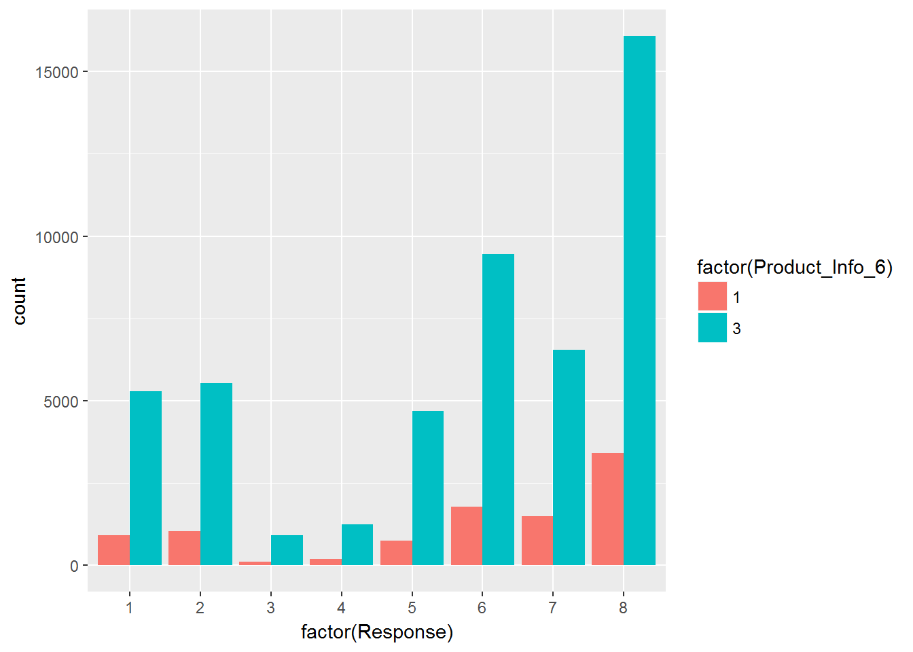

Product_Info_7 : 2번은 거의 없으며, Response 8을 제외하고는 존재하지 않음

ggplot(train, aes(x=factor(Response), fill=factor(Product_Info_7)))+  
 geom_bar(position = "dodge")

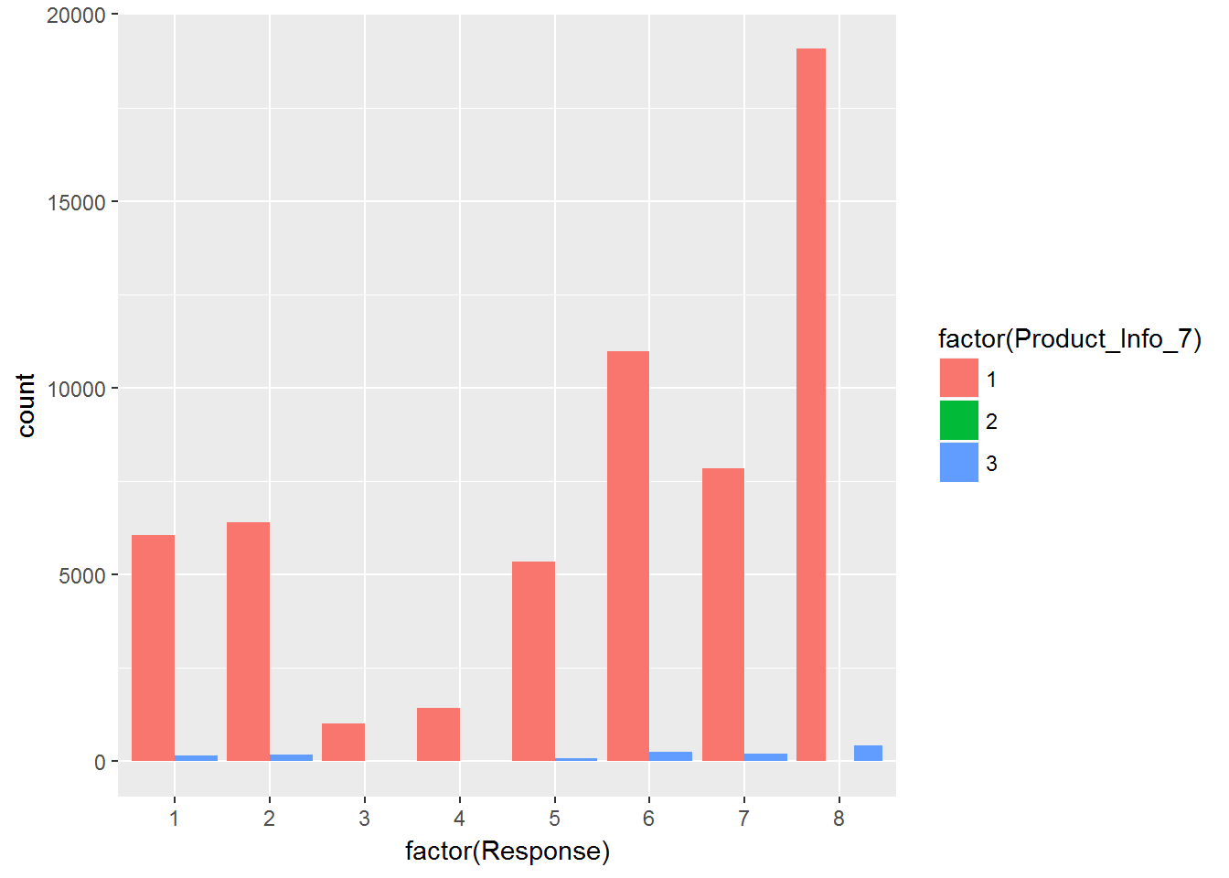

Product_Info_7 : 3번은 Response가 3~6일때 카운트가 적음

train %>%  
 select(Response, Product_Info_7) %>%  
 group_by(Response) %>%  
 summarise(is3 = sum(Product_Info_7 == 3)/n()) %>%  
 reshape2::melt(id.vars="Response",variable.names="is3") %>%   
 ggplot(aes(x = factor(Response), y = value, fill = variable)) +   
 geom_col(position = "dodge")

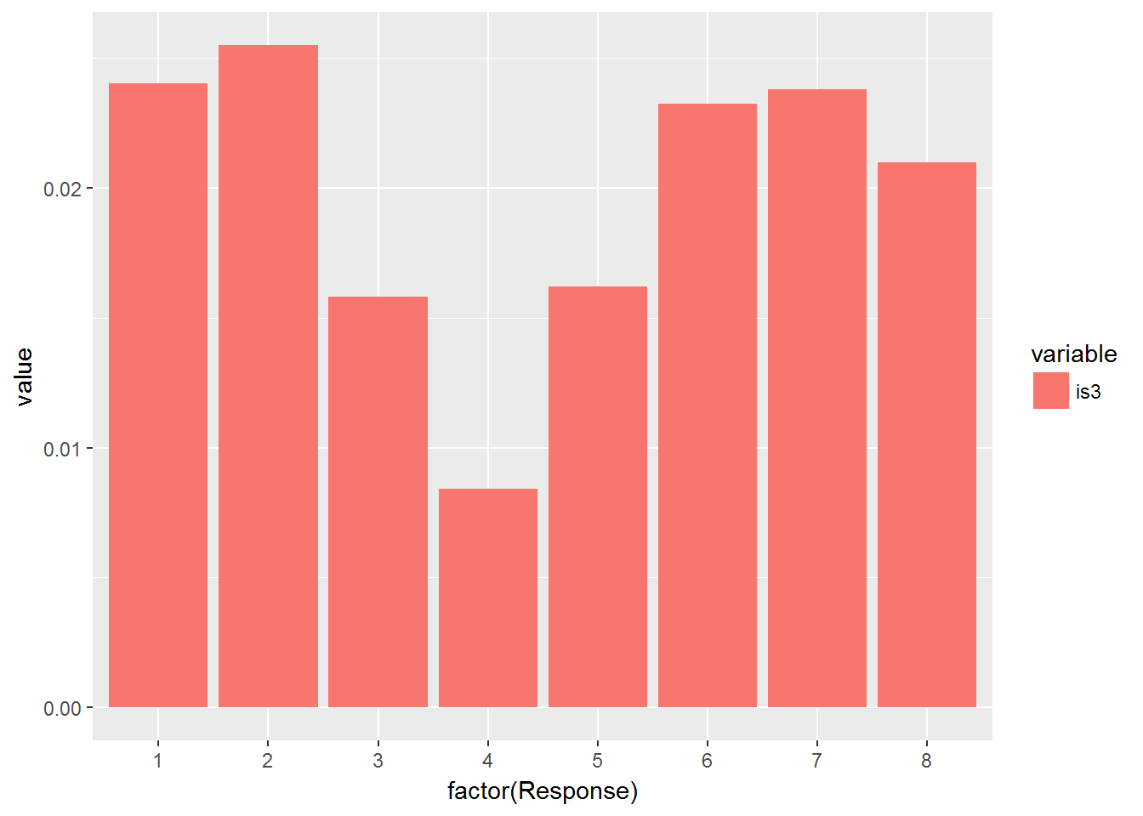

Ins_age : 나이는 평균적으로 Response가 1에 가까울 수록 높게 나타났으며 8일 수록 적게 나타남

ggplot(train[,list(mean_Ins_Age=mean(Ins_Age)),by="Response"],  
 aes(x=Response, y=mean_Ins_Age)) + geom_bar(stat="identity")

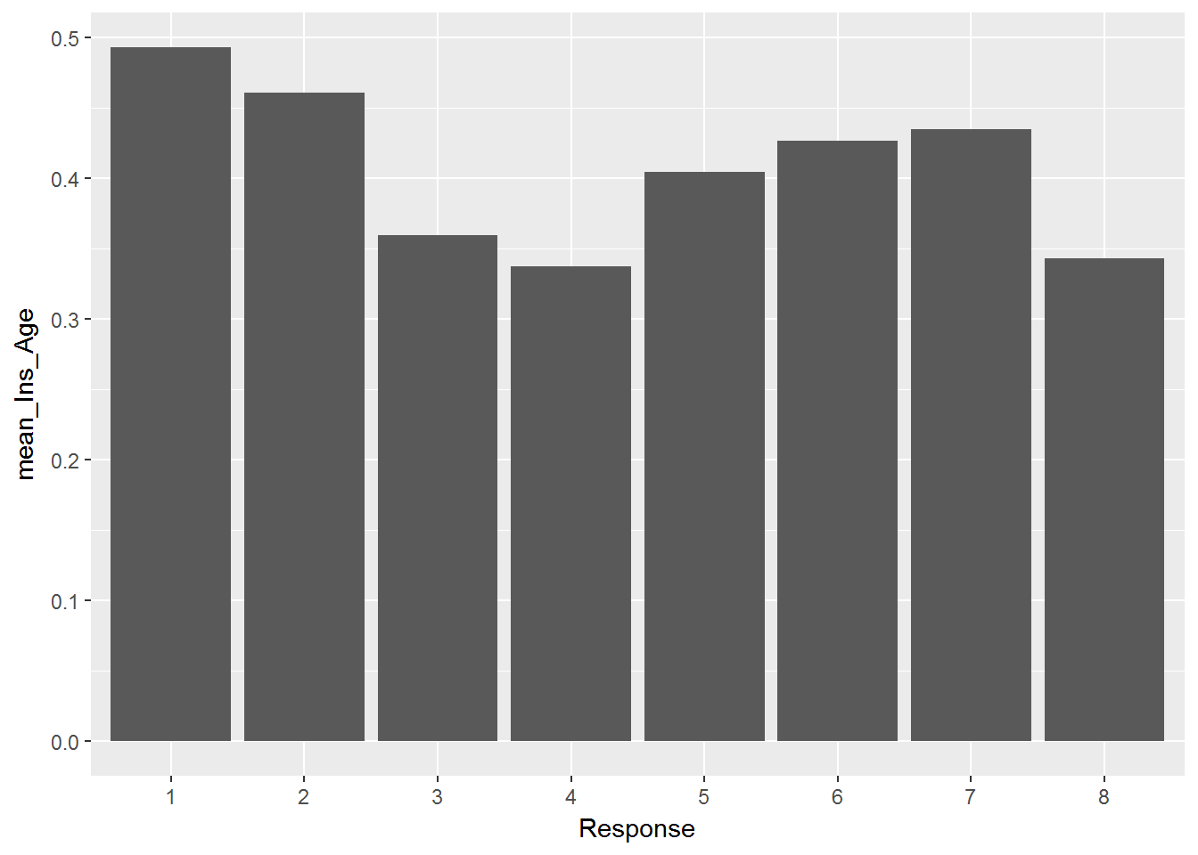

BMI, Tt, Wt, Ins_Age : 정규 분포

hist(train$BMI)

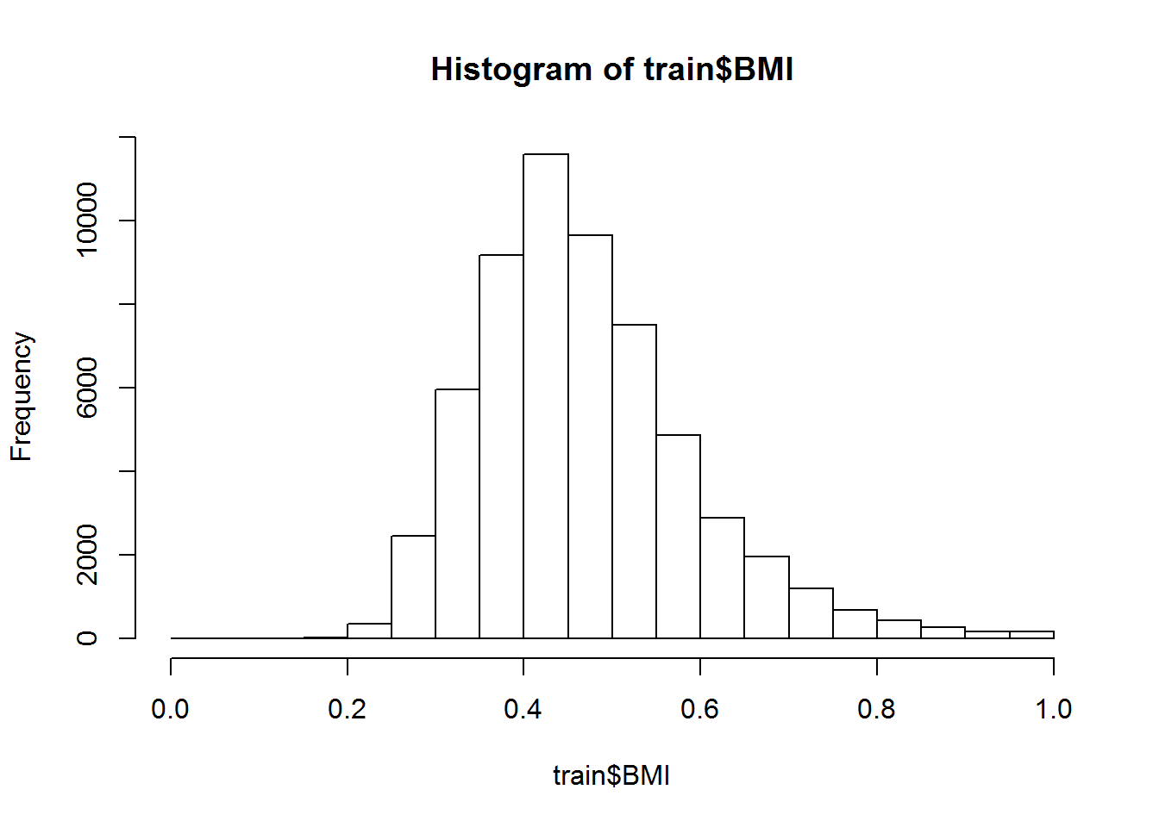

hist(log(train$Wt))

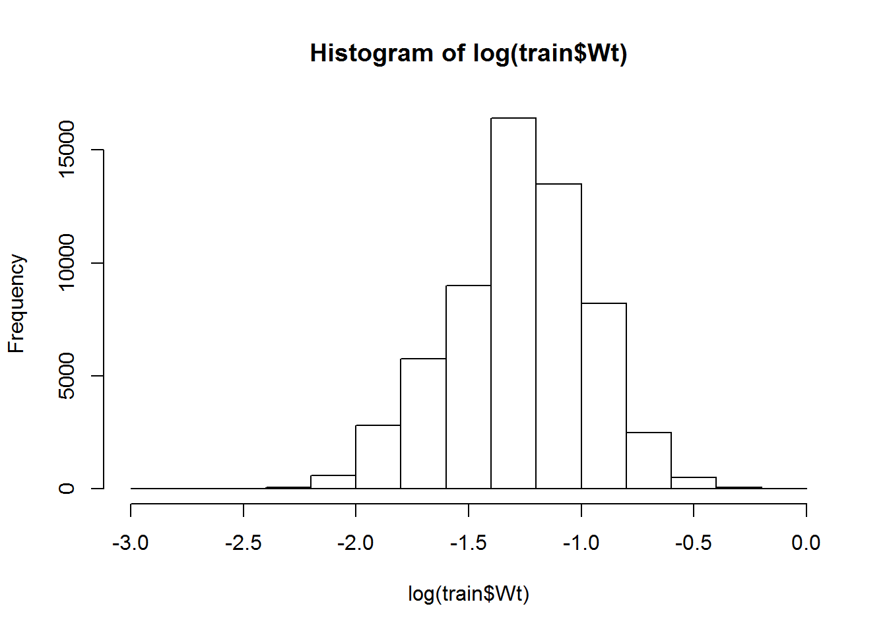

hist(train$Wt)

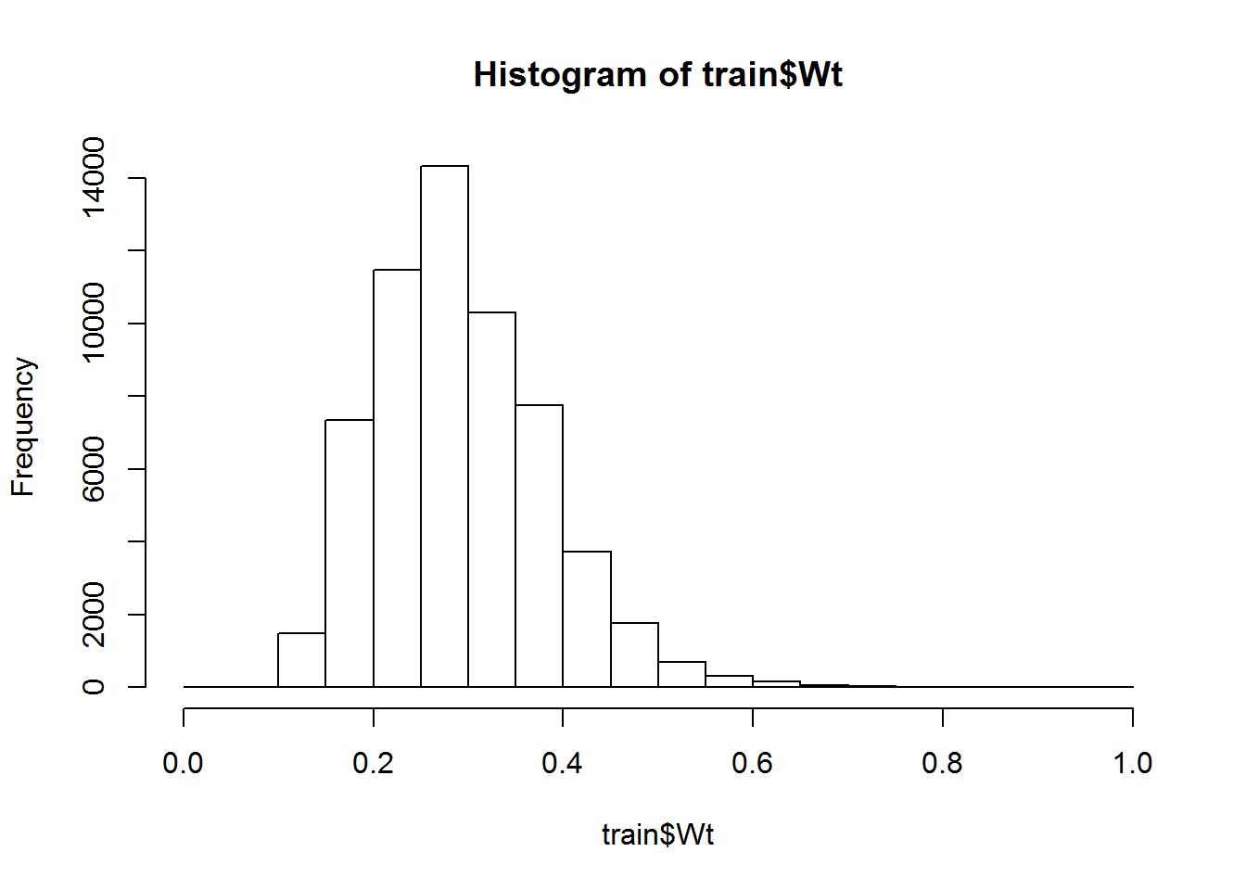

hist(train$Ht)

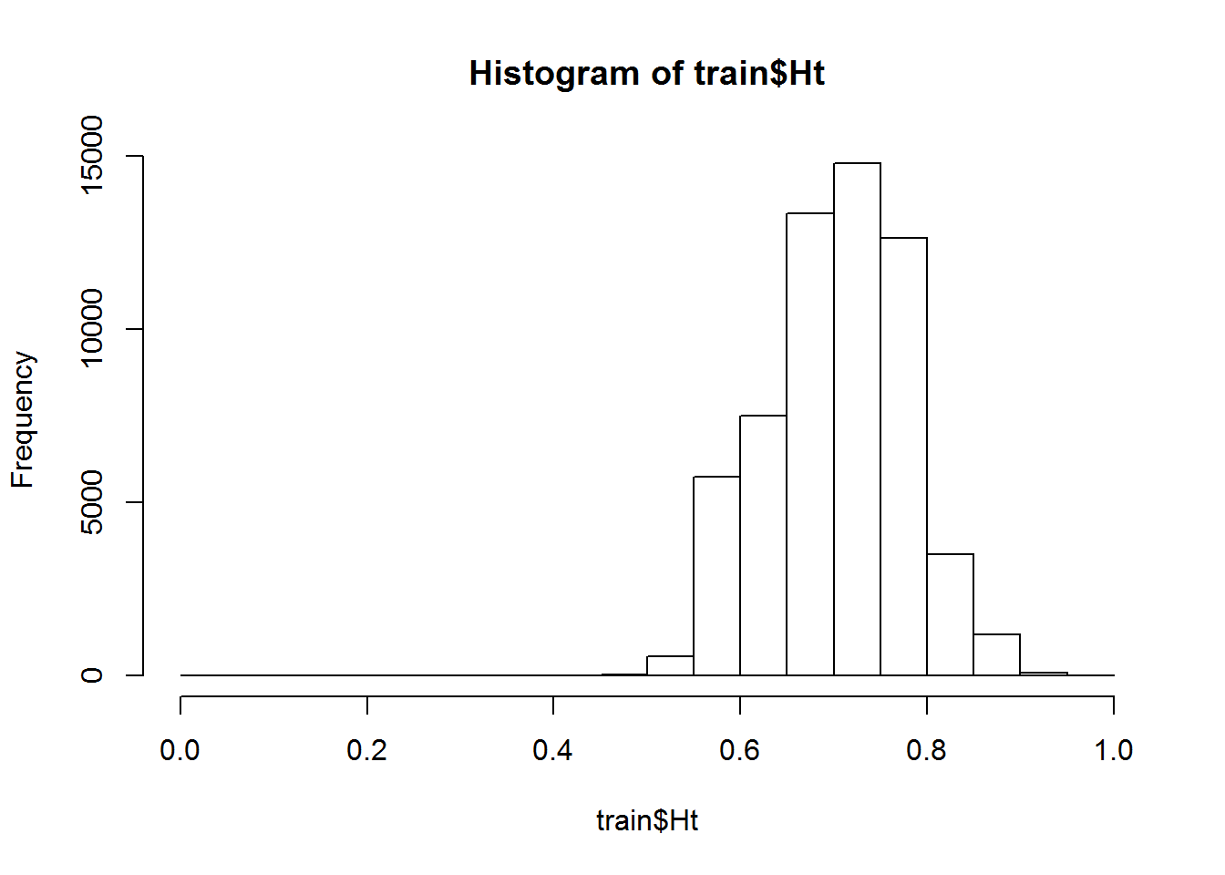

hist(train$Ins_Age)

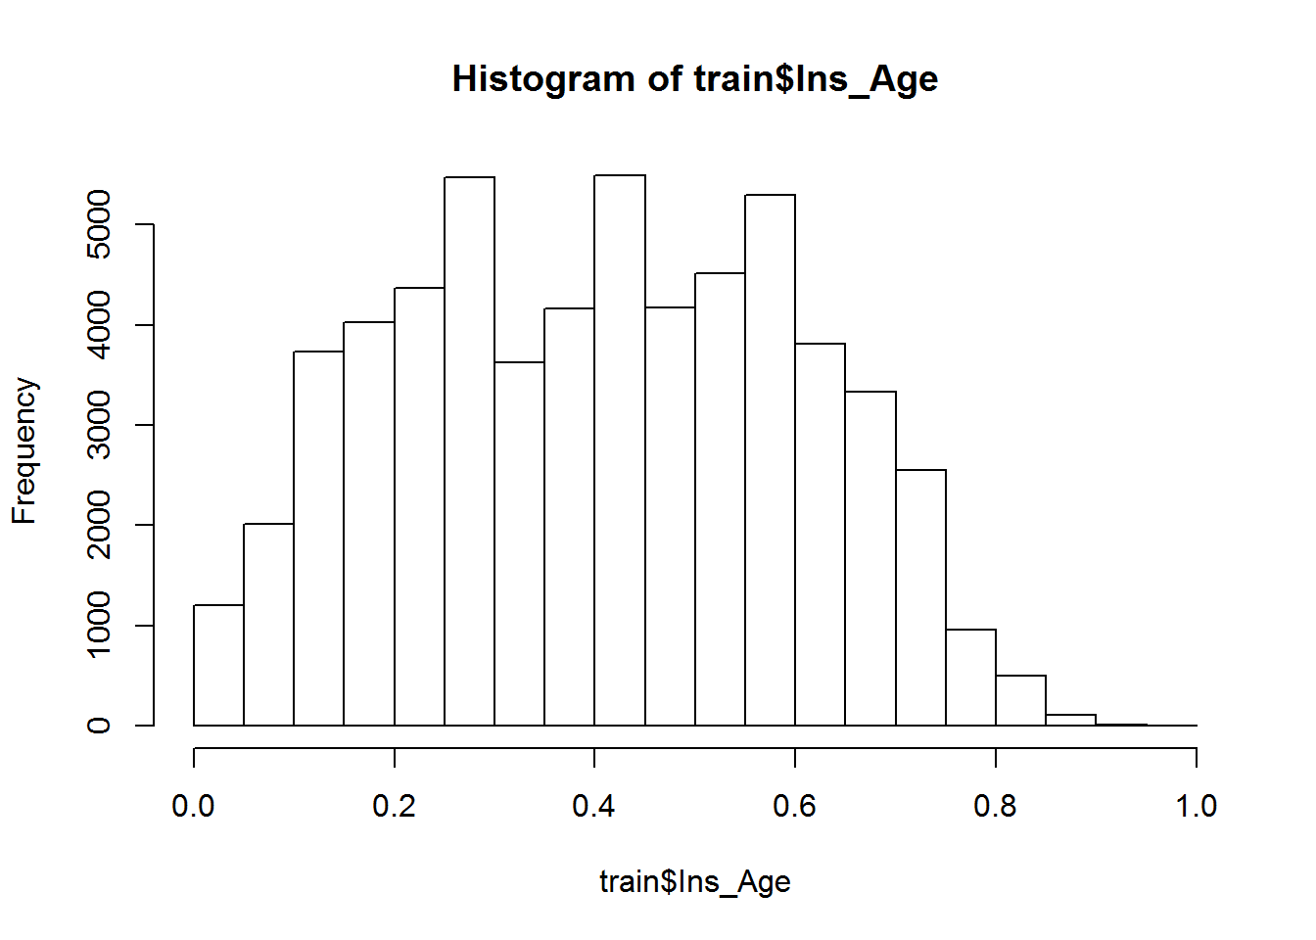

BMI : Response별 평균 BMI

ggplot(train[,list(mean_BMI=mean(BMI)),by="Response"],  
 aes(x=Response, y=mean_BMI)) + geom_bar(stat="identity")

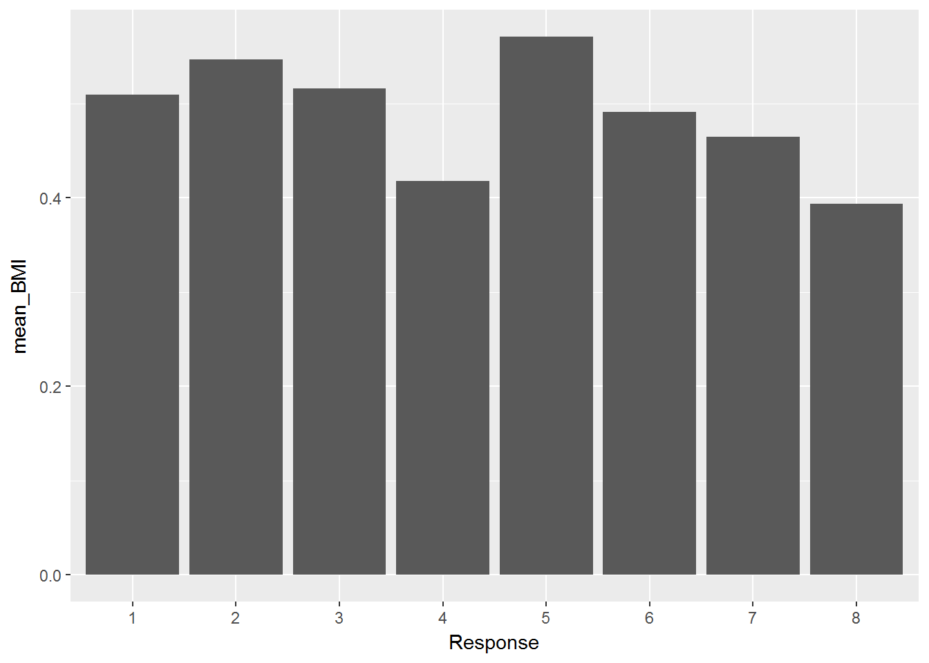

Ins_age, Density Plot : age가 0.6이상인 경우에는 response 1등급이 가장 많으며, age가 0.3미만인 경우에는 response 8등급이 가정 많다.

ggplot(train, aes(Ins_Age , colour = Response)) + geom_density()

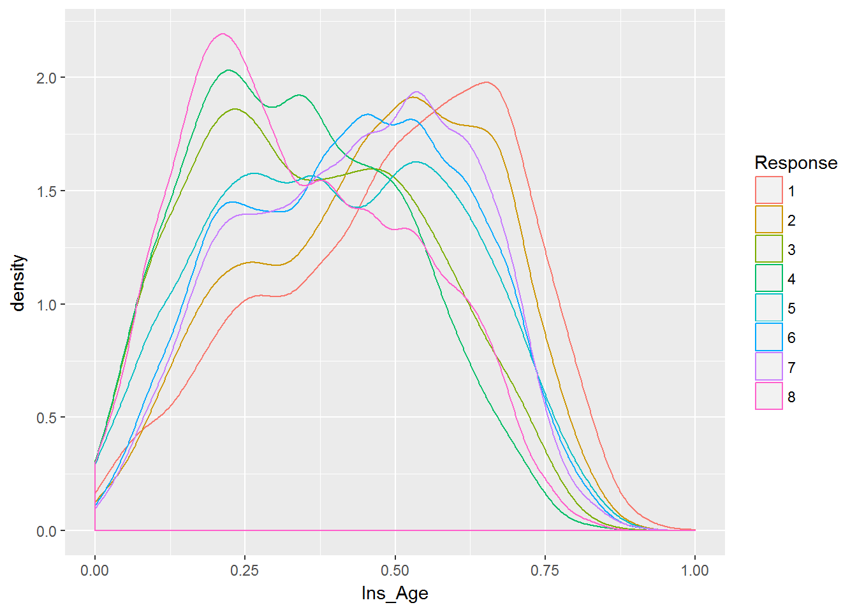

ggplot(train, aes(x=Response, y=Ins_Age)) + geom_boxplot(notch=TRUE)

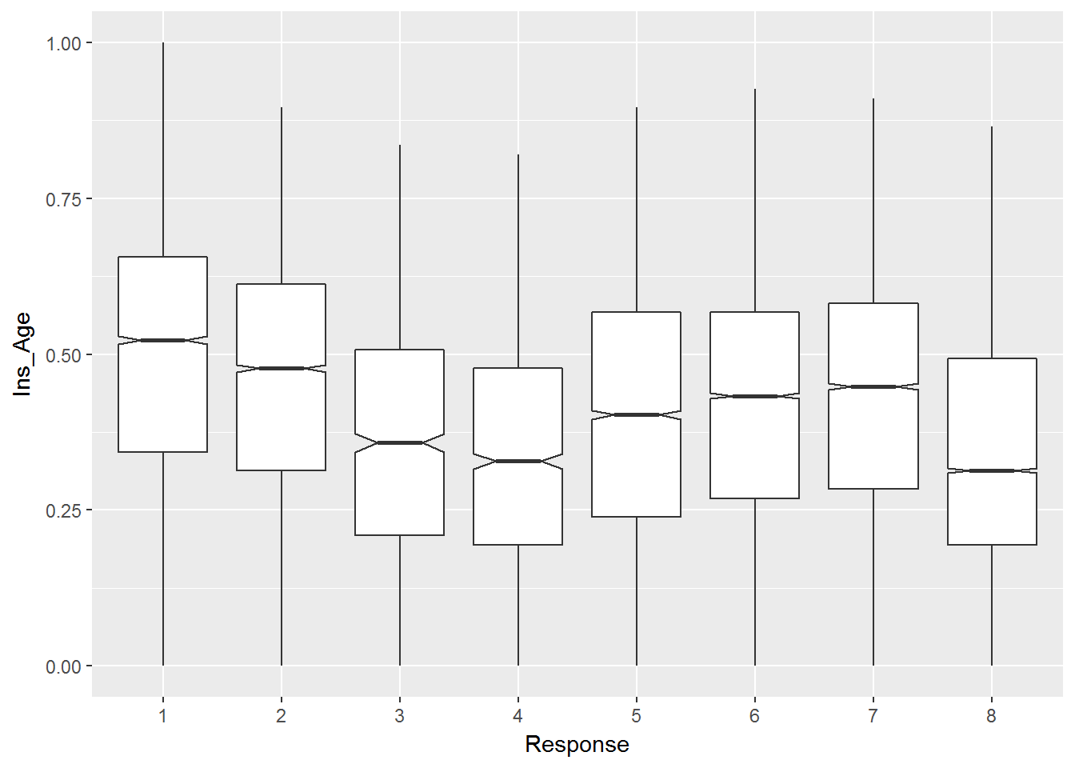

BMI, Density Plot : BMI 0.4미만이면 8등급의 인원 비율이 가장 높으며 BMI가 0.8이상인 경우는 대부분 1,2,3등급에 속한다

ggplot(train, aes(BMI, colour = Response)) + geom_density()

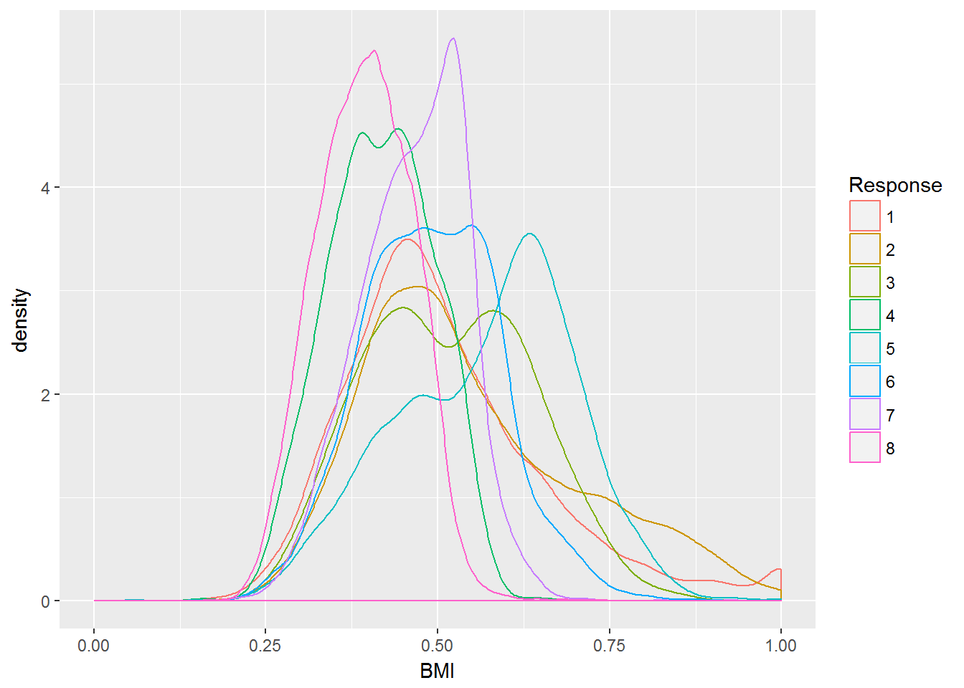

ggplot(train, aes(x=Response, y=BMI)) + geom_boxplot(notch=TRUE)

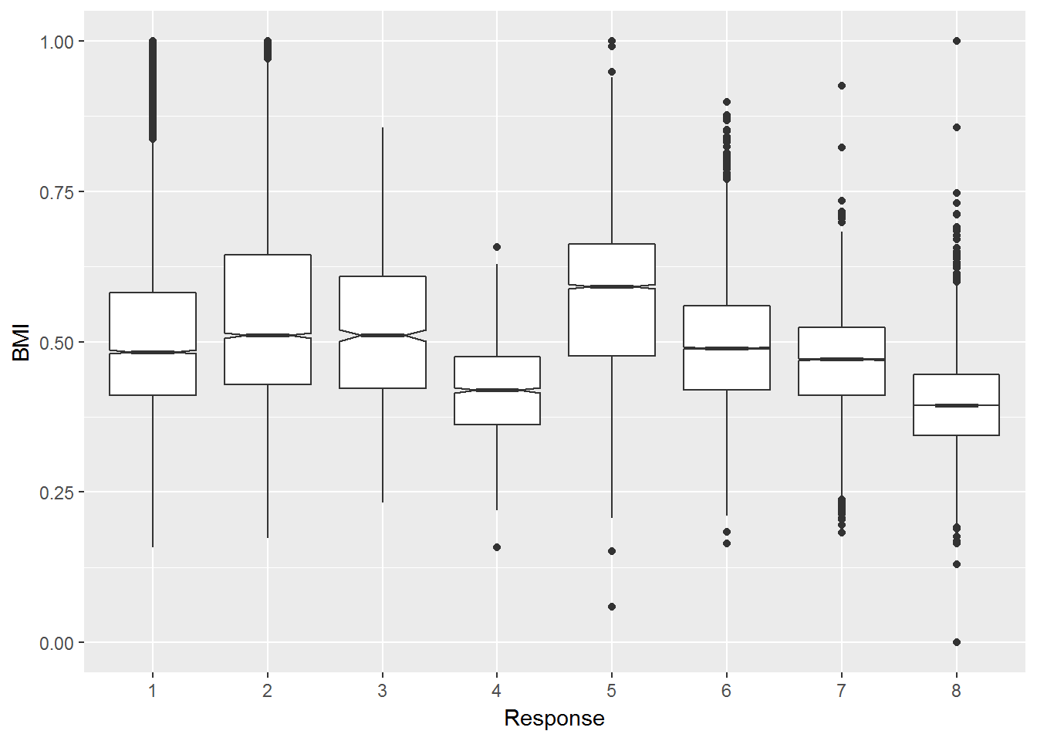

BMI & Ins_Age : 전체적으로 크게 상관 없는듯

ggplot(train, aes(x=BMI, y= Ins_Age)) +  
 geom_point(shape=1) +   
 geom_smooth(method=lm) + facet_wrap(~ Response , ncol=2)

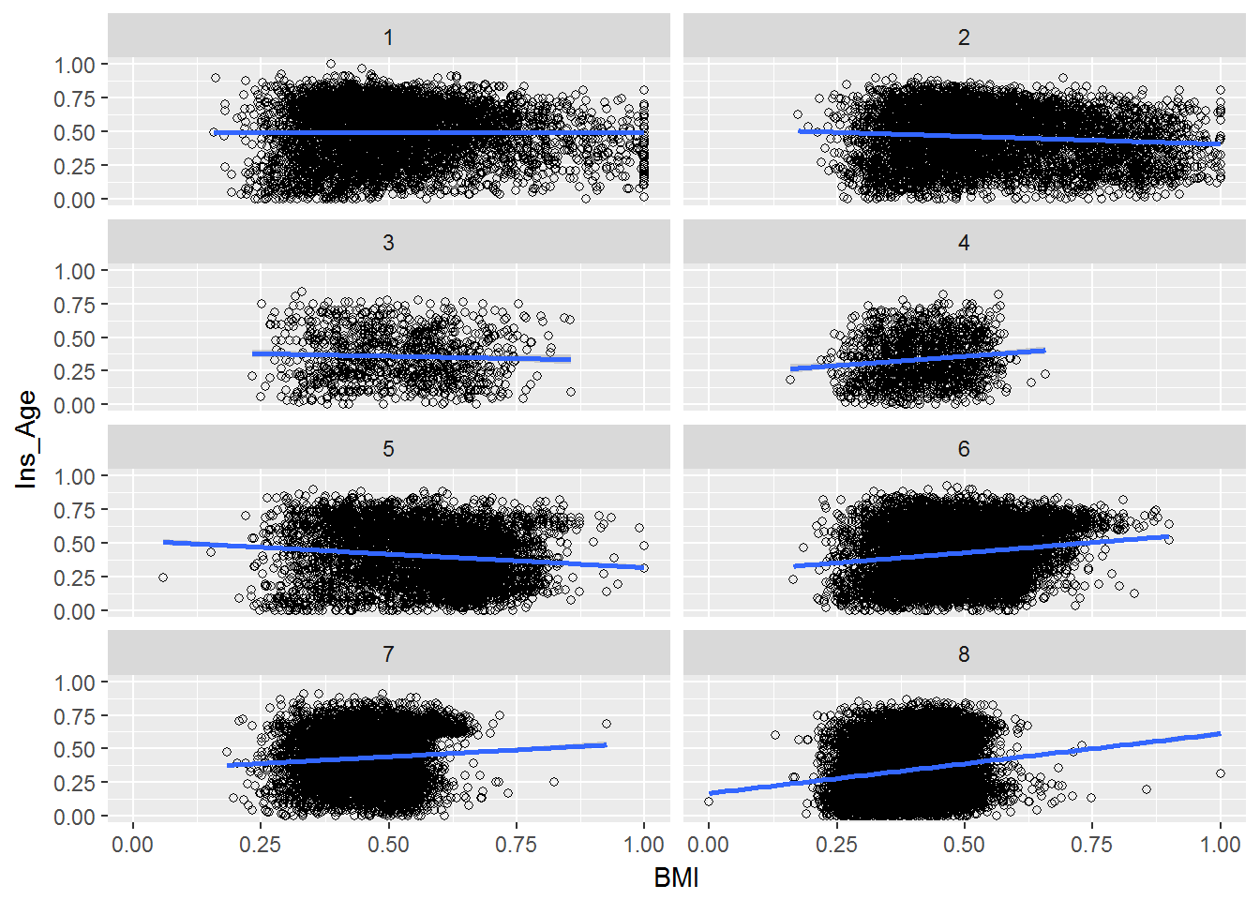

Employment : Response 와 비슷하게 나타남

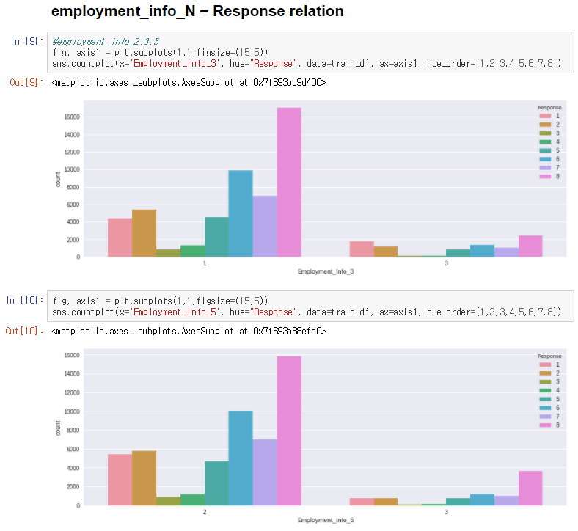

BMI_Ins_Age

Ht : Response 8의 경우 0~0.65 구간의 값이 가장 많음

Ins_Age : Response 8의 경우 0.2 ~04 구간이 많게 나타남

BMI : Response 8의 경우 0 ~ 0.385 구간이 역시 많음 / 0.53~1은 매우 적음

ggplot(train, aes(x=factor(Response), fill=factor(cut(Wt,breaks = c(0,.23,.3,.35,1.0)))))+  
 geom_bar(position = "dodge")

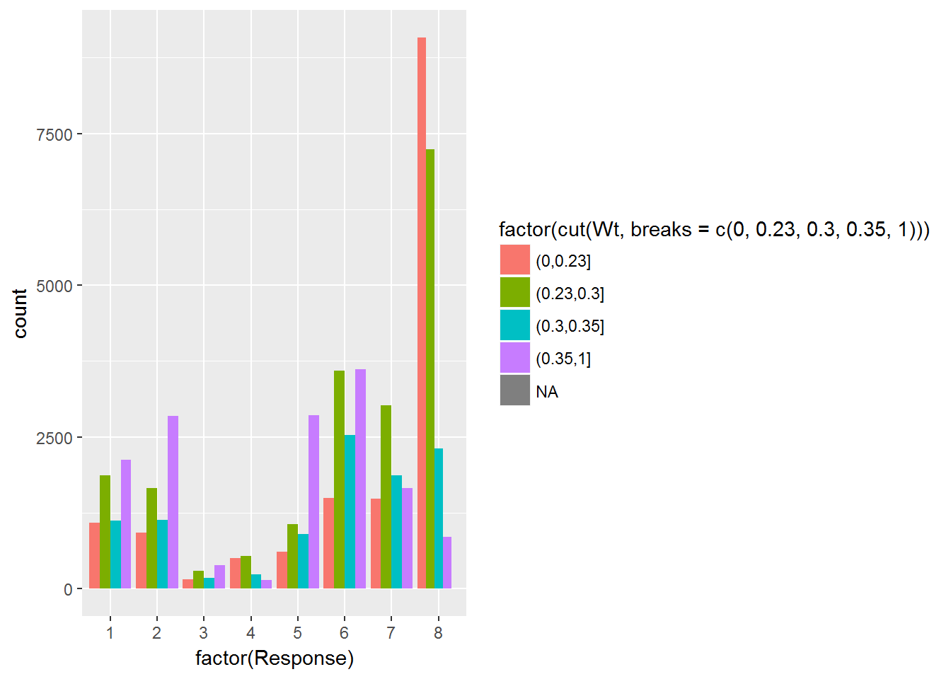

ggplot(train, aes(x=factor(Response), fill=factor(cut(Ht,breaks = c(0,.65,.7,.76,1.0)))))+  
 geom_bar(position = "dodge")

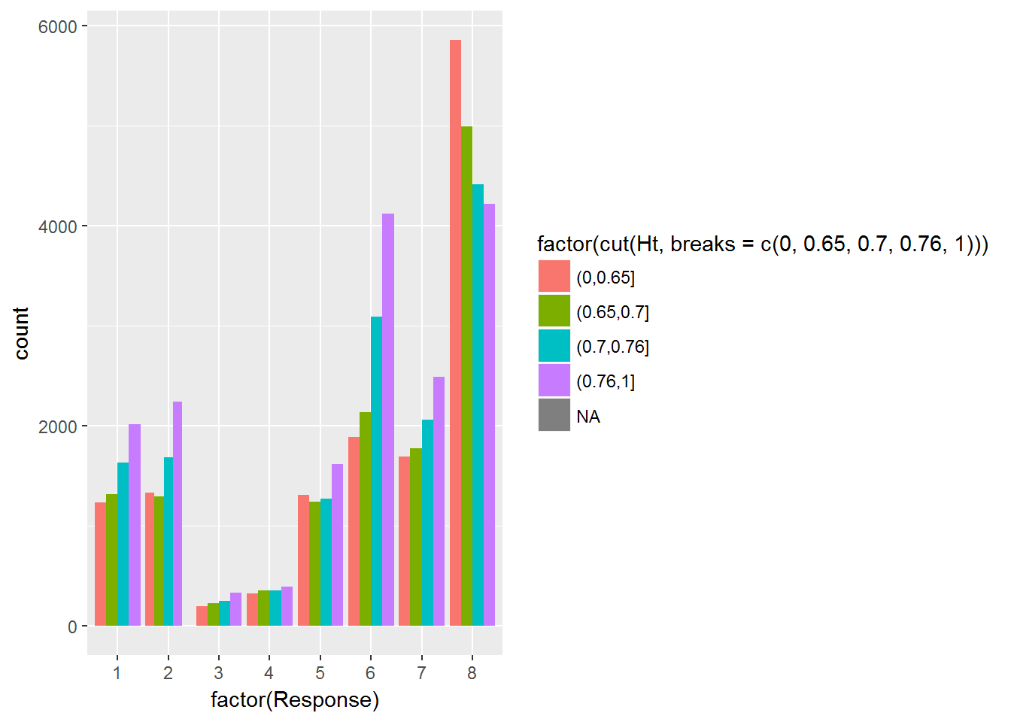

ggplot(train, aes(x=factor(Response), fill=factor(cut(Ins_Age,breaks = c(0,.2,.4,.6,.8,1.0)))))+  
 geom_bar(position = "dodge")

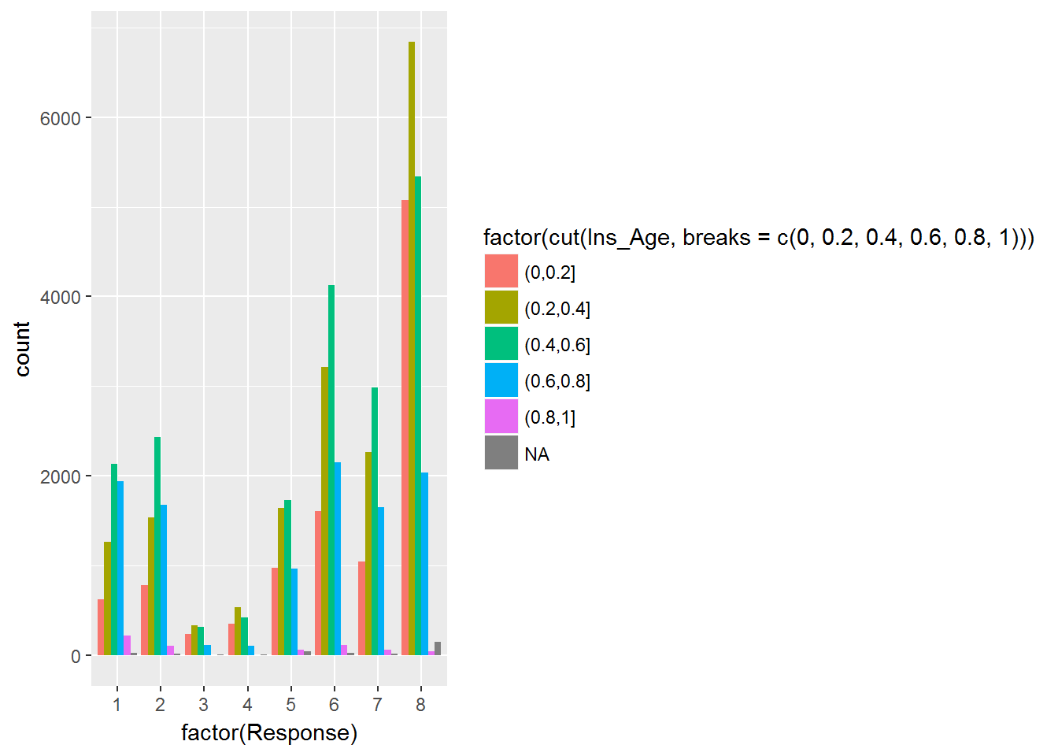

ggplot(train, aes(x=factor(Response), fill=factor(cut(BMI,breaks = c(0,.385,.47,.53,1.0)))))+  
 geom_bar(position = "dodge")

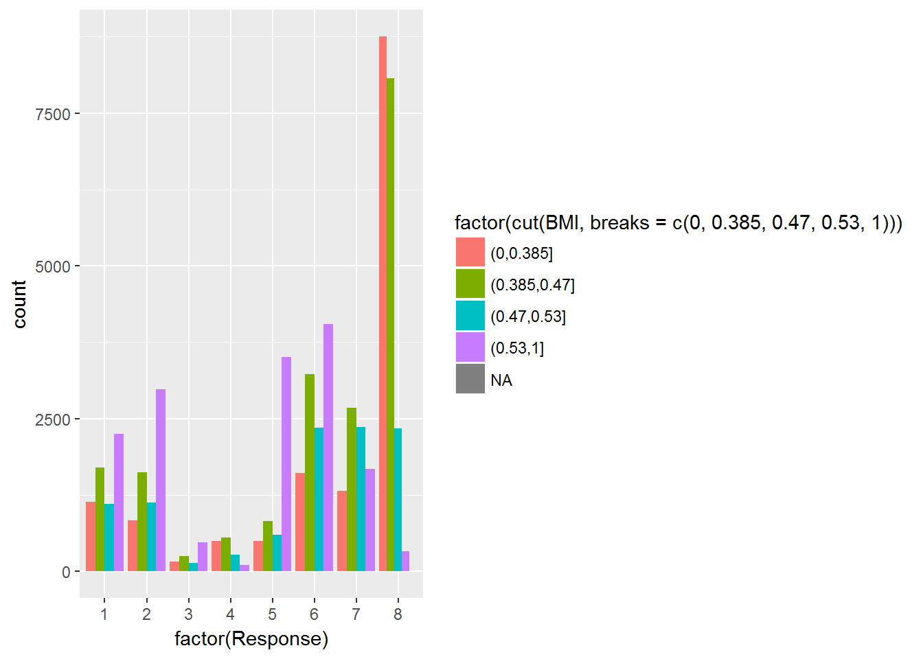

Medical_Keyword

grid.arrange(ggplot(train, aes(Medical_Keyword_2 , colour = Response)) + geom_density(),   
 ggplot(train, aes(Medical_Keyword_3 , colour = Response)) + geom_density())

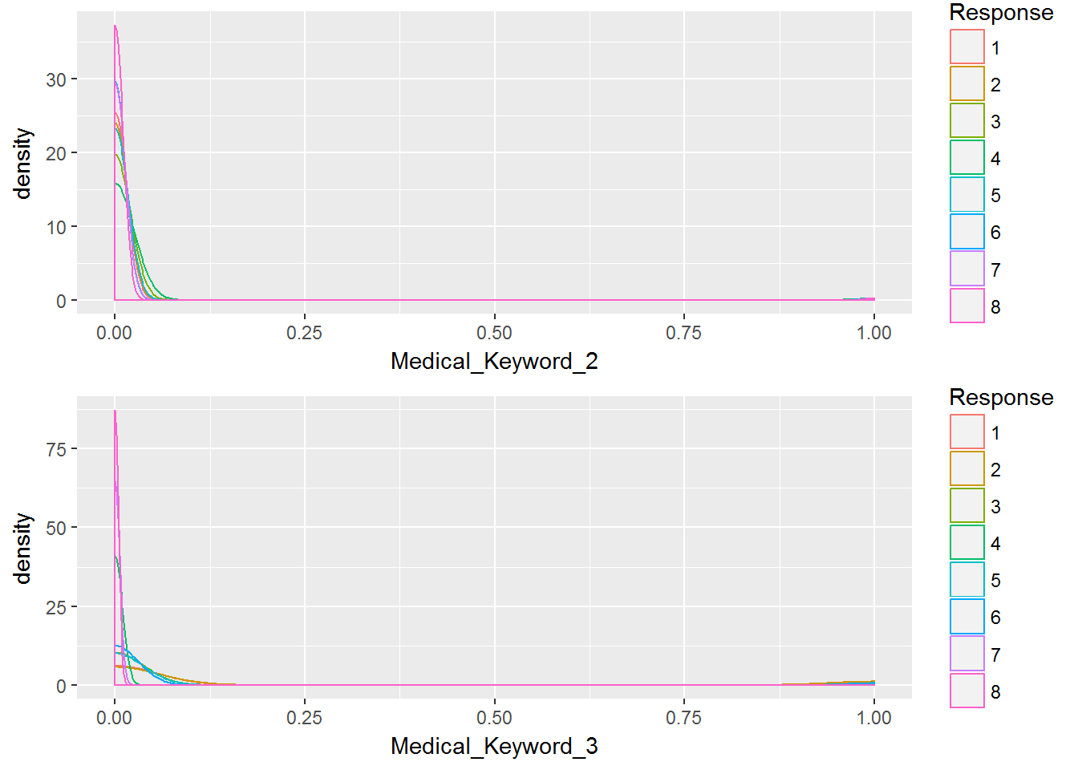

grid.arrange(ggplot(train, aes(Medical_Keyword_4 , colour = Response)) + geom_density(),   
 ggplot(train, aes(Medical_Keyword_5 , colour = Response)) + geom_density())

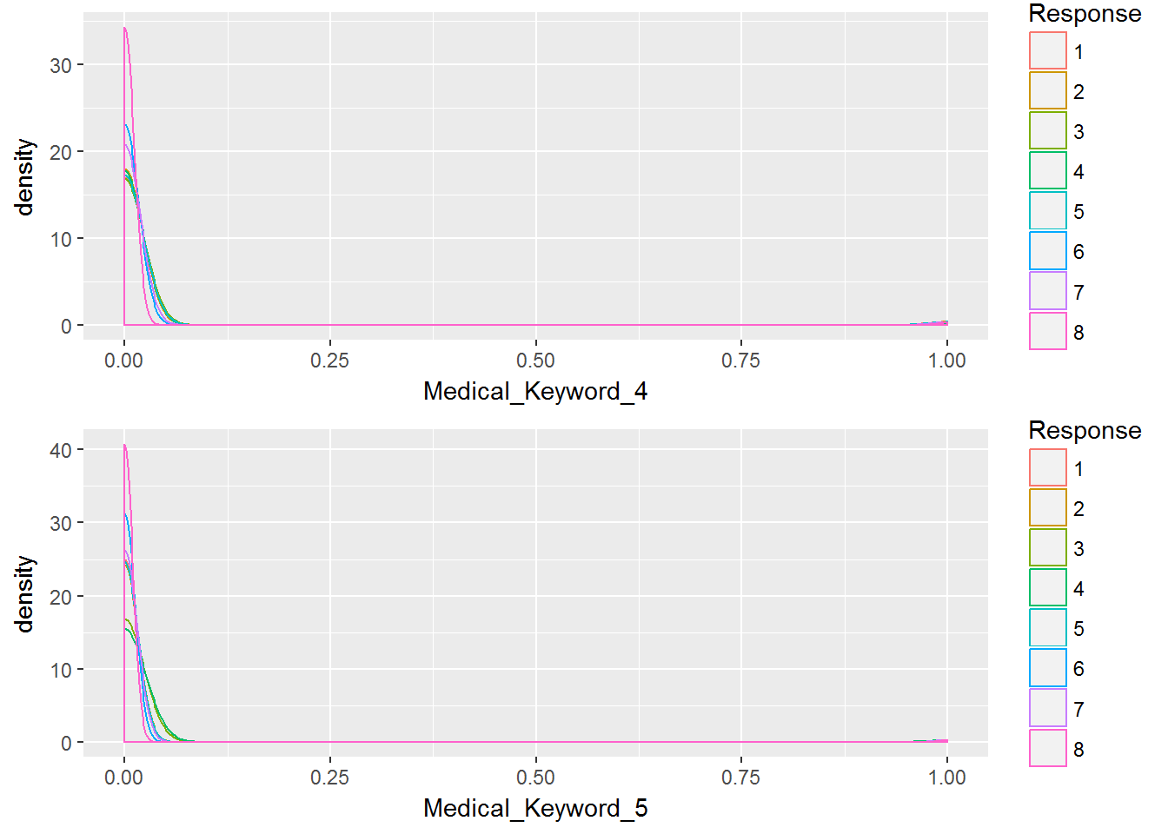

grid.arrange(ggplot(train, aes(Medical_Keyword_6 , colour = Response)) + geom_density(),   
 ggplot(train, aes(Medical_Keyword_7 , colour = Response)) + geom_density())

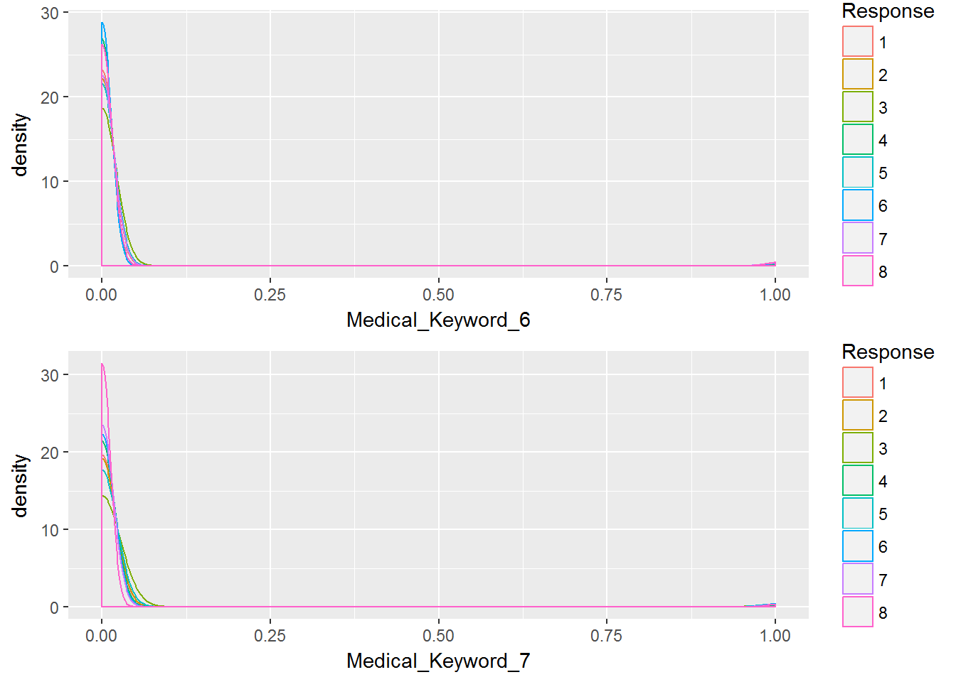

Medical_keyword_8 : Response5에서 높게 나타남

grid.arrange(ggplot(train, aes(Medical_Keyword_8 , colour = Response)) + geom_density(),   
 ggplot(train, aes(Medical_Keyword_9 , colour = Response)) + geom_density())

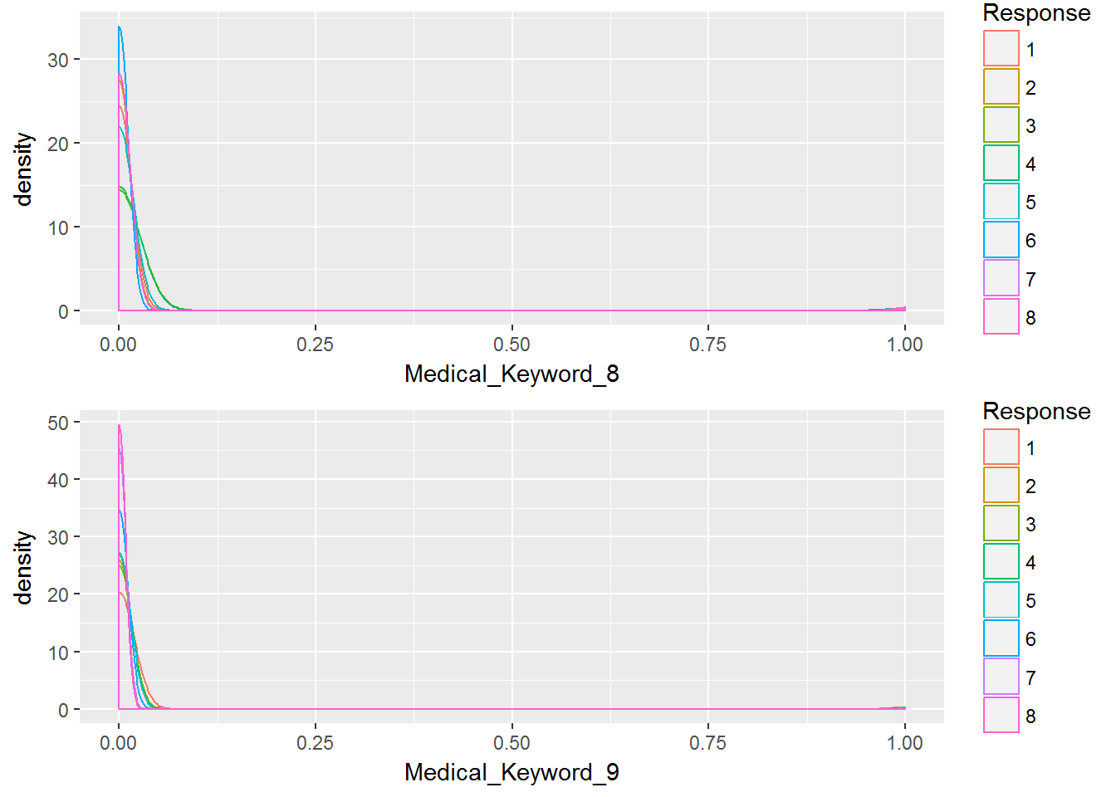

Int_Age & Medical_History1 : Ins_Age가 높고 Medical History1이 높을 수록 Response는 6이 많다

6예측 용이, 0.6 ~0.7은 4가 많음

특히나 Int_Age_MH1에 따른 편차가 존재 / Response 5는 Ins_Age가 커질수록 빈도가 줄어드는 경향이 있음

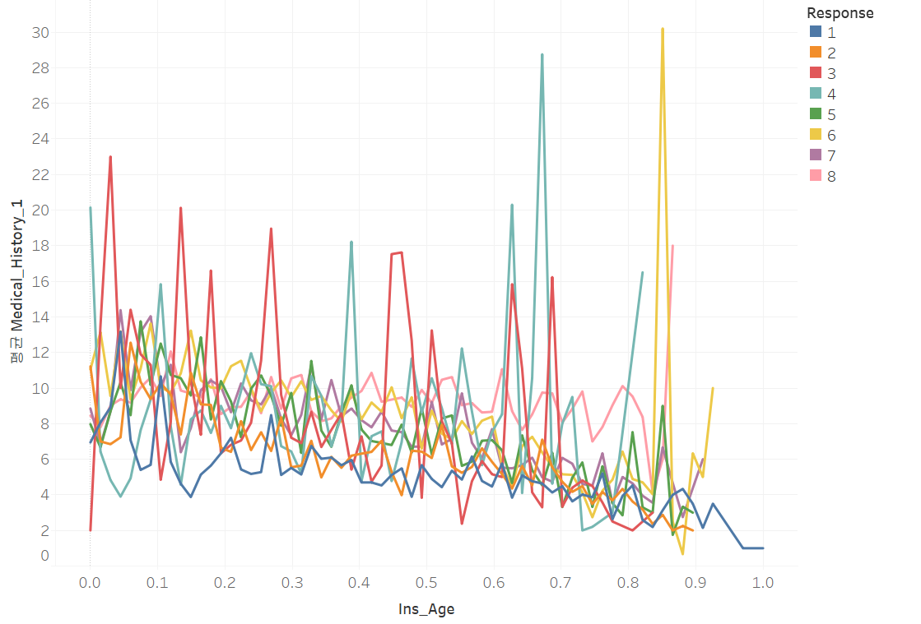

Int_Age_MH1

Medical_History2 : Response에 따라 편차 존재

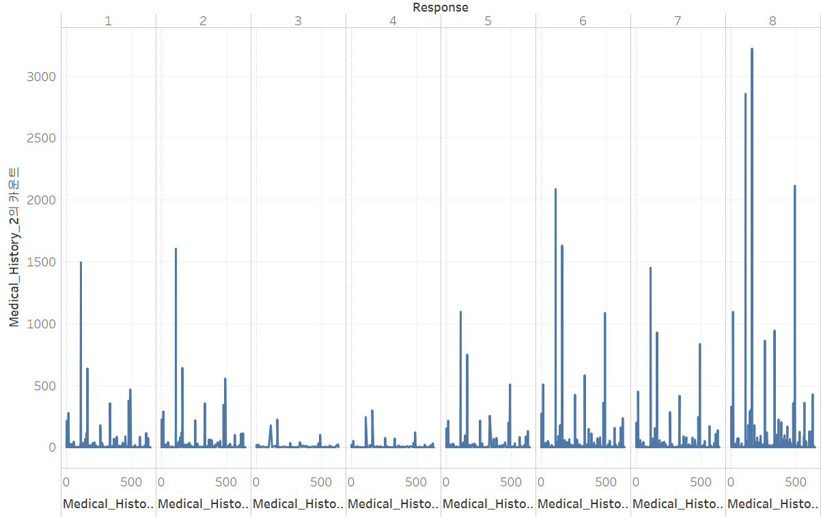

MH2_Count

Product Information2 & Medical History1 : 상품에 따라 등급이 다양하게 나타남

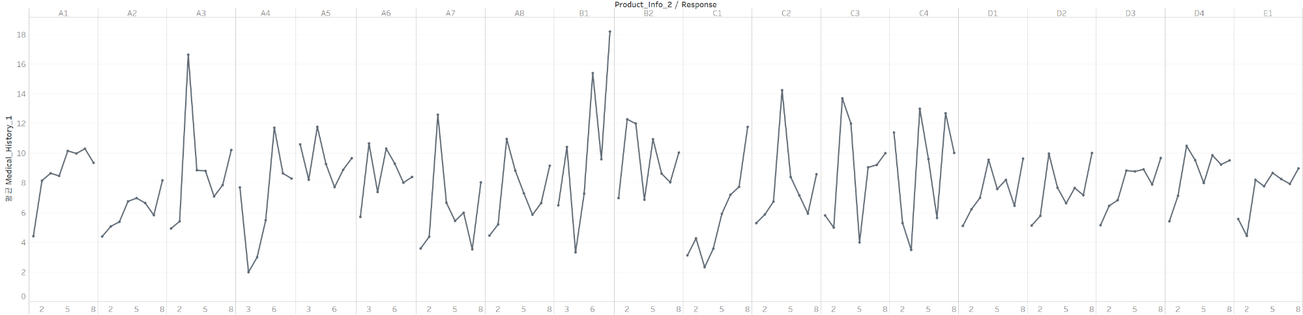

PI2_MH1

많은 na를 가지고 있는 변수들이 있다는 것

어떤 변수는 na값들이 더 많은 경우도 있다. 그래서 na의 값과 na가 아닌 값들을 비교했다.

train %>%  
 mutate(new_Employment_Info_4 = as.numeric(is.na(Employment_Info_4))) %>%  
 mutate(new_Employment_Info_6 = as.numeric(is.na(Employment_Info_6))) %>%  
 mutate(new_Insurance_History_5 = as.numeric(is.na(Insurance_History_5))) %>%  
 mutate(new_Family_Hist_2 = as.numeric(is.na(Family_Hist_2))) %>%  
 mutate(new_Family_Hist_3 = as.numeric(is.na(Family_Hist_3))) %>%  
 mutate(new_Family_Hist_4 = as.numeric(is.na(Family_Hist_4))) %>%  
 mutate(new_Family_Hist_5 = as.numeric(is.na(Family_Hist_5))) %>%  
 mutate(new_Medical_History_1 = as.numeric(is.na(Medical_History_1))) %>%  
 mutate(new_Medical_History_10 = as.numeric(is.na(Medical_History_10))) %>%  
 mutate(new_Medical_History_15 = as.numeric(is.na(Medical_History_15))) %>%  
 mutate(new_Medical_History_24 = as.numeric(is.na(Medical_History_24))) %>%  
 mutate(new_Medical_History_32 = as.numeric(is.na(Medical_History_32))) -> train

na(1)와 not-na(0)의 비교 시각화

ggplot(data = train, aes(factor(Response), fill = factor(new_Employment_Info_4))) +  
 geom_bar(position = "dodge")

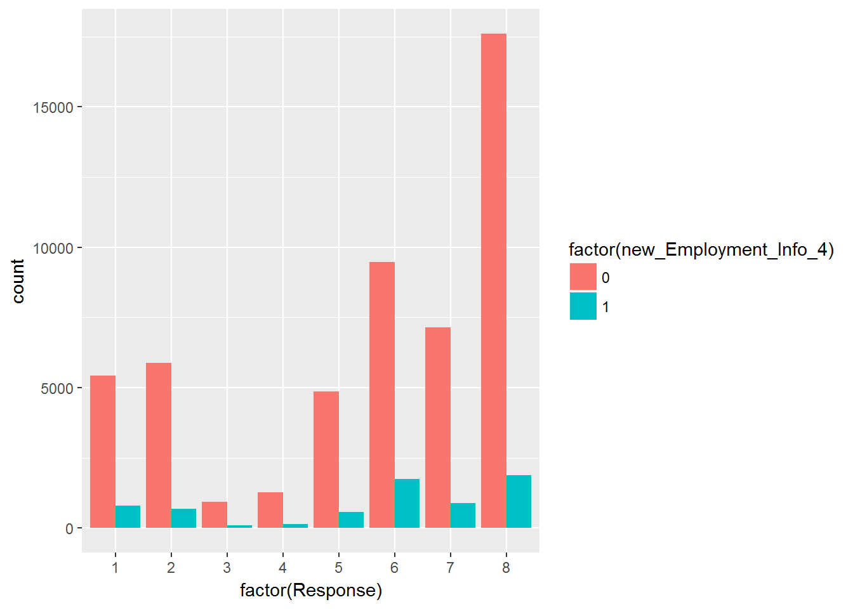

ggplot(data = train, aes(factor(Response), fill = factor(new_Employment_Info_6))) +  
 geom_bar(position = "dodge")

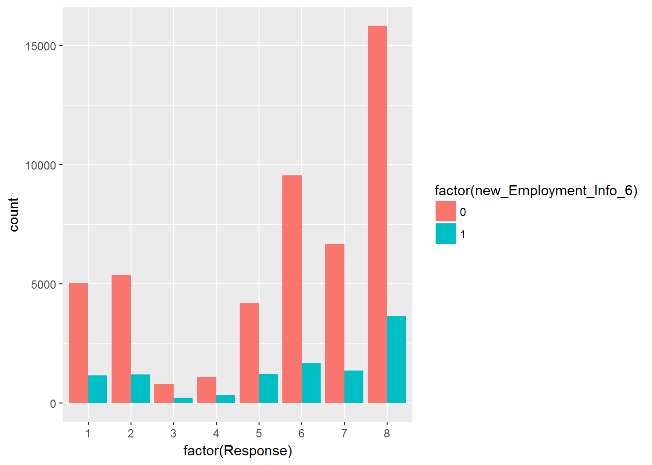

ggplot(data = train, aes(factor(Response), fill = factor(new_Insurance_History_5))) +  
 geom_bar(position = "dodge")

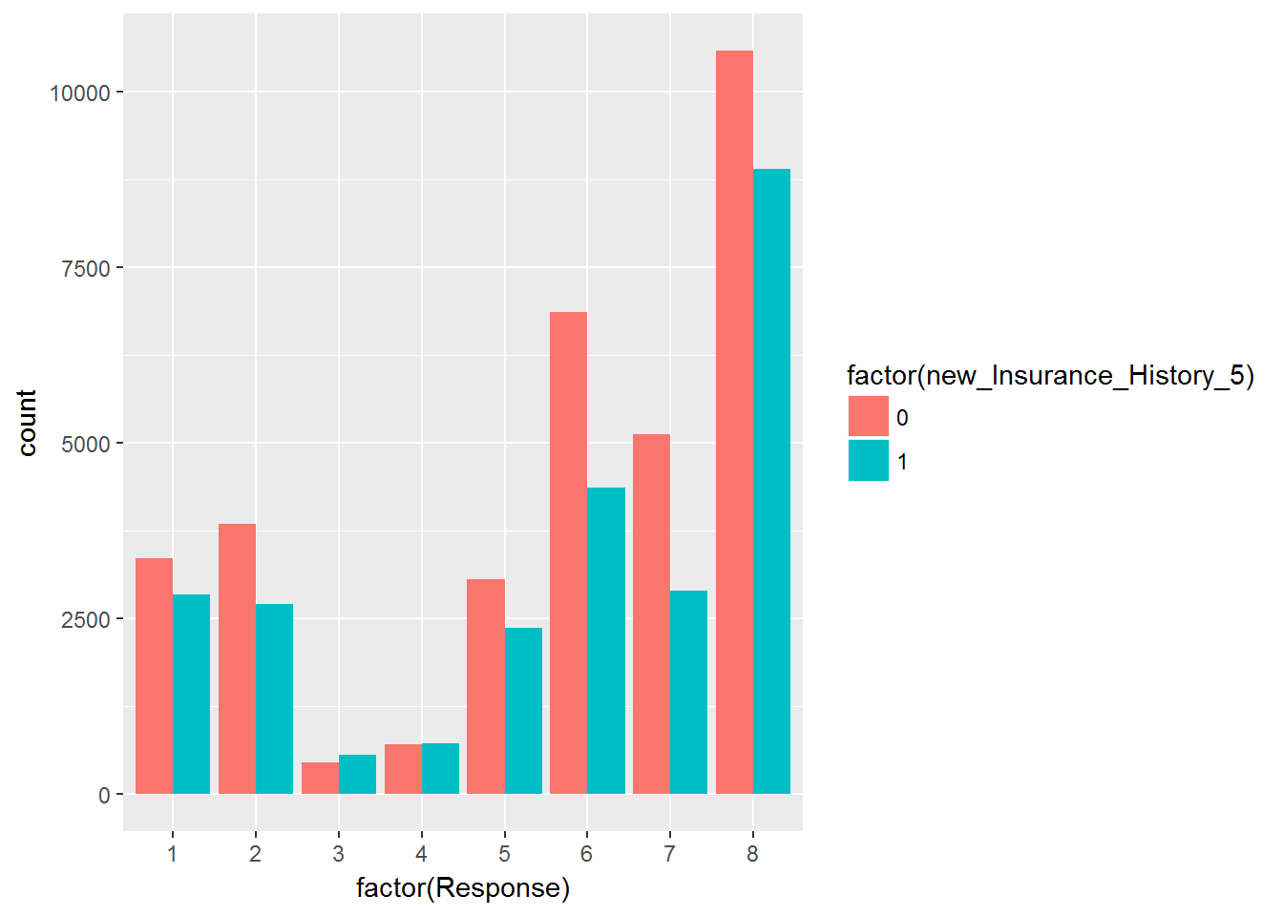

ggplot(data = train, aes(factor(Response), fill = factor(new_Family_Hist_2))) +  
 geom_bar(position = "dodge")

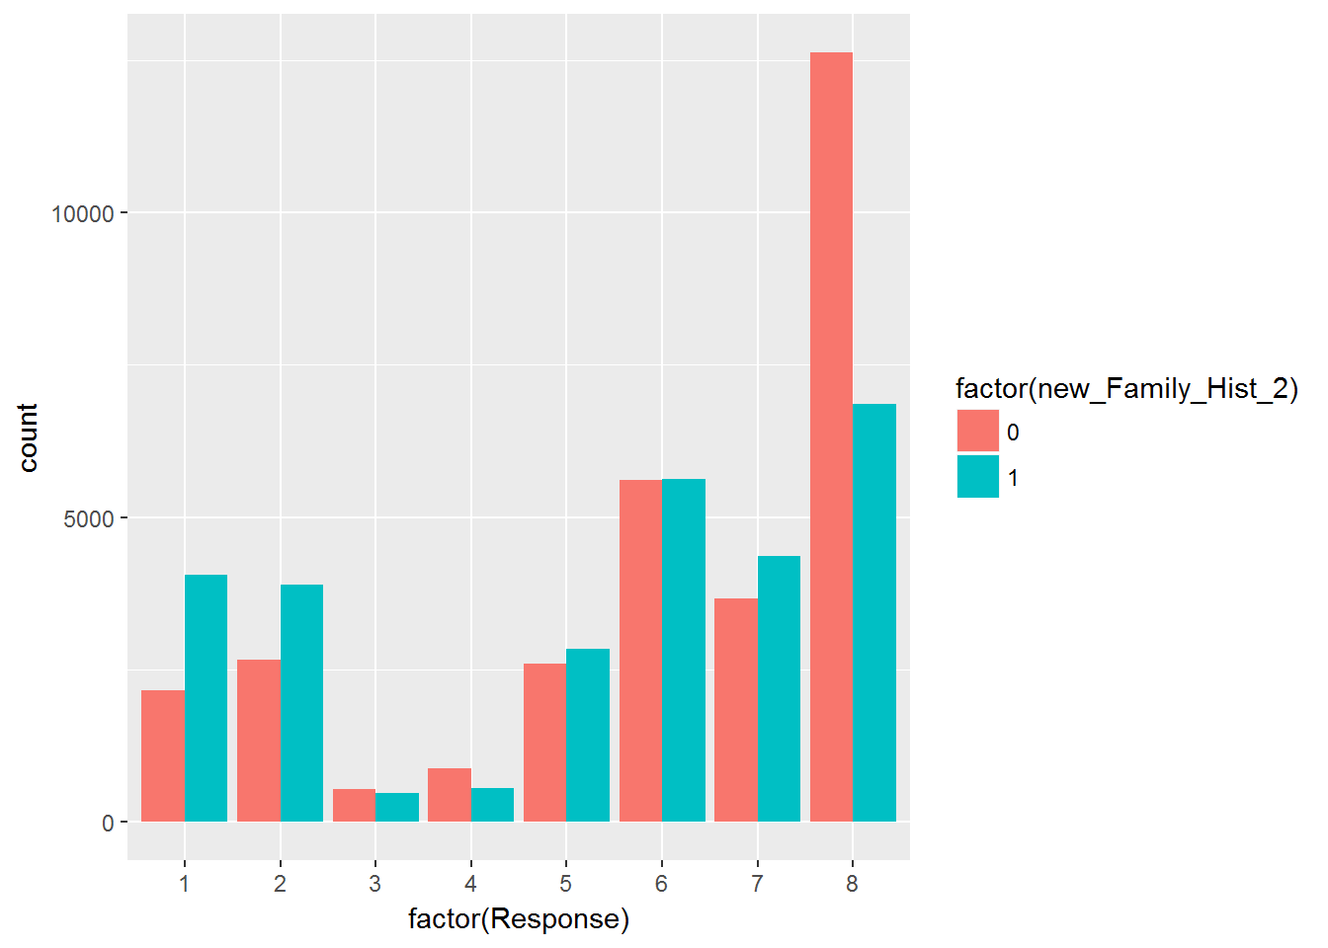

ggplot(data = train, aes(factor(Response), fill = factor(new_Family_Hist_3))) +  
 geom_bar(position = "dodge")

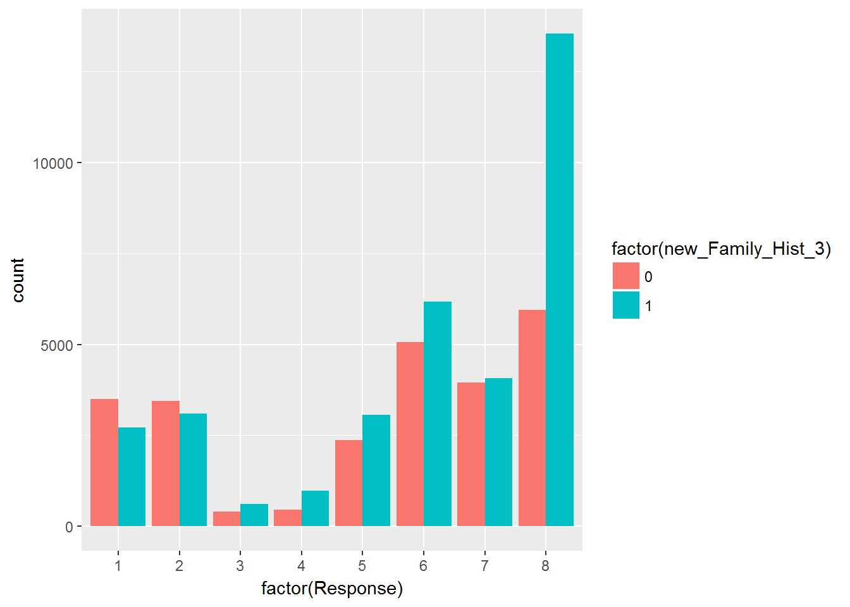

ggplot(data = train, aes(factor(Response), fill = factor(new_Family_Hist_4))) +  
 geom_bar(position = "dodge")

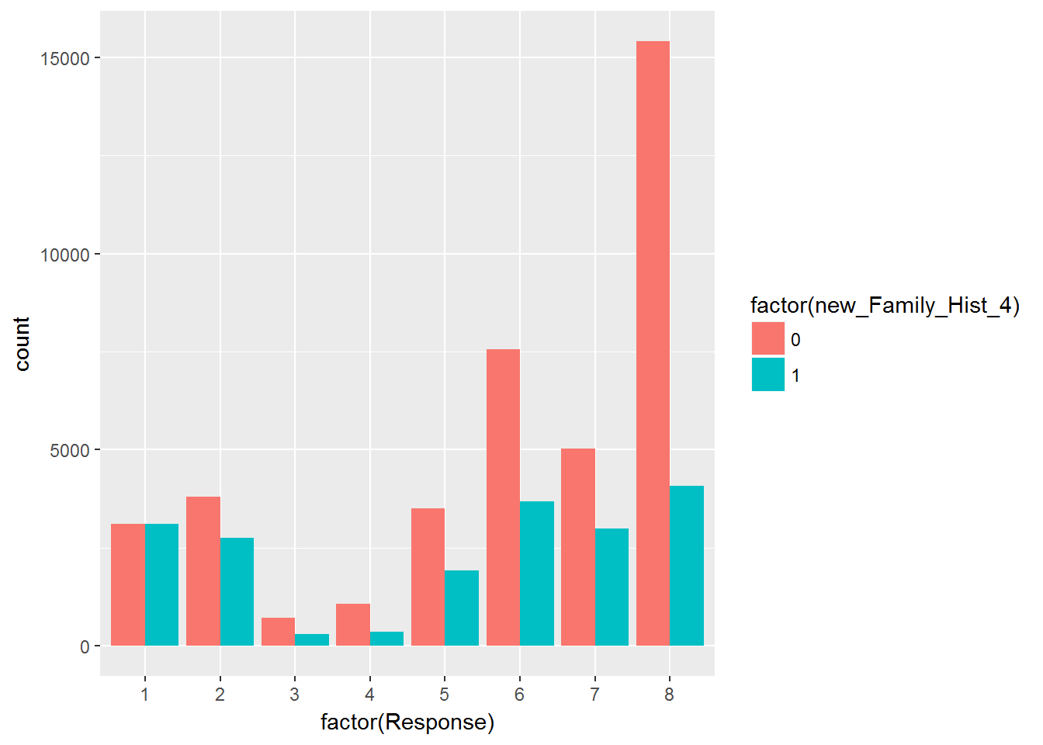

ggplot(data = train, aes(factor(Response), fill = factor(new_Family_Hist_5))) +  
 geom_bar(position = "dodge")

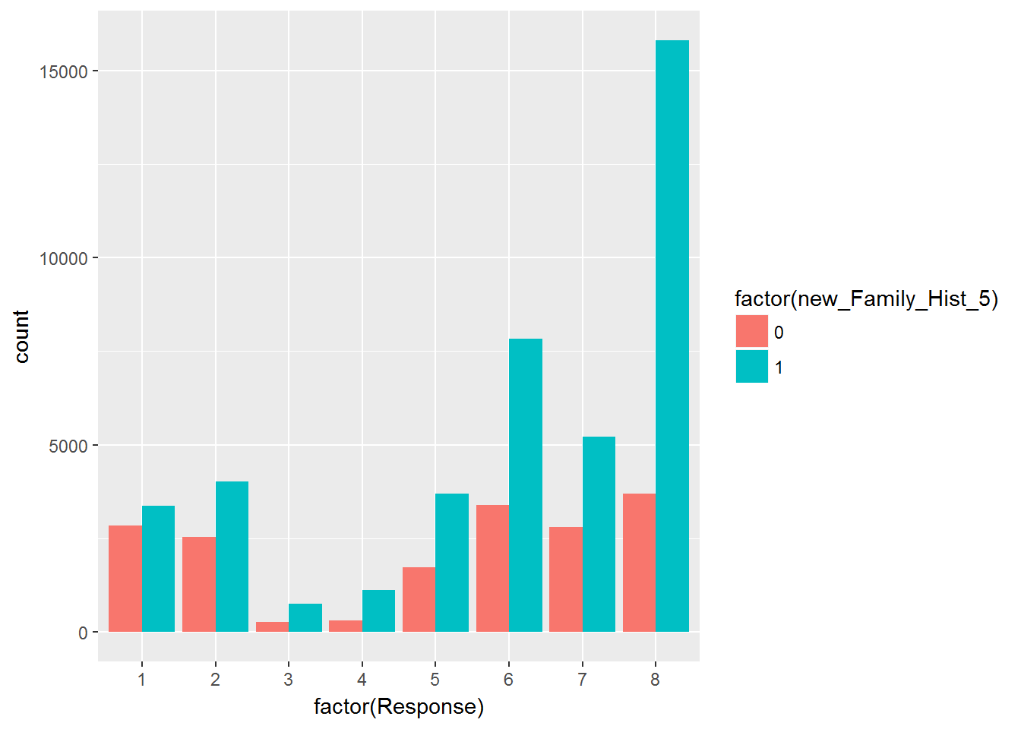

ggplot(data = train, aes(factor(Response), fill = factor(new_Medical_History_1))) +  
 geom_bar(position = "dodge")

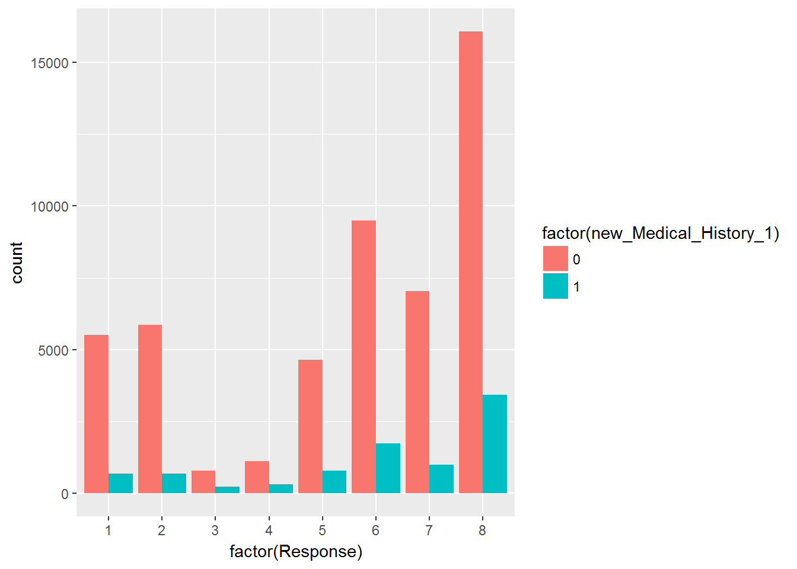

ggplot(data = train, aes(factor(Response), fill = factor(new_Medical_History_10))) +  
 geom_bar(position = "dodge")

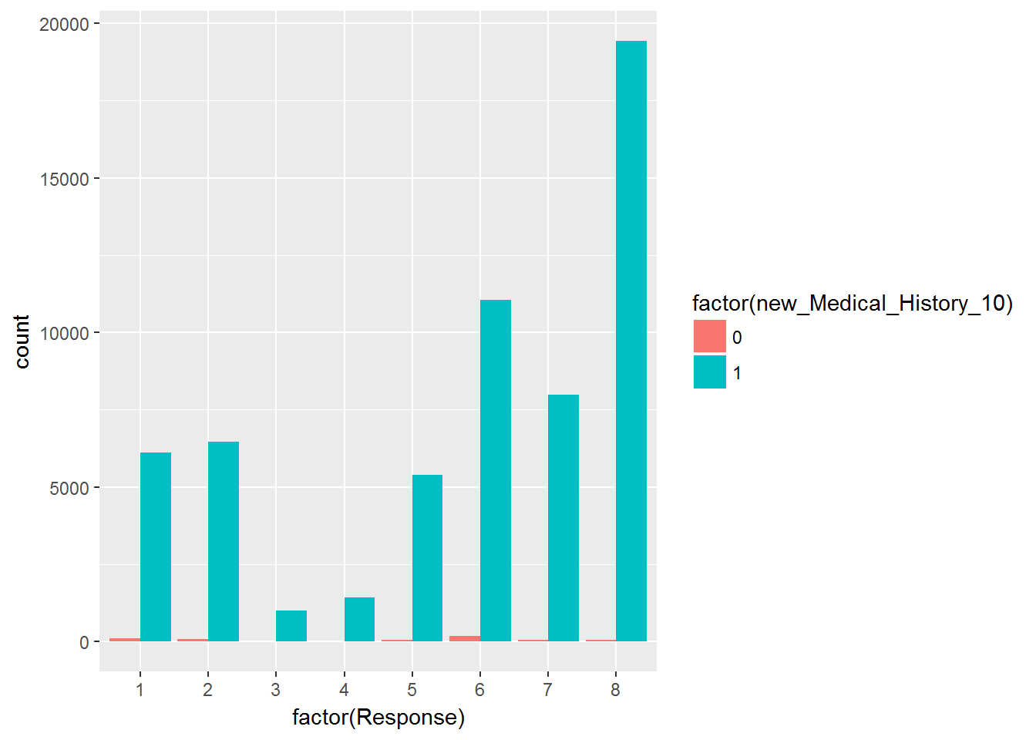

ggplot(data = train, aes(factor(Response), fill = factor(new_Medical_History_15))) +  
 geom_bar(position = "dodge")

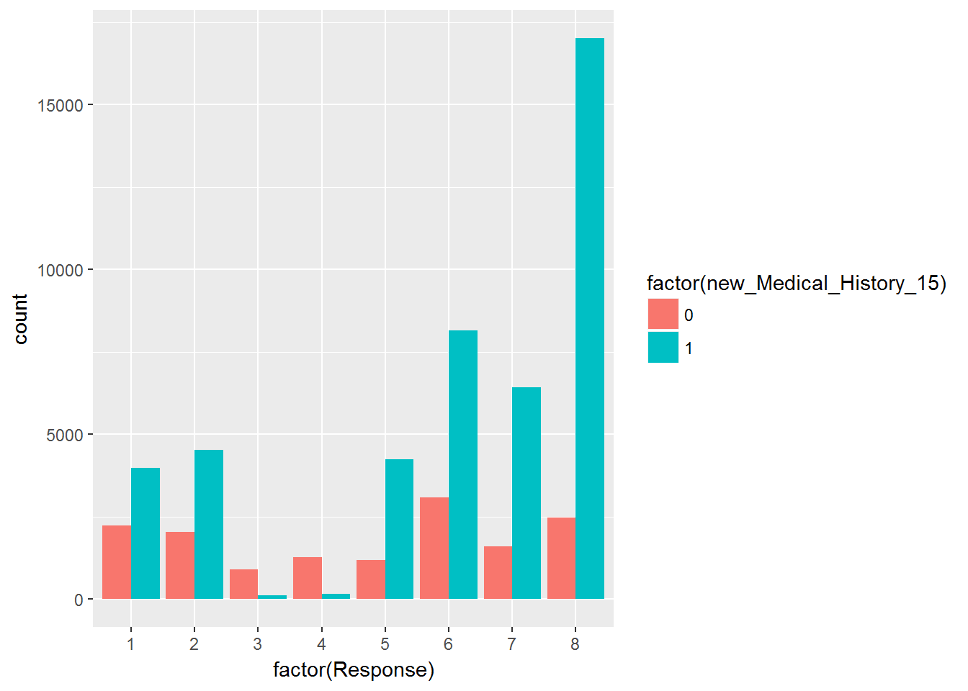

ggplot(data = train, aes(factor(Response), fill = factor(new_Medical_History_24))) +  
 geom_bar(position = "dodge")

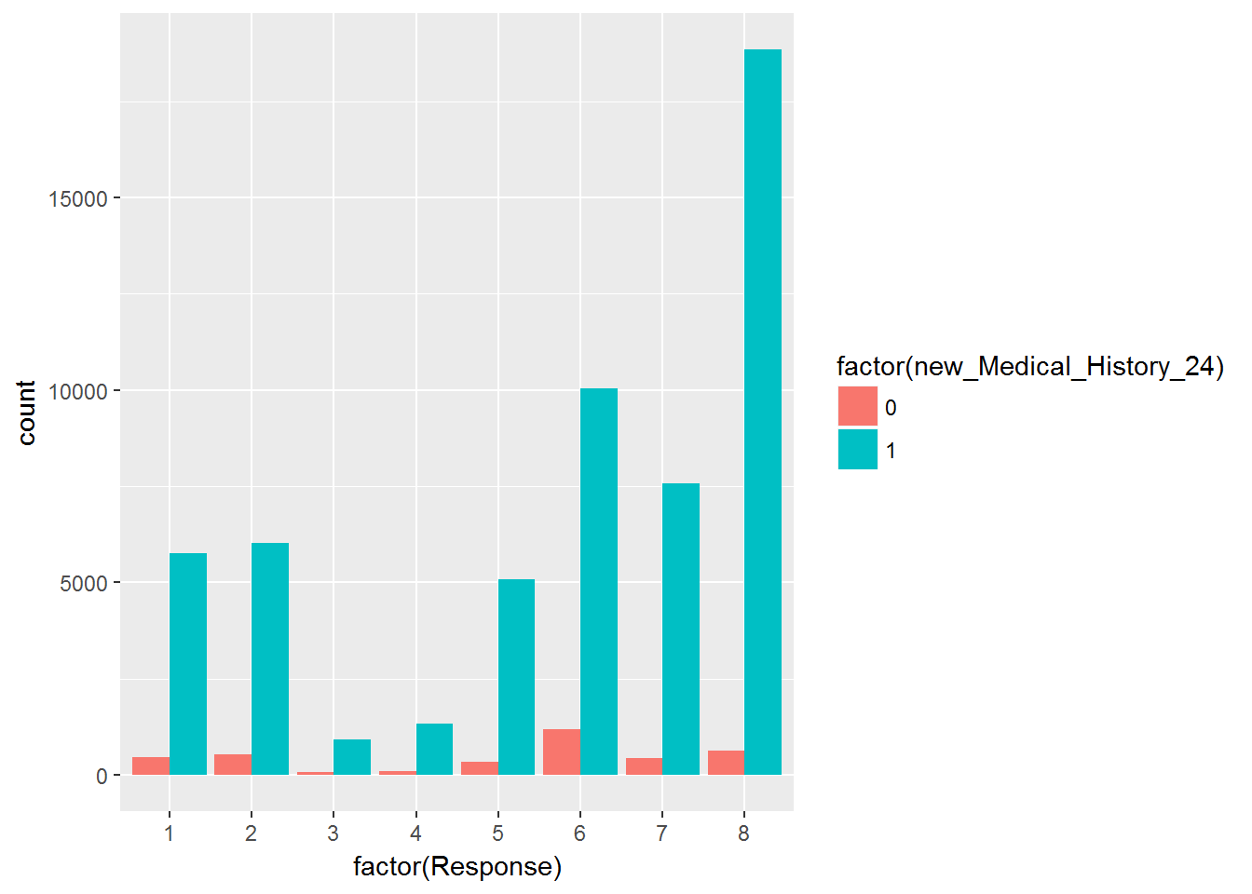

ggplot(data = train, aes(factor(Response), fill = factor(new_Medical_History_32))) +  
 geom_bar(position = "dodge")

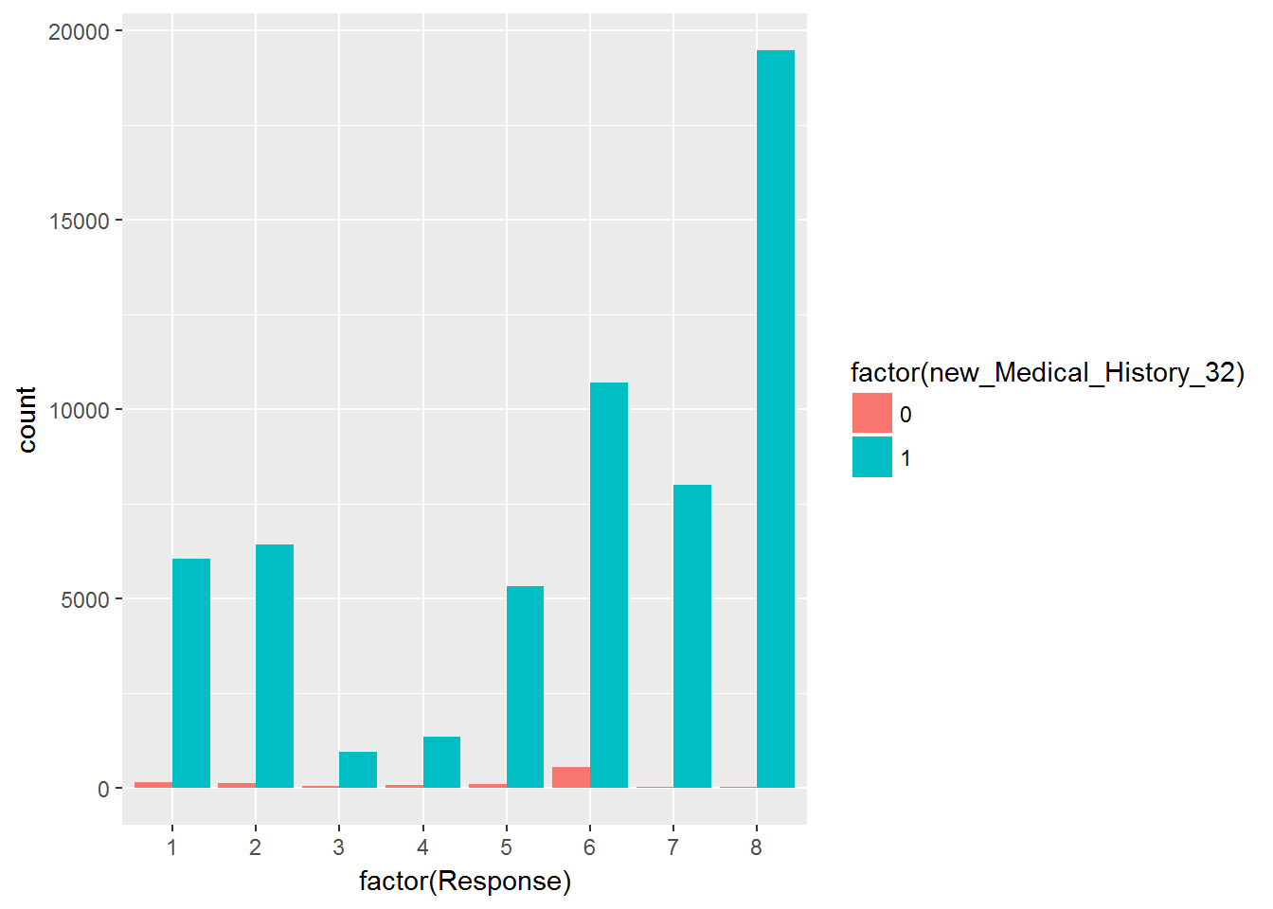

is.na 변수 갯수 히스토그램

qplot(rowSums(is.na(train)), geom="histogram",binwidth = 1, col=I("red"))

