ITAI 2373

Lab 01

01/24/2025

Screenshot of the completed lab.

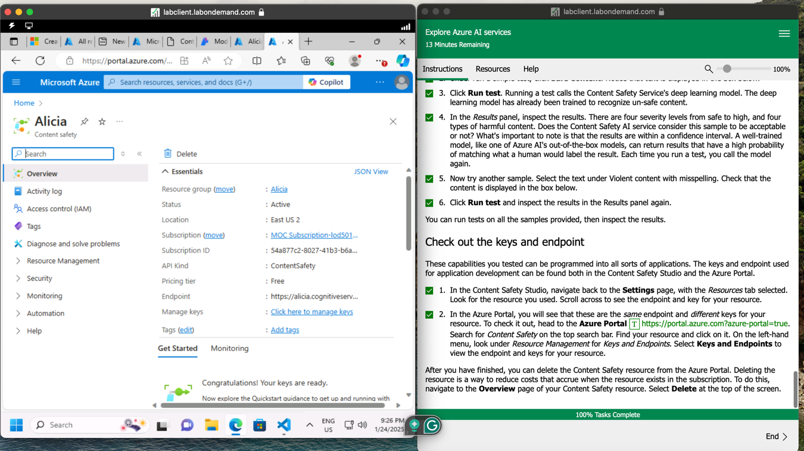

Reflective Journal

This lab was very informative regarding Azure AI. However, I faced several challenges because it was my first time using the Skillable platform, which made it difficult to understand the instructions. I had to re-read the instructions five times to fully grasp how to work in the lab. Once I understood them, everything went smoothly, and I was able to gain a better understanding of how Azure works.

I learned a lot from this experience. Azure is a cloud computing platform that helps manage applications efficiently. While working on the lab, I noticed that Azure is very flexible. The platform makes it easy to run applications and organize tasks, which is crucial when working with various programs.

Finally, I was able to fully grasp how azure works. Hopefully, I get tom work on it in the future.