Alicia Gonzalez

ITAI 2373

01/25/2025

Lab 01

Screenshot of Lab 02

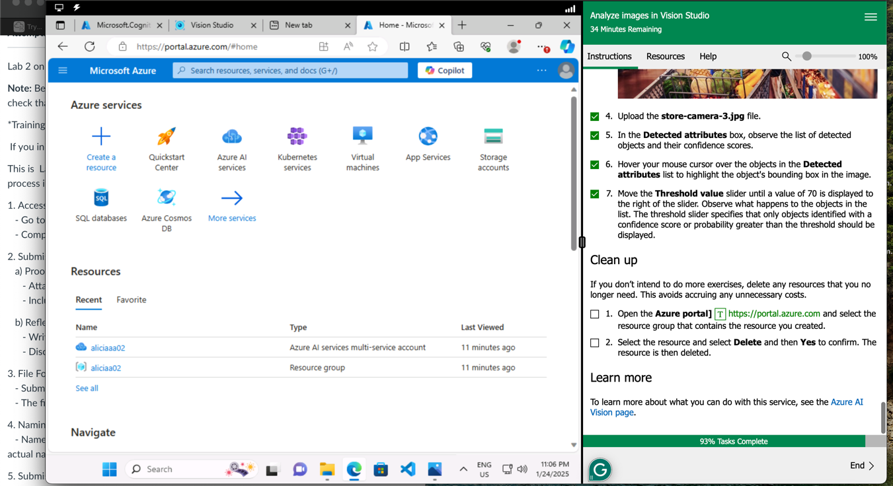

Reflection Paper

During this lab, I gained valuable experience in both theoretical knowledge and practical skills. It was very insightful, providing me with a deeper understanding of automated machine learning. The main challenge I encountered was navigating the Skillable platform. Just like in the first lab, it took me a long time to fully understand how the lab works. However, aside from that, everything else went very smoothly.

I learned how to create and manage an Azure Machine Learning workspace, which is essential for organizing and tracking AI experiments efficiently. The lab also highlighted the importance of model evaluation metrics, such as accuracy and precision, in determining the performance of AI models.

In conclusion, I look forward to applying the skills I learned while working in this lab.