Alicia Gonzalez Cruz

02/08/2025

ITAI 2373

Lab 03

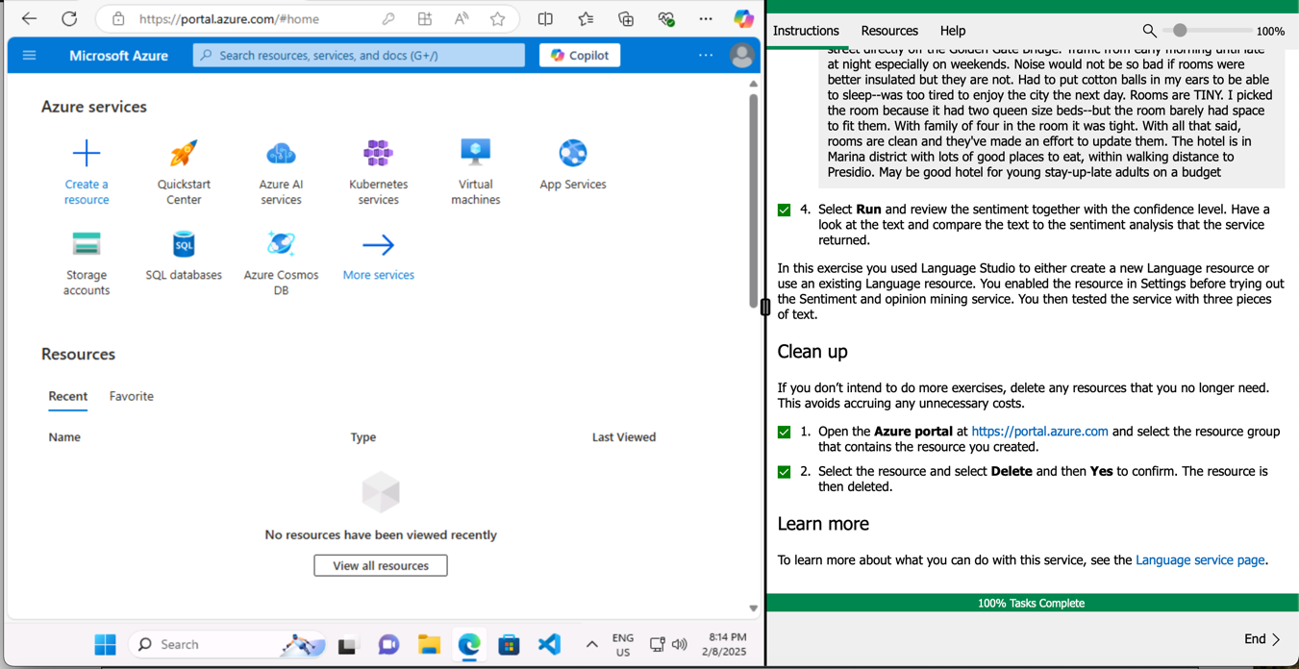

Reflection

This lab was rather easier and less complicated than the last labs. I really liked working with Azure because it makes everything easier to understand. In this lab I explored Azure AI Language which helped me analyze examples of hotel reviews. I used those reviews to understand whether they were negative or positive, which was interesting. I think the most important part of this lab was the understanding of how Natural Language processing works, and how I can use NLP to extract meaning from text, as well as identify key phrases. NLP does have many capabilities, and I am happy that I am able to understand better how it works.