ITAI 2373

Alicia Gonzalez Cruz

02/27/2024

Prof. Anna Devarakonda

AI 900 Lab 4 on MSLE Skillable Platform

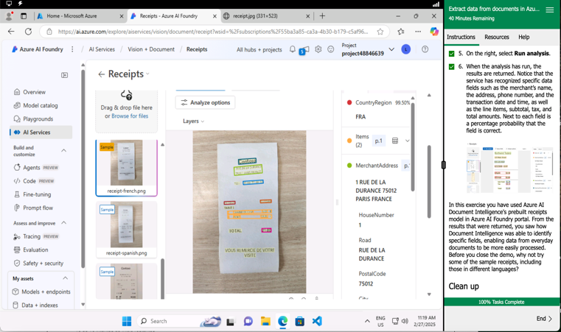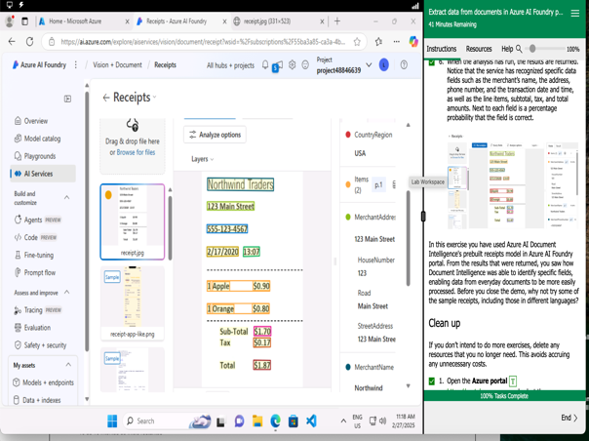

Reflective Journal

I found Lab 4 to be very informative regarding how to use Azure to extract data from documents. In the beginning, I had some trouble understanding how to create a project within the Azure AI portal because, for some reason, the necessary resources—such as the key vault and Azure AI services—were not being loaded into the project. I was able to overcome this challenge by starting over, and I realized the issue was that I had not been reading the instructions correctly. After that, everything in the lab went smoothly. I really liked how easy it was to run analyses on multiple documents. The Azure AI Foundry portal is a very useful tool for identifying specific data from simple documents.

Furthermore, I was able to run data in many other documents in different languages, and the AI tool was able to translate everything for me, and even give me the information I needed, which is very cool.