Alicia Gonzalez Cruz

ITAI 2372

04/26/2026

Lab 05- Skillable Platform

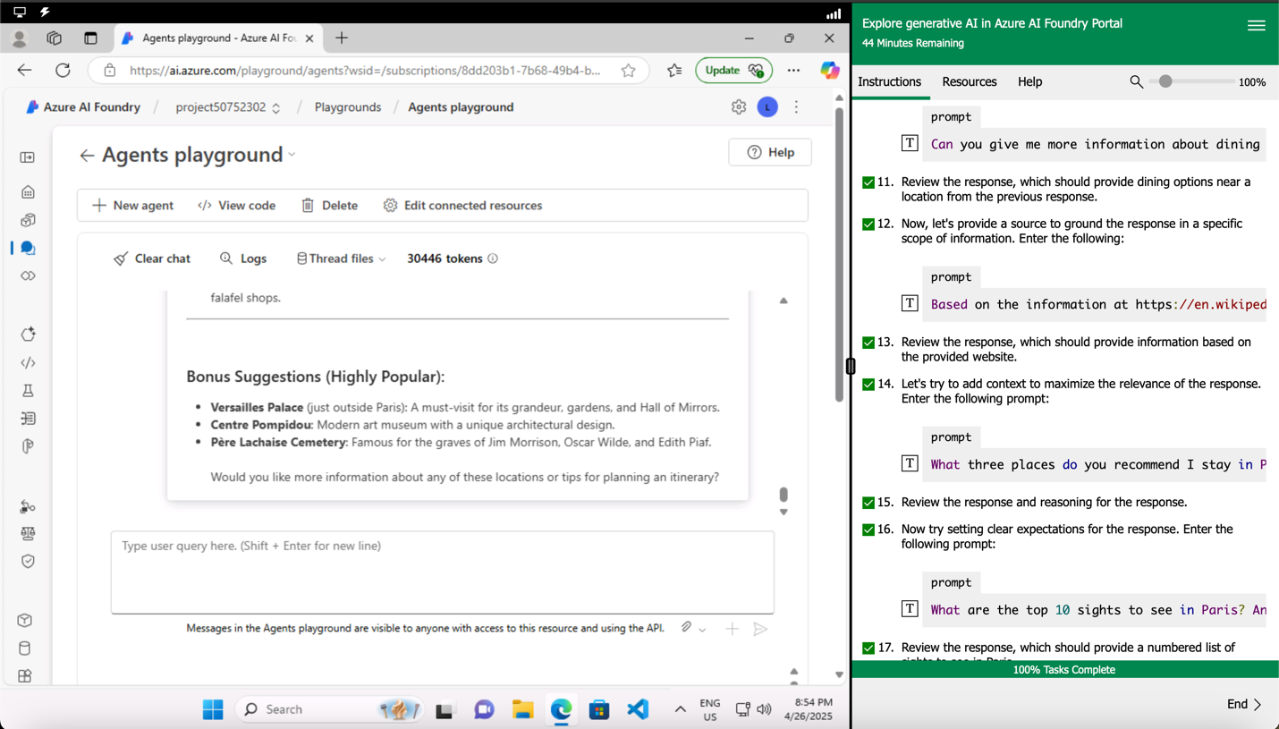

Reflection

Trying out generative AI in the Azure AI Foundry portal was a pretty cool experience. It showed me how AI can help build smart applications, not just answer random questions. Setting up a project was easy — I just had to create a hub, a project, and link a few resources like a storage account and key vault. Once everything was set up, I explored the Chat playground and deployed a GPT-4 model, which was awesome because I could play around with different prompts. I learned that being clear with your prompts and giving the AI some context makes a difference in getting better answers. It was also interesting to see how important it is to set clear goals and even provide sources, so the AI stays focused. Overall, this exercise made me realize how useful and flexible generative AI can be, especially when it’s used the right way.