**Jeffrey Cruz**

**CS 361**

**Prolog Assignment**

**PROLOG**

1. Let us consider the following set of facts that describe the mother predicate.

mother(linda, paul).

mother(cathy, andrew).

mother(cathy, laura)

* Define a predicate female(X) which holds iff X is a female
  + Female(linda)
  + Female(cathy)
  + Female(laura)
* Define a predicate sister(X,Y) which holds iff X and Y are sisters
  + Sister(X,Y) :- Female(X),Female(Y),mother(Z,X), mother(Z,Y)
* Implement female and sister in PROLOG
  + female(linda).
  + female(cathy).
  + female(laura).
  + female(athena).
  + mother(linda, paul).
  + mother(cathy, andrew).
  + mother(cathy, laura).
  + mother(cathy,athena)
  + sister(X,Y) :-female(X),female(Y),mother(Z,X), mother(Z,Y).
* Provide screenshots
* 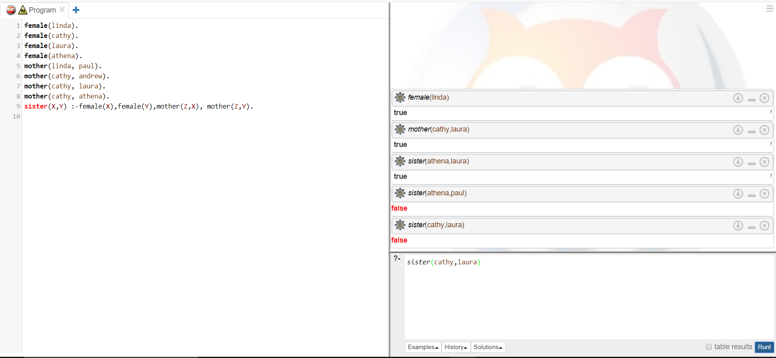

1. Implement the function g such that g(x) = x+5.

g(X,Y) :-

integer(X),

Y is X+5.

