Plantilla unal pec

Este será el subtítulo para esta platnilla

Julián Cruz

2021-06-13

# First title ever

## R Markdown

This is an R Markdown document. Markdown is a simple formatting syntax for authoring HTML, PDF, and MS Word documents. For more details on using R Markdown see <http://rmarkdown.rstudio.com>.

When you click the **Knit** button a document will be generated that includes both content as well as the output of any embedded R code chunks within the document. You can embed an R code chunk like this:

summary(cars)

## speed dist   
## Min. : 4.0 Min. : 2.00   
## 1st Qu.:12.0 1st Qu.: 26.00   
## Median :15.0 Median : 36.00   
## Mean :15.4 Mean : 42.98   
## 3rd Qu.:19.0 3rd Qu.: 56.00   
## Max. :25.0 Max. :120.00

## Including Plots

You can also embed plots, for example:

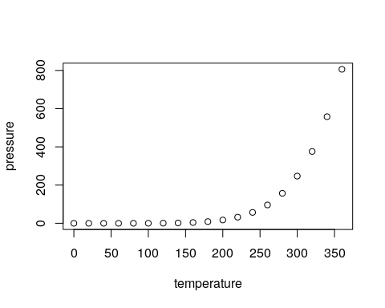

Note that the echo = FALSE parameter was added to the code chunk to prevent printing of the R code that generated the plot.

## including lists

### Bulleted lists

There is a compact bulleted list

* This is first
* This is second
  + This is a child of the second point
  + This is a second child

There is a spaced bulleted list

* This is first
* This is second
  + This is a child of the second point
  + This is a second child

### Numbrered lists

There is a compact numbered list

1. This is first
2. This is second
   1. This is a child of the second point
   2. This is a second child

There is a compact numbered list

1. This is first
2. This is second
   1. This is a child of the second point
   2. This is a second child

## Including tables

## We also want to have some code  
##   
  
library("magrittr")  
library("dplyr")

##   
## Attaching package: 'dplyr'

## The following objects are masked from 'package:stats':  
##   
## filter, lag

## The following objects are masked from 'package:base':  
##   
## intersect, setdiff, setequal, union

library("knitr")  
  
iris %>%   
 group_by(Species) %>%   
 summarise_all(mean) %>%   
 kable

| Species | Sepal.Length | Sepal.Width | Petal.Length | Petal.Width |
| --- | --- | --- | --- | --- |
| setosa | 5.006 | 3.428 | 1.462 | 0.246 |
| versicolor | 5.936 | 2.770 | 4.260 | 1.326 |
| virginica | 6.588 | 2.974 | 5.552 | 2.026 |